ANNEXURE 1
CONSENT FORM
PARTICIPANT ID:

Hello,I am ______________________ from Aziz Fatimah medical and dental college. We are interviewing people to gather data on vaccination hesitancy in parents in FAISALABAD,PAKISTAN I know you are busy,so this will take only a few minutes.Your participation is completely voluntary and anonymous.If you do not want to answer a question or wish to stop the interview,just let me know.

Would you be willing to take the survey?
YES/NO

ANNEXURE 2
QUESTIONNAIRE
DEMOGRAPHIC DATA
Full Name :_______________ Age :_______________
Address:_____________________________________________________ Gender: 〇 Male 〇 Female
HOUSEHOLD CHARACTERISTICS
FAMILY MEMBERS
〇 1-3 〇 4 -7 〇8-10
〇 more than 10
AMENITIES
Landline present in house. Yes/no
Owns a radio. Yes/No
Owns a television. Yes/No
Owns a refrigerator. Yes /No
Owns an electric or gas stove. Yes/no
Owns a car. Yes /No
Number of amenities:__________
CHILD CHARACTERISTICS
AGE:_________
GENDER. Male /female

MATERNAL CHARACTERISTICS
AGE:_________
Able to read or write. Yes/no
Education:
〇 No education
〇 Primary education
〇 Secondary education
〇 Higher education
EMPLOYED. Yes/no
Mother owns a mobile. Yes/no
PATERNAL CHARACTERISTICS
AGE:_________
Able to read or write. Yes/no
Education:
〇 No education
〇 Primary education
〇 Secondary education
〇 Higher education
EMPLOYED. Yes/no
Father owns a mobile. Yes/no
Father involved in child care ? Yes /No
Core Vaccine Hesitancy Survey
To be asked to parents/caregivers about childhood vaccinations
1.Do you believe that vaccines can protect children from serious diseases?Y/N
2. Do you think that most parents like you have their children vaccinated with all the recommended vaccines?Y/N
3.Have you ever been reluctant or hesitated to get a vaccination for your child?Y/N
4. Have you ever refused a vaccination for your child? Y/N
What was/were the reason(s)?(Use list below to code response)
Did not think it was needed
Heard or read negative media
Did not know where to get vaccination
Had a bad experience or reaction with previous vaccination
Did not know where to get good/reliable information
Had a bad experience with previous vaccinator/health clinic
Not possible to leave other work (at home or other)
Someone else told me they/their child had a bad reaction
Did not think the vaccine was effective
Someone else told me that the vaccine was not safe
Did not think the vaccine was safe/concerned about side effects
Fear of needles
Religious reasons
Other(explain)
Other beliefs/traditional medicine
5.Has distance,timing of clinic,time needed to get to clinic or wait at clinic and/or costs in getting to clinic prevented you from getting your child immunized?Y/N
6. Are there other pressures in your life that prevent you from getting your child immunized on time?Y/N
7.Are there any reasons you think children should not be vaccinated?Y /N
8.Do you think that it is difficult for some ethnic or religious groups in your community /region to get vaccination for their children?Y /N
If yes,is it because
a. they choose not to vaccinate?
b. they do not feel welcome at the health service?
C. health services don't reach them?
9.Have you ever received or heard negative information about vaccination?Y /N
10.If yes,did you still take your child to get vaccinated after you heard the negative information? Y/N
Do leaders (religious,political,teachers,health care workers)in your community supporvaccines for infants and children? Y/N

Vaccine Hesitancy 5 point Likert scale questions:
scale 1 =strongly disagree to-scale 5 =strongly agree
1 2 3 4 5
L1.Childhood vaccines important for my child's health
L2.Childhood vaccines are effective
L3.Having my child vaccinated is important for the health of others in my community
L4.All childhood vaccines offered by the government program in my community are beneficial.
L5.New vaccines carry more risks than older vaccines
L6.The information I receive about vaccines from the vaccine program is reliable and trustworthy.
L7.Getting vaccines is a good way to protect my child/children from disease.
L8.Generally I do what my doctor or health care provider recommends about vaccines for my child/children.
L9.I am concerned about serious adverse effects of vaccines.
L10.My child/children does or do not need vaccines for diseases that are not common anymore.

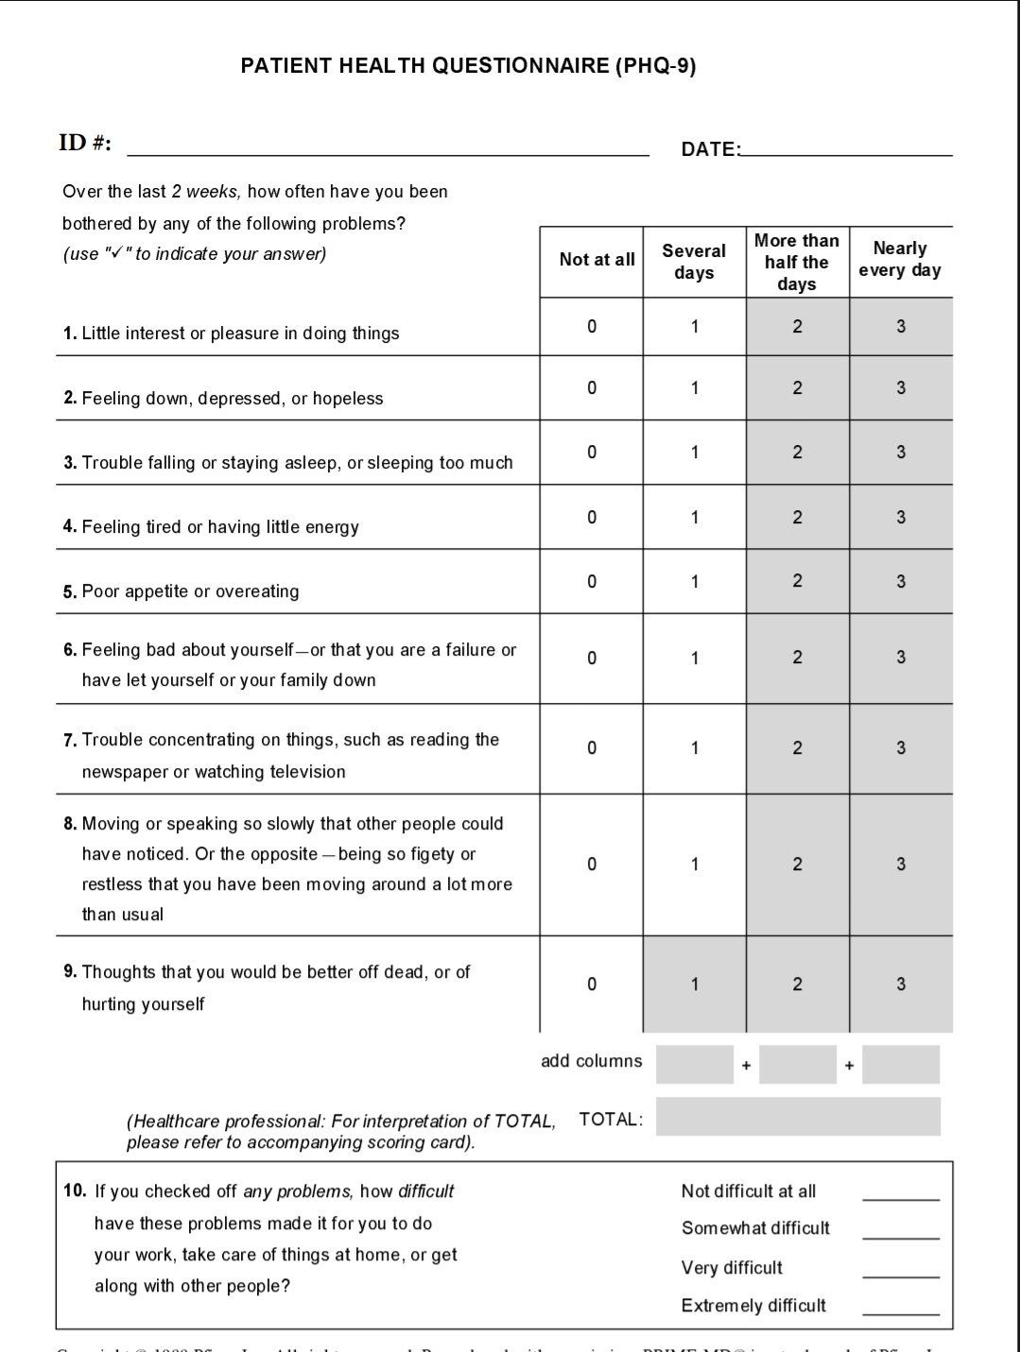
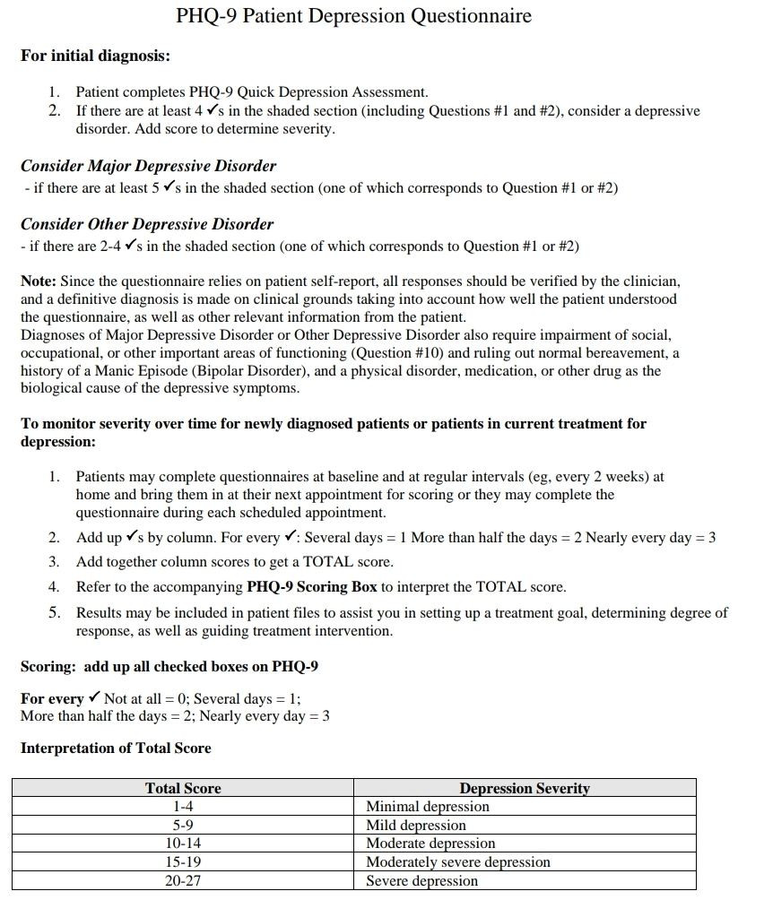

Household Food Insecurity Access Scale (HFIAS)Measurement Tool
QUESTIONS
1.In the past four weeks,did you worry that your household would not have enough food?
0=No(skip to Q2)
1=Yes
1.a How often did this happen?
1=Rarely (once or twice in the past four weeks)
2=Sometimes (three to ten times in the past four weeks)
3=Often(more than ten times in the past four weeks)
2.In the past four weeks were you or any household member not able to eat the kinds of foods you preferred because of a lack of resources?
0=No(skip to Q3)
1=Yes
2.a How often did this happen?
1=Rarely(once or twice in the past four
weeks)
2=Sometimes (three to ten times in the past four weeks)
3=Often(more than ten times in the past four weeks)
3.In the past four weeks,did you or any household member have to eat a limited variety of foods due to a lack of resources?
0=No(skip to Q4)
1=Yes
3.aHow often did this happen?
1=Rarely (once or twice in the past four weeks)
2=Sometimes (three to ten times in the past four weeks)
3=Often(more than ten times in the past four weeks)
4.In the past four weeks,did you or any household member have to eat some foods that you really did not want to eat because of a lack of resources to obtain other types of food?
0=No(skip to Q5)
1 =Yes
4.aHow often did this happen?
1=Rarely(once or twice in the past four weeks)
2=Sometimes(three to ten times in the past four weeks)
3=Often(more than ten times in the past four weeks)
5.In the past four weeks,did you or any household member have to eat a smaller meal than you felt you needed because there was not enough food?
0=No(skip to Q6)
1=Yes
5.aHow often did this happen?
1=Rarely(once or twice in the past foui weeks)
2=Sometimes(three to ten times in the past four weeks)
3=Often(more than ten times in the past four weeks)
6.In the past four weeks,did you or any other household member have to eat fewer meals in a day because there was not enough food?
0=No(skip to Q7)
1=Yes
6.aHow often did this happen?
1=Rarely(once or twice in the past foui weeks)
2=Sometimes(three to ten times in the past four weeks)
3=Often(more than ten times in the past four weeks)
7.In the past four weeks,was there ever no food to eat of any kind in your household because of lack ofresources to get food?
0=No(skip to Q8)
1=Yes
7.aHow often did this happen?
1=Rarely (once or twice in the past four weeks)
2=Sometimes(three to ten times in the pastfour weeks)
3=Often(more than ten times in the past four weeks)
8.In the past four weeks,did you or any household member go to sleep at night hungry because there was not enough food?
0=No(skip to Q9)
1=Yes
8.aHow often did this happen?
1=Rarely(once or twice in the past four weeks)
2=Sometimes(three to ten times in the past four weeks
3=Often(more than ten times in the past four weeks)
9.In the past four weeks,did you or any household member go a whole day and night without eating anything because there was not enough food?
0=No(questionnaire is finished)
1 =Yes
9.aHow often did this happen?
1=Rarely(once or twice in the past fourweeks)
2=Sometimes(three to ten times in the pastfour weeks
3=Often(more than ten times in the past four weeks)
Household Food Insecurity Access Scale Score
The HFIAS score is a continuous measure of the degree of food insecurity (access)in the household in the past four weeks (30 days).First,a HFIAS score variable is caleulated for each household by summing the codes for each frequency-of-oecurrence question. Before summing the frequency-of-oceurrence codes,the data analyst should code frequency-of-occurrence as O for all cases where the answer to the corresponding
occurrence question was“no”(i.e.,ifQl=0 then Qla=0,if Q2=0 then Q2a=0,ete.).The maximum score for a household is 27(the household response to all nine frequency-of occurrence questions was“often”,coded with response code of3);the minimum score is 0(the household responded"no"to all occurrence questions,frequency-of-occurrence questions were skipped by the interviewer,and subsequently coded as O by the data analyst.)The higher the score,the more food insecurity (access)the household experienced.The lower the score,the less food insecurity (access)a household experienced
HFIAS Score(0-27)
Sum of the frequency-of-occurrence during the past four weeks for the 9 food insecurity related conditions .Sum frequency of occurrence question response code (Qla+Q2a+ Q3a+Q4a+Q5a +Q6a+Q7 a+Q8a+Q9a)

ANNEXURE 3
Gantt's chart
Sr# | Actions | Times in month
 |  | 1 | 2 | 3 | 4 | 5 | 6 | 7 | 8 | 9
 |  | Pre - project preparation |  |  | Main study + data collection |  |  | Data processing and reporting
1 | Data Collection tool designing
2 | ERC approval
3 | Grant submission
4 | Pre - testing
5 | Conduction of study
6 | Organizing data
7 | Data processing
8 | Report writing
9 | Submission of report

