8. Supplemental material
Appendix 1 Normalized confusion matrices displaying the cross-validation results for each location and modality.
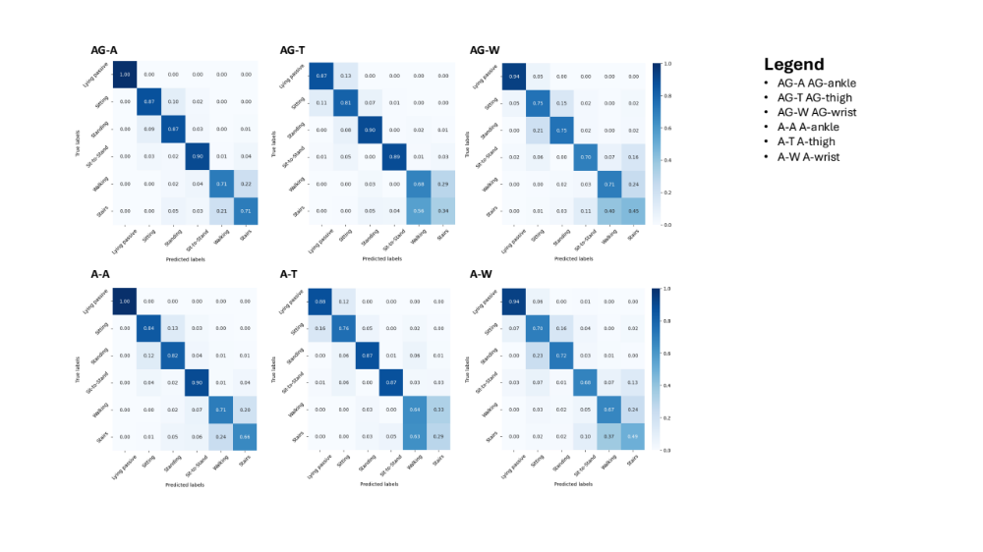AG-A: Ankle model using accelerometer & gyroscope features, AG-T: Thigh model using accelerometer & gyroscope features, AG-W: Wrist model using accelerometer & gyroscope features, A-A: Ankle model using accelerometer features, A-T: Thigh model using accelerometer features, A-W: Wrist model using accelerometer features

Appendix 2: Results of the patient questionnaire
Total count measurements
N=86 (100 %)
 | n | percentage
Was wearing the sensors a bothering factor for you today? | 86
Yes, very | 1 | 1.2%
Yes, a little | 1 | 1.2%
Some | 0 | 0.0%
No | 84 | 97.7%
Which body location was the least disturbing? (multiple answers possible) | 86
wrist | 61 | 70.9%
ankle | 75 | 87.2%
thigh | 58 | 67.4%
Which body location was the most annoying? | 84
wrist | 5 | 5.9%
ankle | 3 | 3.6%
thigh | 2 | 2.4%
none | 75 | 89.3%
Did you experience any problems with the patch? | 85
Yes | 11 | 12.9%
No | 73 | 85.9%
Did you have to take off one or more sensors during the day? | 86
No | 80 | 93%
Yes, one | 5 | 5.8%
Yes, two or more | 1 | 1.2%

Appendix 3 Questionnaire for Participants After Each Day of Participation
Question | Answer Options
How long did the patient wear the sensors? | 1) 1 Day 2) 2 Days 3) 3 Days 4) 4 Days 5) 5 Days
Was wearing the sensors a disturbing factor for you today? | 1) Yes, very 2) Yes, a little 3) Somewhat 4) No
Which wearing location was the least disturbing? | 1) Wrist 2) Ankle 3) Thigh
Which wearing location was the most disturbing? | 1) Wrist 2) Ankle 3) Thigh
If problems with the adhesive occurred, which ones? | 1) Yes 2) No
If problems with the adhesive occurred, which ones? | (Notes)
Did you have to take off one or more sensors during the day? | 1) No 2) Yes, one 3) Yes, two or more
If yes, why? | (Notes)

