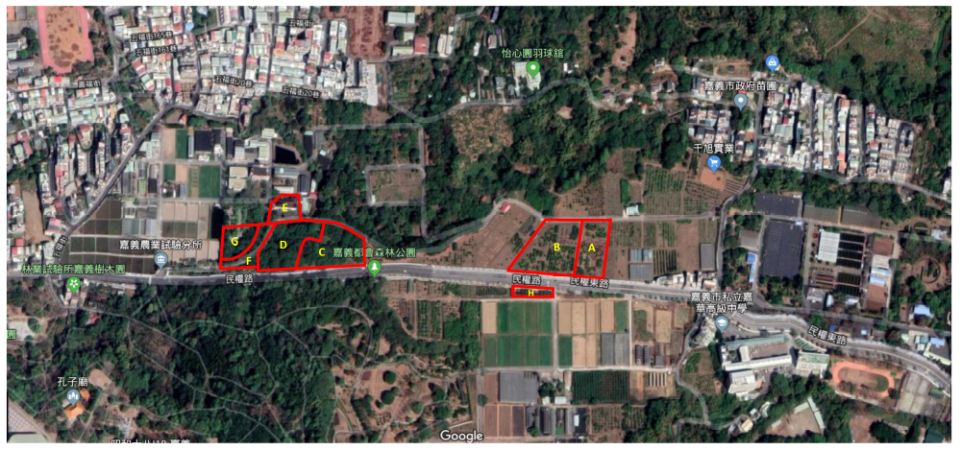
Figure S1. The map of the litchi orchards including CA and SA managements. The litchi orchards were located at 23°29'5.1288''N, 120°28'12.2592''E. The red frames indicate the experimental fields. A, B, and H refer to the CA management. C, D, E, F, and G refer to the SA management. The map was obtained from the Google map.

