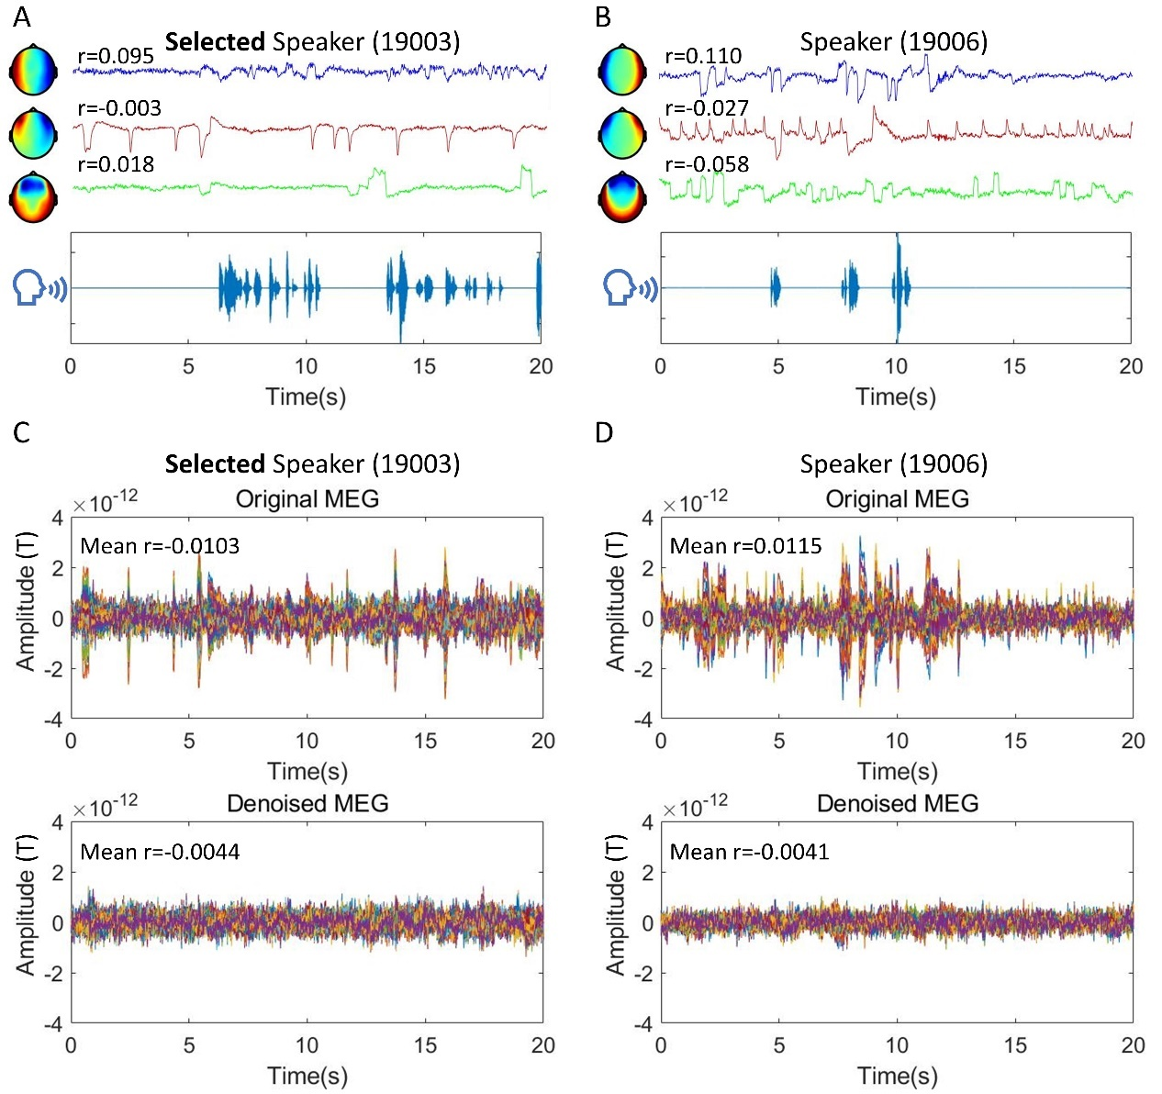
Figure S1. MEG signal qualities for two representative speakers with high signal-noise-ratio (SNR). Speaker 19003 was selected for the analyses reported in this study. (A) and (B) Independent components (ICs) related to muscle movements (top), blinks (middle), and eye movements (bottom) were correctly identified with ICA. The sound waves of the selected speaker (19003, SNR = 8.67 dB) in (A) and another speaker (19006, SNR = 7.12 dB) in (B) are shown along with the ICs. Pearson’s correlation (r) between each IC and the sound envelope is indicated near the IC topographies (magnetometers only). (C) and (D) Original (top panels, bandpass-filtered: 0.3–45 Hz) and denoised (bottom panels, with ICs related to blinks, eye movements, and muscle movements removed) MEG signals are presented for the selected speaker (19003) in (C) and speaker 19006 in (D). Mean Pearson’s r values with the sound envelope across all 102 magnetometers were significantly decreased after artifact removal.
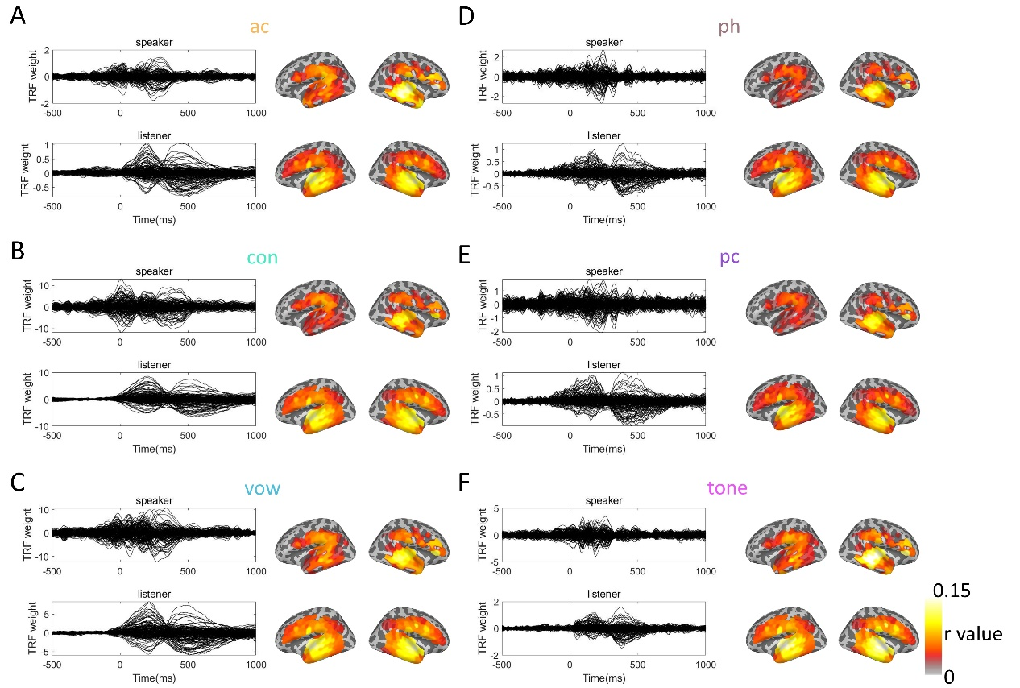
Figure S2. Feature-based temporal response functions (TRFs) for speakers and listeners. (A to F) Each panel presents results for various linguistic features: (A) acoustic (ac), (B) consonants (con), (C) vowels (vow), (D) phonemes (ph), (E) pitch contours (pc), and (F) tone. Left panels: Temporal response function (TRF) weights for the speaker (upper plots) and listener (lower plots) over time, with time 0 marking the onset of the feature. TRF weights represent the neural encoding associated with each feature. Right panels: Distribution of correlation coefficients (r values) for both the speaker (upper brain maps) and listener (lower brain maps) across cortical regions of interest. The color scale illustrates the strength of the correlation (ranging from 0 to 0.15). These findings underscore the differences in feature-specific neural responses between speakers and listeners.

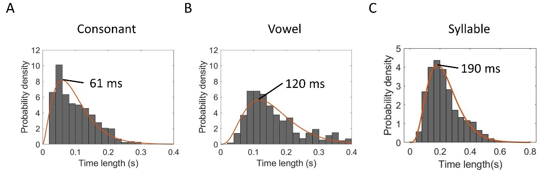
Figure S3. Speech production rates of the speaker for consonant, vowel and syllable (also tone). (A) and (B) The distribution of consonant and vowel durations in the speech stimuli, with a peak around 61 ms and 120 ms, respectively. Consonants and vowels were labeled by trained annotators. (C) The distribution of syllable durations in the speech stimuli, with a peak around 190 ms. Syllables were labeled based on the time length of Mandarin characters, corresponding to their spoken duration. The histograms represent the probability density of syllable and phrase durations, with an overlaid curve showing the gamma-fitted distribution. These results illustrate the temporal structure of speech stimuli at different linguistic levels.

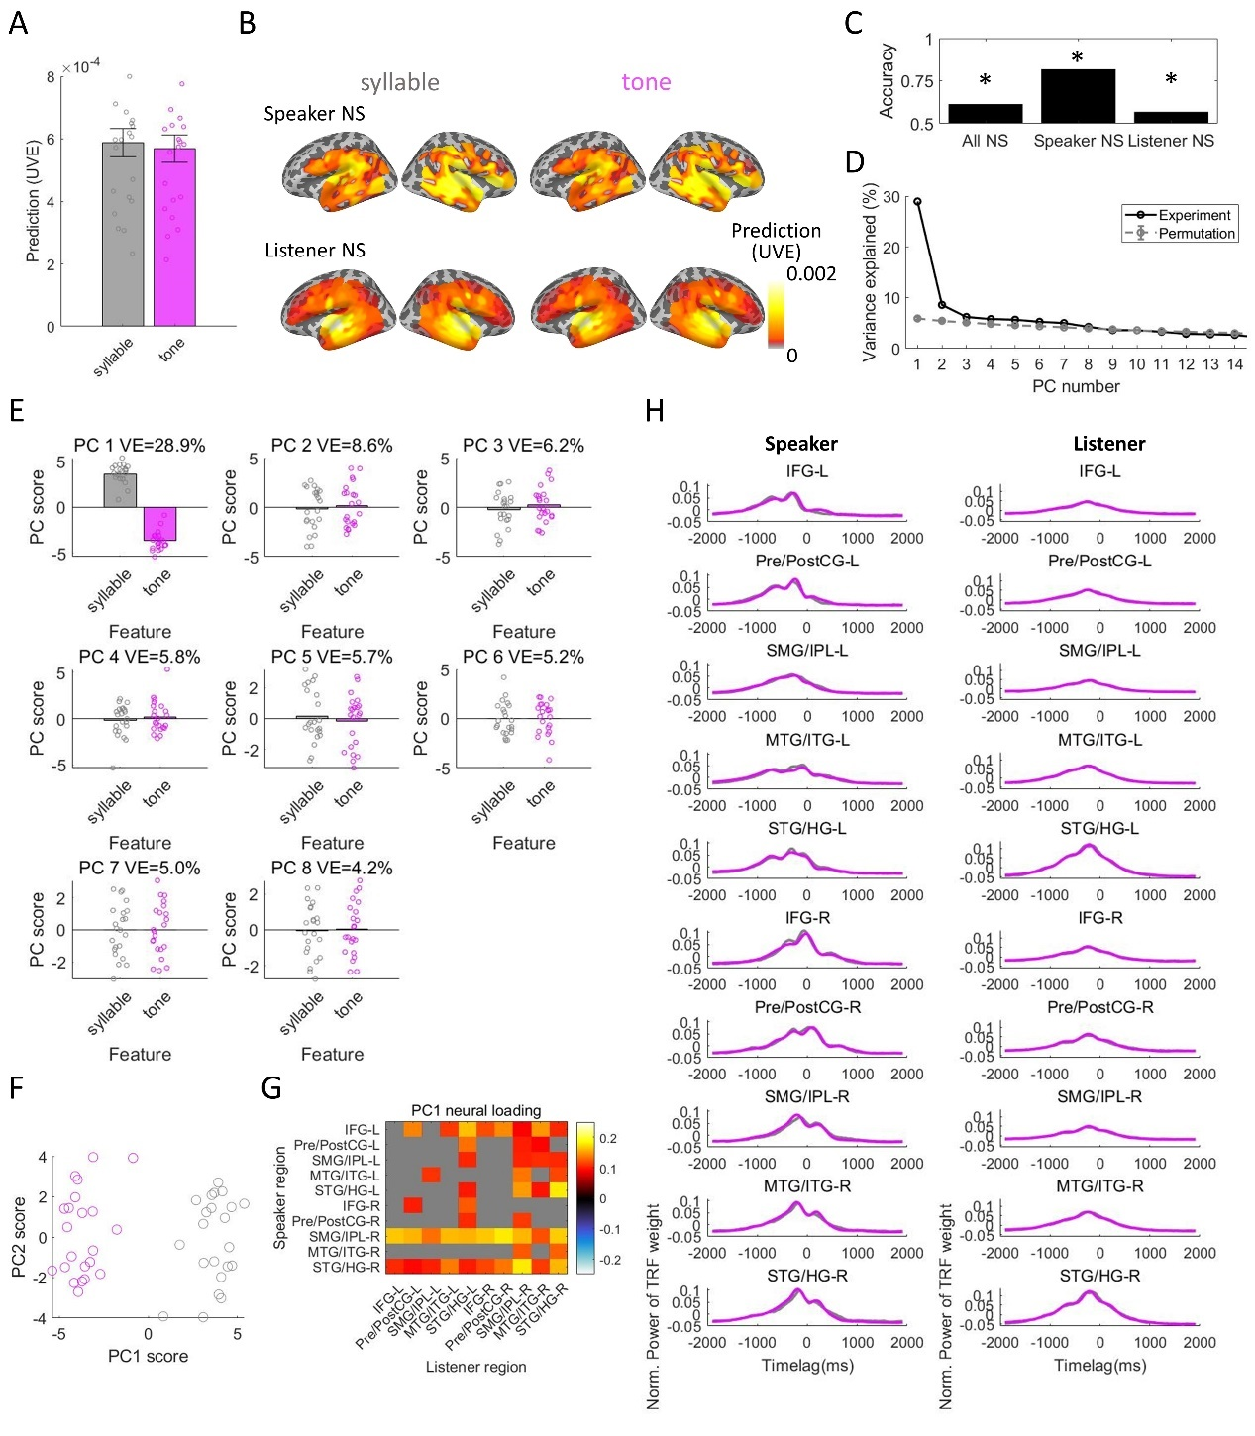
Figure S4. Feature-driven speaker-listener neural synchronization (NS) for syllable and tone categories. (A) The unique contribution of syllable and tone categories in NS (i.e., interbrain neural prediction). NS indicates the unique variance explained (UVE [R2]), averaged across speaker-listener region pairs (mean ± SEM). Colored circles represent neural predictions for each speaker-listener pair. The two features contributed similarly to NS. (B) Feature-driven speaker-to-listener neural predictions for the speaker (upper panels) and listener (lower panels) regions as they map onto the surface brains. (C) The classification accuracies of syllable and tone categories rely on their inter-brain NS patterns, indicating that the two features underlie distinct NS spatial patterns. Asterisks indicate that classification accuracy is significantly better than chance level (permutation test, p < 0.05). A leave-one-pair-out cross-validation procedure was performed using regularized linear discriminant analysis for this classification. (D) The variance explained by principal components (PCs) corresponding to the NS spatial patterns. Black and gray lines represent PCs derived from the actual MEG and shuffled data, respectively. The top 8 PCs were significantly better than chance. (E) PC scores across the two features for the 8 PCs, with the first PC showing significant differences in scores between features (two-sample t-tests, p < 0.05, FDR-corrected). (F) Illustrates that the first two PCs create a 2-dimensional neural space that best differentiates between syllable and tone categories, with each colored circle indicating the PC score for each speaker-listener pair. (G) Neural loadings for the first PC across all speaker-listener region pairs, with pairs having loadings not significantly different from chance shaded in gray. (H) Normalized power of temporal response function (TRF) weights for the two features (represented by different colored lines) across regions (mean ± SEM) for the speaker (left panels) and listeners (right panels).

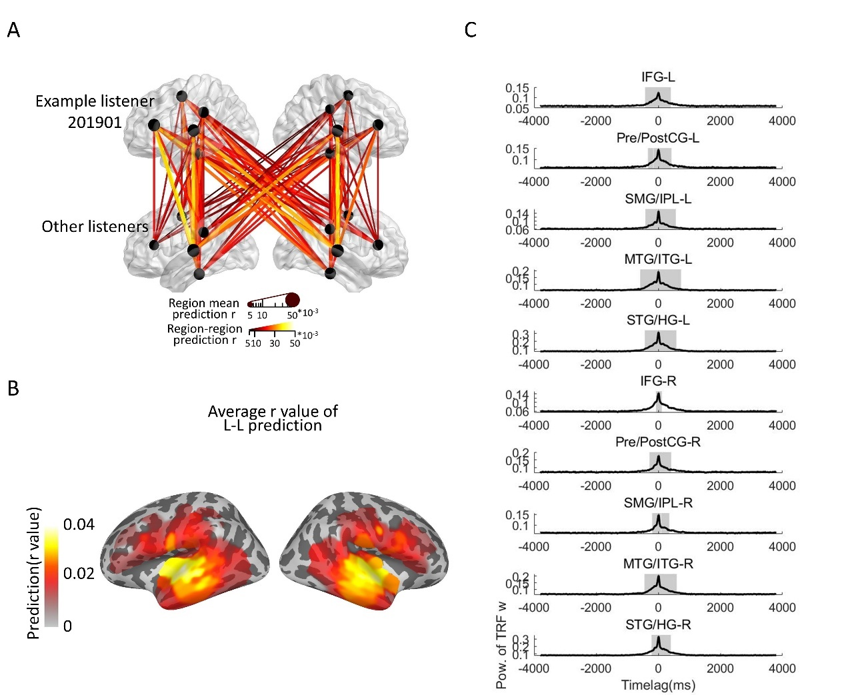
Figure S5. Listener-listener neural synchronization (NS) patterns. (A) Neural synchronizations between one representative listener and other listeners across all significant ROI pairs, where the size and color of the connecting lines indicate the degree of prediction. The size of regions reflects the mean predictions across all region pairs. Only significant regional pairs are included (permutation test, p < 0.05). (B) The average interbrain prediction r values across all cortical regions. (C) The mean power-transformed TRF weights, with shaded areas highlighting periods significantly greater than the threshold estimated via permutation tests. There is no time lag in NS between listeners.

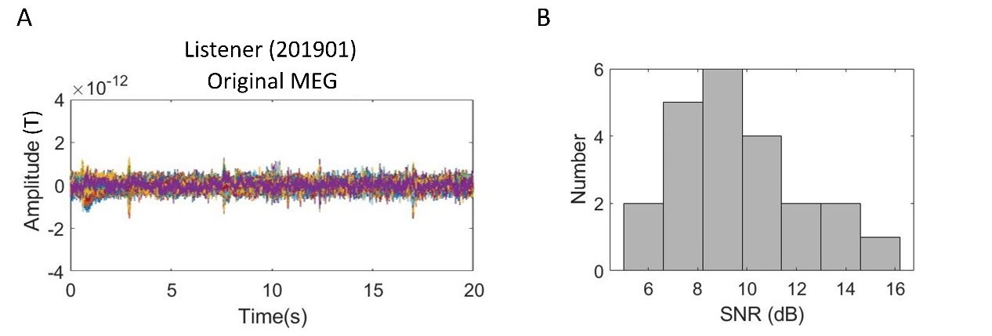
Figure S6. MEG signal qualities for 22 listeners. (A) Raw MEG signals (bandpass-filtered: 0.3-45 Hz) of one representative listener. All 102 magnetometers are shown. (B) Signal-to-noise ratios (SNR) of MEG for the 22 listeners in the listening experiment. The mean is 9.50 dB, and the range is from 5.29 dB to 16.08 dB.

 | Acoustic | Consonant | Vowel | Pitch Height | Pitch Change | Tone Category
R² | -0.065 | 0.184 | 0.258 | 0.215 | 0.154 | 0.186
MSE | 1.55e-3 | 1.18e-3 | 1.07e-3 | 1.14e-3 | 1.23e-3 | 1.18e-3
Table S1. Prediction performance of listeners’ comprehension scores with feature-driven NS patterns.

 | 19002 | 19003 | 19004 | 19006 | 19007 | 19008
SNR (dB) | 3.20 | 8.67 | 4.41 | 7.12 | 6.49 | 3.59
Table S2. Signal-to-noise ratios (SNR) of MEG for the six speakers in the production experiment. The audio recordings and MEG data of subject 19003 were chosen based on audio quality, speech production fluency, and MEG SNR. The MEG SNR of subject 19003 (8.67 dB) is similar to those of the listeners (Fig. S6).

