Rapid Dye Removal using MoO₃-Incorporated V₂O₅ Nanocomposites: Laboratory Experiments and Real-World Applications
Jaspreet Kaur, and Rajesh Kumar*
*rajeshphysicspu@gmail.com

Supplementary data
Contents:
Figure S1: Calibration plot of concentration of MB dye versus UV-Vis absorbance.
Figure S2: Removal percentage graph with different adsorbent dosage of MV-50.
Figure S3: Kinetic model fitting (A) Pseudo First Order Model (B) Pseudo Second order Model with different concentration of MV-50
Table S1: First and second –order Kinetic Parameters for the adsorption of MB of MV-50 sample

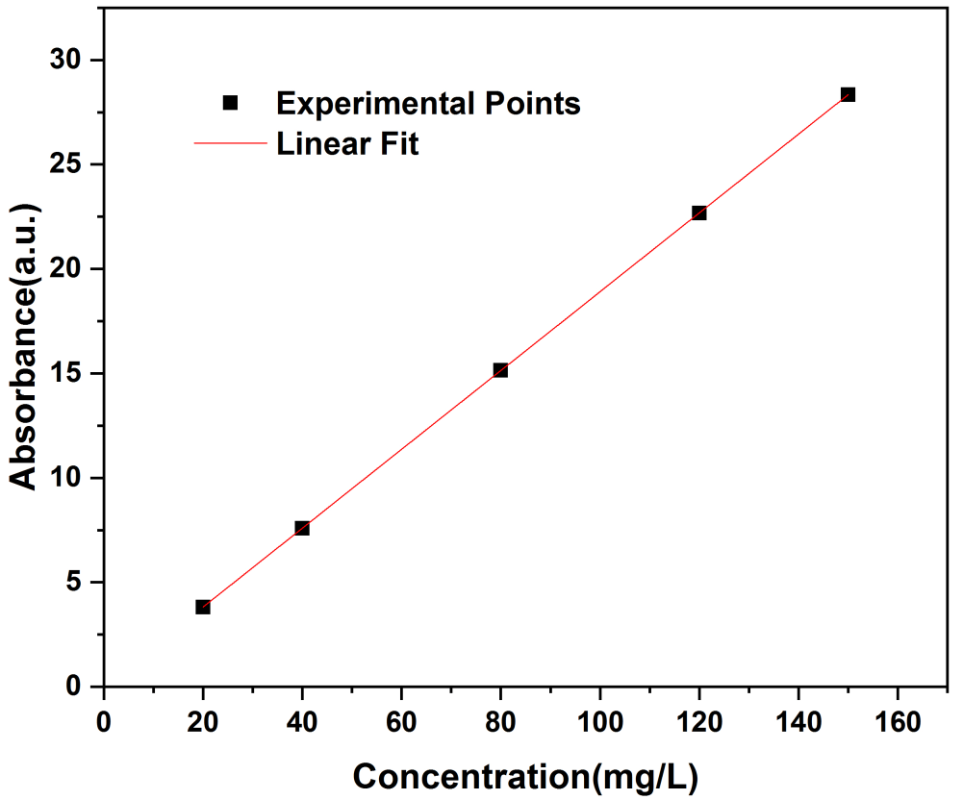
Figure S1: Calibration plot of concentration of MB dye versus UV-Vis absorbance.

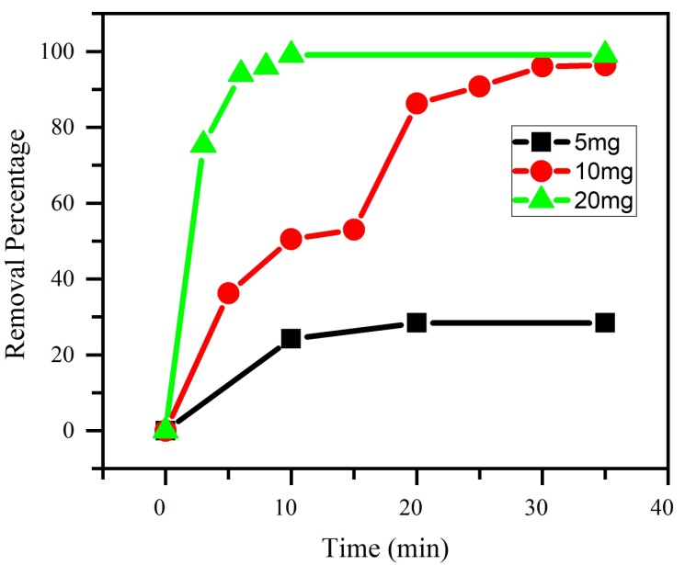
Figure S2: Removal percentage graph with different adsorbent dosage of MV-50

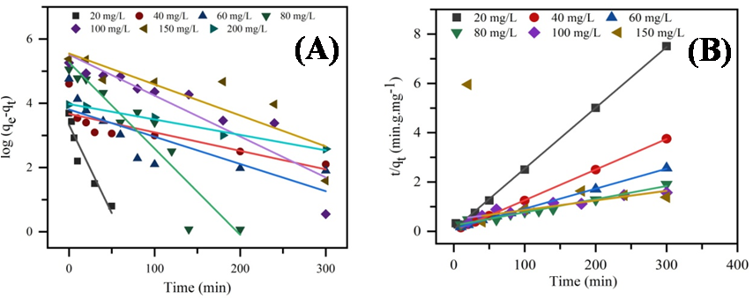
Figure S3: Kinetic model fitting (A) Pseudo First Order Model (B) Pseudo Second order Model with different concentration of MV-50
Table S1: First and second –order Kinetic Parameters for the adsorption of MB of MV-50 sample
Adsorbent | C_{o} (mg/L) | q_{exp} (mg/g) | PFO PSO
 |  |  | q_{th} (mg/g) | k₁  (min⁻¹) | R² | q_{th} (mg/g) | k₂(g/mg min) | R²
 | 20 | 39.95 | 27.93 | 0.120 | 0.90 | 40.6 | 0.0073 | 0.99
 | 40 | 99.95 | 39.29 | 0.011 | 0.68 | 80.6 | 0.0072 | 0.99
MV-50 | 60 | 116.9 | 45.01 | 0.018 | 0.65 | 123.4 | 0.0006 | 0.99
 | 80 | 157.0 | 195.19 | 0.059 | 0.88 | 188.6 | 0.0001 | 0.97
 | 100 | 192.72 | 248.38 | 0.027 | 0.83 | 256.4 | 0.00003 | 0.91
 | 150 | 216.96 | 257.23 | 0.020 | 0.74 | 333.3 | 0.00001 | 0.62

