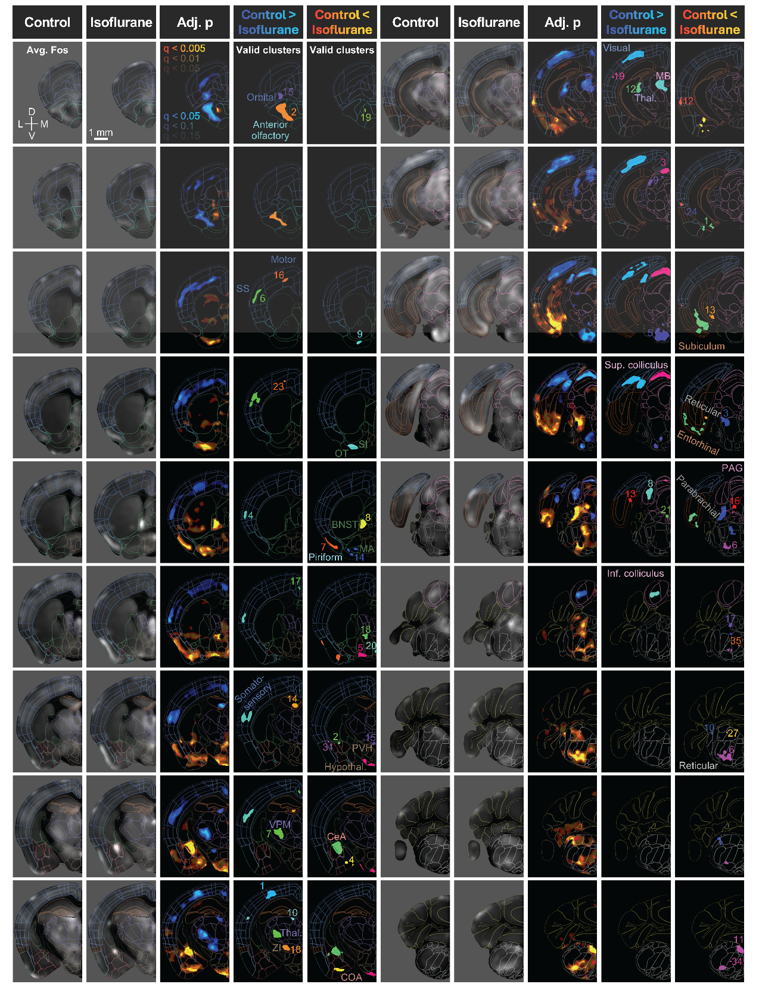

Extended Figure 5. Identification of isoflurane-activated clusters from UNRAVEL analysis. Voxel-wise data from Fig 2e-h were warped to the Allen Mouse Brain Common Coordinate Framework (CCFv3) for display in coronal brain slices, overlaid with a colored wireframe using FSLeyes. Input images for voxel-wise comparisons were averaged for each group to show background-subtracted and z-scored Fos immunofluorescence. FDR-corrected p-value maps show increases (warm colors) and decreases (cool colors) in Fos expression resulting from isoflurane treatment. For each effect direction, the most stringent q-value threshold is fully opaque (100%), the next most stringent is semi-opaque (66%), and the least stringent is less opaque (33%). Valid clusters with significant differences in Fos+ cell density were randomly colored and labeled with their IDs. Abbreviations: Adj. = adjusted; Avg. = average; SS = somatosensory; OT = olfactory tubercle; SI = substantia innominata; BNST = bed nucleus of the stria terminalis; MA = magnocellular nucleus; PVH = paraventricular hypothalamic nucleus; Hypothal. = hypothalamus; CeA = central amygdala; Thal. = thalamus; ZI = zona incerta; COA = cortical amygdalar area; MB = midbrain; Sup. = superior; PAG = periaqueductal gray; Inf. = inferior.

