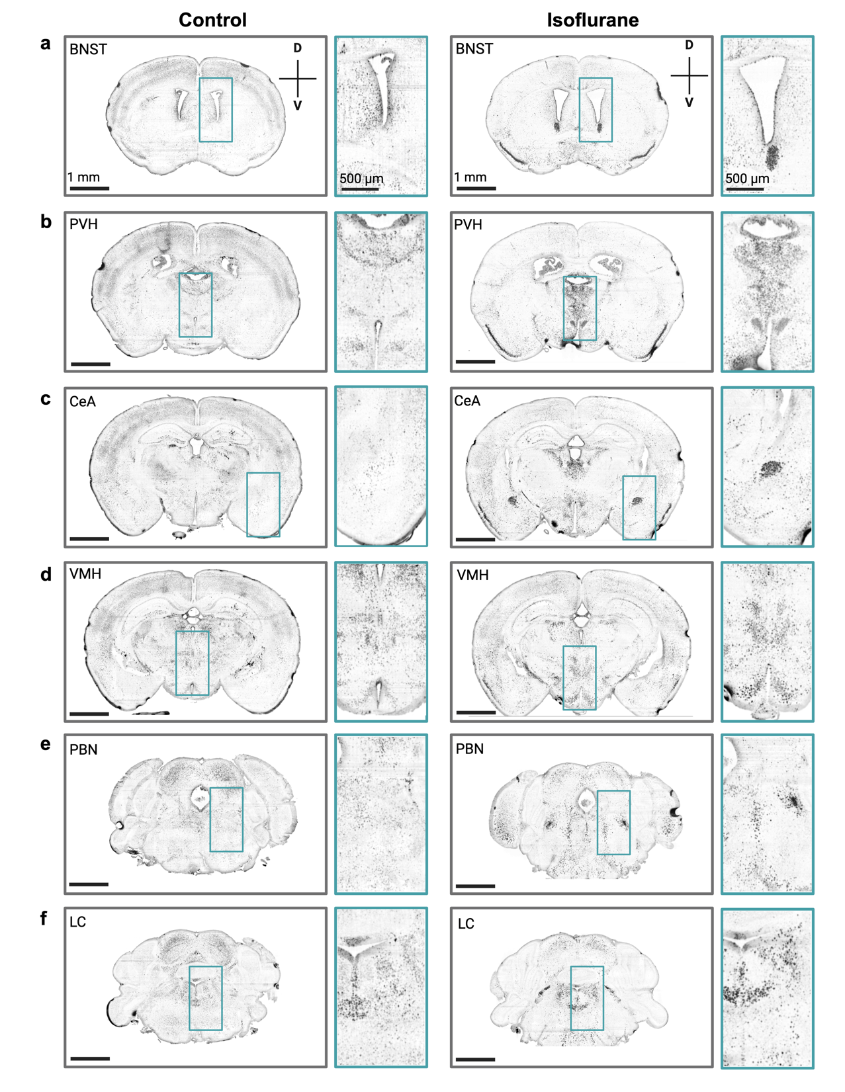
Extended Figure 6. Representative Fos immunolabeling from cleared intact brains. Images from a representative control (left column) and an isoflurane mouse (right column) from Figure 2. Images were acquired with a light sheet microscope using a 3.6X objective in the horizontal plane and then re-sliced to the coronal plane to identify (a) BNST = bed nucleus of the stria terminalis, (b) PVH = paraventricular hypothalamus, (c) CeA = central amygdala, (d) VMH = ventromedial hypothalamus, (e) PBN = parabrachial nucleus, (f) LC = locus coeruleus. Scale bars are 1mm for the full coronal slice and 500 μm for the inset image.

