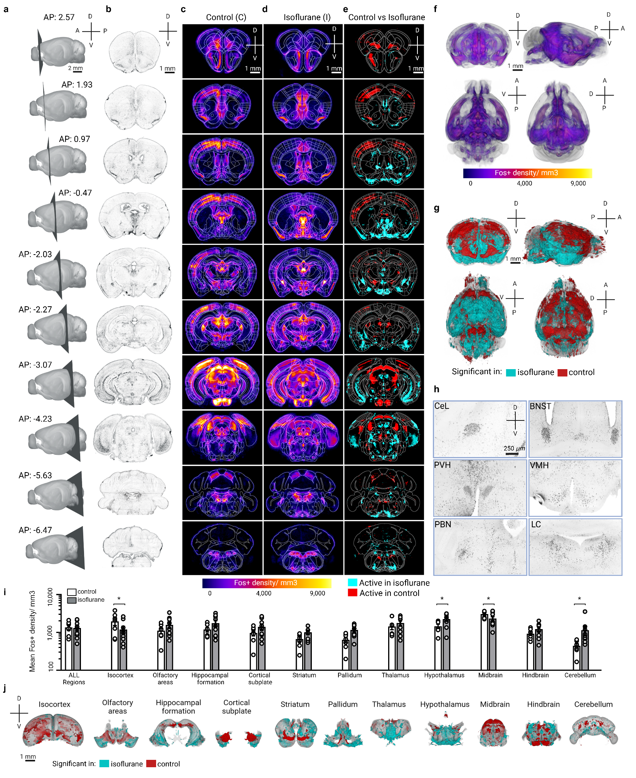
Extended Figure 4. Fos activity mapping reveals subcortical isoflurane-activated hotspots. (a) Intact whole brains were imaged horizontally with light sheet microscopy to acquire cellular resolution Fos+ signal then digitally resliced in the coronal plane at the indicated AP positions. (b) Representative mean intensity projection of the raw 3.6X Fos+ signal from the isoflurane condition virtually re-sliced to the coronal plane at the indicated AP positions. (c) Mean Fos+ density in the control condition across all samples (n=7) shown as a heatmap. (d) Mean Fos+ density in the isoflurane condition across all samples (n=9) shown as a heatmap in the indicated AP coronal plane. (e) Pairwise comparison of significant Fos+ regions in control vs isoflurane condition with blue indicating higher Fos+ activity in the isoflurane condition and red indicating higher Fos+ activity in control condition. (f) 3D mean Fos+ density heatmaps from the isoflurane condition shown as sections in panel d. (g) Voxel-wise significance map of regions significantly regulated in the isoflurane (blue) or control (red) conditions. (h) Representative raw Fos+ immunolabeling at the indicated regions: CeL = centrolateral amygdala; BNST = bed nucleus of stria terminalis; PVH = paraventricular hypothalamus; VMH = ventromedial hypothalamus; PBN = parabrachial nucleus; LC = locus coeruleus. (i) Mean Fos density calculated across larger brain subdivisions after atlas registration by ClearMap in control vs isoflurane conditions shows significant differences in isocortex, hypothalamus, midbrain and cerebellum. (unpaired t-test, *p<0.05). (j) Regions significantly activated in isoflurane (blue) or control (red). Scale bars shown are 1mm except in panel h insets where scale bar is 250 µm.

