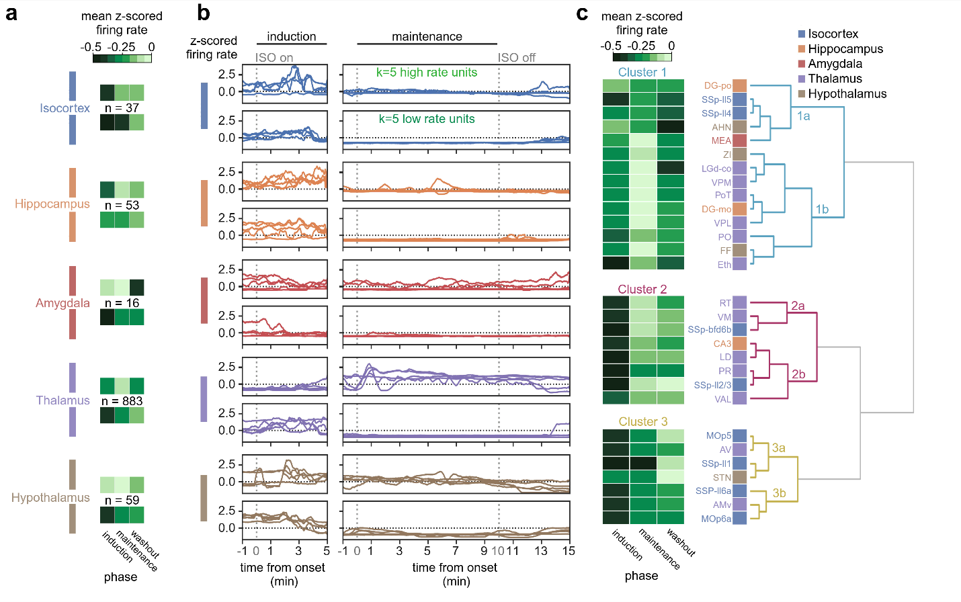
Extended Figure 8. Response variability during isoflurane. (a) Heatmaps showing mean normalized firing for each major region (isocortex, hippocampus, amygdala, thalamus, and hypothalamus) across anesthetic phases (induction, maintenance, washout) with the total unit counts (n) for each region. (b) Representative traces from units in major regions with diverse responses under isoflurane. For each major region, traces show 5 units (k=5 from total unit count n for each region) with the highest (top) and lowest (bottom) mean normalized firing during the maintenance phase. Left traces show 1 min prior and 5 min following onset of induction at the dashed line (“ISO on”). Right traces show 1 min prior and 10 min following onset of maintenance phase (first dashed line) and the “ISO off” time (right dashed line). (c) Mean z-scored firing from each experimental phase was clustered (Ward’s method) for all subregions obtained in recordings. Hierarchical clustering of subpopulation means revealed 3 heterogeneous clusters (CHI=11.12), each with subclusters (e.g., 1a: Cluster 1a) linking spatially distributed cortical and subcortical structures. See Extended Tables 9 and 12 for detailed data.

