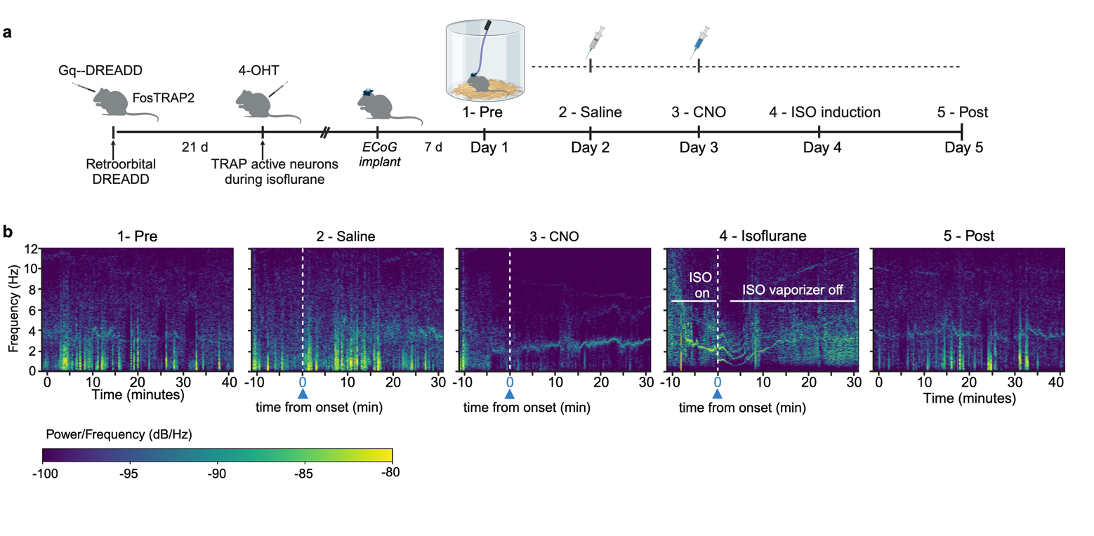
Extended Figure 2. Electrocorticography recordings of the synthetic unconscious state. (a) Experimental timeline: FosTRAP2 transgenic mice received retroorbital AAV injection expressing Gq-DREADD and activity-dependent capture during isoflurane exposure, followed by neural electrocorticography (ECoG) recordings over five days (DREADD = designer receptor engineered to be activated by a designer drug, 4-OHT = 4-hydroxytamoxifen, ECoG = electrocorticography, CNO = clozapine n-oxide, ISO = isoflurane). (b) Day 1 (labeled “1 - Pre”) shows the average 40-minute baseline recording without manipulations. Recordings on Days 2-4 were time-aligned to the approximated onset of intraperitoneal CNO (10 min post-injection) indicated by the white dotted line. Day 5 (labeled “5 - Post”) was obtained without drug manipulation. The spectrograms shown are an average of 4 mice. See Figure 1c-d, Extended Data Table 1 and Methods for further statistical analysis.

