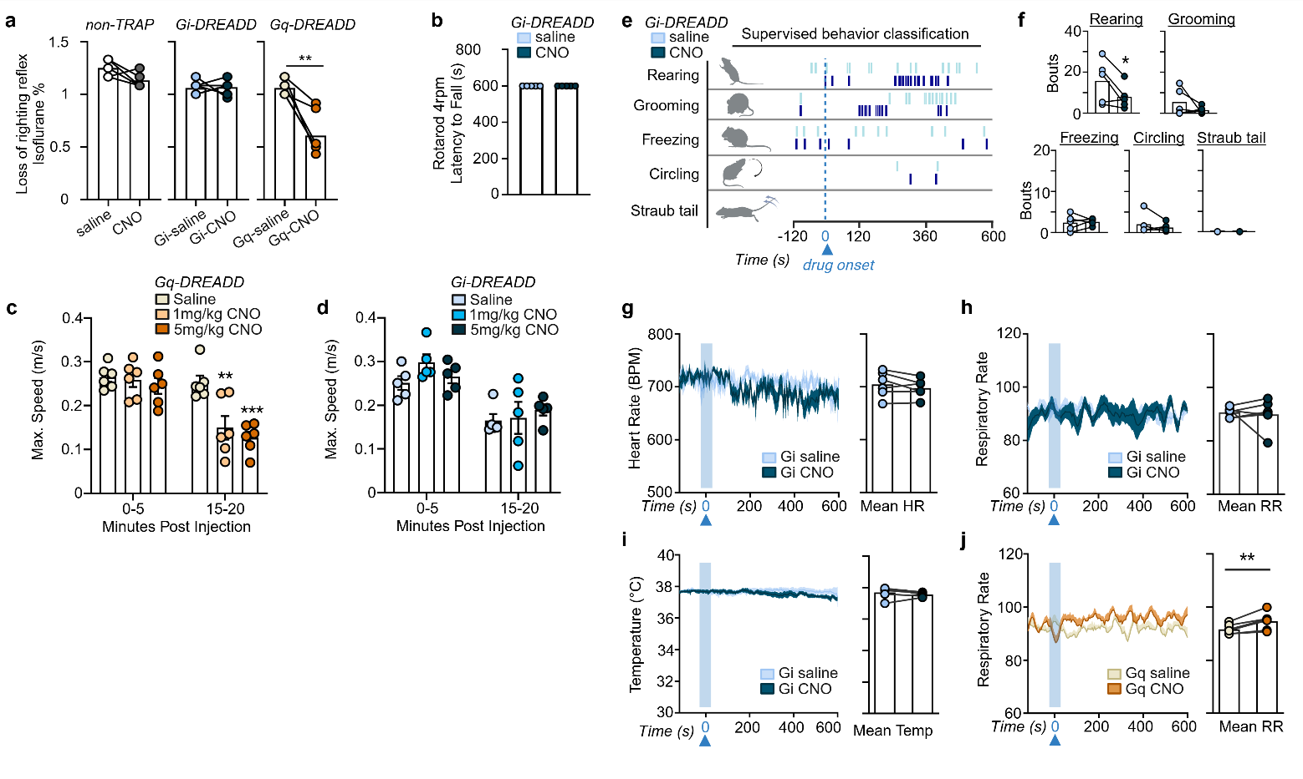
Extended Figure 1. Effects of chemogenetic inhibition after synthetic activity-dependent capture of altered consciousness. (a) The concentration of isoflurane (%), as measured with a gas analyzer sampling from the chamber, at which mice display loss of righting reflex during saline or CNO (10 mg/kg) is significantly reduced in Gq-DREADD but not Gi-DREADD or non-TRAP control (n = 5-6 mice). (b) There is no change in rotarod (4-rpm) performance in Gi-DREADD mice after 5 mg/kg CNO (n = 5 mice). CNO induces dose-dependent reduction in maximum speed (m/s) in the open field only in (c) Gq-DREADD mice (n = 6 mice) and not (d) Gi-DREADD mice (n = 5 mice, 3-4 trials per drug condition). (e) Representative raster plot from all 6 (3 saline, 3 CNO) of one Gi-DREADD animal’s trials after analysis of classified behavior. (f) Bouts of classified behavior for the average of saline and CNO (5 mg/kg) trials per animal expressing inhibiting Gi-DREADD virus (n = 5 mice). There is no change in (g) heart rate (BPM, beats per minute) (h) respiratory rate (breaths per minute) and (i) temperature (Celsius) as recorded from the wireless mechano-acoustic device during trials shown in e-f (n = 6 mice, 2-3 trials per drug condition). (j) Respiratory rate in Gq-DREADD TRAP mice is also unchanged. Drug onset time is approximated by average onset of immobility in Gq-DREADD mice (approx. 10 minutes after CNO injection). See Figure 1 and Methods for experimental details. Error bars show mean ± SEM. 2-way repeated measures ANOVA with Tukey’s post-hoc tests (panel c-d) and paired t-tests, *p<0.05, **p<0.01, ***p<0.001. See Extended Data Table 1 for statistics.

