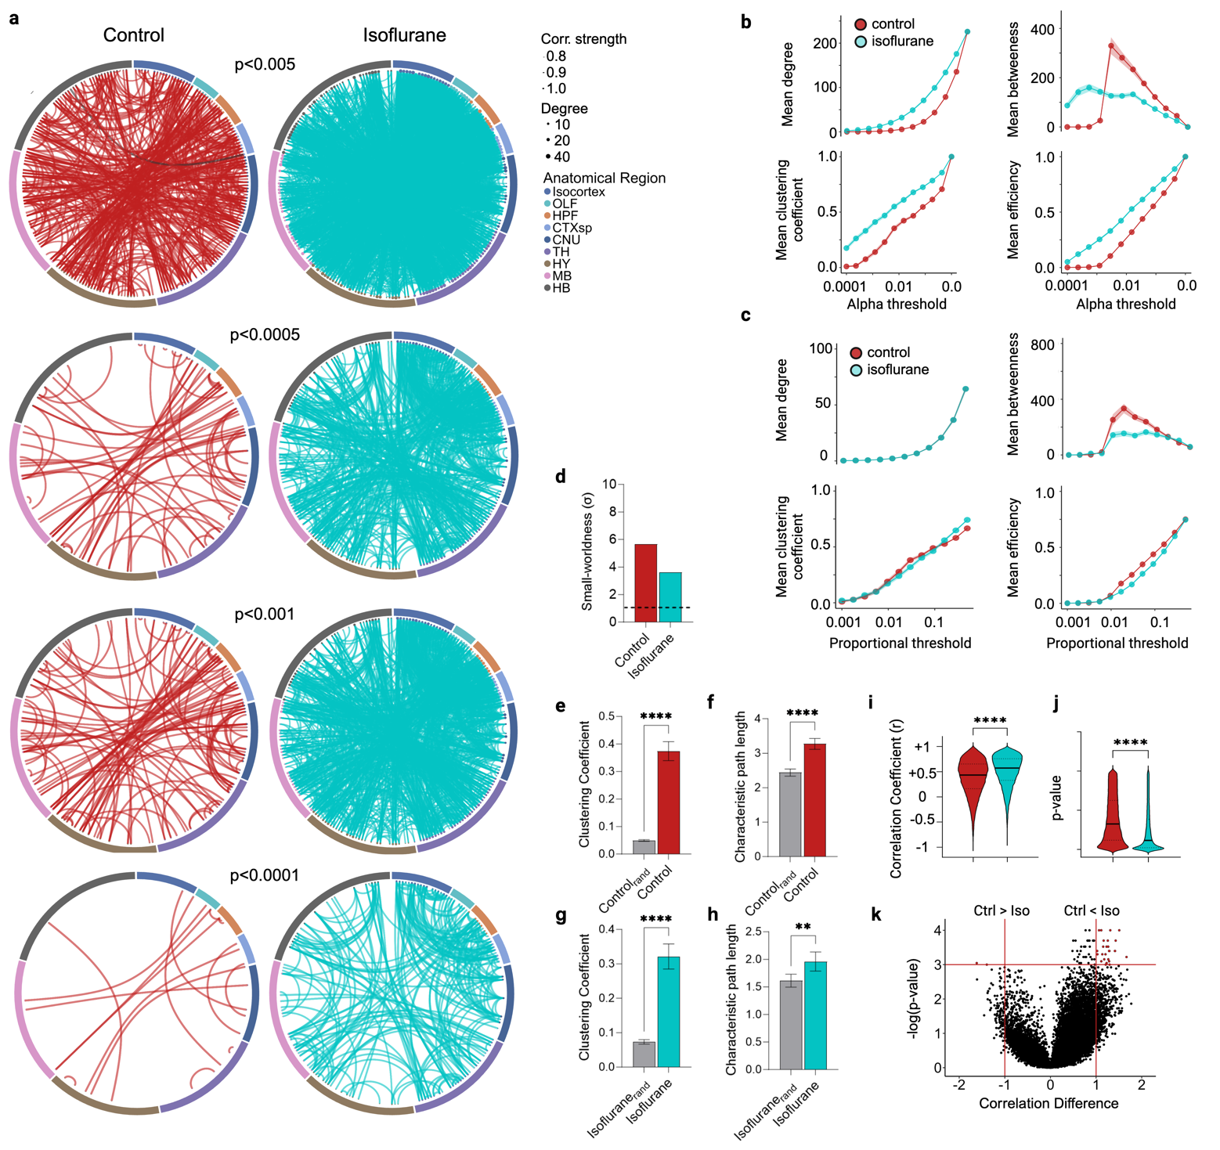
Extended Figure 7. Isoflurane networks are denser across a variety of weight thresholds. (a) control (red) and isoflurane (blue) networks thresholded at various alpha values. (b) Mean degree, clustering, betweenness, and efficiency metrics calculated across a range of significance thresholds and (c) edge proportion thresholds. (d) Assessment of small-world properties of individual networks plotted in Fig 3. Small-world index (σ) for both networks are above the threshold of 1 (black dotted horizontal line). The control network (e) clustering coefficient and (f) path length as well as the isoflurane (g) clustering coefficient and (h) path length are higher than randomly rewired networks with matching degree sequences. (i) Distributions of the Pearson correlation coefficients between all unique regional connections and their associated (j) p-value for the control and isoflurane networks. (k) Volcano plot illustrating the regional correlations which most differ between the networks. The horizontal red line denotes a significance threshold of p < 0.001. Red points in the upper right (control < isoflurane) and upper left quadrants (control > isoflurane), defined by vertical red line lines, indicate regional correlation differences with a magnitude shift greater than 1 between groups. Two-tailed Student’s t-test: **p<0.01, ****p<0.0001. Error bars represent mean ± SEM. See Extended Data Tables 6-8 for full abbreviations and detailed statistics.

