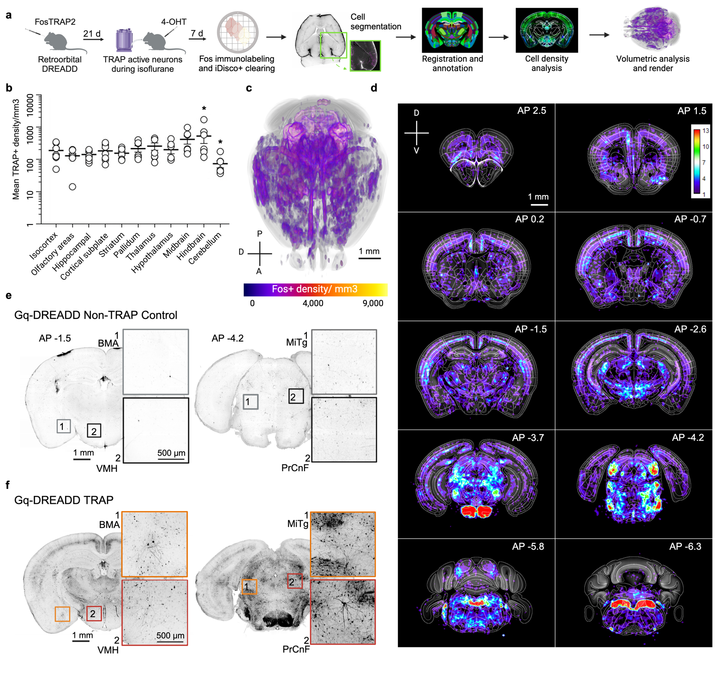
Extended Figure 3. DREADD immunolabeling after synthetic activity-dependent capture. (a) Experimental timeline: FosTRAP2 transgenic mice received retroorbital injection of an AAV-PHP.eB Cre-dependent Gq-DREADD followed by activity-dependent capture (TRAP) during isoflurane exposure with 4-hydroxytamoxifen (4-OHT). After experiments, intact brains were immunolabeled for mCherry-DREADD and cleared by iDisco+. ClearMap was used to register brains, detect Fos+ cells, and generate cell counts and density heat maps. (b) Mean TRAP+ cell density calculated across larger brain subdivisions after atlas registration by ClearMap shows similar TRAP+ cell density across the brain, except for significant differences in the hindbrain and cerebellum (1-way ANOVA, *p<0.05). (c) 3-dimensional mean density heatmap (n=7 mice). (d) Mean TRAP+ density across all samples shown as voxel-based 2D-projection heatmaps (calibration bar is arbitrary units). (e) Representative whole brain light sheet microscopy images after iDisco clearing and mCherry-DREADD immunolabeling digitally sliced to the 2D coronal plane from one control mouse expressing retroorbital AAV-PHP.eB Cre-dependent Gq-DREADD with oil vehicle administered during isoflurane exposure (non-TRAP control, see Methods) and (f) one Gq-DREADD-expressing mouse that received 4-OHT during isoflurane exposure for activity-dependent capture of synthetic unconscious state. Abbreviations: SSp= primary somatosensory cortex, HDB = horizontal limb of diagonal band, BMA = basomedial amygdala, VMH = ventromedial hypothalamus, MiTG = microcellular tegmental nucleus, PrCnF = precuneiform area, PNO = pontine reticular, MnR = median raphe nucleus. Scale bar for full coronal slices is 1mm, inset scale bar is 500 µm.

