Supplementary information

SampleID | Raw | Clean | Clean Per | Raw base | Clean base | Base Per | Unique Tag | Q30 | DUP
HSPA1B_input_1 | 55988180 | 55303866 | 98.78% | 8.40G | 6.93G | 82.54% | 4926615(8.91%) | 96.27% | 99.02%
HSPA1B_input_2 | 71984960 | 71182157 | 98.88% | 10.80G | 8.73G | 80.87% | 5816643(8.17%) | 96.50% | 99.04%
HSPA1B_IP_1 | 37083650 | 33066108 | 89.17% | 5.56G | 4.41G | 79.27% | 4212833(12.74%) | 95.87% | 97.44%
HSPA1B_IP_2 | 48286648 | 43901307 | 90.92% | 7.24G | 5.74G | 79.22% | 4609070(10.50%) | 96.01% | 98.05%
Table S1: Statistics of sequencing results.

(1) Raw data: the number of original sequences transformed from the original image data obtained by sequencing through base calling; (2) Clean reads: the raw reads are stripped of the adapter sequence, and the number of valid sequences obtained after low-quality bases is used for ubsequent analysis; (3) Raw base: the count the number of bases it contains, based on the number and length of raw reads, in G; (4) Clean base: according to the number and length of clean reads,count the number of bases it contains, in G; (5) Unique tag: unique tag, the number of non-repeating reads and its proportion of clean reads; (6) Q30: Proportion of bases whose sequencing error rate is less than 0.1%; (7) DUP: duplication level. The ratio of duplicate reads to total reads

Table S2. Mapping of clean reads on the reference genome.
Sample | HSPA1B_IP_1 | HSPA1B_IP_2 | HSPA1B_input_1 | HSPA1B_input_2
Total reads | 33066108 | 43901307 | 55303866 | 71182157
Total mapped | 15537403(46.99%) | 23102953(52.62%) | 35240772(63.72%) | 45655036(64.14%)
Total Uniquely mapped | 9922600(63.86%) | 15210916(65.84%) | 22134472(62.81%) | 28632329(62.71%)
Total Multiple mapped | 5614803(36.14%) | 7892037(34.16%) | 13106300(37.19%) | 17022707(37.29%)
Splice reads | 4861(0.05%) | 7265(0.05%) | 6892(0.03%) | 9043(0.03%)
Nonsplice reads | 9917739(99.95%) | 15203651(99.95%) | 22127580(99.97%) | 28623286(99.97%)
rmdup reads | 245314(2.47%) | 288341(1.9%) | 339962(1.54%) | 390962(1.37%)
Sense reads | 199687(81.4%) | 235605(81.71%) | 278385(81.89%) | 319485(81.72%)
Antisense reads | 45627(18.6%) | 52736(18.29%) | 61577(18.11%) | 71477(18.28%)

Table S3. Reads distribution across reference genomic regions.
Sample | 5'UTR | 3'UTR | CDS | Nc_exon | Introns | Intergenic | Antisense
HSPA1B_IP_1 | 313  (0.13%) | 20419  (8.32%) | 2061  (0.84%) | 89193  (36.36%) | 31241  (12.74%) | 56457  (23.01%) | 45627  (18.60%)
HSPA1B_IP_2 | 451  (0.16%) | 24676  (8.56%) | 2873  (1.00%) | 112748  (39.10%) | 34341  (11.91%) | 60513  (20.99%) | 52736  (18.29%)
HSPA1B_input_1 | 760  (0.22%) | 30550  (8.99%) | 7523  (2.21%) | 138994  (40.89%) | 35544  (10.46%) | 65011  (19.12%) | 61577  (18.11%)
HSPA1B_input_2 | 1118  (0.29%) | 34248  (8.76%) | 9544  (2.44%) | 156820  (40.11%) | 42323  (10.83%) | 75429  (19.29%) | 71477  (18.28%)

Table S4. The top 10 representative biological process pathways of HSPA1B-bound genes in GO database.
Term | Database | ID | Input number | Background number | P-Value | Corrected  P-Value | Input
synaptic transmission | Gene Ontology | GO:0007268 | 7 | 124 | 0.0000 | 0.0000 | Dlg2|Grik2|Dlgap1|Grm5|Grm7|Gabra3|Fgf14
nervous system development | Gene Ontology | GO:0007399 | 7 | 325 | 0.0000 | 0.0001 | Srgap2|Mbd5|Tnik|Magi2|Chl1|Zeb1|Fgf14
mRNA processing | Gene Ontology | GO:0006397 | 6 | 295 | 0.0002 | 0.0005 | Prpf38b|Adarb2|Celf2|Sfpq|Rbm25|Scaf1
ion transport | Gene Ontology | GO:0006811 | 7 | 561 | 0.0009 | 0.0017 | Kcnd2|Grik2|Trpc5|Kcnb2|Kcnip4|Gabra3|Gabra2
signal transduction | Gene Ontology | GO:0007165 | 10 | 1126 | 0.0009 | 0.0017 | Mrgpre|Grik2|Gpr158|Sparcl1|Srgap2|Magi2|Grm5|Grm7|Grm1|Gabra3
regulation of transcription, DNA-dependent | Gene Ontology | GO:0006355 | 11 | 1845 | 0.0116 | 0.0174 | Irf2|Sertad2|Zfp445|Zfp488|Elk3|Sfpq|Grm5|Zeb1|Uhrf1|St18|Hivep3
transcription, DNA-dependent | Gene Ontology | GO:0006351 | 10 | 1759 | 0.0225 | 0.0290 | Irf2|Sertad2|Zfp445|Zfp488|Elk3|Sfpq|Zeb1|Uhrf1|St18|Hivep3
G-protein coupled receptor signaling pathway | Gene Ontology | GO:0007186 | 5 | 606 | 0.0279 | 0.0314 | Grm5|Grm7|Gpr158|Grm1|Mrgpre
transport | Gene Ontology | GO:0006810 | 8 | 1725 | 0.1103 | 0.1103 | Stau2|Kcnd2|Grik2|Trpc5|Kcnb2|Kcnip4|Gabra3|Gabra2

Table S5. The top 10 representative pathways of HSPA1B-bound genes KEGG database.
Term | Database | ID | Input number | Background number | P-Value | Corrected P-Value | Input
Glutamatergic synapse | KEGG PATHWAY | mmu04724 | 6 | 117 | 0.0000 | 0.0010 | Grik2|Adcy9|Dlgap1|Grm5|Grm7|Grm1
Retrograde endocannabinoid signaling | KEGG PATHWAY | mmu04723 | 5 | 104 | 0.0001 | 0.0038 | Grm5|Grm1|Adcy9|Gabra3|Gabra2
N-Glycan biosynthesis | KEGG PATHWAY | mmu00510 | 3 | 50 | 0.0015 | 0.0300 | Mgat5|Mgat4c|Fut8
Neuroactive ligand-receptor interaction | KEGG PATHWAY | mmu04080 | 6 | 282 | 0.0016 | 0.0300 | Grik2|Grm5|Grm7|Grm1|Gabra3|Gabra2
Gap junction | KEGG PATHWAY | mmu04540 | 3 | 88 | 0.0074 | 0.0945 | Grm5|Adcy9|Grm1
GABAergic synapse | KEGG PATHWAY | mmu04727 | 3 | 90 | 0.0078 | 0.0945 | Adcy9|Gabra3|Gabra2
Morphine addiction | KEGG PATHWAY | mmu05032 | 3 | 93 | 0.0086 | 0.0945 | Adcy9|Gabra3|Gabra2
Nicotine addiction | KEGG PATHWAY | mmu05033 | 2 | 40 | 0.0142 | 0.1369 | Gabra3|Gabra2
Valine, leucine and isoleucine degradation | KEGG PATHWAY | mmu00280 | 2 | 53 | 0.0242 | 0.2073 | Pcca|Oxct1
Long-term potentiation | KEGG PATHWAY | mmu04720 | 2 | 68 | 0.0384 | 0.2955 | Grm5|Grm1
Synthesis and degradation of ketone bodies | KEGG PATHWAY | mmu00072 | 1 | 11 | 0.0492 | 0.3117 | Oxct1

Table S6. Representative pathways of DEGs in KEGG database.
Term | ID | Input number | Background number | P-Value | Corrected P-Value | Input
Antigen processing and presentation | mmu04612 | 14 | 79 | 0.0000 | 0.0000 | Cd74|Cd8b1|H2-Q6|Klrd1|H2-Oa|Ciita|H2-Q7|H2-M2|H2-Aa|Ifi30|H2-DMb2|H2-DMb1|H2-Eb1|H2-Ab1
Staphylococcus aureus infection | mmu05150 | 12 | 52 | 0.0000 | 0.0000 | H2-Oa|Cfb|H2-Aa|H2-DMb2|H2-DMb1|Itgal|H2-Eb1|Icam1|H2-Ab1|C3|Fcgr4|Selp
Cell adhesion molecules (CAMs) | mmu04514 | 18 | 159 | 0.0000 | 0.0000 | Sell|Cd8b1|H2-Q6|Itgb7|H2-Oa|H2-Ab1|Sele|H2-Q7|H2-M2|H2-Aa|H2-DMb2|H2-DMb1|Itgal|H2-Eb1|Icam1|Cd22|Selp|Siglec1
Viral myocarditis | mmu05416 | 14 | 90 | 0.0000 | 0.0000 | Myh2|Myh1|H2-Oa|Sgcg|H2-Ab1|H2-Q7|H2-M2|H2-Aa|H2-DMb2|H2-DMb1|Itgal|H2-Eb1|Icam1|H2-Q6
Herpes simplex infection | mmu05168 | 19 | 204 | 0.0000 | 0.0000 | Cd74|Ccl2|H2-Q6|H2-Oa|Ccl5|H2-Ab1|H2-Q7|H2-M2|H2-Aa|H2-DMb1|Tlr2|H2-DMb2|Oas3|H2-Eb1|Ikbke|C3|Il1b|Tlr9|Oas1g
Graft-versus-host disease | mmu05332 | 11 | 55 | 0.0000 | 0.0000 | H2-Q6|Klrd1|H2-Oa|H2-Ab1|H2-Q7|H2-M2|H2-Aa|H2-DMb2|H2-DMb1|H2-Eb1|Il1b
Phagosome | mmu04145 | 17 | 176 | 0.0000 | 0.0000 | Tlr2|H2-Q6|Olr1|H2-Oa|Clec7a|H2-Ab1|H2-Q7|H2-M2|H2-Aa|Cd36|Cybb|H2-DMb2|H2-DMb1|H2- Eb1|C3|Fcgr4|Cd209f
Inflammatory bowel disease (IBD) | mmu05321 | 11 | 59 | 0.0000 | 0.0000 | Il18rap|H2-Oa|Il2rg|Il12rb1|H2-Ab1|H2-Aa|Tlr2|H2-DMb2|H2-DMb1|H2-Eb1|Il1b
Rheumatoid arthritis | mmu05323 | 12 | 84 | 0.0000 | 0.0000 | Ccl2|H2-Oa|Ccl5|H2-Ab1|H2-Aa|Tlr2|H2-DMb2|H2-DMb1|Itgal|H2-Eb1|Icam1|Il1b
Cytokine-cytokine receptor interaction | mmu04060 | 19 | 261 | 0.0000 | 0.0000 | Ccl2|Csf2rb|Il2rb|Ccl7|Il18rap|Ccl5|Il12rb1|Prl|Ccl8|Il2rg|Cxcr5|Ccr6|Ccr7|Ccr8|Cxcl10|Il1b|Ccl22|Csf2rb2|Il2ra
Tuberculosis | mmu05152 | 16 | 179 | 0.0000 | 0.0000 | Cd74|Itgax|Tlr9|H2-Oa|Clec7a|Ciita|H2-Aa|Tlr2|H2-DMb2|H2-DMb1|H2-Eb1|H2-Ab1|C3|Il1b|Fcgr4|Cd209f
Type I diabetes mellitus | mmu04940 | 10 | 60 | 0.0000 | 0.0000 | H2-Q6|H2-Oa|H2-Ab1|H2-Q7|H2-M2|H2-Aa|H2-DMb2|H2-DMb1|H2-Eb1|Il1b
Influenza A | mmu05164 | 15 | 171 | 0.0000 | 0.0000 | Ccl2|H2-Oa|Ccl5|H2-Ab1|Ciita|H2-Aa|H2-DMb1|H2-DMb2|Oas3|H2-Eb1|Icam1|Ikbke|Cxcl10|Il1b|Oas1g
Malaria | mmu05144 | 9 | 49 | 0.0000 | 0.0000 | Ccl2|Sele|Cd36|Tlr2|Itgal|Icam1|Il1b|Tlr9|Selp
Leishmaniasis | mmu05140 | 10 | 66 | 0.0000 | 0.0000 | H2-Oa|H2-Ab1|H2-Aa|Tlr2|H2-DMb2|H2-DMb1|H2-Eb1|C3|Il1b|Fcgr4
Allograft rejection | mmu05330 | 9 | 54 | 0.0000 | 0.0000 | H2-Q6|H2-Oa|H2-Ab1|H2-Q7|H2-M2|H2-Aa|H2-DMb2|H2-DMb1|H2-Eb1
Autoimmune thyroid disease | mmu05320 | 9 | 69 | 0.0000 | 0.0000 | H2-Q6|H2-Oa|H2-Ab1|H2-Q7|H2-M2|H2-Aa|H2-DMb2|H2-DMb1|H2-Eb1
Asthma | mmu05310 | 6 | 25 | 0.0000 | 0.0000 | H2-Oa|H2-Ab1|H2-Aa|H2-DMb2|H2-DMb1|H2-Eb1
HTLV-I infection | mmu05166 | 16 | 280 | 0.0000 | 0.0000 | Il2ra|Il2rb|H2-Q6|H2-Oa|Il2rg|H2-Ab1|H2-Q7|H2-M2|H2-Aa|H2-DMb2|H2-DMb1|Itgal|H2- Eb1|Icam1|Cd3e|Atf3
Intestinal immune network for IgA production | mmu04672 | 7 | 43 | 0.0000 | 0.0000 | H2-Oa|Itgb7|H2-Ab1|H2-Aa|H2-DMb2|H2-DMb1|H2-Eb1
Hematopoietic cell lineage | mmu04640 | 9 | 87 | 0.0000 | 0.0000 | Il2ra|Cd22|Gp1ba|Cd36|H2-Eb1|Cd8b1|Il1b|Cd3e|Cd19
Measles | mmu05162 | 11 | 139 | 0.0000 | 0.0000 | Il2ra|Il2rb|Il2rg|Tlr2|Oas3|Ikbke|Il1b|Tlr9|Cd209f|Cd3e|Oas1g
Primary immunodeficiency | mmu05340 | 6 | 36 | 0.0000 | 0.0000 | Il2rg|Ciita|Cd8b1|Cd79a|Cd3e|Cd19
Chemokine signaling pathway | mmu04062 | 12 | 194 | 0.0000 | 0.0000 | Ccl2|Ccl7|Ccl5|Ccl8|Fgr|Ccr6|Cxcr5|Ccr7|Ccr8|Cxcl10|Ccl22|Itk
TNF signaling pathway | mmu04668 | 9 | 110 | 0.0000 | 0.0001 | Ccl2|Mlkl|Ccl5|Sele|Icam1|Cxcl10|Ifi47|Gm5431|Il1b
Toxoplasmosis | mmu05145 | 9 | 113 | 0.0000 | 0.0001 | H2-Oa|Ciita|H2-Aa|Tlr2|H2-DMb2|H2-DMb1|Igtp|H2-Eb1|H2-Ab1
Chagas disease (American trypanosomiasis) | mmu05142 | 7 | 104 | 0.0005 | 0.0018 | Ccl2|Ccl5|Tlr2|C3|Il1b|Tlr9|Cd3e
Systemic lupus erythematosus | mmu05322 | 8 | 147 | 0.0008 | 0.0029 | H2-Oa|H2-Ab1|H2-Aa|H2-DMb2|H2-DMb1|H2-Eb1|C3|Fcgr4
Jak-STAT signaling pathway | mmu04630 | 8 | 155 | 0.0012 | 0.0039 | Csf2rb|Il2ra|Il2rb|Csf2rb2|Il12rb1|Prl|Il2rg|Gh
African trypanosomiasis | mmu05143 | 4 | 35 | 0.0012 | 0.0039 | Sele|Il1b|Tlr9|Icam1
Cytosolic DNA-sensing pathway | mmu04623 | 5 | 61 | 0.0014 | 0.0043 | Zbp1|Il1b|Ikbke|Cxcl10|Ccl5
Toll-like receptor signaling pathway | mmu04620 | 6 | 101 | 0.0024 | 0.0074 | Ccl5|Tlr2|Ikbke|Cxcl10|Il1b|Tlr9
NOD-like receptor signaling pathway | mmu04621 | 4 | 59 | 0.0083 | 0.0243 | Ccl2|Mefv|Il1b|Ccl5

Table S7. Primer lists for RT-PCR validation
Internal Reference：
mus-GAPDH-F： GGAGATGCTCAGTGTTGG
mus-GAPDH-R： TGACAATGAATACGGCTACA
Cd52-F | GAGGCACATTAAGGTATTGG
Cd52-R | GCCGCTTCTGGTACTAAC
Cd74-F | GCTGATCCAGATTACCAAGA
Cd74-R | TTCATGCGAAGGCTCTCC
Lcn2-F | GACAGTGAGCAGAGATGG
Lcn2-R | CCTGAGTGTCATGTGTCTG
Oxt-F | CCTACAGCGGATCTCAGA
Oxt-R | TATCCAGGTCCAGCACAG
Ifi30-F | TTCCATCACCATCAGCCA
Ifi30-R | TCACCACCTGTCAGAGTC
Cxcl10-F | CAGCAGGATGAGGCAGAA
Cxcl10-R | TTCATCCACCGCTGAGAG
Ccl5-F | GGACTAGAGCAAGCAATGA
Ccl5-R | GCCAACCCAGAGAAGAAG
Icam1-F | CCAAGGAGATCACATTCAC
Icam1-R | TCGGAGACATTAGAGAACAA
Igtp-F | CACAGACATAGACCTTCATACT
Igtp-R | AGTGAACGCTCTGGAGTC
Ifi47-F | CTACGAGTGCTGCTGAAG
Ifi47-R | CGTCAACCACTATGTTAAGG
Erdr1-F | GCGGTCAAGATGTCTCTG
Erdr1-R | TGTGTCCTGTGTGCTGTG
Numa1-M-F | TACGCAGAAGGTGAGTTGGA
Numa1-AS-F | TAGGAGTCCGGTGAGTTGGA
Numa1-M/AS-R | CCAAGAAAGGAGCGTAGCTG
Rnf146-M/AS-F | GGCTATTCTTACATTCCCATCA
Rnf146-M-R | CTATAATTAGCACAGAGAAT
Rnf146-AS-R | CGGCCGAGAGCACAGAGAAT
Rbfox3-M/AS-F | AGTAGTCCTGGGTGGGATGAGG
Rbfox3-AS-R | CCTCCAACAGGGCAATCAGG
Rbfox3-M-R | CTGCAAACAGGGCAATCAGG
Ptpro-M/AS-F | TGTGGAGCTGGCACGTTTGT
Ptpro-M-R | ACTCCTACGCCAACTGTAGG
Ptpro-AS-R | ATTTTTACTCCAACTGTAGG
Aifm1-M/AS-F | TAGGCTGCTGCCATCTTTCC
Aifm1-AS-R | TGGTGCATATTTGTGCAGTG
Aifm1-M-R | CGGCTTCCAGTTGTGCAGTG
Bdnf-M-F | AGCCACAATGTTCCACCAGG
Bdnf-AS-F | CGCAAAGAAGTTCCACCAGG
BdnfM/AS-R | GCAACCGAAGTATGAAATAACC
Astn2-M/AS-F | GTGTTTCGTCATCTGCTTCTG
Astn2-M-R | AAATCTCGAGGGGGAATCAG
Astn2-AS-R | GAGAAGAAAGGGGGAATCAG
Gphn-M/AS-F | TCCCTTAGCACTACTCCTTCA
Gphn-AS-R | GTCTAATTTGTTTTGGTGTTG
Gphn-M-R | TGGACTGGACTTTTGGTGTTG
Spata13-M-F | ACATCCAATGTCTCTTCAGA
Spata13-AS-F | CTTCACATGGTCTCTTCAGA
Spata13-M/AS-R | AAGTCTTCCTCACTACCATTATC
Tenm2-M/AS-F | TGGTGGAGGATTATGGGAGC
Tenm2-AS-R | AGCTGAGGCAGGTCGTCCCAT
Tenm2-M-R | GACGACAATGGTCGTCCCAT
Rbfox1-M-F | GCAGCTGAGGGGTAATCAGG
Rbfox1-AS-F | GGTGCAGCAGGGTAATCAGG
Rbfox1-M/AS-R | AGGGATGCCATTCTGGGGTG

Table S8. Exon detection results in RNA-seq data.
Sample | Detected_exon | AnnotatedExon | Ratio
Ctrl_1st | 207623 | 284601 | 72.95%
Ctrl_2nd | 210848 | 284601 | 74.09%
Ctrl_3rd | 204052 | 284601 | 71.70%
Ctrl_4th | 203224 | 284601 | 71.41%
Ctrl_5th | 210110 | 284601 | 73.83%
HSPA1B_1st | 207264 | 284601 | 72.83%
HSPA1B_2nd | 207471 | 284601 | 72.90%
HSPA1B_3rd | 204572 | 284601 | 71.88%
HSPA1B_4th | 208907 | 284601 | 73.40%
HSPA1B_5th | 204568 | 284601 | 71.88%
Total | 234376 | 284601 | 82.35%

Table S9. Classification of all RASE events between sample groups.
Sample | Type | 3pMXE | 5pMXE | A3SS | A3SS&ES | A5SS | A5SS&ES | ES | IntronR | MXE | cassetteExon | Total
HSPA1B_vs_Ctrl | Up | 17 | 49 | 116 | 8 | 196 | 11 | 84 | 152 | 14 | 86 | 733
HSPA1B_vs_Ctrl | Down | 16 | 53 | 116 | 11 | 188 | 11 | 63 | 137 | 10 | 59 | 664

Table S10. The representative biological process pathways of HSPA1B-RASE in GO database.
Term | ID | Input number | Background number | P-Value | Corrected P-Value | Input
regulation of Rho protein signal transduction | GO:0035023 | 15 | 64 | 0.0000 | 0.0001 | Spata13|Rasgrf1|Arhgef16|Farp1|Kalrn|Vav3|Plekhg5|Arhgef2|Mcf2l|Arhgef1|Arhgef28|Eps8l1|Als2cl|Arhgef25|Fgd2
stress fiber assembly | GO:0043149 | 5 | 10 | 0.0001 | 0.00540 | Sorbs1|Kctd13|Cul3|Phactr1|Arrb1
regulation of RNA splicing | GO:0043484 | 7 | 24 | 0.0001 | 0.0072 | Rbfox3|Rbfox1|Son|Fastk|Clk1|Mbnl1|Clk2
mRNA splice site selection | GO:0006376 | 5 | 13 | 0.0003 | 0.0122 | Mbnl1|Celf1|Srsf6|Celf2|Luc7l3
methylation | GO:0032259 | 19 | 161 | 0.0005 | 0.0153 | Mettl8|Camkmt|Thumpd2|Setd8|Ntmt1|Nsun5|Setd1b|Trmt2b|Trmt61a|Carm1|Prdm5|Mettl20|Ece2|Mettl25|Trmt10b|Ocln|Whsc1|Setd4|Mettl15
chromatin modification | GO:0016568 | 26 | 259 | 0.0006 | 0.0164 | Whsc1|Mbtd1|Prdm5|Sfmbt1|Zmynd11|Kat6b|Kat7|Dapk3|Kansl1|Hdac7|0610010K14Rik|Smarce1|Jmjd1c|Phf1|Nr3c1|Kdm4b|Setd1b|Rcbtb1|Ing1|Brd3|Tlk2|Phf21a|Carm1|Setd8|Satb1|Bre
transcription, DNA-dependent | GO:0006351 | 117 | 1759 | 0.0007 | 0.0164 | Ncoa2|Prdm16|Ncoa5|Prdm5|Ccnc|Med8|Cnot4|Trim30a|Irf5|Mier1|Mier2|Kat7|Ovol2|Gtf3c4|Mitf|Smarca2|Pbx1|Atf2|Nr3c1|Zzz3|Nr4a1|Sfmbt1|Ablim2|Pbx4|Sox5|Zfp112|Akna|Carm1|Ssbp3|Lpin1|Gabpb1|Med28|Pkn2|Osr1|Pias3|Crem|Zmynd11|Kat6b|Zfp354a|Prr13|Mbd1|Jmjd1c|Zfp184|Zfp668|Phf1|Arnt|Tcf7l2|Zfp426|Zfp629|Zmiz1|Elf2|Kctd1|Foxj3|Zbtb6|Sox13|Phf21a|Sox17|Trp53inp1|Sfswap|Med16|St18|Lrif1|Whsc1|Zkscan1|Zkscan3|Zbtb43|Bbx|Zbtb48|Hdac7|Bnc2|Mlxipl|Zfp518b|Gtf2ird1|Ss18|Sp100|Nfatc1|Nfatc2|Setd1b|Ikbkg|Zfp90|Batf2|Zfp329|Zfp687|Arrb1|Lcorl|Ctnnd2|Tcf4|Tcf3|Mbtd1|Fubp1|Polr3c|Dapk3|Zfp451|Bclaf1|E4f1|Tenm2|Thoc1|Zcchc12|Zbtb18|Med23|Tfcp2|Rcbtb1|Brwd1|Brd3|Kdm4b|Mina|Rxrg|Birc2|Rxrb|Son|Setd8|Ebf4|Cc2d1a|Zxdc|Satb1|Zic1|Dlx5
regulation of transcription, DNA-dependent | GO:0006355 | 121 | 1845 | 0.0009 | 0.0179 | Ncoa2|Prdm16|Ncoa5|Prdm5|Ccnc|Med8|Cnot4|Trim30a|Tmpo|Irf5|Mier1|Mier2|Kat7|Ovol2|Mitf|Smarca2|Pbx1|Mta1|Atf2|Nr3c1|Zzz3|Nr4a1|Sfmbt1|Pbx4|Sox5|Zfp112|Fubp1|Carm1|Ssbp3|Lpin1|Gabpb1|Zcchc12|Pkn2|Osr1|Pias3|Crem|Zmynd11|Kat6b|Zfp354a|Zfp551|Brca2|Cbfa2t2|Prr13|Zfp687|Mbd1|Jmjd1c|Zfp184|Med23|Phf1|Arnt|Tcf7l2|Zfp426|Zfp629|Zmiz1|Elf2|Kctd1|Foxj3|Zbtb6|Sox13|Phf21a|Sox17|Trp53inp1|Sfswap|Med16|St18|Lrif1|Whsc1|Zkscan1|Zkscan3|Zbtb43|Bbx|Zbtb48|Hdac7|Bnc2|Mlxipl|Zfp518b|Gtf2ird1|Ss18|Sp100|Ralgapa1|Nfatc1|Nfatc2|Setd1b|Ikbkg|Zfp90|Batf2|Zfp329|Akna|Arrb1|Mta3|Lcorl|Tcf4|Tcf3|Mbtd1|Ctnnd2|Dapk3|Zfp451|Bclaf1|E4f1|Tenm2|Thoc1|Med28|Zbtb18|Zfp668|Tfcp2|Rcbtb1|Brwd1|Brd3|Kdm4b|Mina|Rxrg|Birc2|Rxrb|Son|Setd8|Ebf4|Cc2d1a|Zxdc|Satb1|Zic1|Dlx5
cortical actin cytoskeleton organization | GO:0030866 | 5 | 17 | 0.0012 | 0.0179 | Epb4.1|Fmnl2|Epb4.1l2|Dlg1|Tln1
bone development | GO:0060348 | 8 | 43 | 0.0012 | 0.0179 | Papss2|Prpsap2|Whsc1|Bbx|Fam73b|Tulp3|Fgfr2|Cadm1
B cell receptor signaling pathway | GO:0050853 | 6 | 25 | 0.0012 | 0.0179 | Nfatc2|Lime1|Lat2|Vav3|Tec|Ptprc
regulation of synaptic plasticity | GO:0048167 | 7 | 34 | 0.0013 | 0.0179 | Rasgrf1|Myo6|Syngap1|Ctnnd2|Hrh1|Grin1|Bdnf
phosphorylation | GO:0016310 | 51 | 665 | 0.0016 | 0.0208 | Tlk2|Pnck|Kalrn|Pkn2|Map3k12|Csnk1g1|Irak1|Dapk3|Matk|Rps6ka1|Csnk1a1|Sgk1|Sik2|Pip5k1c|Cdk13|Pip5k1a|Cdk16|Ppip5k1|Cdkn1c|Ikbke|Akap8l|Pi4k2b|Dyrk4|Clk1|Clk2|Araf|Fgfr2|Srpk3|Ulk3|Ptk2|Camk1d|Wnk2|Ikbkg|Cit|Mapk9|Mast4|Pacsin2|Ephb2|Papss2|Tsks|Cdk12|Aurkaip1|Grk4|Tec|Dclk1|Fastk|Ddr2|Csnk1e|Cdk4|Prkar1b|Mapk7
regulation of long-term neuronal synaptic plasticity | GO:0048169 | 6 | 27 | 0.0019 | 0.0226 | Rab11a|Grik2|Rims1|Syngap1|Bdnf|Grin1
negative regulation of phosphatase activity | GO:0010923 | 8 | 48 | 0.0024 | 0.0276 | Cd2bp2|Dlg3|Tsks|Sytl2|Rrp1b|Camsap3|Farp1|Elfn2
intracellular signal transduction | GO:0035556 | 30 | 356 | 0.0038 | 0.0395 | Tec|Kalrn|Mcf2l|Arhgef28|Myo9b|Myo9a|Dapk3|Rasgrf1|Rps6ka1|Asb7|Sik2|Asb8|Ss18|Araf|Spsb2|Spata13|Nfatc1|Gucy2e|Lat2|Arhgef2|Cit|Cblb|Tlk2|Rgs11|Dclk1|Rapgef5|Plcd4|Dvl1|Nrg3|Vav3
apoptotic process | GO:0006915 | 41 | 531 | 0.0040 | 0.0395 | Casp6|Zdhhc16|Pkn2|Dab2ip|Casp8|Dffa|Zfand6|Slc5a11|Tmbim6|Dapk3|Cadm1|Bcl2l1|Traf1|Traf3|Sgk1|Fam188a|Ctsc|Bclaf1|Atg4d|Dnase2a|Thoc1|Fgfr2|Sh3kbp1|Tm2d1|Pmaip1|Nisch|Nr4a1|Bad|Shf|Aifm1|Rtn3|Chil1|Birc6|Rffl|Birc2|Fastk|Mfsd10|Trp53inp1|Rabep1|Bre|Bnip2
phosphatidylinositol metabolic process | GO:0046488 | 5 | 23 | 0.0050 | 0.0466 | Pip5k1c|Pip5k1a|Inpp5e|Plcd4|Mtmr2
regulation of apoptotic process | GO:0042981 | 13 | 116 | 0.0054 | 0.0478 | Bcl2l1|Traf1|Traf3|Pmaip1|Traf6|Bnc2|Casp6|Prdx2|Casp8|Birc2|Bad|Thoc1|Dapk3
ionotropic glutamate receptor signaling pathway | GO:0035235 | 5 | 24 | 0.0060 | 0.0490 | Gria2|Grin2c|Grik2|Grin1|Cpeb4
positive regulation of canonical Wnt receptor signaling pathway | GO:0090263 | 8 | 56 | 0.0065 | 0.0490 | Fgfr2|Dvl1|Csnk1e|Dixdc1|Tmem198|Dlx5|Dapk3|Rnf146
cell morphogenesis | GO:0000902 | 9 | 68 | 0.0067 | 0.0490 | Ephb2|Csnk1a1|Arhgef2|Adam8|Ss18|Ptpro|Idua|P2rx7|Cul3
actin filament organization | GO:0007015 | 7 | 45 | 0.0067 | 0.0490 | Dlg1|Enah|Arhgef2|Arhgap17|Cfl2|Sorbs1|Dbn1

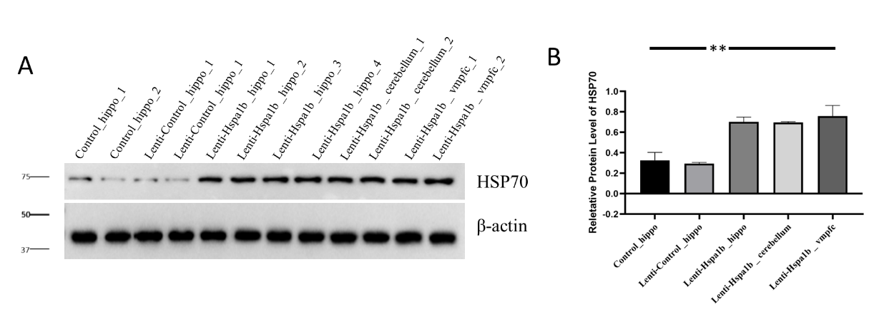
Figure S1 depicts Western blot (WB) analyses conducted on various tissues from three groups to evaluate Hspa1b expression. The results indicate overexpression of Hspa1b in hippocampus, cerebellum and vmpfc.

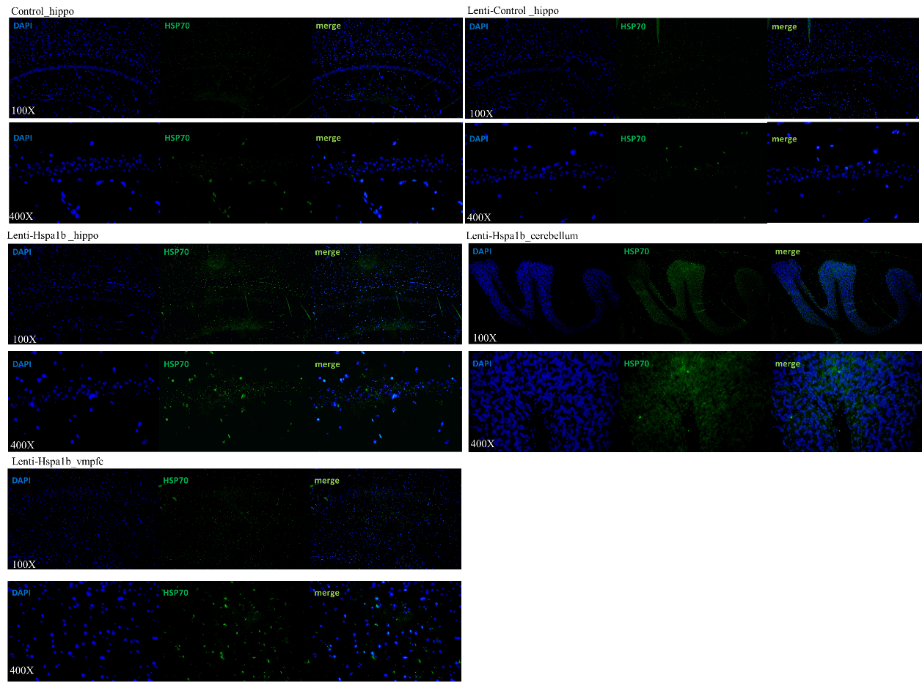
Figure S2 depicts the immunofluorescence analyses conducted on various tissues from three groups to evaluate Hspa1b expression. The results indicate overexpression of Hspa1b in hippocampus, cerebellum and vmpfc.

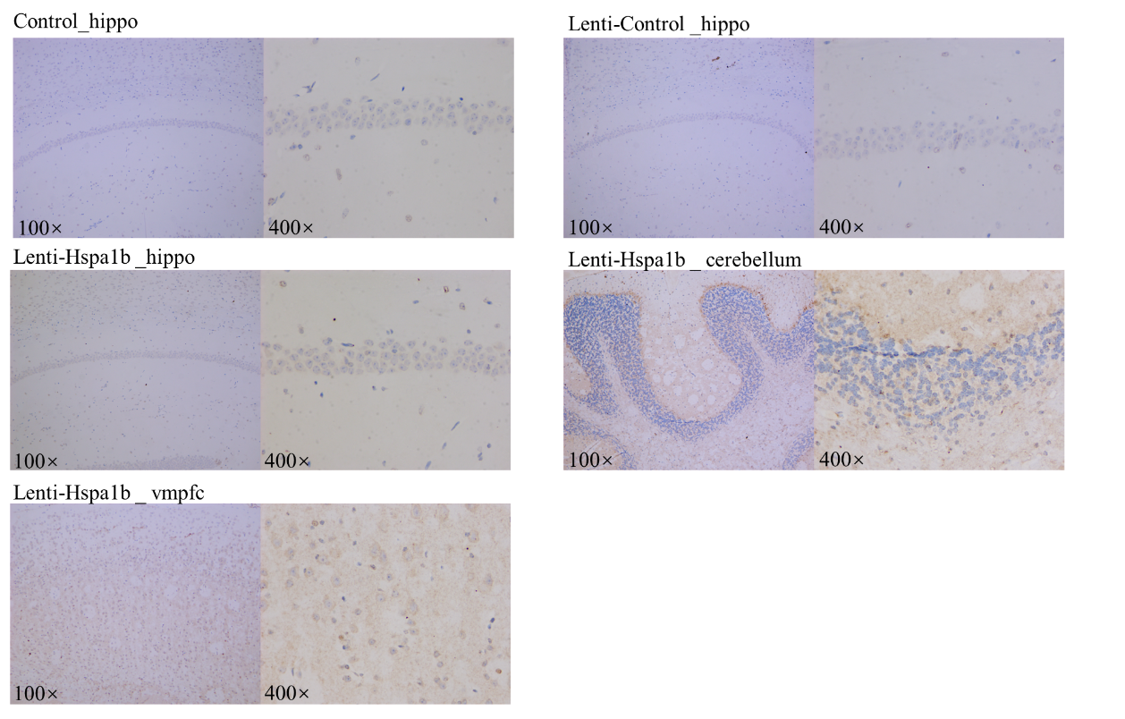
Figure S3 depicts the immunohistochemistry analyses conducted on various tissues from three groups to evaluate Hspa1b expression. The results indicate overexpression of Hspa1b in hippocampus, cerebellum and vmpfc.

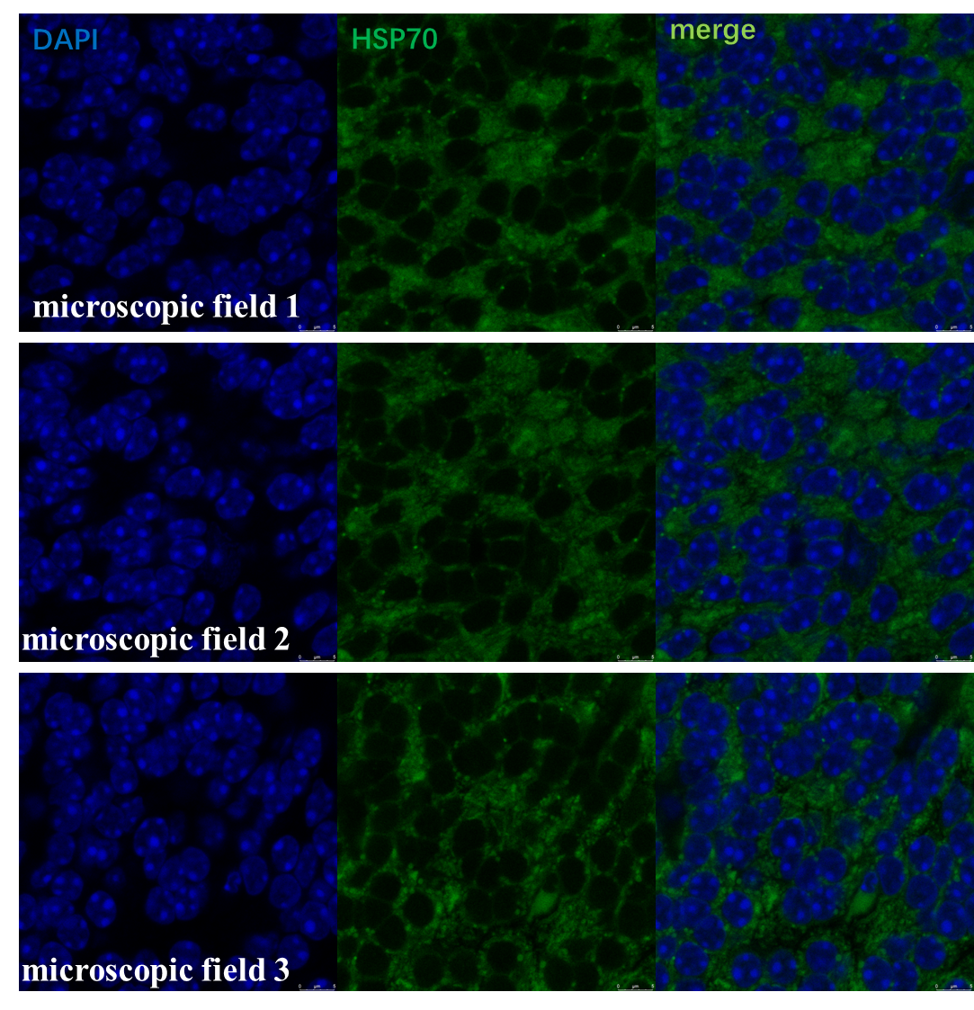
Figure S4. Confocal microscopy showing the subcellular localization of overexpressed Hspa1b in hippocampus tissue of the overexpressed group.

Figure S5. Principle component analysis using the transcript expression values for input control and Hspa1b immunoprecipitated (IP) samples. The results indicate that the two IP samples exhibited good clustering.

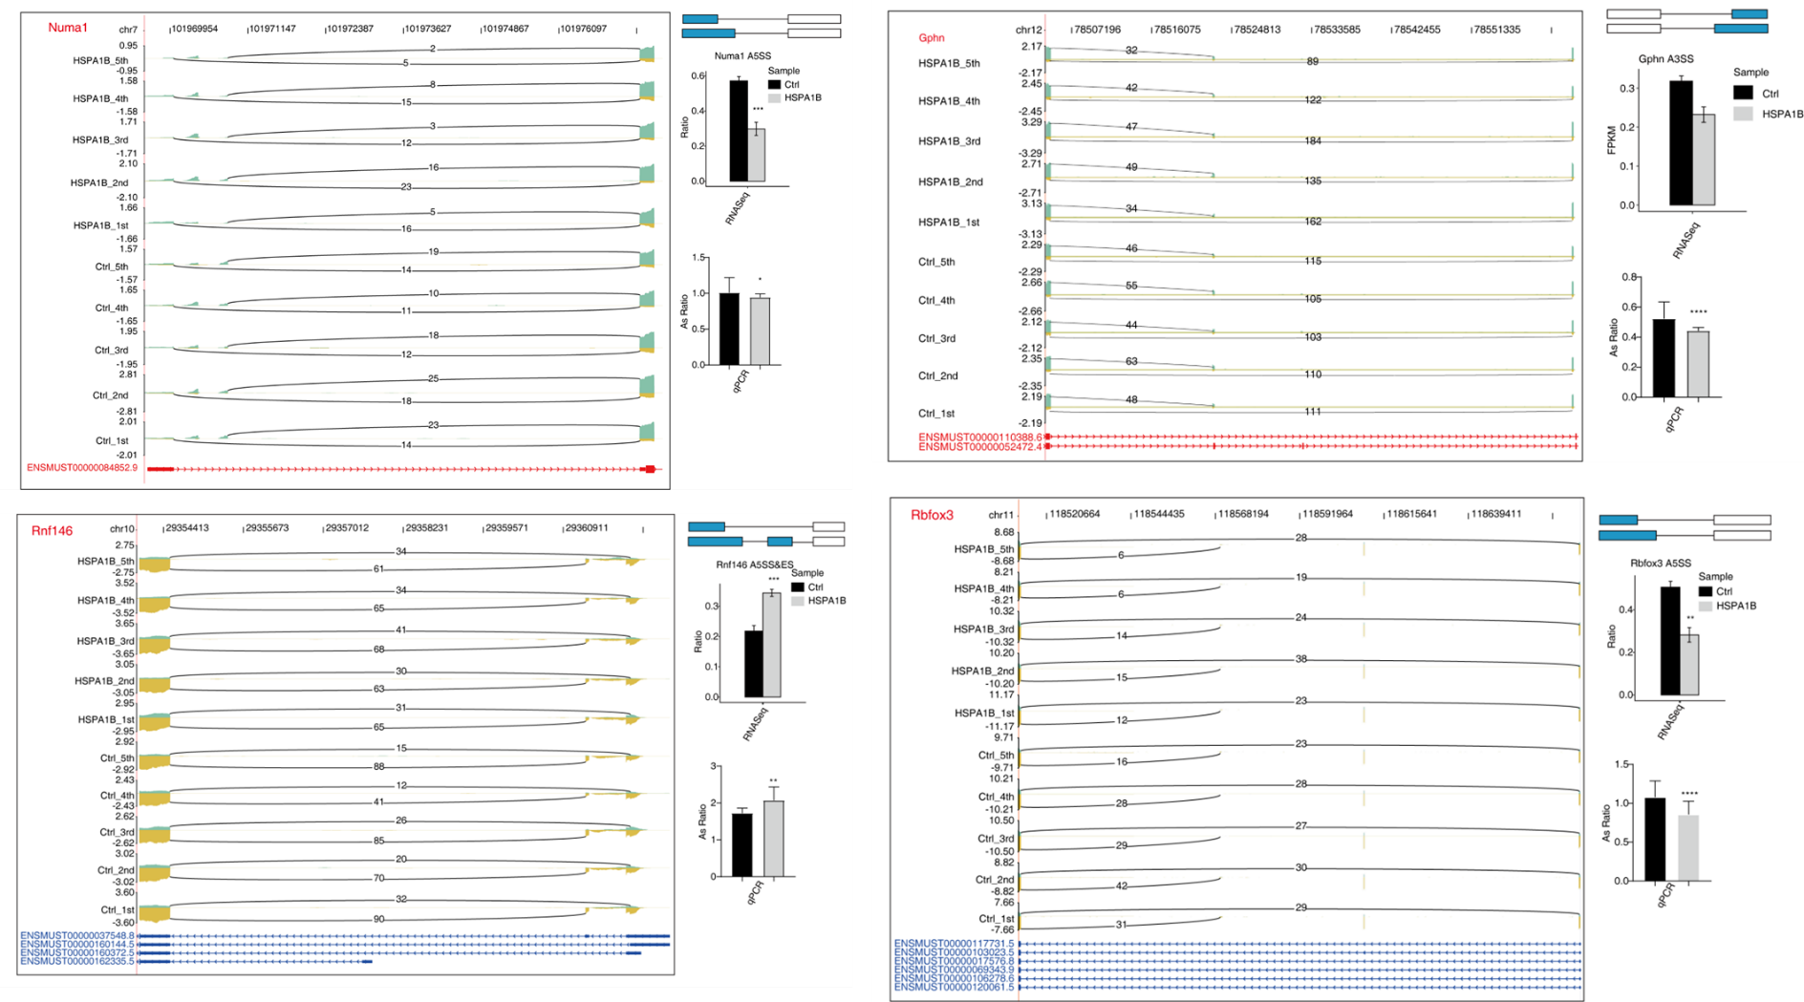

Figure S6. HSPA1B-regulates alternative splicing of several genes. IGV-sashimi plots show AS changes in HSPA1B overexpression cells and control cells (left), and the transcripts for the gene are shown below. The schematic diagrams depict the structures of ASEs (right, top). The constitutive exon sequences are denoted with white boxes, intron sequences with horizontal line, while alternative exons with blue boxes. RNA-seq quantification of ASEs are shown at the bottom of the right panel. The altered ratio of AS events in RNA-seq was calculated using the formula: alternative splice junction reads / (alternative splice junction reads + model splice junction reads). Student’s t test was performed to compare HSPA1B-OE and control cells with significance set at a P value of less than 0.05. *P < 0.05. **P < 0.01. ***P＜0.001.

