Supplementary information

Single amino acid bionanozyme for environmental remediation
Pandeeswar Makam¹, Sharma S. R. K. C. Yamijala², Linda J. W. Shimon³, Bryan M. Wong²* & Ehud Gazit^{1,4}*
Affiliations:
¹Department of Molecular Microbiology and Biotechnology, George S. Wise Faculty of Life Sciences, Tel Aviv University, Tel Aviv 6997801, Israel.
² Department of Chemical & Environmental Engineering and Materials Science & Engineering Program, University of California-Riverside, Riverside, CA, 92521, USA.
³ Chemical Research Support, The Weizmann Institute of Science, 7610001 Rehovot, Israel.
⁴ Department of Materials Science and Engineering, Iby and Aladar Fleischman Faculty of Engineering, Tel Aviv University, Tel Aviv 6997801, Israel.
*Correspondence to: Ehud Gazit (ehudg@post.tau.ac.il) and Bryan M. Wong (bmwong@engr.ucr.edu)

Supplementary Table 1. Crystallographic Data collection and refinement statistics of F-Cu
Compound | F-Cu
CCDC | 1871975
Diffractometer | ESRF ID23-1
Empirical formula | C₁₈H₂₀CuN₂O₄
Formula weight (g/mol) | 391.90
Crystal description | Blue plate
Temperature (K) | 100
Wavelength (Å) | 0.70
Crystal system | Monoclinic
Space group | P2₁
a, b, c (Å) | 9.4800(19), 5.1500(10), 16.670(3)
α, β, γ (°) | 90, 98.93(3), 90
Volume (Å³) | 804.0(3)
Z | 2
Density calculated (mg/m³) | 1.619
Absorption coefficient (mm⁻¹) | 1.385
F(000) | 406
Crystal size (mm) | 0.15x0.10x0.01
Theta range for data collection (°) | 1.218 to 31.926
Reflections collected (unique) | 9071(5472)
R int | 0.0435
Completeness (%) | 95.3
Data\restraints\  parameters | 5472/1/242
Goodness-of-fit on F² | 1.105
Final R [I>2σ(I)] | R1=0.0462, wR2=0.1234
R (all data) | R1=0.0475, wR2=0.1256
Largest diff. peak and hole (e. Å⁻³) | 1.416 and -0.548

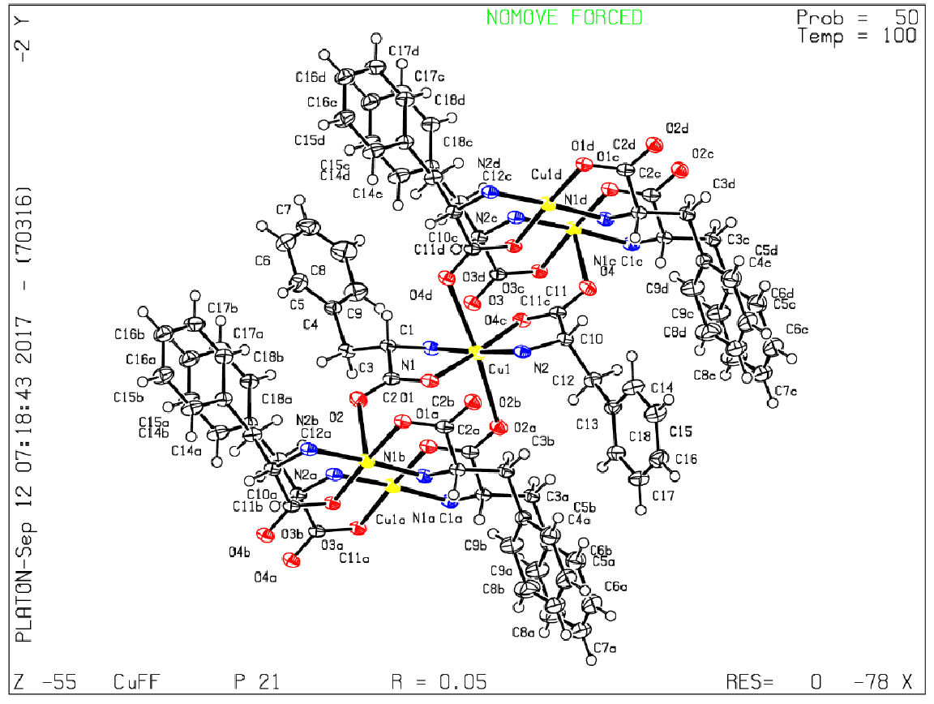

ORTEP diagram of F-Cu crystal structure

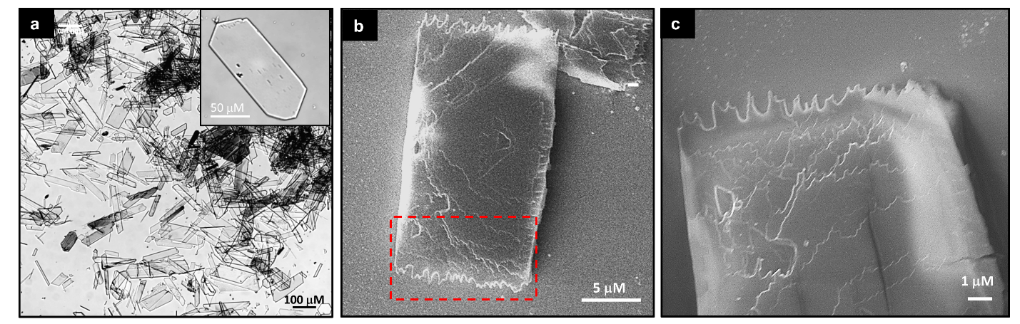

Supplementary Fig. S1. Microscopic images of F-Cu crystals. a, Optical microscope images. inset enlarged single-crystal image b and c, HRSEM images

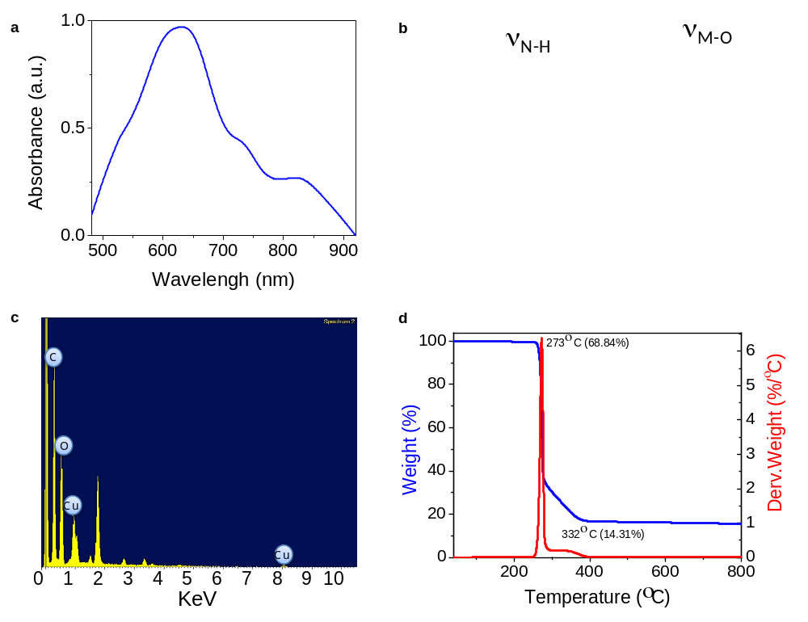

Supplementary Fig. S2. Spectroscopic characterization of F-Cu bionanozyme. a, UV-vis absorption spectra. b, FTIR spectra (3270–3040 (ν_{N-H}) and 580–540 cm^{–1} (ν_{M-O}) region) of phenylalanine (F) and F-Cu. c, EDS spectra. d, TGA of F-Cu bionanozyme (blue curve) revealing the high thermal stability (≤ 273 °c). The weight losses are depicted by the first derivative curve (red).

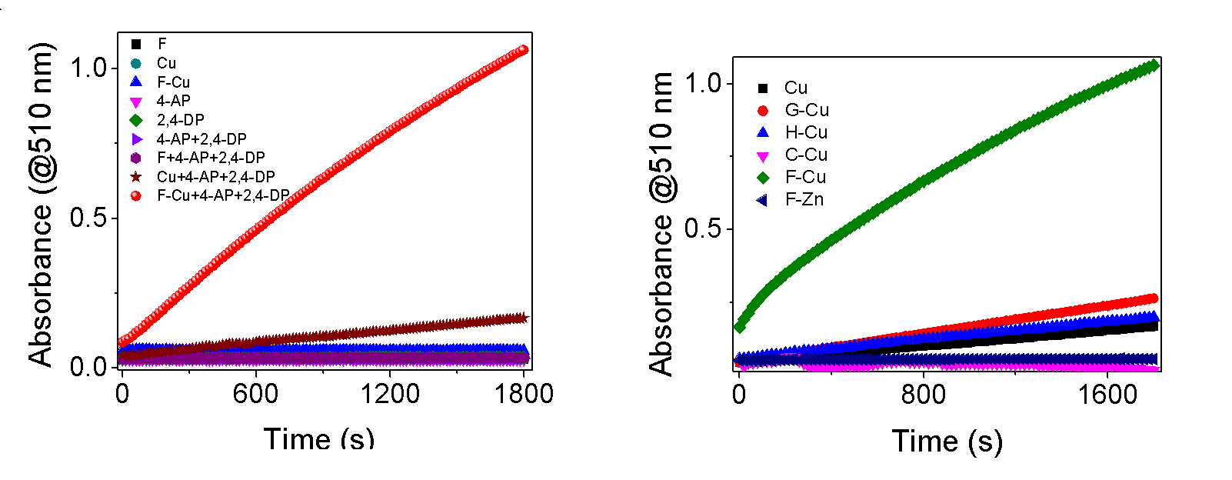
Supplementary Fig. S3. Catalytic activity in control experiments, a, Reaction progress in the presence of all the control building blocks of F-Cu bionanozyme. Only F-Cu bionanozyme can catalyze the oxidation of 2,4-DP into colored product absorbance at 510 nm. No significant oxidation was observed when omitting either the phenylalanine (F) molecule or Cu from the catalytic system. b, Reaction progress in the presence of different copper complexes of amino acids (glycine (G-Cu), histidine (H-Cu), cysteine (C-Cu), and phenylalanine (F-Cu)) and phenylalanine-zinc (F-Zn) complex

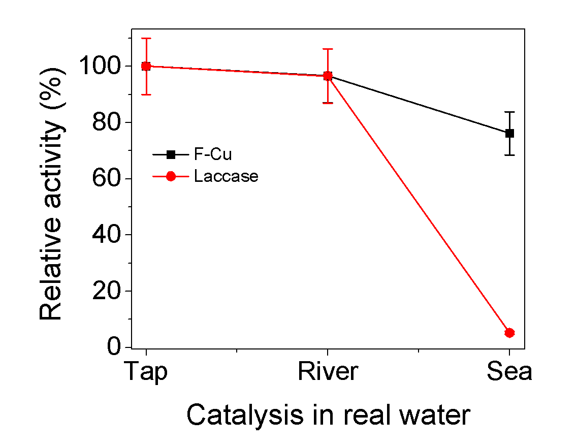

Supplementary Fig. S4. Relative catalytic activity of F-Cu bionanozyme in real water samples (tap water, river water, and seawater).

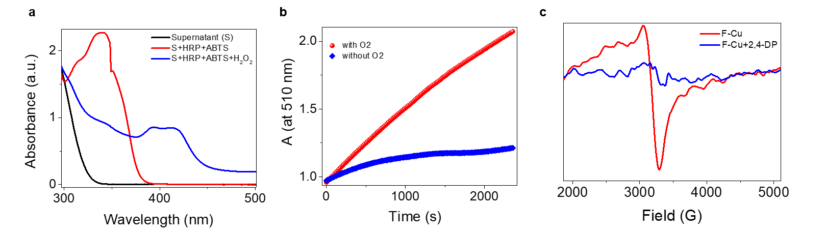

Supplementary Fig. S5. Evaluation of laccase-mimicking catalytic activity of F-Cu bionanozymes. a, UV-visible absorbance spectra of the control experiment testing the in-situ production of H₂O₂. b, UV-vis kinetic traces at 510 nm in the presence and absence of oxygen (O₂), Solutions were made anaerobic (without O₂) by bubbling water-vapor saturated nitrogen for 45 min. c, EPR spectra of F-Cu bionanozyme before and after addition of substrate 2,4-DP.

References
1. J. P. Perdew, K. Burke, M. Ernzerhof, Phys. Rev. Lett. 1996, 77, 3865.
2. V. Blum, et al. Comput. Phys. Commun. 2009, 180, 2175.
3. A.Tkatchenko, M. Scheffler, Phys. Rev. Lett. 2009, 102, 073005.
4. G. Henkelman, B. P. Uberuaga, H. Jónsson, J. Chem. Phys. 2000, 113, 9901.
5. W. E, W. Ren, E.Vanden-Eijnden, J. Chem. Phys. 2007, 126, 164103.

Supplementary Movie S1. In-situ monitoring of the F-Cu crystallization process under optical microscope.

Supplementary Movie S2. In-situ optical microscopy observation of phenylalanine-coordinated Copper ions (F–Cu) crystallization kinetics.

Supplementary Movie S3 in-situ reaction monitoring of 2,4-DP and 4-AP catalyzed by F-Cu crystals.

Supplementary Movie S4 Real-time monitoring of 2,4-DP and 4-AP oxidation in the presence and absence of F-Cu catalyst.

