Figure S1 Forest plots of stratified analysis of cadmium with periodontitis.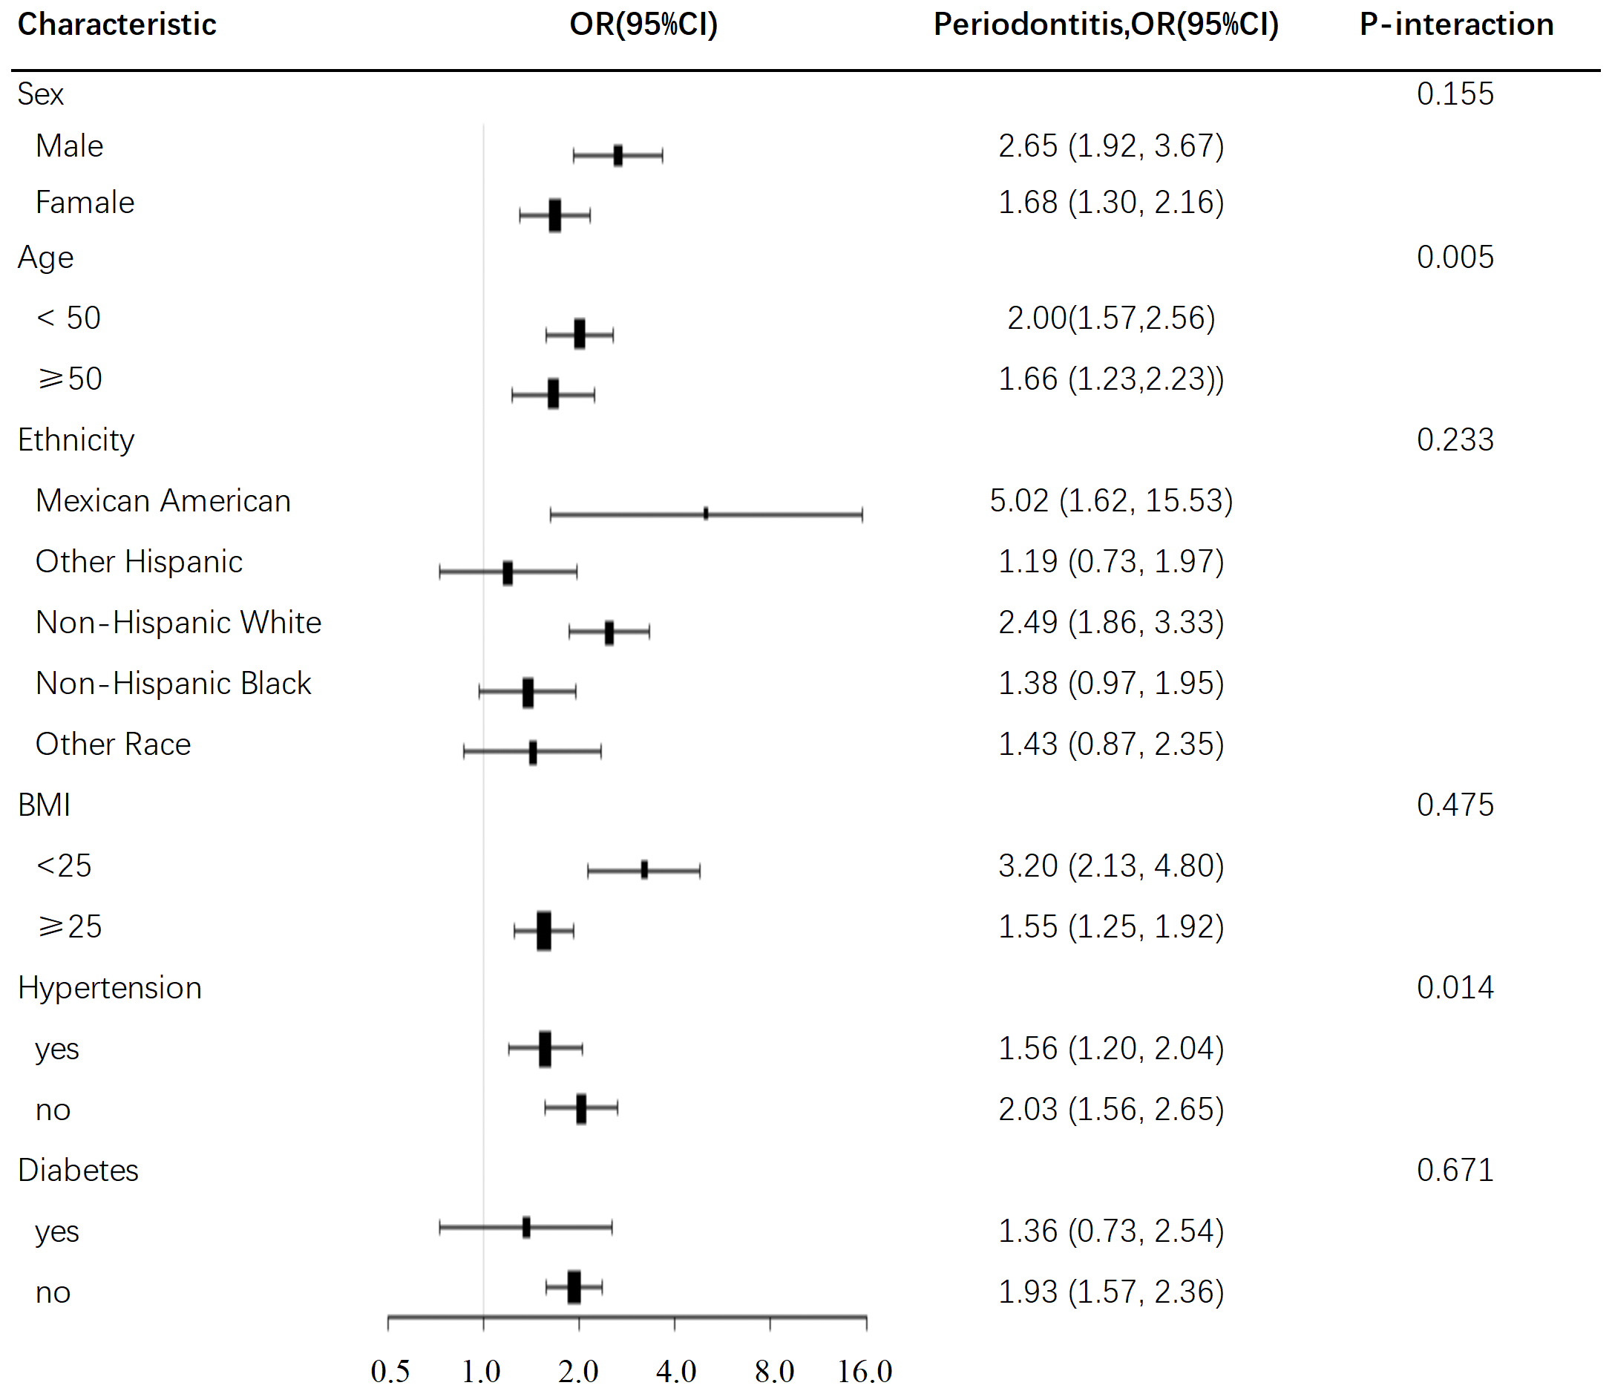
Note: Age, gender, race/ethnicity, PIR, BMI, smoking status, Vitamin D, Hypertension, Diabetes were all adjusted except the variable itself.
Abbreviations: OR: odd ratio; CI: confidence interval

Table S2 Logistic regression analyses of the associations between cadmium and periodontitis
 | Non-adjusted | Adjust I (Complete case) | Adjust II (Multiple imputation)
 | 1.83 (1.52, 2.21) <0.05 | 1.51 (1.22, 1.86) <0.05 | 1.51 (1.21, 1.86) <0.05
Cadmium quartile
Low | 1.0 | 1.0 | 1.0
Middle | 1.30 (0.75, 2.25) 0.35 | 1.38 (0.76, 2.51) 0.29 | 1.39 (0.76, 2.52) 0.28
High | 2.06 (1.22, 3.49) <0.05 | 1.71 (0.94, 3.10) 0.08 | 1.71 (0.94, 3.11) 0.08
Note: Adjusted for age, gender, race/ethnicity, PIR, BMI, smoking status, Vitamin D, Hypertension, Diabetes
Abbreviations: OR: odd ratio; CI: confidence interval

