Supplemental File
Additional Methods
Laboratory analysis: The biochemical analyses were carried out on venous blood, performed with fasting of at least 8 hours and included: CBC, Hb values, WBC values, PLT values, glycemia, complete lipid profile, creatininemia, natremia, kalemia. Plasma was obtained by addition of disodium ethylenediaminetetraacetate (Na₂EDTA) (1 mg/mL) and blood centrifugation at 3000 RPM for 15 min at room temperature. The urine analysis was performed in the morning upon awakening and included albuminuria. To calculate GFR, the Cockcroft Gault formula was used [(140-age) x body weight / (creatinine level x 72)]. The value was multiplied by 0.85 for females.

Electrocardiography: The 12-lead electrocardiographic evaluation took into consideration cardiac rhythm, HR and electrocardiographic parameters for the diagnosis of LV hypertrophy (according to 2024 ESC Guidelines for the management of elevated BP and hypertension). The presence of a non-sinus rhythm or the presence of LV hypertrophy were among the exclusion criteria from the current study. Any HR value was accepted in the current study.

Echocardiography: All the parameters were verified to have been performed using 2.5 MHz Cardiac Sector Ultrasound transducer probe. The 2D transthoracic echocardiography was obtained from medical reports, based on images of parasternal long-axis, short-axis and three standard apical chamber views, using a 17-segment model for the left ventricle (Suppl. Fig. 4). All the parameters were measured according to guidelines of the American Society of Echocardiography (ASE, 2005). The study of heart valves included the descriptive evaluation in the report and the Doppler calculation using continuous wave (CW) Doppler and pulsed wave (PW) Doppler.
EF was calculated by Simpson biplane method, tracing the endocardium in the apical four and two-chamber view in diastole and systole in order to acquire the LV end diastolic volume (LVEDV) and LV end systolic volume (LVESV); as SV is LVEDV – LVESV, EF was calculated as [SV / LVEDV]. LV mass was calculated by the formula 0.8(1.04[([LVEDD + IVSTd +PWTd]³ - LVEDD³)]) + 0.6 (d, diastolic); LV mass index = LV mass/BSA. RWT was obtained by the formula (2*PWT)/LVEDD. Left atrial volume (LAV) was calculated in the apical 4 and 2-chamber views, so that LAVi was obtained by LAV indexed by BSA. E-wave was calculated by PW Doppler on mitral valve in the four apical view. e’ wave was calculated by tissue Doppler in the interventricular septum in order to calculate the E/e’.
All 17 segments in the three apical chamber views were acquired, and the GLS of the left ventricle was assessed by the software speckle tracking echocardiography. The timing of the valvular events was determined by visualizing the opening and closure of aortic and mitral valves from the three-chamber apical view of LV and by placing a cursor corresponding to mitral valve opening (MVO), mitral valve closure (MVC), aortic valve opening (AVO), and aortic valve closure (AVC) along the RR interval of the accompanying electrocardiographic trace. BP was non-invasively measured with a brachial cuff and both the systolic and diastolic components were inserted into the application. Peak systolic LV pressure was considered to be equal to peak arterial pressure in the absence of a gradient through the left ventricular outflow tract (LVOT) and the aortic valve. All apical images were recorded in 40–80 frames per second (fps) with clear visualization of the endocardial border, and the region of interest (ROI) width cover only the whole myocardium. Additionally, the application demonstrated the pressure strain loop (PSL) that was equal to the GWI of the left ventricle. The software automatically calculated the different phases of the cardiac cycle, the bull’s eye and the four components of MW (Suppl. Fig. 5). All MW components apart from GWE had the same units and are expressed in mmHg% as they reflected the power over the cardiac cycle longitudinal strain (Suppl. Fig. 6). PWV was calculated from cfPWV using linear probes for vascular ultrasound as follows: assessment of carotid-femoral distance (calculated in meters by tape measure) and the carotid-femoral pulse transit time (PTT) (change in time between the R wave on electrocardiogram-peak period of time of the femoral and carotid pulse waves) (Suppl. Fig. 7).

Echo vascular ultrasound: The assessment of carotid IMT and the presence of carotid plaques were performed by 7.0-10 MHz linear array transducer. Carotid IMT was assessed at the level of the common carotid artery and the presence of carotid plaques from the origin of the common carotid artery to the internal carotid artery. As previously described, carotid IMT value > 0,9 mm or the presence of carotid plaque were considered exclusion criteria in the current study.
ABI was noninvasively assessed with a sphygmomanometer and vascular probe. The ankle SBP was calculated by placing the sphygmomanometer cuff at the distal third of the calf and calculating the ankle SBP by means of a vascular probe at the level of the posterior tibial artery.
The brachial SBP was non-invasively calculated with a brachial cuff, as routine in the calculation of the SBP. ABI has been calculated by formula as follows: ankle SBP / brachial SBP.

Additional calculations: VAC was non-invasively calculated as cfPWV / GLS. Ea was non-invasively calculated as (SBP x 0.9) / SV. SV was calculated using the Simpson method on echocardiography. The assessment of GLS was performed by speckle tracking software (Echocardiography Vivid 90), calculating the strain of longitudinal fibers of left ventricle by three apical chamber views. Software algorithms traced the ultrasonic speckles frame by frame within a ROI over one cardiac cycle, with electrocardiographic trace, and were able to quantify the magnitude of deformation and generate strain. (Suppl. Fig. 5). MW was measured by Echography Vivid 90 from the PSL areas constructed by LV pressure curves combined with strain GLS.
The assessment of PSL involves SBP, longitudinal strain of LV cardiomyocytes and the timing of aortic and mitral valve opening and closure. The area of PSL, determined by multiplying the instantaneous LV pressure by the rate of segmental shortening, which was computed by differentiating the strain curve, corresponding approximately to the MW index (MWI). This index represented the work assessed from MVC to MVO, measured in mmHg% and integrated over the cardiac cycle. MW and its components (GWI, GCW, GWW, GWE) were investigated.
Suppl. Fig. 1. Management of elevated BP and hypertension (2024 ESC Guidelines).
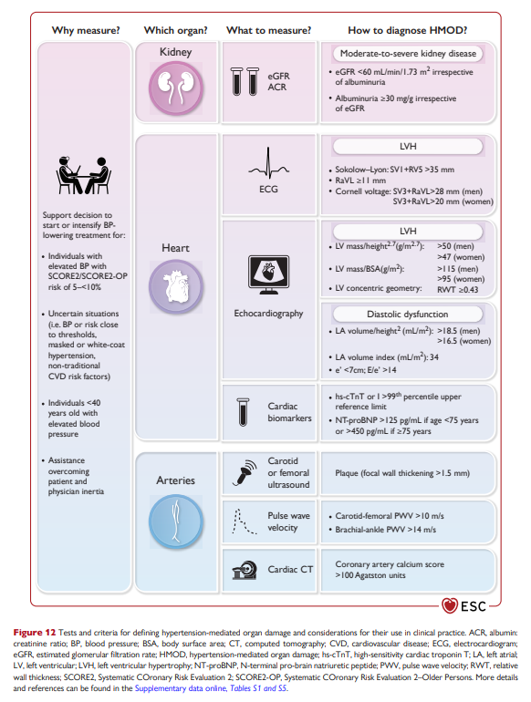

Suppl. Fig. 2. Tests and criteria for defining hypertension-mediated organ damage and considerations for their use in clinical practice: Recommendations for pharmacological treatment of hypertension (2024 ESC Guidelines).

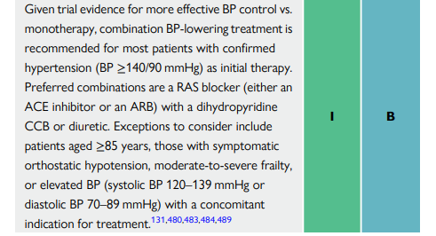

Suppl. Fig. 3. Flow chart of the study.
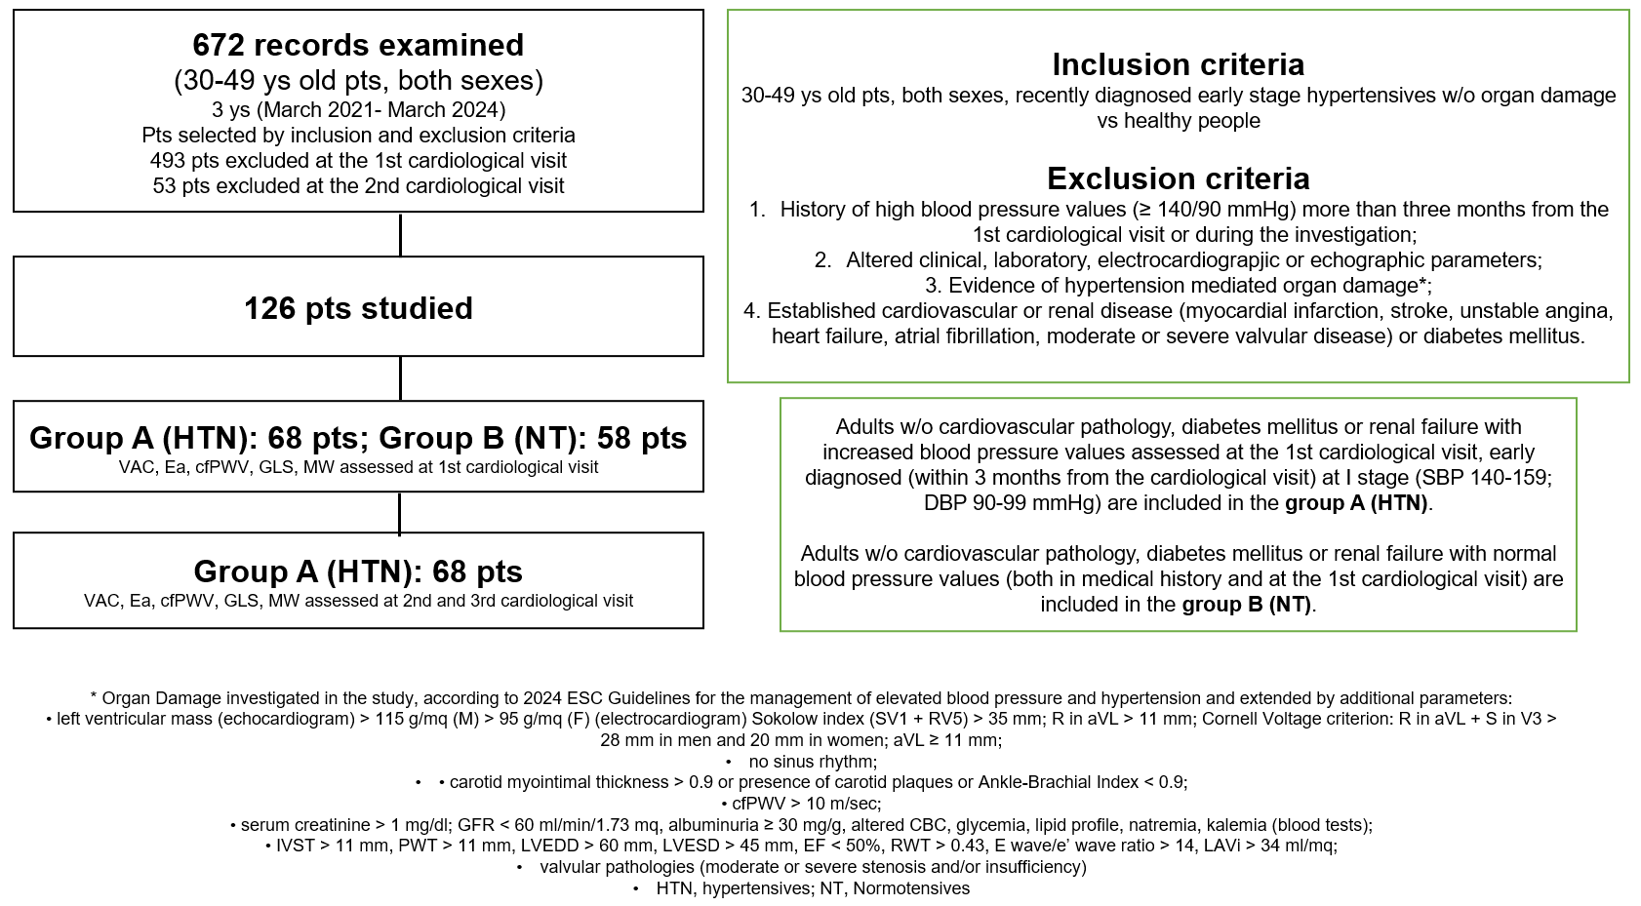

Suppl. Fig. 4. The echocardiographic three apical chamber views of the left ventricle displayed different anatomical areas of the left ventricle along with the short axis from the base to the apex of the left ventricle.
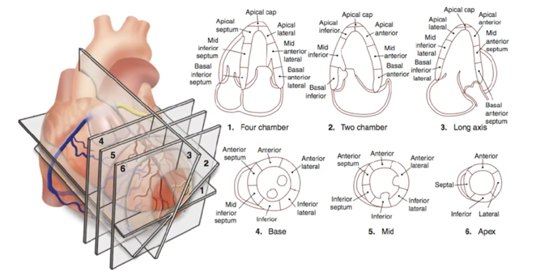
- Four chamber view: inferior interventricular septum and the antero-lateral wall
- Two chamber view: inferior and anterior walls
- Long axis (three chamber): anterior interventricular septum and infero-lateral wall
- Basal segments of the left ventricle
- Mid segments of the left ventricle
- Apical segments of the left ventricle
Echocardiographic three LV apical chamber views by the American Heart Association (AHA).

Suppl. Fig. 5. Speckle tracking echocardiography.
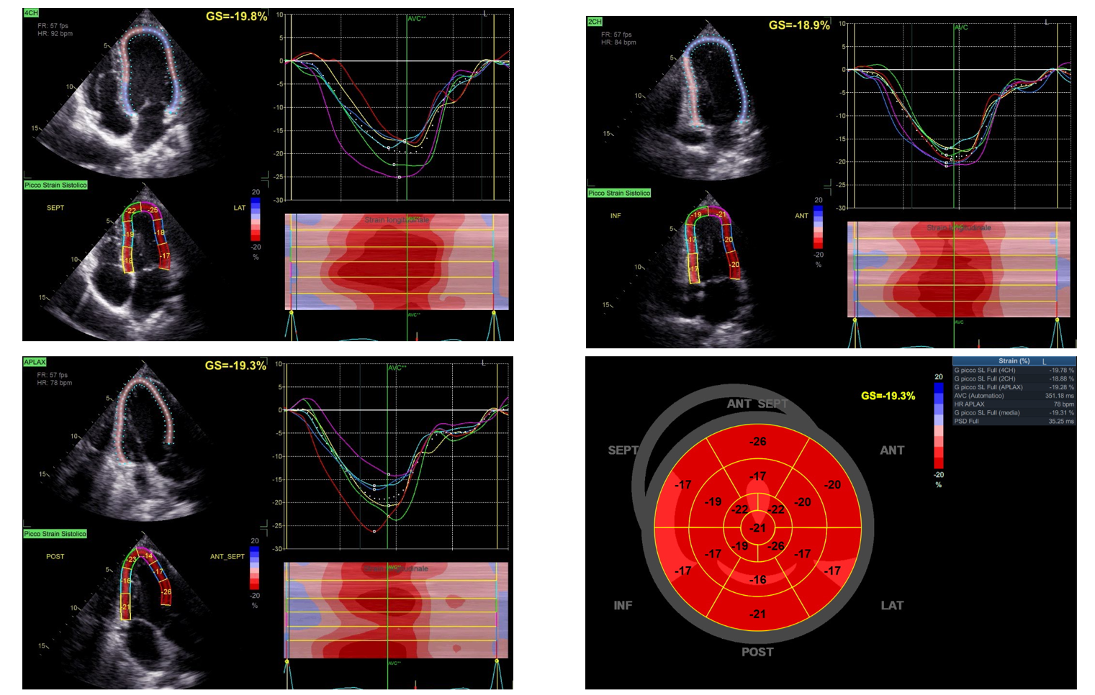
Echographic representation of deformation of cardiomyocytes displayed in all the three apical chamber views of the left ventricle. Bull’s eye representation of all the 17 segments: the numbers in each segment represent the GLS calculated by the software.
Echocardiographic image used with patient consent.

Suppl. Fig. 6. MW representation.
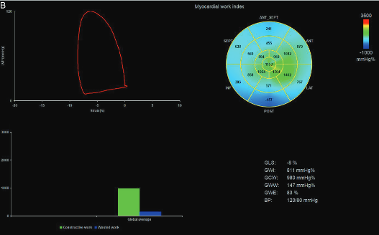
GWI is calculated from MVC to MVO. including isovolumetric contraction (IVC), ejection time (ET) and isovolumetric relaxation (IVR).
GCW is the work performed during systolic shortening. plus the negative work performed during lengthening in IVR.
GWW is the negative work performed during lengthening in systole. plus the work performed during shortening in IVR.
GWE is the constructive work divided by the sum of constructive and wasted work.
Echocardiographic image used with patient consent.

Suppl. Fig. 7. Calculation of cfPWV by echo vascular Doppler.
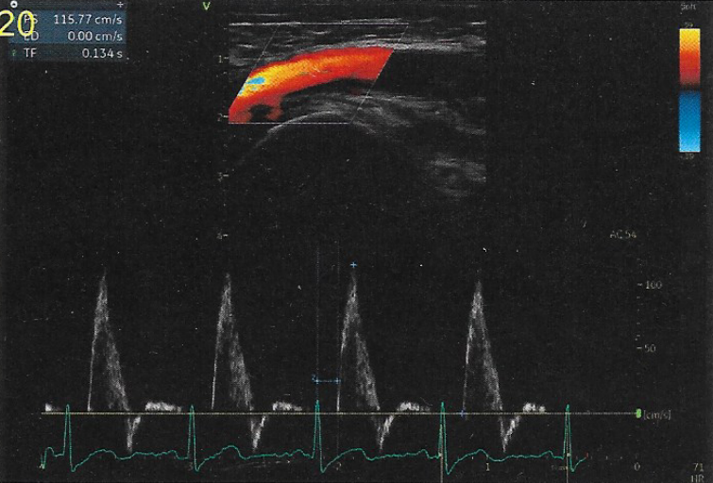
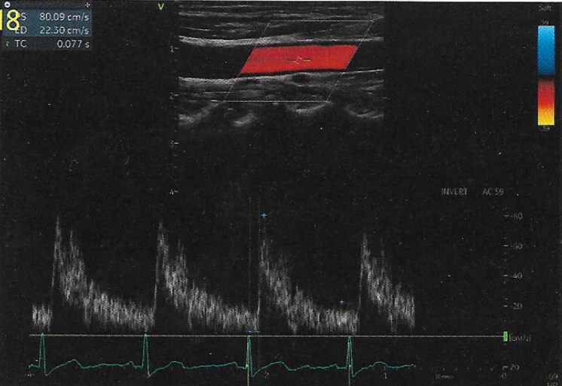
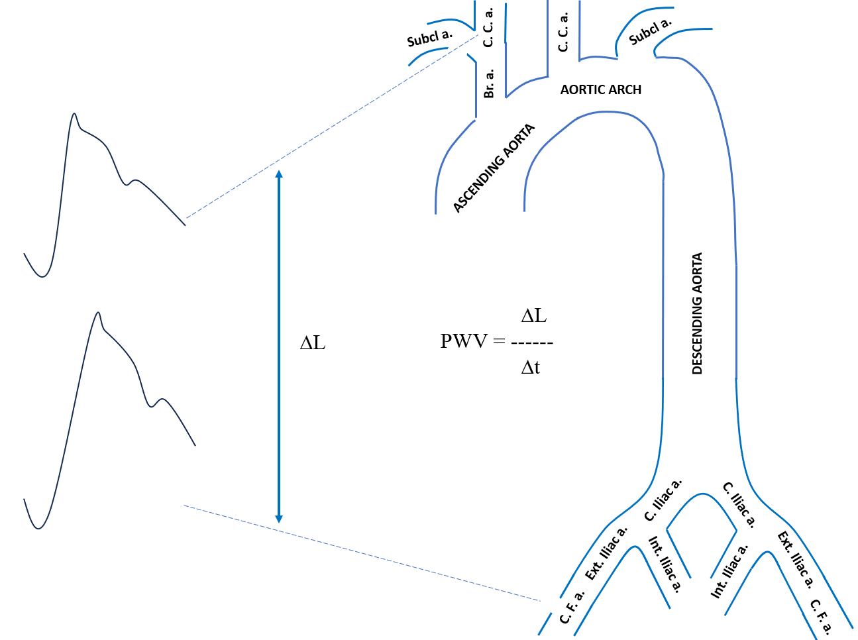
cfPWV is calculated by carotid-femoral distance (calculated in meters) and the carotid-femoral PTT (change in time between the R wave on electrocardiogram-peak period of time of the femoral pulse wave and the R wave on electrocardiogram-peak period of time of carotid pulse wave).
Br.a.; Brachiocephalic artery; C.C.a.: Common Carotid artery; C.F.a.: Common Femoral artery; C. Iliac a.: Common Iliac Artery; Ext. Iliac. a.: External Iliac artery; Int. Iliac a.: Internal Iliac artery; PTT: Pulse Transit Time; PWV: Pulse Wave Velocity; Subcl. a.: Subclavian artery.
The image was created using Microsoft Power Point 2019 exploiting the echo vascular image used with patient consent.

