Anatomical | Pathological
Apical foramen  Dentinal Tubules  Accessory & lateral canals | Cracks  Root Fractures  Root Resorptions  Iatrogenic perforations
Table 1: portals of communication between the pulp and periodontium.
Case 1 details
A 57-year-old male patient attended complaining of bleeding gums and loose lower anterior teeth. The patient had been referred for non-surgical root canal treatment (NSRCT) of tooth 31 following several rounds of subgingival professional mechanical plaque removal (PMPR) without any improvement in pocket depths.

Relevant medical history: chronic myeloid leukaemia, controlled with hydroxycarbamide, non-smoker.

The patient brushes three times daily and uses various sizes of interdental brushes daily.

On examination, apart from tooth 31, the patient had generalised periodontitis, stage II, grade A, currently stable. The patient’s oral hygiene was reasonable.

Tooth 31 was grade II mobile, had suppuration from the gingival margin and pockets ranging from 7 to 10mm at six sites around the tooth. The tooth was positive to cold and electric pulp testing. There was significant spacing between the remaining lower anterior teeth.
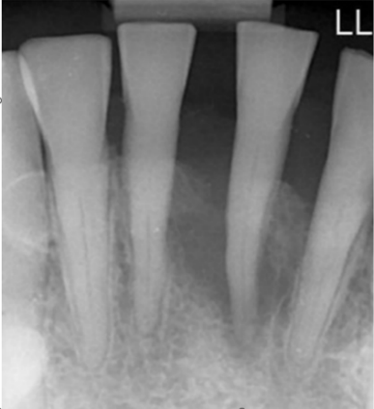

a)
- Periapical radiograph showing teeth: 42, 41, 31, 32
Table 2: Vignette case 1
Case | Case 2 details
A 49-year-old male patient was referred for NSRCT of teeth 16 and 26. He complained of sore gums for many years around the posterior teeth which was making eating difficult.

Relevant medical history: well controlled type 2 diabetes and hypertension. Taking Amlodipine, Linagliptin and Metformin. Smokes 10 cigarettes per day.

On examination the patient had evidence of generalised periodontitis, stage III, grade B, currently in remission, risk factors- smoking and diabetes. The full mouth plaque score was 35%. The bleeding score was 25%.

Teeth 16 and 26 were both negative to cold testing and were unrestored. There was no evidence of cracks on either the 16 or 26, however tooth 26 was tender to percussion and had suppuration from the buccal gingival sulcus.

Pocket depths recorded around tooth 16 were:
MB-4 | B-3 | DB-6
MP-7 | P-10 | DP-5

Pocket depths recorded around tooth 26 were:
MB-3 | B-3 | DB-6
MP-5 | P-5 | DP-6

Both teeth 16 and 26 had class II furcation involvement. The patient was apprehensive about losing further teeth.
- 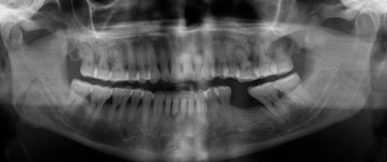
- 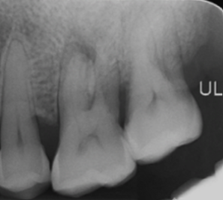
- 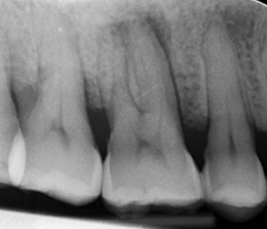
- Full mouth OPG; b) periapical radiograph of teeth 25, 26, 27; c) periapical radiograph of teeth 17, 16, 15
Table 3: Vignette case 2
Case | Case 3 details
3 | A 39-year-old female patient was referred for re-NSRCT of tooth 13. The patient’s main complaint was that the tooth was loose.  Relevant medical history: Hypertension, taking amlodipine. Stopped smoking 12 years ago, at which time she was smoking 10 cigarettes per day.  The patient’s oral hygiene regime involved using an electric toothbrush twice daily with adjunctive blue and yellow interdental brushes. She also visited her hygienist for PMPR every three months.  On examination the patient had a good level of oral hygiene, however there was evidence of generalised periodontitis, stage II, grade B, currently unstable at a few posterior sites. The worst site of bone loss was focused on tooth 13, however the remaining dentition had up to a maximum level of 30% horizontal bone loss. Tooth 13 had suppuration from around the gingival margin. There was a 9mm pocket and 6mm of recession mid-buccally. The previous NSRCT was carried out under rubber dam isolation.  The dentition was generally heavily restored.
 | - 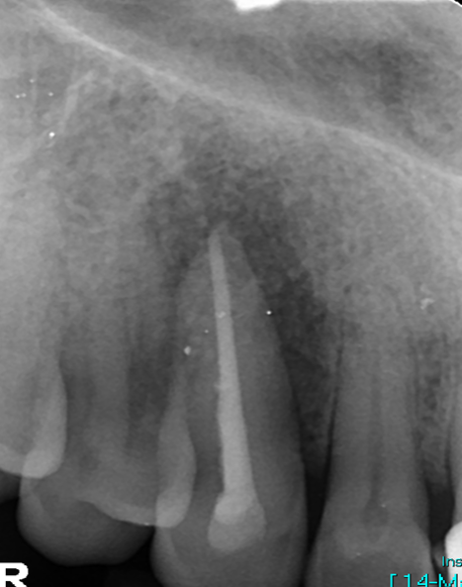
- Periapical radiograph of tooth 13
Table 4: Vignette case 3
Case 4 details
A 69-year-old patient complained of a wobbly tooth 21. The tooth had become progressively looser over the last 18 months. There was a previous history of trauma over 40 years ago to tooth 21.

Relevant medical history: Hypertension well controlled with Amlodipine.

The patient had several courses of PMPR before being referred. They used interdental brushes and brushed twice daily using an electric toothbrush.

On examination, the patient had generalised periodontitis, stage III, grade B, currently unstable.

Tooth 21 was negative to cold testing, was grade III mobile, and had a 6mm periodontal pocket mesially. There was minimal space in intercuspal position between the upper and lower anterior teeth.
- 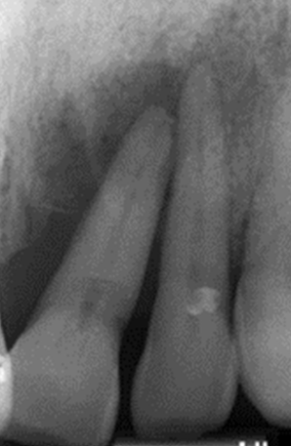
- Periapical radiograph teeth 21, 22
Table 5: Vignette case 4

 | Preferred classification system (expressed as % of participants)
 | Dietrichet al. (19) | Herreraet al. (3) | Kim and Kratchman (20) | Simonet al. (21) | Other | Participants comments regarding the selection of “other” classification system
Case 1
Endodontist, n=28 | 7% | 21% | 14% | 46% | 11% | - “Abbott and Salgado (22)”  - “In my view the above case would not be considered an EPL as although the tooth has significant periodontal attachment loss if it is responding the canal may still be vital although the sensitivity testing is of course only assessing the nerve as opposed to blood supply!”  - “None”
Periodontist, n=22 | 5% | 64% | 5% | 23% | 5%
Case 2
Endodontist, n=28 | 7% | 21% | 14% | 50% | 7% | - “Abbott and Salgado (22)”  - “None”
Periodontist, n=22 | 9% | 64% | 5% | 18% | 5%
Case 3
Endodontist, n=28 | 4% | 32% | 11% | 36% | 18% | - “Abbott and Salgado (22)”  - “Although we could technically consider the above a perio-endo lesion I would consider this Chronic Lateral Periodontitis secondary to a Cracked Root”  - “VRF”  - “None”  - “It has a crack, so classification not used”
Periodontist, n=22 | 5% | 64% | 5% | 23% | 5%
Case 4
Endodontist, n=28 | 7% | 21% | 14% | 50% | 7% | - “Abbott and Salgado (22)”  - “None”
Periodontist, n=22 | 9% | 64% | 5% | 18% | 5%
 | Mean rank of prognostic factors (expressed as % of participants)
Case 1 | Level of bone loss | Oral Hygiene status | Occlusion | Anterior Tooth | Patient Age | Mandibular Tooth
Endodontist, n=28 | 1.32 | 2.79 | 3.18 | 4.07 | 4.61 | 5.04
Periodontist, n=22 | 1.19 | 2.38 | 3.29 | 4.52 | 4.62 | 5
Case 2 | Level of bone loss | Furcation involvement | Periapical lesion | Oral hygiene status | Medical history | Maxillary teeth | Posterior teeth | Patient age
Endodontist, n=28 | 1.86 | 2.54 | 3.21 | 3.82 | 4.32 | 6.96 | 6.57 | 6.71
Periodontist, n=22 | 1.91 | 2.73 | 2.86 | 4.23 | 5.27 | 5.86 | 6.14 | 7
Case 3 | Presence of a crack | Level of bone loss | Occlusion | Quality of previous NSRCT | Coronal seal | Oral hygiene status | Patient age | Maxillary tooth
Endodontist, n=28 | 1.43 | 2.71 | 3.86 | 4.21 | 4.68 | 5.07 | 6.89 | 7.14
Periodontist, n=22 | 1.82 | 3.05 | 4.18 | 3.68 | 4.82 | 5.18 | 6.95 | 6.32
Case 4 | Level of bone loss | Periapical lesion | Occlusion | Oral hygiene status | Patient age | Anterior tooth | Maxillary tooth
Endodontist, n=28 | 1.36 | 2.61 | 3.11 | 4.04 | 5.75 | 5.14 | 6
Periodontist, n=22 | 1.64 | 2.27 | 3.59 | 4.68 | 5.64 | 4.82 | 5.36
 | Preferred management strategy (expressed as % of participants)
 | Extract +/- prosthetic replacement. | NSRCT & PMPR | NSRCT | PMPR | Periodontal surgery & NSRCT | Periodontal surgery | EMS & NSRCT | EMS & periodontal surgery | Leave and monitor
Case 1
Endodontist, n=28 | 32% | 7% | 4% | 18% | 11% | 29% | 0% | 0% | 0%
Periodontist, n=22 | 41% | 18% | 0% | 18% | 18% | 5% | 0% | 0% | 0%
Case 2
Endodontist, n=28 | 7% | 68% | 11% | 4% | 11% | 0% | 0% | 0% | 0%
Periodontist, n=22 | 5% | 82% | 0% | 0% | 5% | 0% | 5% | 5% | 0%
Case 3
Endodontist, n=28 | 82% | 4% | 4% | 0% | 4% | 4% | 0% | 0% | 4%
Periodontist, n=22 | 91% | 9% | 0% | 0% | 0% | 0% | 0% | 0% | 0%
Case 4
Endodontist, n=28 | 46% | 32% | 4% | 4% | 14% | 0% | 0% | 0% | 0%
Periodontist, n=22 | 86% | 14% | 0% | 0% | 0% | 0% | 0% | 0% | 0%
 | Timing of combined treatment (for clinicians who selected combined endodontic & periodontal treatment, expressed as number of participants)
Case 1 | They should be done at the same time | Periodontal treatment first, 3 months wait, proceed with any endodontic treatment | Single visit NSRCT, wait 3 months, proceed with periodontal treatment | 2-visit NSRCT with 2 weeks between appointments; periodontal treatment 3 months after obturation | 2-visit NSRCT with 2 weeks between appointments; periodontal treatment at the same time as obturation | 1 or 2-visit NSRCT; >3 months wait until periodontal treatment
Endodontist, n=5 | 1 | 1 | 1 | 1 | 1 | 0
Periodontist, n=8 | 2 | 1 | 3 | 1 | 1 | 0
Case 2
Endodontist, n=22 | 11 | 0 | 4 | 3 | 3 | 1
Periodontist, n=20 | 5 | 0 | 9 | 5 | 1 | 0
Case 3
Endodontist, n=2 | 2 | 0 | 0 | 0 | 0 | 0
Periodontist, n=2 | 0 | 0 | 1 | 0 | 1 | 0
Case 4
Endodontist, n=13 | 3 | 0 | 1 | 4 | 4 | 1
Periodontist, n=3 | 1 | 0 | 0 | 2 | 0 | 0
 | Predicted survival rate if not opted for extraction (expressed as number of participants)
 | <1 year | 1-3 years | 3-5 years | >5 years
Case 1
Endodontist, n=19 | 2 | 11 | 3 | 3
Periodontist, n=13 | 2 | 6 | 3 | 2
Case 2
Endodontist, n=26 | 0 | 2 | 15 | 9
Periodontist, n=21 | 0 | 5 | 11 | 5
Case 3
Endodontist, n=5 | 1 | 2 | 2 | 0
Periodontist, n=2 | 0 | 2 | 0 | 0
Case 4
Endodontist, n= 15 | 3 | 6 | 4 | 2
Periodontist, n=3 | 0 | 1 | 2 | 0
Table 6: classification systems used, ranked prognostic factors, management strategies and long-term predicted survival rates that participants selected, stratified according to speciality type. NSRCT=non-surgical root canal/ re-root canal treatment; PMPR= professional mechanical plaque removal; periodontal surgery= open flap debridement plus use of a membrane and/or graft and/ or enamel matrix derivative; EMS= endodontic microsurgery

