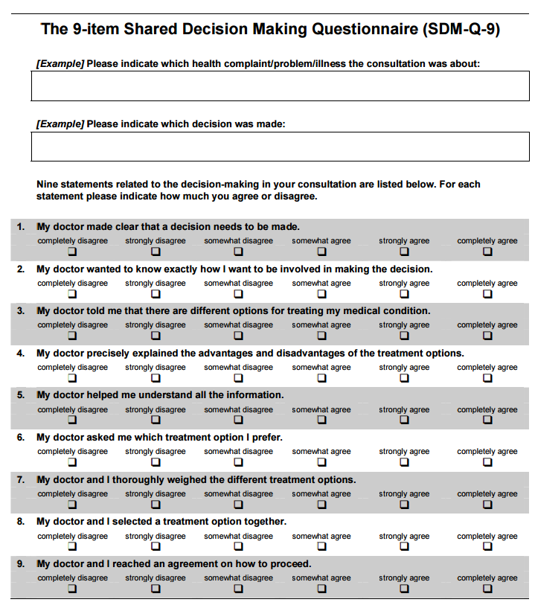
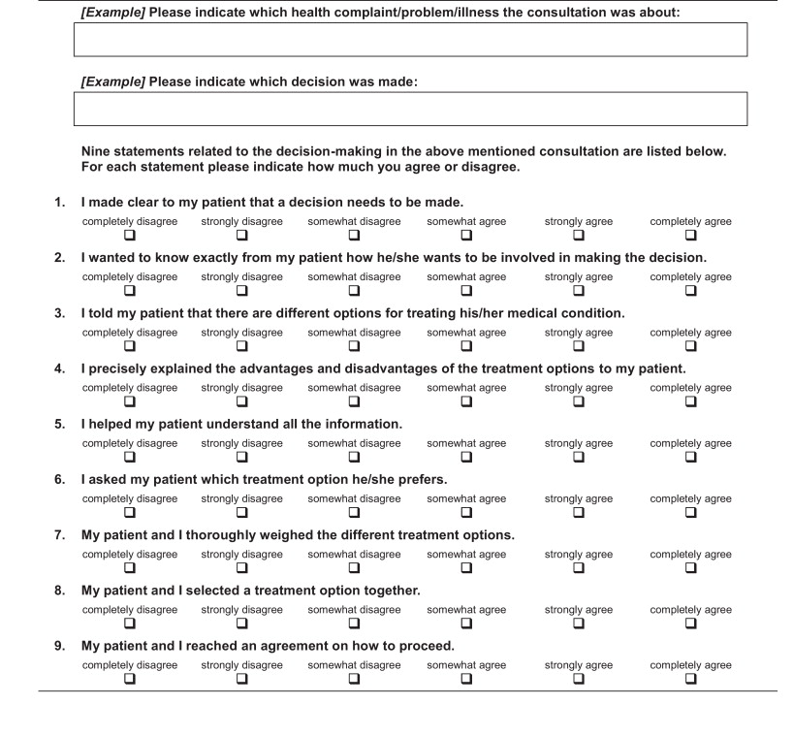
Table 2: SDM-Q-9 and SDM-Q-Doc questionnaires

