Table S1. Multivariate Cox proportional hazards model of Aspergillus and 28-day mortality
 | Hazard ratio | 95% CI | P value
Model 1 | 0.493 | 0.056 - 4.286 | 0.521
Model 2 | 1.000 | 0.999 - 1.000 | 0.311
Model 3 | 1.043 | 0.677 - 1.605 | 0.849

Note:
Models 1-3 respectively show the correlation between the relative abundance, absolute load, and logarithm of absolute load of Aspergillus and the 28-day mortality. All models were adjusted for gender, age, and immunosuppression, Underlying diseases and SOFA score.

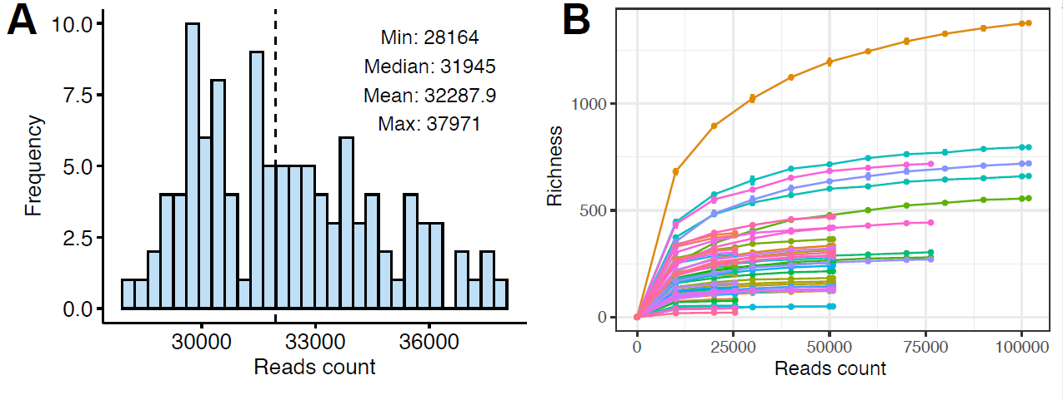

Figure S1. The distribution of read counts for the ITS sequencing data (A). The relationship between reads counts and species richness in the ITS sequencing data (B).

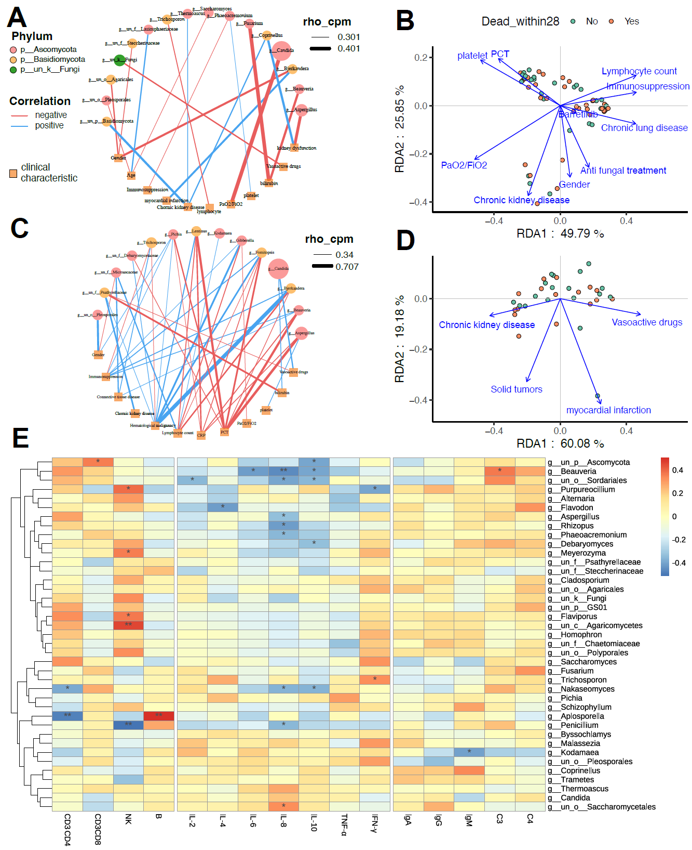
Figure S2. The association of clinical indicators with genera abundance on day 1 (A, B) and day 7 (C, D). The association between baseline immunoglobulin, complement, lymphocyte, and cytokines of patients and mycobiome on day 1 (E).

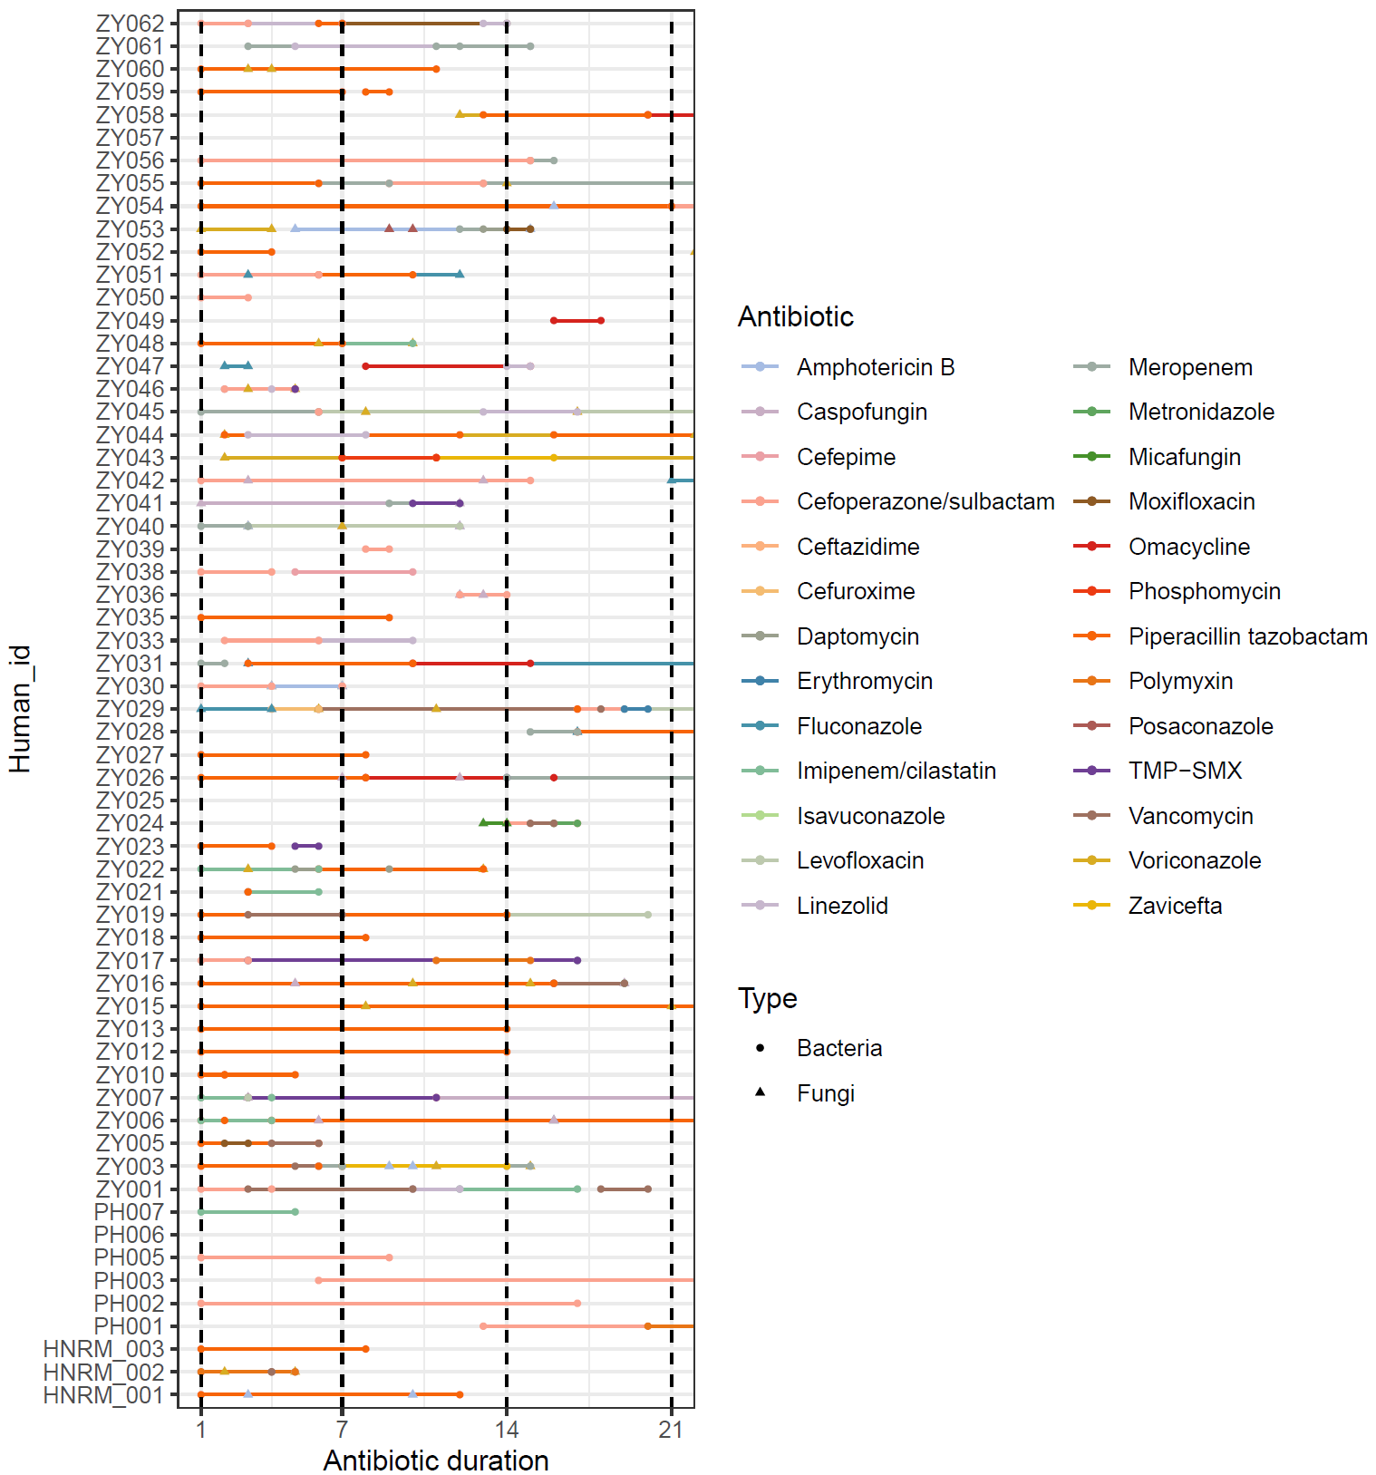
Figure S3. Landscape of antibiotic use for all patients within 21 days after enrollment.

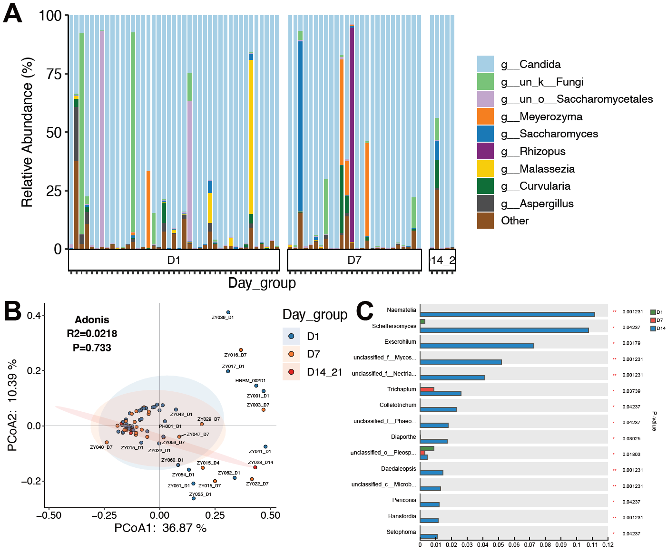
Figure S4. The relative abundances of mycobiome (A). PCoA at the genus level dissimilarities in the gut mycobiome (B). Changes in different fungal abundance at three different time points (C).

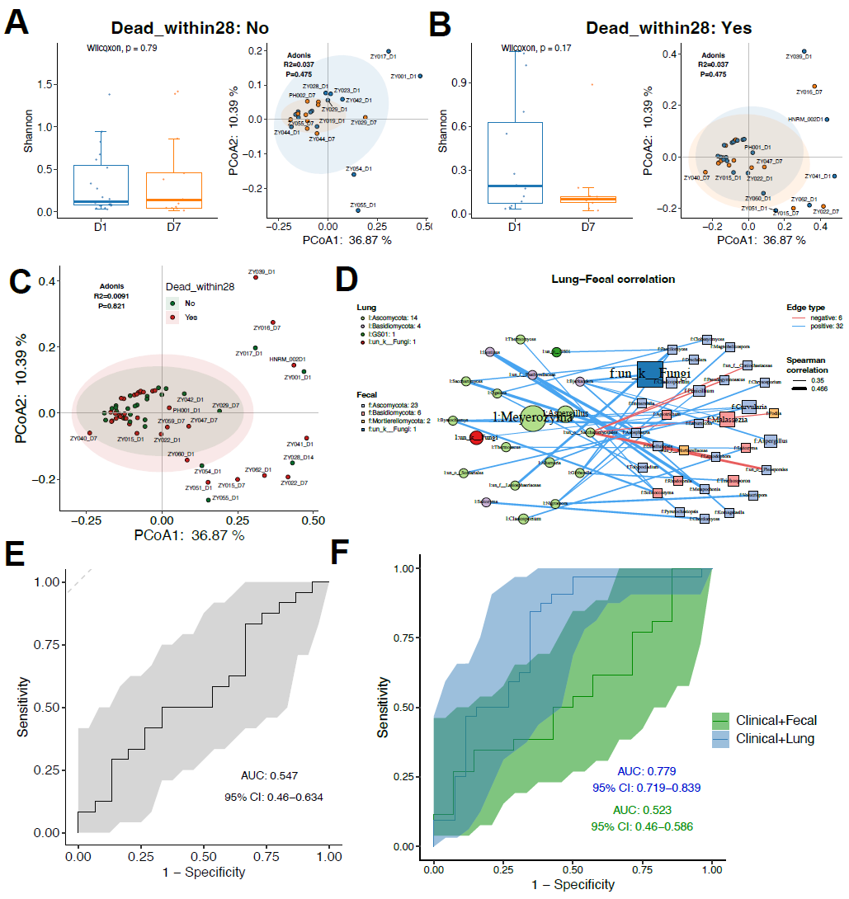
Figure S5. Comparative analysis of α and β diversity between the survival group (A) and the deceased group (B). β diversity analysis on Day 1 between patients with different outcomes (C). Association network diagrams of fungi in the gut and lung (D). ROC curve comparison in the random forest model using the gut mycobiome (E). ROC curve comparison in the random forest model using either the gut or lung mycobiome combined with clinical characteristics (F).

