Supplementary material

Supplementary Table I. Cav1 shRNAs oligonucleotides sequences.
shRNA |  | Sequence
shRNA 1 | F | CCGGCGACGTGGTCAAGATTGACTTCTCGAGAAGTCAATCTTGACCACGTCGTTTTTG
shRNA 1 | R | AATTCAAAAACGACGTGGTCAAGATTGACTTCTCGAGAAGTCAATCTTGACCACGTCG
shRNA 2 | F | CCGGGCTTCCTGATTGAGATTCAGTCTCGAGACTGAATCTCAATCAGGAAGCTTTTTG
shRNA 2 | R | AATTCAAAAAGCTTCCTGATTGAGATTCAGTCTCGAGACTGAATCTCAATCAGGAAGC
shRNA 3 | F | CCGGCCGCTTGTTGTCTACGATCTTCTCGAGAAGATCGTAGACAACAAGCGGTTTTTG
shRNA 3 | R | AATTCAAAAACCGCTTGTTGTCTACGATCTTCTCGAGAAGATCGTAGACAACAAGCGG

Supplementary Table II. qPCR oligonucleotides sequence.
Gen name |  | Sequence | Gen name |  | Sequence
Trp63 | F | CAGATTCAGAACGGCTCCTC | Jag1 | F | TGCAGAACGTGAATGGAGAG
Trp63 | R | GATGGAGAGAGGGCATCAAA | Jag1 | R | GCGGGACTGATACTCCTTGA
Krt5 | F | CATCGATTGCACCTGCTCTA | Jag2 | F | CACACCTGGAGCTGCAGATC
Krt5 | R | TCCAGCAGCTTCCTGTAGG | Jag2 | R | TTCTTTGCCCATCCAGCCAT
Foxj1 | F | GTTTCATCCACCCATGTTCC | Dll1 | F | GGTTTGTGTGTGACGAGCAC
Foxj1 | R | GTAGGACCCTTCTGGGCTTC | Dll1 | R | AGTGCAGTACTGGCCTTTCC
Mcidas | F | CAGATCAAGGCAACAACGAA
Mcidas | R | TTAGGGTCACGATTGTGCAG
Scgb1a1 | F | CATCATGAAGCTCACGGAGA
Scgb1a1 | R | AGGTGAGATGCTCGCAGTTT
Scgb3a2 | F | TTCCCTCATTTGATCCCTTG
Scgb3a2 | R | CACGTAGCAAAGGCTTCTCC
Spdef | F | CAGGGCCTGTCTGCTTTCTA
Spdef | R | CATCGATTGCACCTGCTCTA
Muc5ac | F | ACACAACCTCCTCAGTCCCT
Muc5ac | R | GTGGTAGAACTGACTGGGGC
Eif1α | F | AATGTGCTTTGACGGTGTGA
Eif1α | R | TGATTTTGGCATGTTCTGGA
Cav1 | F | ACACAGTTTCGACGGCATCT
Cav1 | R | CCCAGATGTGCAGGAAGGAG
Cav2 | F | CCATCCCCTTGGCCTTCATT
 | R | AGTTGCATGCTGACCGATGA
Cav3 | F | ACATTAAGGTGGTGCTGCGA
 | R | CCGCACCAAGTTTTCCCATC
Hes1 | F | AGTGCATGAACGAGGTGACC
Hes1 | R | TCATGGCGTTGATCTGGGTC
Hes5 | F | TCTGCGAAGTTCCTGGTCAC
Hes5 | R | GCAGTTCCGCCTTCACAAAA
Hey1 | F | GTTTGGGGTTTCGGGAATGC
Hey1 | R | TGTGTGGGTGATGTCCGAAG
Hey2 | F | ACAGTGCCCTTTGGAAACCA
Hey2 | R | GAGGCTCTGGTGGAATTGCT
Notch1 | F | CACCTGCAGGCAAGATGTTA
 | R | AGTTCACAGTGGGGACCAGT
Notch2 | F | ATCTCATCCCTGCGAAAATG
 | R | GGCATCTGTAGGAACCAGGA

Supplementary Figure 1
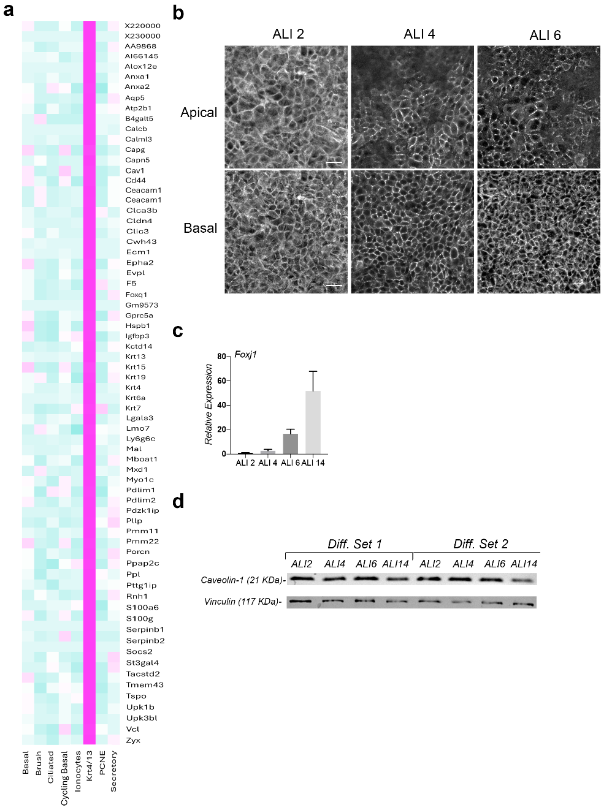
Supplementary Figure 1: Characterization of Gene and Protein Expression During Airway Epithelial Cell Differentiation.
- Heatmap for genes with an average expression of at least 1 count/cell in KRT4/13, more than double the expression in all other cell types. (b) Maximal projection of confocal images of caveolin-1 expression in apical and basal strata at the onset of the differentiation process (ALI 2, ALI 4 and ALI 6). (c) Relative expression of Foxj1 used as a marker for proper airway cell differentiation. (d) Western blot images for caveolin-1 protein levels assayed during the differentiation process at ALI 2, ALI 4, ALI 6, and ALI 14. Vinculin was assayed as a loading control. Scale bar in panel b represent 20 μm.

Supplementary Figure 2
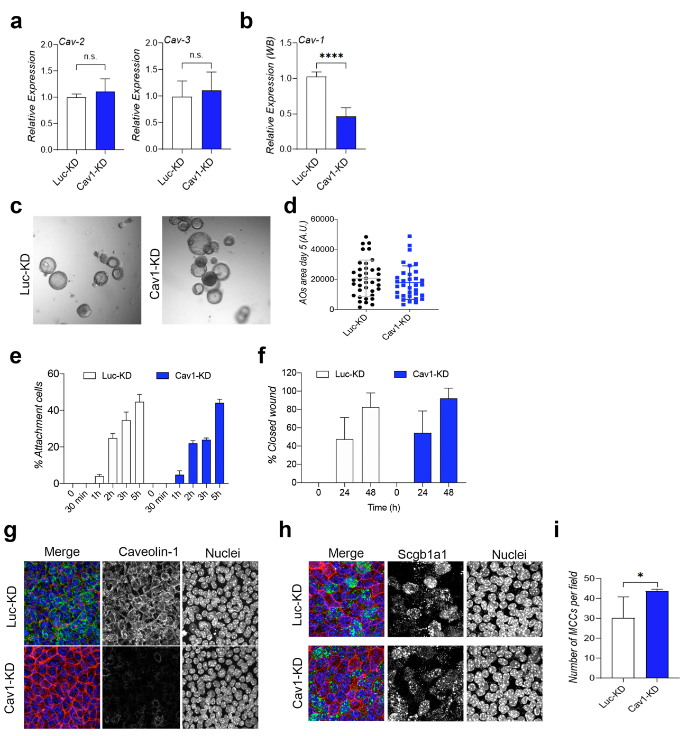

Supplementary Figure 2: Impact of Caveolin-1 Knockdown on Cell Adhesion, Migration, and Differentiation in Airway Epithelial Cells
- Caveolin-2 (Cav-2) and Caveolin-3 (Cav-3) mRNA expression levels in Luc-KD and Cav1-KD in BSCs. (b) Relative protein expression levels quantification of caveolin-1. (c) Representative images of AOs development in Luc-KD and Cav1-KD cells. (d) AOs size quantification (A.U.) at 5 days. (e) Cell adhesion percentage in Luc-KD and Cav1-KD cells. (f) Migration percentage in Luc-KD and Cav1-KD cells. (g) Maximal projection of confocal images in Luc-KD and Cav1-KD differentiated cells for caveolin-1 in green, phalloidin in red, and nucleus in blue to confirm the low expression of caveolin-1 in Cav1-KD cells. (h) Maximal projection of confocal images in Luc-KD and Cav1-KD differentiated cells for Scgb1a1 in green, phalloidin in red, and nucleus in blue. (i) Quantification of the number of MCCs per field in Luc-KD and Cav1-KD cells. p-values in all conditions were obtained using two-tailed t-test (**** represents p<0,0001 * represents p<0,05 and n.s. means no significative differences).

Supplementary Figure 3
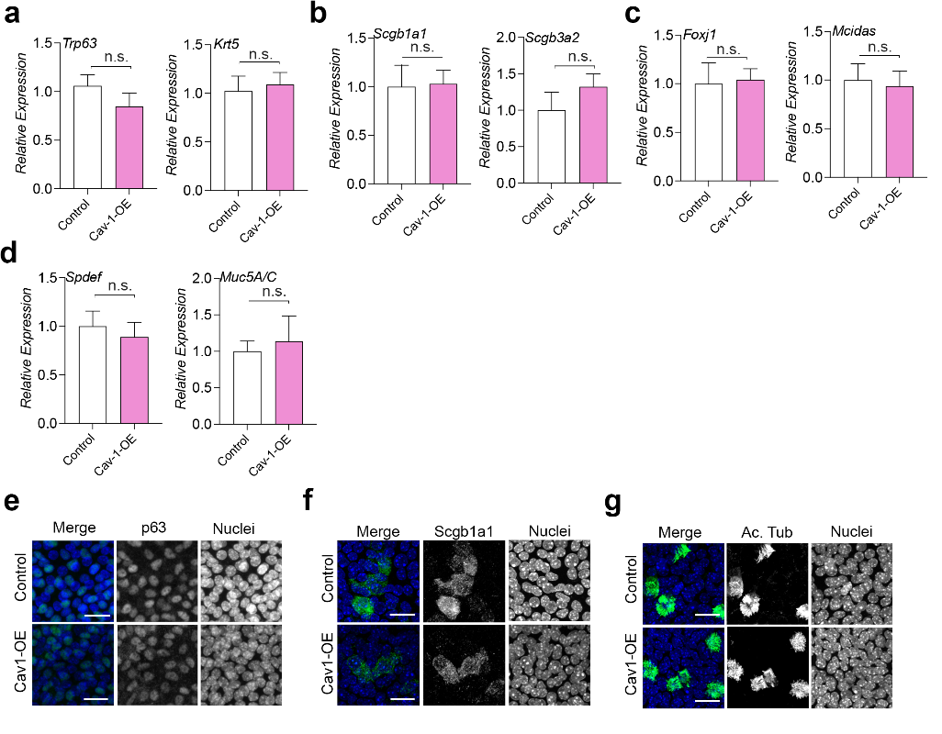
Supplementary Figure 3: Differential mRNA expression and confocal imaging analysis in Caveolin-1 overexpressing cells.
(a-d) mRNA expression levels in control versus Cav1-OE (Caveolin1 overexpression). Trp63 and Krt5 for BScs (a), Scgb1a1 and Scgb3a2 for CCs (b), Spdef and Muc5ac for GCs (c), and Foxj1 and Mcidas for MCCs (d). (e-g) Maximal projection of confocal images in Luc-KD and Cav1-OE differentiated cells for p63 (e), Scgb1a1 (f) and Acetylated tubulin (Ac. Tub) (l) in green, and nucleus in blue. Scale bar in panels e, f and g represent 20 μm. p-values in all conditions were obtained using two-tailed t-test (n.s. means no significative differences).

Supplementary Figure 4
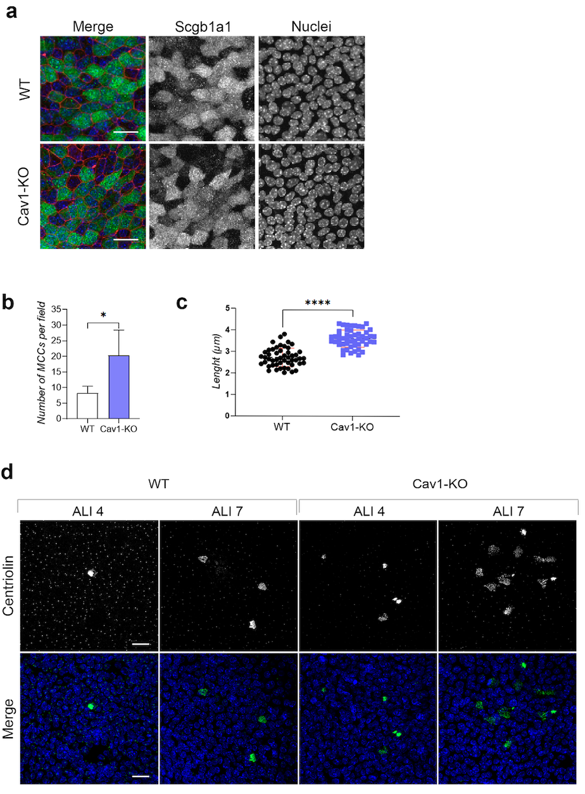
Supplementary Figure 4: Confocal imaging and quantitative analysis of differentiated cells in wild-type and Caveolin-1 knockout conditions. (a) Maximal projection of confocal images in WT and Cav1-KO differentiated cells for Scgb1a1 in green, phalloidin in red and nucleus in blue. (b) Quantification of MCCs per field of view in WT and Cav1-KO cultures. (c) Quantification of cilia length in WT and Cav1-KO. (d) Centriolin immunofluorescence in control (WT) and Cav1-KO cells in ALI 4 and ALI 7 showing the different stages of multiciliated cells. Scale bar in panels a and d represent 20 μm. p-values in all conditions were obtained using two-tailed t-test (**** represents p<0,0001 and * represents p<0,05).

Supplementary Figure 5
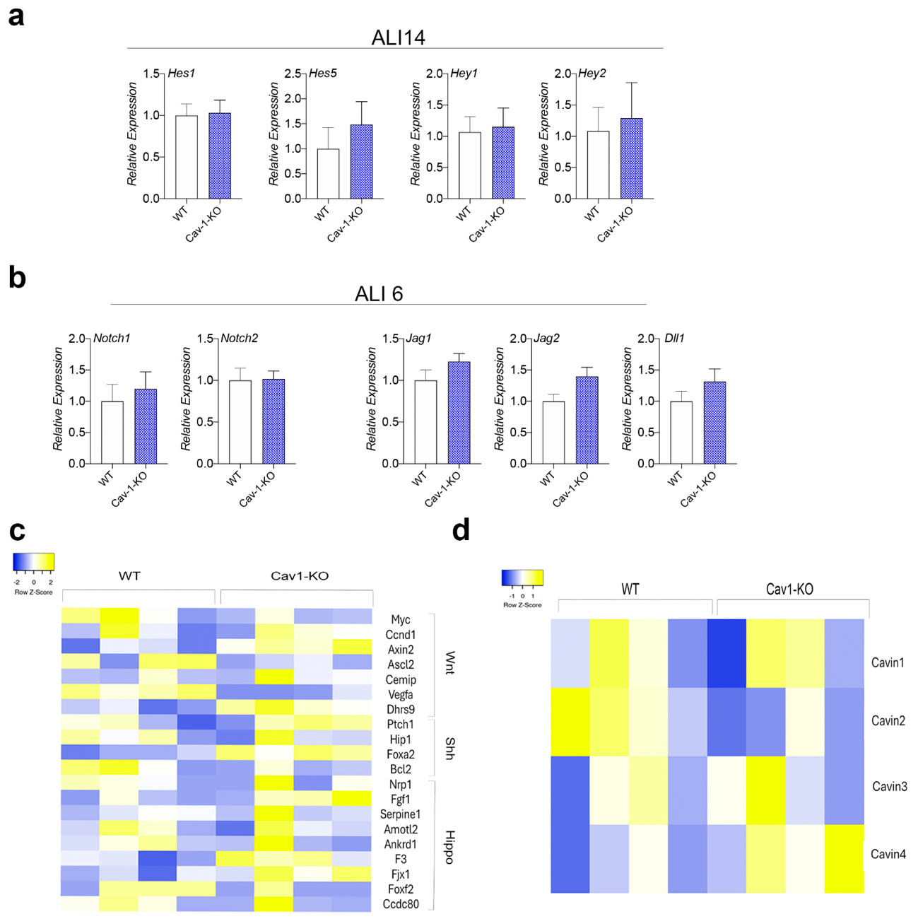

Supplementary Figure 5: Gene expression analysis in wild-type and Caveolin1 knockout cells. (a) Principal NICD target genes (Hes1, Hes5, Hey1 and Hey2) mRNA expression levels in wild-type (WT) versus Cav1-KO in ALI 14. (b) mRNA expression levels in WT versus Cav1-KO in ALI 6 for a gene list related to the Notch receptor (Notch1 and Notch2) and Notch ligands (Jag1, Jag2 and Dll1). (c) Heat map of gene expression in WT and Cav1-KO cells in ALI 6 for signaling pathways targets. (d) Heat map of gene expression in WT and Cav1-KO cells in ALI 6 for Cavin1, Cavin2, Cavin3 and Cavin4.

Supplementary Figure 6
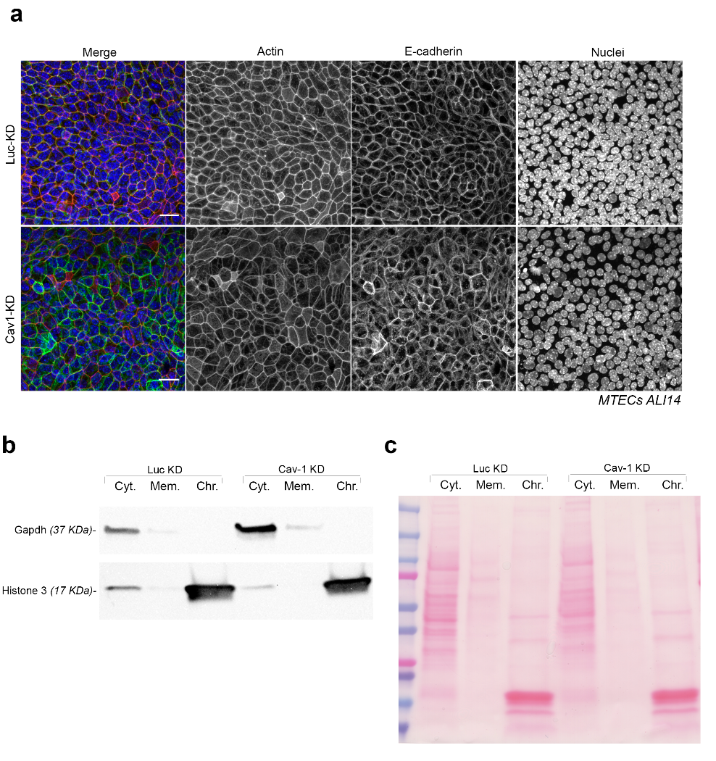
Supplementary Figure 6: Confocal imaging and subcellular distribution analysis in control and Caveolin1 knockdown cells.
(a) Maximal projection of confocal images for E-Cadherin1 (in green), actin (in red) and nucleus (in blue) in control and Cav1-KD cells in ALI 14. (b) Analysis of Gapdh and Histone 3 subcellular distribution in the cytosol (Cyt.), membrane (Mem.), and chromatin (Chr.) fractions of control and Cav1-KD cells. (c) Image of the transferred membrane stained with Ponceau S to visualize homogeneous loading across experimental conditions. Scale bar in panels a represent 20 μm.

