Supporting Information

Isolated Single-Atomic Cu Catalyst Supported on P-doped Carbon for Hydrochlorination of Acetylene

Ting Wangª, Zhao Jiangª, Qi Tangª, Bolin Wang^{a,b}, Saisai Wangª, Mingde Yuª, Renqin Chang^{a,c}, Yuxue Yueª, Jia Zhao^{a,}*, Xiaonian Li^{a,}*

ª Industrial Catalysis Institute of Zhejiang University of Technology, Hangzhou, 310014, People’s Republic of China
^{b} College of Environment, Zhejiang University of Technology, Hangzhou, 310014, People’s Republic of China
^{c} Research Center of Analysis Measurement, Zhejiang University of Technology,
Hangzhou, 310014, People’s Republic of China
* Corresponding author. Tel: +86 571 88871656. E-mail: jiazhao@zjut.edu.cn (Jia Zhao)
* Corresponding author. Tel: +86 571 88320002. E-mail: xnli@zjut.edu.cn (Xiaonian Li)

Table S1 C, Cu, P and O contents determined by XPS and EDS analysis over different samples.
Sample | XPS  (wt.%) |  |  |  | EDS  (wt.%)
Sample | C | P | Cu | O | C | P | Cu | O
Cu/PC200 | 51.00 | 13.20 | 8.17 | 27.63 | 55.51 | 12.06 | 10.41 | 22.02
Cu/PC400 | 46.00 | 13.81 | 9.17 | 31.02 | 54.04 | 12.38 | 8.14 | 25.44
Cu/PC600 | 56.72 | 11.58 | 8.39 | 23.32 | 57.06 | 11.81 | 9.88 | 21.25
Cu/PC800 | 76.51 | 5.25 | 9.33 | 8.91 | 74.95 | 6.32 | 10.37 | 8.36

Table S2 Textural properties of the phosphorus-doped carbon materials.
Sample | S_{BET} (m² g⁻¹) ª | Volume (cm⁻³ g⁻¹) ^{b} | Diameter (nm) ^{c}
AC | 1204 | 0.61 | 2.03
PC200 | 186 | 0.12 | 2.40
PC400 | 203 | 0.13 | 2.36
PC600 | 910 | 0.47 | 2.04
PC800 | 1005 | 0.58 | 2.19
ª measured using the Brunauer-Emmett-Teller (BET) method; ^{b} calculated dependent on the adsorbed N₂ volume; ^{c} determined by Barrett-Joyner-Halenda (BJH) method.

Table S3 X-ray photoelectron spectroscopy (XPS) data of Cu 2p spectra of fresh P-doped Cu-based catalysts from this work.
Sample | Cu⁺/Cu⁰ ª |  |  | Cu²⁺ ª
Sample | Position/  eV | FWHM^{b}/  eV | Area/  % | Position/  eV | FWHM^{b}/  eV | Area/  %
Cu/PC200 | 932.4 | 2.25 | 71.4 | 934.6 | 2.91 | 28.6
Cu/PC400 | 932.4 | 2.20 | 67.7 | 934.5 | 2.91 | 32.3
Cu/PC600 | 932.4 | 2.15 | 64.9 | 934.5 | 3.22 | 35.1
Cu/PC800 | 932.3 | 2.15 | 27.4 | 934.6 | 2.41 | 72.6
ª based on reference values; ^{b} FWHM = full width at half maximum.

Table S4 X-ray photoelectron spectroscopy (XPS) data of Cu XAES spectra of fresh P-doped Cu-based catalysts from this work.
Sample | Cu⁰ ª |  |  | Cu⁺ ª
Sample | Position/  eV | FWHM^{b}/  eV | Area/  % | Position/  eV | FWHM^{b}/  eV | Area/  %
Cu/PC200 | 918.6 | 3.78 | 19.2 | 916.6 | 4.13 | 52.2
Cu/PC400 | 918.6 | 3.61 | 14.1 | 916.6 | 4.21 | 53.6
Cu/PC600 | 918.7 | 3.63 | 10.0 | 916.6 | 4.22 | 54.9
Cu/PC800 | 918.6 | 3.61 | 3.6 | 916.6 | 4.28 | 23.8
ª based on reference values; ^{b} FWHM = full width at half maximum.

Table S5 X-ray photoelectron spectroscopy (XPS) data of P 2p spectra of fresh P-doped Cu-based catalysts from this work.
Sample | P-C ª |  |  | P-O ª |  |  | P=O ª
Sample | Position/  eV | FWHM^{b}/  eV | Area/  % | Position/  eV | FWHM^{b}/  eV | Area/  % | Position/  eV | FWHM^{b}/  eV | Area/  %
Cu/PC200 | 133.0 | 1.32 | 15.6 | 134.2 | 1.77 | 71.2 | 135.2 | 1.94 | 13.2
Cu/PC400 | 133.0 | 1.50 | 27.4 | 134.3 | 1.96 | 59.9 | 135.2 | 1.96 | 12.7
Cu/PC600 | 133.1 | 1.28 | 33.7 | 134.1 | 1.63 | 54.5 | 135.1 | 1.96 | 11.8
Cu/PC800 | 133.0 | 1.52 | 41.6 | 134.3 | 1.60 | 48.3 | 135.1 | 1.95 | 10.1
ª based on reference values; ^{b} FWHM = full width at half maximum.

Table S6 X-ray photoelectron spectroscopy (XPS) data of O 1s spectra of fresh P-doped Cu-based catalysts from this work.
Sample | P=O ª |  |  | P-O-Cu ª
Sample | Position/  eV | FWHM^{b}/  eV | Area/  % | Position/  eV | FWHM^{b}/  eV | Area/  %
Cu/PC200 | 531.5 | 1.62 | 29.6 | 532.7 | 2.29 | 70.4
Cu/PC400 | 531.3 | 1.80 | 28.2 | 532.5 | 2.60 | 71.8
Cu/PC600 | 531.4 | 1.73 | 26.2 | 532.6 | 2.40 | 73.8
Cu/PC800 | 531.3 | 1.66 | 25.3 | 532.6 | 2.48 | 74.7
ª based on reference values; ^{b} FWHM = full width at half maximu

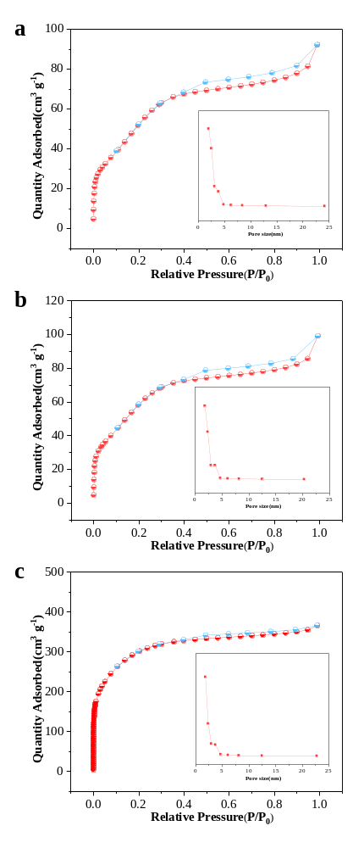
Fig. S1 N₂ gas adsorption / desorption isotherms of (a) PC200, (b) PC400 and (c) PC600.

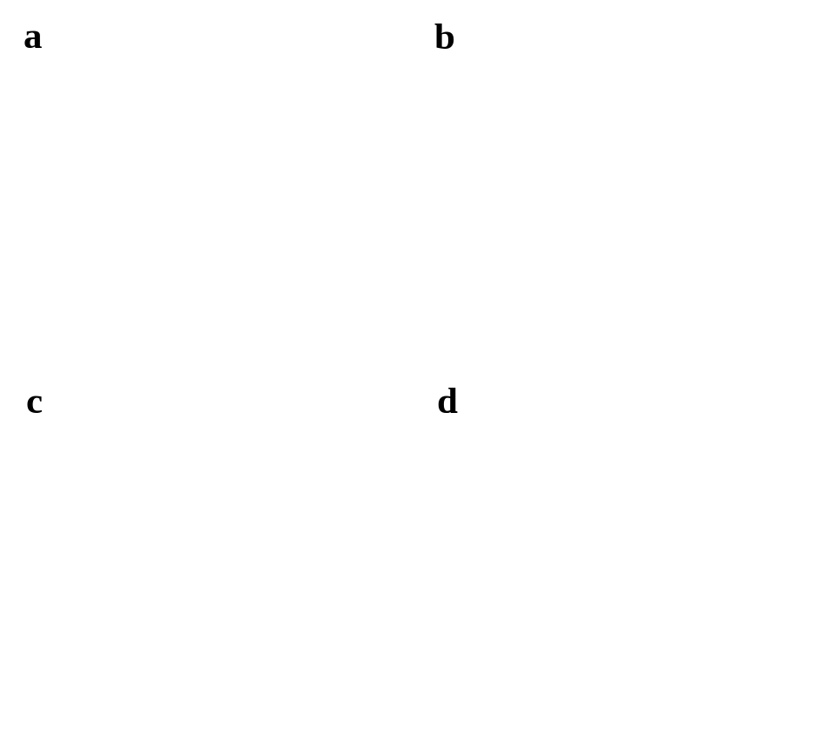
Fig. S2 HRTEM image of (a) Cu/PC200, (b) Cu/PC400, (c) Cu/PC600 and (d) Cu/PC800 catalysts.

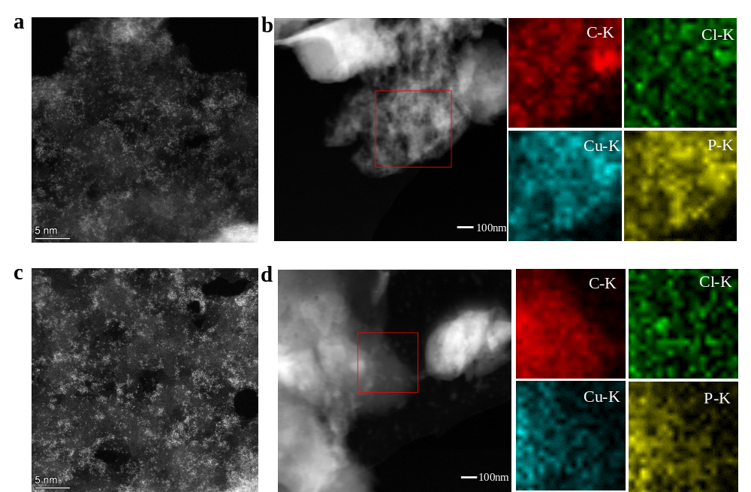
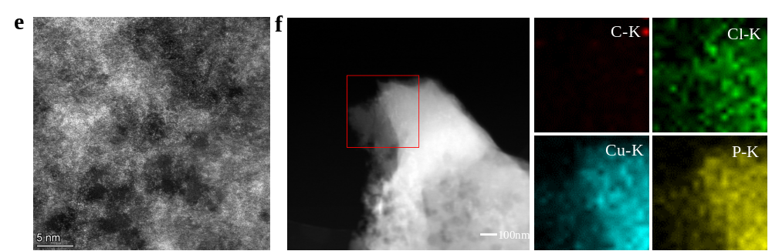
Fig. S3 (a) Representative HAADF-STEM images and (b) EDS elemental mapping of fresh Cu/PC200, (c) Representative HAADF-STEM images and (d) EDS elemental mapping of fresh Cu/PC400, (e) Representative HAADF-STEM images and (f) EDS elemental mapping of fresh Cu/PC600.

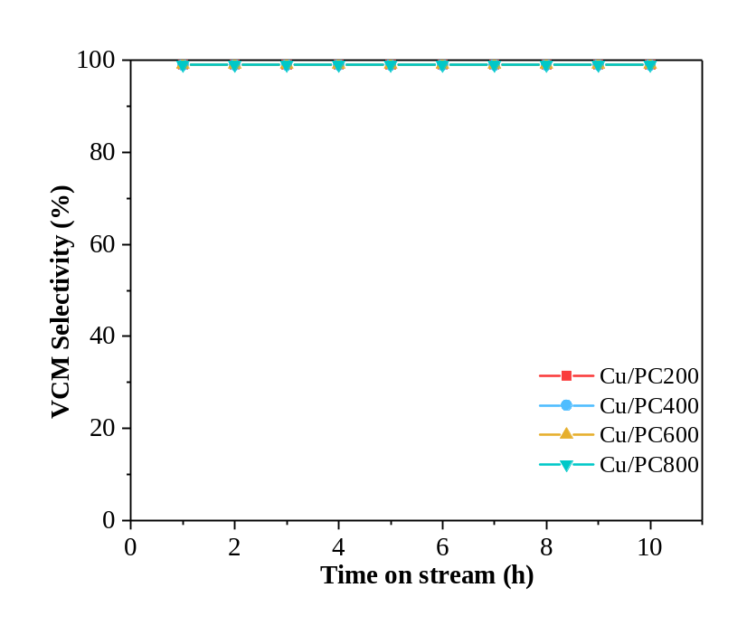
Fig. S4 Selectivity to VCM over P-doped Cu-based catalysts.

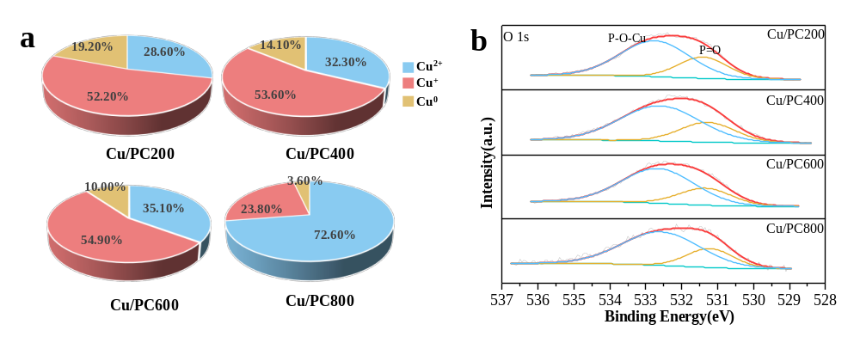
Fig. S5 (a) Corresponding-Cu contents and (b) O 1s XPS spectra of fresh P-doped Cu-based catalysts.

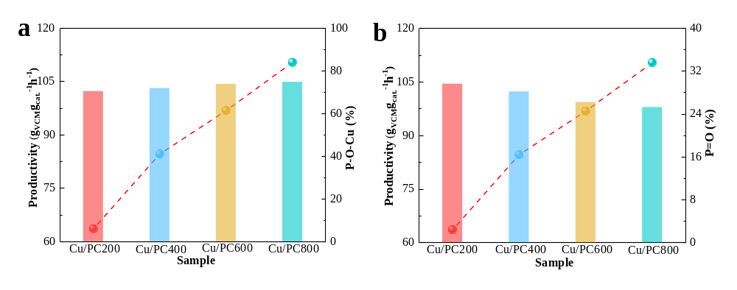
Fig. S6 Correlation diagram of (a-b) oxygen species content and productivity.

Fig. S7 (a) Structure and coordinate of C₁₃H₉ cluster, (b-f) optimized configurations of C₂H₂ adsorption on (b) C₃P, (c) P=O, (d) (OH)₂P=O, (e) P(OH)₂, (f) (OH)P=O, respectively.

