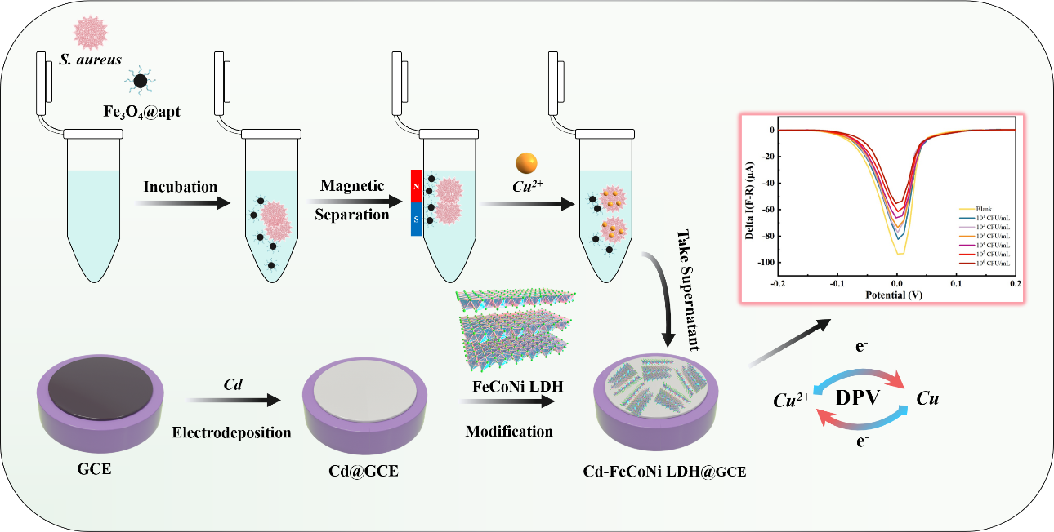
Scheme 1 Schematic illustration. Construction of the electrochemical biosensor for S. aureus detection based on the microbial adsorption effect of Cu²⁺ and Cd-FeCoNi LDHs.

