Supporting Information
Boosted electrocatalytic activity on FeCoNi layered double hydroxide incorporating Cd deposition for label-free detection of Staphylococcus aureus via its biosorption of Cu²⁺ ions
Huamin Zhaoª, Xiaoxi Zhengª, Jihao Su^{b}, Jun Wang ª, Xinrui Wangª, Hang Li^{a*}, Juan Wang^{a*}, Kexin Shen^{c*}, Chao Zhao^{a*}
ª School of Public Health, Jilin University, Changchun, 130021, China,
^{b} College of Physics, Qingdao University, Qingdao, 266071, China,
^{c} China-Japan Union Hospital of Jilin University, 130021, China.
* Email: lihang21@mails.jlu.edu.cn (H. Li), jwang0723@jlu.edu.cn (J. Wang), shenkexin1314@jlu.edu.cn (K. Shen), czhao0529@jlu.edu.cn (C. Zhao).

Contents
Tables
Table S1 Bacterial strains employed in this work
Table S2 An overview for electrochemical detection of S. aureus
Figures
Fig. S1 SEM images of bimetallic LDHs
Fig. S2 FTIR and XRD spectra of LDHs
Fig. S3 SEM images of Cd deposite
Fig. S4 Optimization of the DPV current response to Cu²⁺
Fig. S5 Long-term stability
Fig. S6 TEM image of MNPs
Fig. S7 Magnetic measurements
Fig. S8 FTIR spectra of S. aureus and Cu²⁺-treated S. aureus
Fig. S9 Optimization of experimental conditions for the electrochemical sensing of S. aureus
Text
Experimental section
References

Tables
Table S1 Bacterial strains employed in this work.
Bacteria | Abbreviation | ATCC No.
Staphylococcus aureus | S. aureus | 25923
Salmonella typhimurium | S. typhimurium | 13311
Listeria monocytogenes | L. monocytogenes | 19111
Escherichia coli O157:H7 | E. coli O157:H7 | 35150
Vibrio parahaemolyticu | V. parahemolyticus | 17802
Shigella flexneri | S. flexneri | 12022

Table S2 An overview for electrochemical detection of S. aureus.
Substrate | Assay type | Detection range (CFU/mL) | LOD (CFU/mL) | Reference
AgNPs | DPV | 10¹-10⁶ | 1 | ¹
Gold electrode | EIS | 10¹-10⁴ | 10 | ²
rGO-AuNP/GCE | EIS | 10¹-10⁶ | 10 | ³
SWCNTs/SPE | DPV/CV | 10¹-10⁷ | 13 | ⁴
Cd/FeCoNi LDH | DPV | 10⁰-10⁶ | 5 | This work

Figures
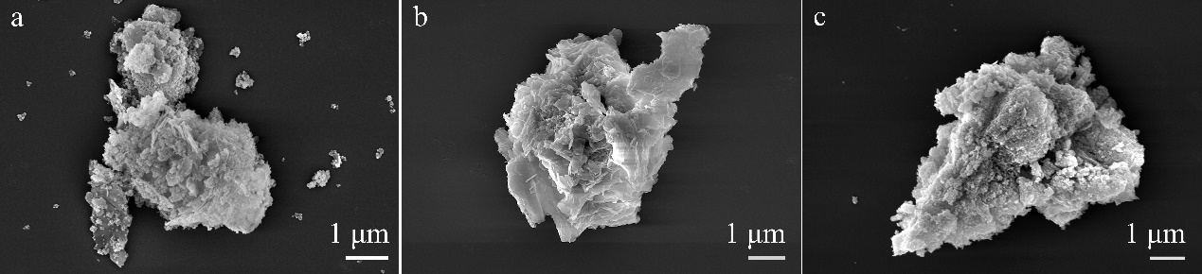
Fig. S1 SEM images of bimetallic LDHs. (a) FeNi LDH, (b) CoNi LDH and (c) FeCo LDH.
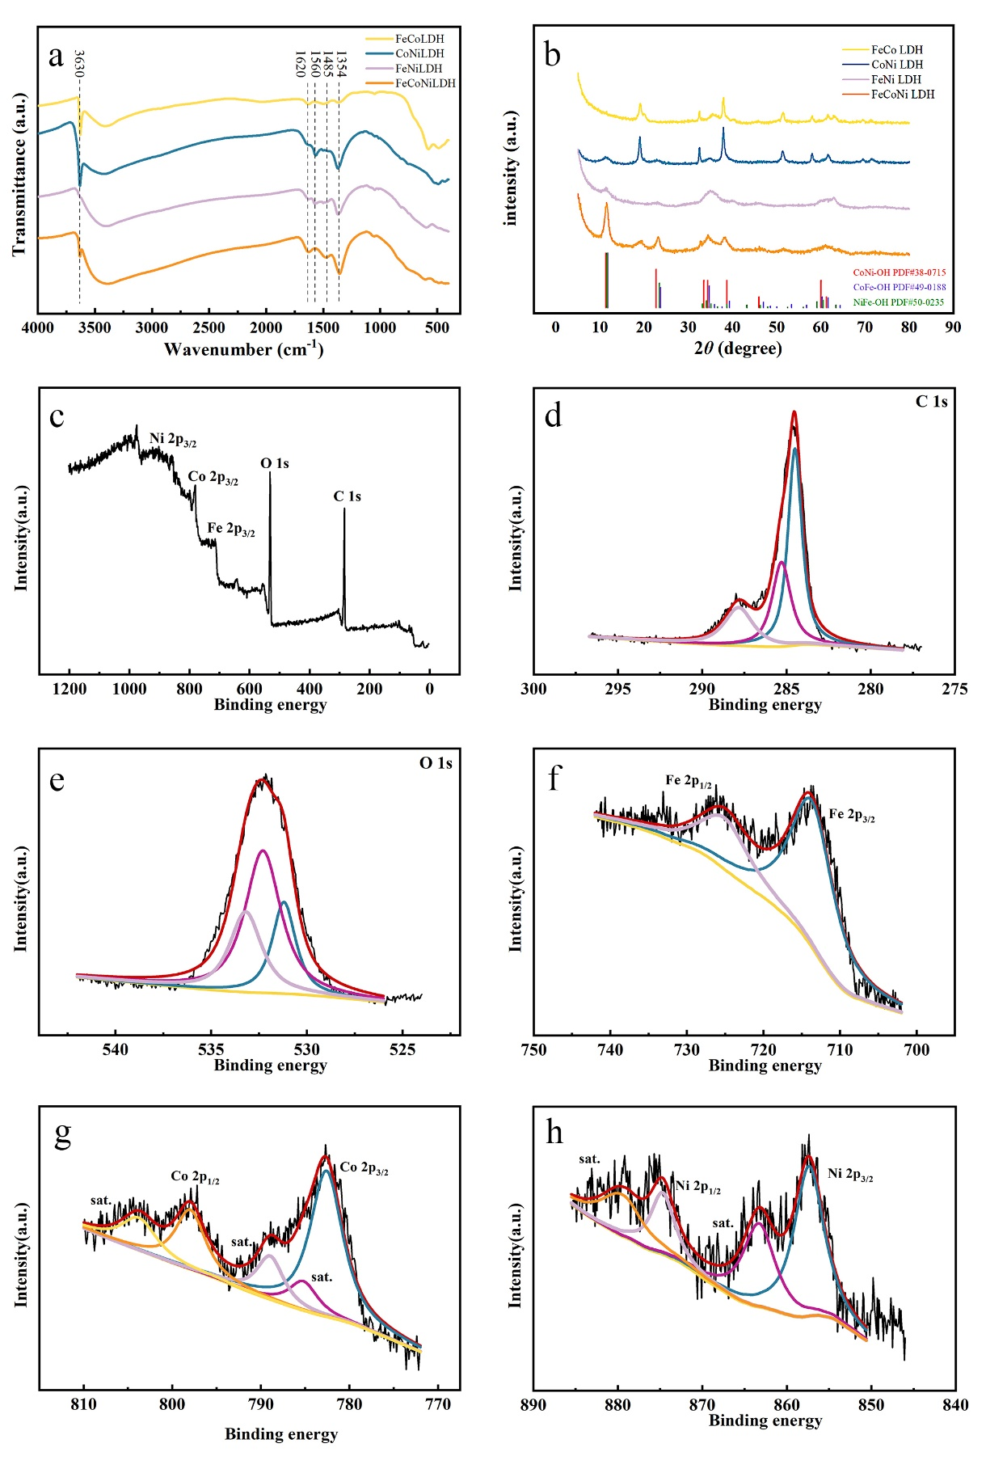
Fig. S2 The characterization of chemical composition of LDHs. (a) FTIR and (b) XRD spectra of LDHs. XPS spectra of (c) FeCoNi LDH, (d) C 1s, (e) O 1s, (f) Fe 2p, (g) Co 2p and (h) Ni 2p.

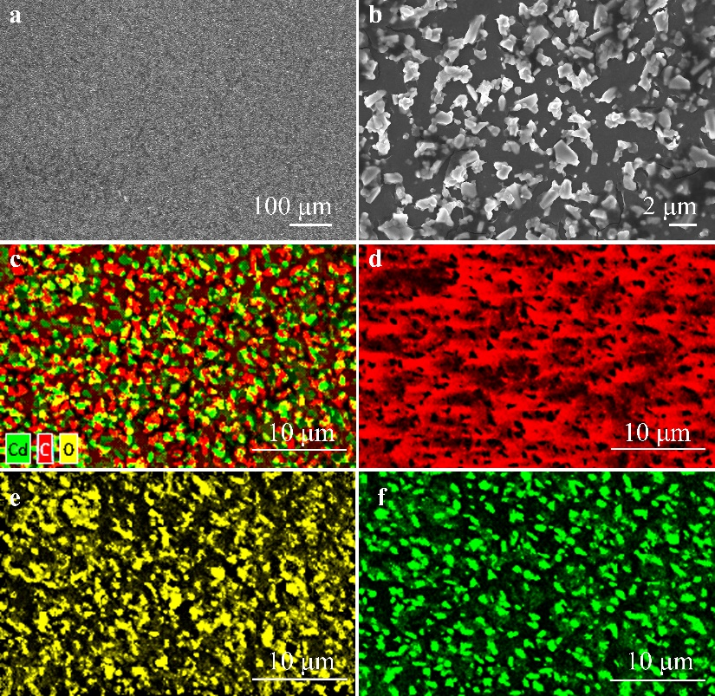
Fig. S3 SEM and EDS mapping of Cd deposite. SEM images at different scales, (a) 100 μm, (b) 2 μm. EDS elemental mapping of (a) Cd deposite, (b) C, (c) O and (d) Cd.

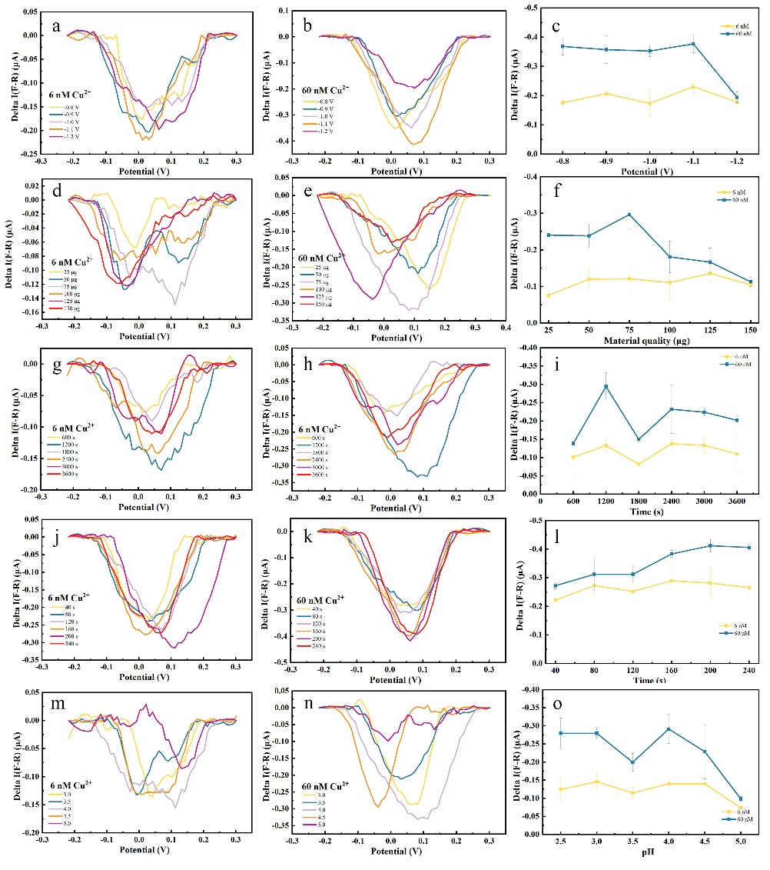
Fig. S4 Optimization of the DPV current response to 6 nM and 60 nM Cu²⁺ for Cd/FeCoNi LDH-modified electrodes. (a-c) Anodic preconcentration voltage for Cu²⁺; (d-f) electrode material modification mass; (g-i) Cd electrodeposition time; (j-l) anodic preconcentration time for Cu²⁺; and (m-o) pH of HAc/NaAc buffer solution. The optimal detection conditions are: -1.1 V of preconcentration voltage, 75 μg of FeCoNi LDH for electrode modification, 1200 s of the electro-deposition time of Cd, 160 s of preconcentration time and pH=4 of acetic acid buffer.

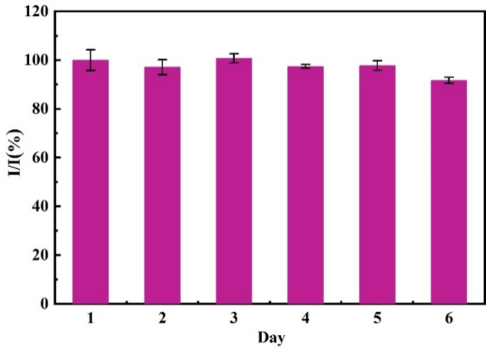
Fig. S5 Long-term stability. The DPASV signal of the Cd-FeCoNi LDH-modified electrode to 5 mM Cu²⁺ was recorded under optimal conditions.

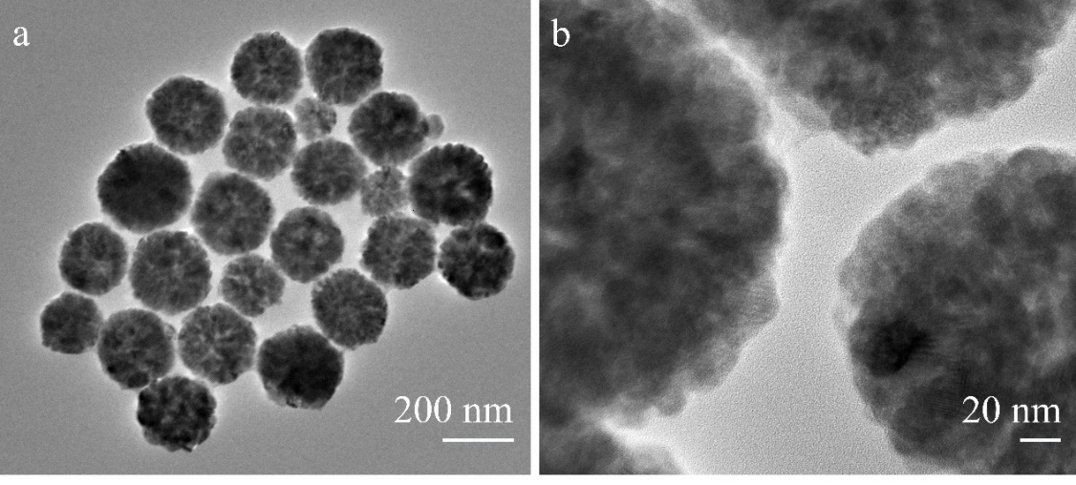
Fig. S6 TEM image of MNPs at different scales. (a) 200 nm, (b) 20 nm. The as-synthesized Fe₃O₄ NPs showed a spherical morphology with sizes ranging from 100 to 200 nm. The enlarged image revealed the rough surface on the nanoparticles, providing more binding sites for aptamer.

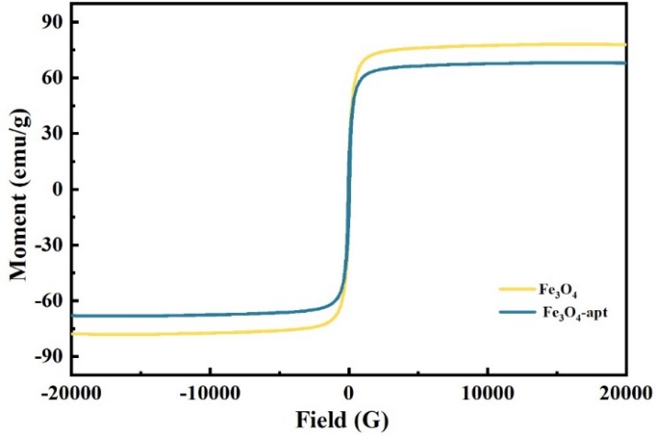
Fig. S7 Magnetic measurements of MNPs (yellow curve), MNPs@apt (blue curve). MNPs and MNPs@apt showed good magnetic responsiveness with the saturation magnetization of 77.99 and 68.11 emu/g, respectively.

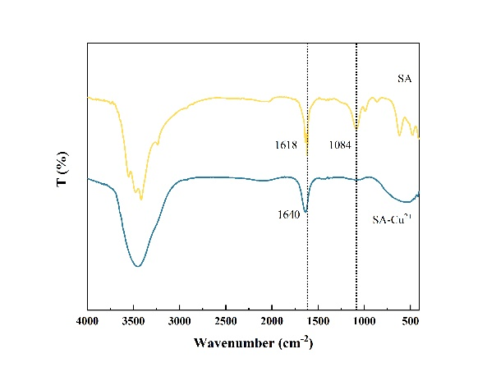
Fig. S8 FTIR spectra of S. aureus (yellow curve) and Cu²⁺-treated S. aureus (blue curve).

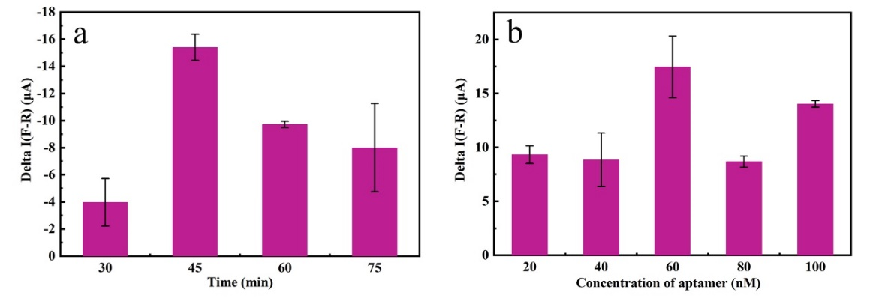
Fig. S9 Optimization of experimental conditions for the electrochemical sensing of S. aureus. (a) Cu²⁺ adsorption time, (b) the concentration of aptamer functionalized on the MNPs. The key experimental factors including the concentration of aptamer and the adsorption time of Cu²⁺ were explored. 10² CFU/ml of S. aureus was used to evaluate of the impact of experimental factors on the detection performance including the concentration of aptamer and the adsorption time of Cu²⁺. The findings indicated that the best detection parameters consisted of preparing the probes with the aptamer concentration of 60 nM and allowing a 45-minute Cu²⁺ adsorption per assay.

Text

Experimental section

Materials and reagents
Cadmium chloride hydrate (CdCl₂·2.5H₂O), Nickel chloride hexahydrate (NiCl₂·6H₂O), N-Hydroxysuccinimide (NHS) were bought from Sigma Company (USA). Ferric chloride hexahydrate (FeCl₃·6H₂O) and trisodium citrate dihydrate were purchased from Tianjin Damao Chemical Institute (Tianjin, China). Copper(II) chloride dihydrate (CuCl₂·3H₂O), potassium nitrate (KNO₃), potassium ferricyanide (K₃Fe(CN)₆), 1-Hydroxy-2,5-pyrrolidinedione (NHS), 1-(3-Dimethylaminopropyl)-3-ethylcarbodiimide (EDC) were bought from Aladdin Chemistry Co. Ltd. (Shanghai, China). Phosphate buffered saline (PBS buffer) was obtained from Sangon Biotechnology Co. Ltd. (Shanghai, China). Cobaltous nitrate hexahydrate (Co(NO₃)₂·6H₂O) was bought from Macklin Company (Shanghai, China). Aluminium oxide (Al₂O₃) was bought from Ecc Detecting Instroments Co. Ltd. (Shanghai, China). Ethanol absolute, ethylene glycol, N, N-Dimethylformamide (DMF) were bought from Jindong Tianzheng Precision Chemical Reagent Factory (Tianjin, China). Acetic acid/sodium acetate buffer and sodium chloride (NaCl) were purchased from Beijing Dingguo Changsheng Biotechnology Co., Ltd. (Beijing, China). Formaldehyde solution was purchased from Beijing Chemical Factory (Beijing, China). Sodium hydroxide (NaOH) was bought from Tiantai Precision Chemical Reagent Factory (Tianjin, China). The sequence of S. aureus aptamers was 5′-NH₂-(CH₂)6- CAC ACC GCA GCA GTG GGA ACG TTT CAG CCA TGC AAG CAT CAC GCC CGT -3′ and synthesized by Sangon Biotechnology Co. Ltd. (Shanghai, China). All chemicals and reagents employed were of analytical grade and were used without any further purification.

Apparatus
The X-ray diffraction (XRD) measurement in the range of 10°-80°(2θ) was performed on the DX-2700B X-ray diffractometer (Cu Kα radiation, λ = 1.5416 A). The microscopic morphology and crystal structure of the sample were analyzed by field emission electron microscope (SEM). The composition of the elements can be known by X-ray energy spectrum (EDS) analysis and element distribution diagram. Transmission electron microscopy (TEM) images of nanoparticles were performed on a JEM-2100F transmission electron microscope operated at an accelerating voltage of 200 kV. The zeta potential measurements were determined using a NanoBrook 90Plus Zeta. Magnetic hysteresis loops were measured with a 7410 vibrating sample magnetometer. The FT-IR measurements were conducted using a Bruker Vertex 70 spectrometer over the range of 4000-400 cm-1.

Bacteria culture
All the bacterial strains listed in Table S1 were stored at -80 °C with 15% glycerol and revived on Luria-Bertani (LB) agar plates. They were cultivated in ordinary LB medium at 37 °C for 18 h-24 h with shaking at 180 rpm except for the high salt medium for V. parahaemolyticus strain. Subsequently, the cultures were harvest at the exponential growth phase by centrifuging at 4000 rpm for 15 minutes at room temperature. 100 μL of the diluted suspensions was plated onto agar plates by spread plating, and bacterial counts were assessed and reported as cfu per mL (CFU/mL).

Synthesis of nanomaterials
Synthesis of magnetic Fe₃O₄ nanoparticles(MNPs)
The magnetic Fe₃O₄ nanoparticles (MNPs) were synthesized through a solvothermal method according to a previous study⁵. Briefly, 1.35 g FeCl₃•6H₂O and 3.6 g NaAc were dissolved in 40 mL ethylene glycol under ultrasonic condition. The obtained homogeneous dark yellow solution was transferred to a 100 mL Teflon-lined stainless-steel autoclave. Afterwards, the autoclave was sealed and maintained at 200 °C for 16 h. After cooling to room temperature naturally, the black products were magnetically separated, washed three times with deionized water and absolute ethanol, respectively. Finally, the products were collected using a permanent magnet and then dried in vacuum at 60 °C for 12 h.
Synthesis of Aptamer-Funtionalized MNPs (MNPs@apt)
The MNPs were conjugated with aptamer through EDC/NHS coupling chemistry ⁶. 1 mL MNPs (5 mg/mL) was treated with 10 mg EDC and 5 mg NHS at room temperature with continuous stirring for 30 minutes. Subsequently, the supernatant was removed by magnetic separation and the precipitated was washed three times with PBS. Then 100 μL aptamer (10 μM) against S.aureus was added and suspended overnight at room temperature. The final magnetic product was washed with PBS.

Calculation of electroactive surface area
Utilizing the Randles–Ševcík equation (Eq. (1)) ⁷, the electroactive surface area (A) of the modified electrodes can be calculated.
$i_{p}=\left(2.69×{10}^{5}\right)n^{3/2}D^{1/2}v^{1/2}AC$ (1)
where i_{p}, n, D, υ, A, and C denote the peak current, the number of transferred electron, the diffusion coefficient of Fe(CN)₆³⁻ (7.6×10⁻⁶ cm²/s), scan rate (V/s), electroactive surface area of modified electrodes (cm²), and concentration of Fe(CN)₆³⁻ (mol/cm³), respectively.

References
1. ABDOLKARIM, ABBASPOUR, FATEMEH, et al. Aptamer-conjugated silver nanoparticles for electrochemical dual-aptamer-based sandwich detection of Staphylococcus aureus. Biosensors & Bioelectronics. 149-55 (2015). https://doi.org/10.1016/j.bios.2014.12.040
2. PEGGY, R. REGINA, S, BEATE, S. et al. Development of an impedimetric aptasensor for the detection of Staphylococcus aureus. International Journal of Molecular Sciences. 18, 12, 2484 (2017). https://doi.org/10.3390/ijms18112484
3. FEI, J. NUO. et al. Impedimetric aptasensor for Staphylococcus aureus based on nanocomposite prepared from reduced graphene oxide and gold nanoparticles J. Microchimica Acta. 181, 967-74 (2014). https://doi.org/10.1007/s00604-014-1195-8
4. BHARDWAJ, J. DEVARAKONDA, S. KUMAR, S. et al. Development of a paper-based electrochemical immunosensor using an antibody-single walled carbon nanotubes bio-conjugate modified electrode for label-free detection of foodborne pathogens. Sensors & Actuators B Chemical. 253, 115-123 (2017). https://doi.org/10.1016/j.snb.2017.06.108
5. MA, Y. ZHAO, Y. XU, X. et al. Magnetic covalent organic framework immobilized gold nanoparticles with high-efficiency catalytic performance for chemiluminescent detection of pesticide triazophos. TALANTA. 235, 122798 (2021). https://doi.org/10.1016/j.talanta.2021.122798
6. SONG, Y. XU, G. WEI, F. et al. Aptamer-based fluorescent platform for ultrasensitive adenosine detection utilizing Fe₃O₄ magnetic nanoparticles and silver nanoparticles. Microchimica Acta. 185, 2, 139 (2018). https://doi.org/10.1007/s00604-018-2681-1
7. GONG, Z. LU, B. WANG, H. et al. Double-amplified electrochemiluminescence immunoassay sensor for highly sensitive detection of CA19-9 using a ternary semiconductor CdSSe. Analytical Chemistry. 96, 4, 1678-1685 (2024). https://doi.org/10.1021/acs.analchem.3c04690

