pH-Dependent Degradation of Andrographolide. Product Identification, Kinetics, and In Vitro Anti-inflammatory Activity and Cytotoxicity Assessment
Wuttichai Jaidee¹, Narawadee Rujanapun¹, Kulawadee Malee¹, Suchada Chaisawadi², Panupong Puttarak^{3,4}, Poonsit Hiransai^{5,6}, Geoffrey A. Cordell⁷, Satyajit D. Sarker⁸, Lutfun Nahar⁹, Rawiwan Charoensup^{1,10}*

¹ Medicinal Plant Innovation Center of Mae Fah Luang University, Mae Fah Luang University, Chiang Rai 57100, Thailand
² Pilot Plant Development and Training Institute, King Mongkut’s University of Technology Thonburi, Bangkok 10150, Thailand
³ Phytomedicine and Pharmaceutical Biotechnology Excellence Center, Faculty of Pharmaceutical Sciences, Prince of Songkhla University, Hat-Yai, Songkhla 90110, Thailand
⁴ Department of Pharmacognosy and Pharmaceutical Botany, Faculty of Pharmaceutical Sciences, Prince of Songkhla University, Hat-Yai, Songkhla 90110, Thailand
⁵ Center of Excellence in Marijuana, Hemp, and Kratom, Walailak University, Nakhon Si Thammarat 80160, Thailand
⁶ School of Allied Health Sciences, Walailak University, Nakhon Si Thammarat 80160, Thailand
⁷ Natural Products Inc., Evanston, IL 60201, USA; Department of Pharmaceutics, College of Pharmacy, University of Florida, Gainesville, FL, 32610, USA
⁸ Centre for Natural Products Discovery, School of Pharmacy and Biomolecular Sciences, Liverpool John Moores University, Byrom Street, Liverpool L3 3AF, UK
⁹ Laboratory of Growth Regulators, Palacký University and Institute of Experimental Botany, The Czech Academy of Sciences, Šlechtitelů 27, 78371 Olomouc, Czech Republic
¹⁰ School of Integrative Medicine, Mae Fah Luang University, Chiang Rai 57100, Thailand

List of Supplementary Materials. |  | Page
Table S1 | Conditions of the Ultra Performance Liquid Chromatography and Mass Spectrometry. | 1
Table S2 | The pH, temperature, and time conditions for the degradation study of andrographolide (1). | 1
Table S3 | ¹H-NMR Chemical shifts (δ) of andrographolide (1) and its degradation products 2-6 in MeOH-d₄. | 2
Table S4 | ¹³C-NMR of andrographolide (1) and its degradation products 2-6 in MeOH-d₄. | 3
Fig. S1 | HPLC chromatograms of degradation products of andrographolide (1) in MeOH at pH 2.0 and 70ºC for 0-28 days. | 4
Fig. S2 | HPLC chromatograms of the degradation of andrographolide (1) in MeOH at pH 6.0 and 70 ºC for 0-5 days. | 5
Fig. S3 | HPLC chromatograms of the degradation of andrographolide (1) in MeOH at pH 8.0 and 70ºC for 0-4 h. | 6
Fig. S4 | HPLC chromatograms of the reactions of andrographolide (1) in DMSO at pH 2.0, pH 8.0, pH 10.0, and pH 12.0 at 70ºC. | 7
Fig. S5 | HPLC chromatograms of the chemical degradation of andrographolide (1) in MeOH at pH 2.0 and pH 4.0 at 70ºC for 7 days. | 8
Fig. S6 | LC-MS-QTOF spectra of enol lactone intermediate in the positive ion mode. | 8
Fig. S7 | HPLC chromatograms of (A) compound 6; (B) the reaction of 6 in MeOH at pH 8.0 and 70ºC for 4 h; (C) the reaction of 1 in MeOH pH 8.0 and 70ºC for 4 h. | 9
Fig. S8 | ¹H-NMR spectrum of 2 in MeOH-d₄ at 500 MHz | 9
Fig. S9 | ¹³C NMR spectrum of 2 in MeOH-d₄ at 500 MHz. | 10
Fig. S10 | LC-MS-QTOF positive mode of 2 | 10
Fig. S11 | ¹H-NMR spectrum of 3 in MeOH-d₄ at 500 MHz | 11
Fig. S12 | ¹³C NMR spectrum of 3 in MeOH-d₄ at 500 MHz. | 11
Fig. S13 | LC-MS-QTOF positive mode of 3 | 12
Fig. S14 | ¹H-NMR spectrum of 4 in MeOH-d₄ at 500 MHz | 12
Fig.S15 | ¹³C NMR spectrum of 4 in MeOH-d₄ at 500 MHz. | 13
Fig. S16 | LC-MS-QTOF positive mode of 4 | 13
Fig. S17 | ¹H-NMR spectrum of 5 in MeOH-d₄ at 500 MHz | 14
Fig. S18 | ¹³C-NMR spectrum of 5 in MeOH-d₄ at 500 MHz | 14
Fig. S19 | LC-MS-QTOF positive mode of 5. | 15
Fig. S20 | ¹H-NMR spectrum of 6 in MeOH-d₄ at 500 MHz | 15
Fig. S21 | ¹³C-NMR spectrum of 6 in MeOH-d₄ at 500 MHz | 16
Fig. S22 | LC-MS-QTOF positive mode of 6. | 16
References |  | 17

Table S1 Conditions of the Ultra Performance Liquid Chromatography and Mass Spectrometry.
Ultra Performance Liquid Chromatography condition
Mobile phase A | 0.1% formic acid in H₂O
Mobile phase B | MeOH
Mobile Phase Ratio | 60:40 A:B
Column | Poroshell EC C-18, 150 x 2.1 mm, 2.7 µm
Flow rate | 0.2 mL/min
Run time | 45 min
Column temperature | 35 ºC
Injection volume | 1.0 µL
Mass Spectrometry parameter
Source Parameters
Ionization mode | Positive
Gas Temp (°C) | 300
Gas Flow (L/min) | 11
Nebulizer (psig) | 45
Scan Source Parameters
VCap | 3500
Fragmentor | 135
Skimmer1 | 65
OctopoleRFPeak | 750

Table S2 The pH, temperature, and time conditions for the degradation study of andrographolide (1).
Solution
pH 2.0 |  | pH 6.0 |  | pH 8.0
Temp. (ºC) | Time (day) | Temp. (ºC) | Time (day) | Temp. (ºC) | Time (h)
70 | 0, 6, 14, 22, 28, 35 | 60 | 0, 1, 4, 5, 6, 7, 8, 11 | 50 | 0, 0.5, 1, 1.5, 2, 2.5, 3, 3.5
77 | 0, 6, 9, 12, 16, 18 | 70 | 0, 1, 4, 5, 6, 7, 8, 11 | 60 | 0, 0.5, 1, 1.5, 2, 2.5, 3, 3.5
85 | 0, 3, 7, 9, 11, 13 | 80 | 0, 1, 4, 5, 6, 7, 8, 11 | 70 | 0, 0.5, 1, 1.5, 2, 2.5, 3, 3.5

Table S3 ¹H-NMR Chemical shifts (δ) of andrographolide (1) and its degradation products 2-6 in MeOH-d₄.
No. | 1¹ | 2² | 3¹ | 4¹ | 5³ | 6¹
3 | 3.41, t (8.2) | 3.37, dd (11.6,4.6) | 3.41, m | 3.40, t (8.0) | 3.40, m | 3.40, dd (11.1, 7.0)
7 | 2.43, dt (12.7, 3.4) | 1.96, m | 2.0-2.1, m | 2.42, brd (14.1) | 2.43, m | 2.45, ddd (13.5, 4.2, 2.3)
 | 2.04, td (12.7, 4.6) | - | - | 2.03, td (14.1, 5.0) | 2.02, m | 2.04, m
9 | 1.92, dd (10, 3.4) | 1.51, m | - | 1.86, m | 1.90, brd, (11.1) | 2.38 d, (10.1)
11 | 2.60, m | 2.26, dd (11.6, 6.9) | 3.00, dd (17.7, 8.4) | 2.37, td (9.8, 6.3) | 2.40, m | 6.86, d (15.8, 10.1)
 | - | 2.17, m | 3.28, dd (17.7, 5.0) | 2.58, br.d (9.8) | 2.25, m
12 | 6.85, td (6.7, 1.3) | 4.67, dd (9.3,6.9) | 6.71, ddd (7.6, 1.8) | 6.80, t (6.3) | 6.63, m | 6.16, d (15.8)
14 | 5.01, d (6.0) | 7.40, m | 5.03, d (6.0) | 4.69, br.t (5.2) | 2.67, m | 7.44, t (2.0)
 |  |  |  |  | 3.09, m
15 | 4.16, dd (10.2, 1.9) | 4.82, brs | 4.23, d (10.4) | 3.75, dd (11.0, 6.7) | 5.55 dd (6.4, 2.1) | 4.87, s
 | 4.46, dd (10.2, 6.0) | 4.84, brs | 4.49, dd (10.3, 6.0) | 3.61, dd (11.0, 5.6) |  | -
17 | 4.67, s | 1.16, s | 1.61, s | 4.50, s | 4.48, brs | 4.50, d (1.7)
 | 4.89, s | - | - | 4.90, s | overlapped | 4.76, d (1.7)
18 | 1.22, s | 1.20, s | 1.22, s | 1.21, s | 1.22, s | 1.23, s
19 | 4.12, d (11.2) | 4.03, d (11.2, 2.3) | 4.18, d (11.0) | 4.12, d (11.1) | 4.12, d (11.1) | 4.13, d (11.1)
 | 3.37, d (11.2) | 3.50, d (11.2) | 3.50, d (11.1) | 3.36, d (11.1) | 3.36, d (11.1) | 3.39, d (11.1)
20 | 0.75, s | 0.90, s | 1.01, s | 0.75, s | 0.74, s | 0.84, s
21 | - | - | - | - | 3.50, s | -
1: Andrographolide
2: Isoandrographolide
3: 9-Dehydro-17-hydro-andrographolide
4: 15-seco-Andrographolide
5: 14-Deoxy-15-methoxyandrographolide
6: 14-Deoxy-11,14-dehydroandrographolide

Table S4 ¹³C-NMR of andrographolide (1) and its degradation products 2-6 in MeOH-d₄.
No. | 1¹ | 2² | 3¹ | 4¹ | 5³ | 6¹
1 | 38.2 | 36.8 | 35.3 | 38.1 | 38.1 | 37.8
2 | 29.1 | 28.1 | 28.2 | 29.0 | 29.0 | 28.9
3 | 81.0 | 81.0 | 81.3 | 80.9 | 80.9 | 81.2
4 | 43.7 | 43.6 | 42.8 | 43.7 | 43.7 | 43.8
5 | 56.5 | 57.6 | 51.9 | 56.4 | 56.3 | 55.8
6 | 25.2 | 21.7 | 19.7 | 25.2 | 25.2 | 23.3
7 | 39.0 | 41.1 | 37.5 | 39.1 | 38.9 | 39.5
8 | 148.8 | 83.2 | 129.2 | 148.9 | 149.0 | 150.1
9 | 57.5 | 59.3 | 134.9 | 57.9 | 56.9 | 62.8
10 | 40.0 | 38.9 | 38.9 | 40.0 | 39.9 | 39.6
11 | 25.8 | 30.1 | 28.6 | 24.5 | 26.6 | 136.5
12 | 149.3 | 72.3 | 150.4 | 149.3 | 143.6 | 122.5
13 | 129.8 | 137.0 | 128.9 | 129.8 | 125.5 | 129.6
14 | 66.7 | 148.4 | 66.7 | 71.4 | 33.5 | 146.7
15 | 76.1 | 71.9 | 76.2 | 66.3 | 104.4 | 71.6
16 | 172.6 | 174.9 | 172.3 | 172.6 | 171.8 | 174.8
17 | 109.1 | 29.6 | 20.9 | 108.9 | 108.5 | 109.1
18 | 23.4 | 23.4 | 20.2 | 23.4 | 23.3 | 24.4
19 | 65.0 | 64.8 | 64.9 | 65.0 | 64.9 | 65.0
20 | 15.5 | 15.8 | 15.6 | 15.6 | 15.5 | 16.3
21 |  |  |  |  | 57.2
1: Andrographolide
2: Isoandrographolide
3: 9-Dehydro-17-hydro-andrographolide
4: 15-seco-Andrographolide
5: 14-Deoxy-15-methoxyandrographolide
6: 14-Deoxy-11,14-dehydroandrographolide

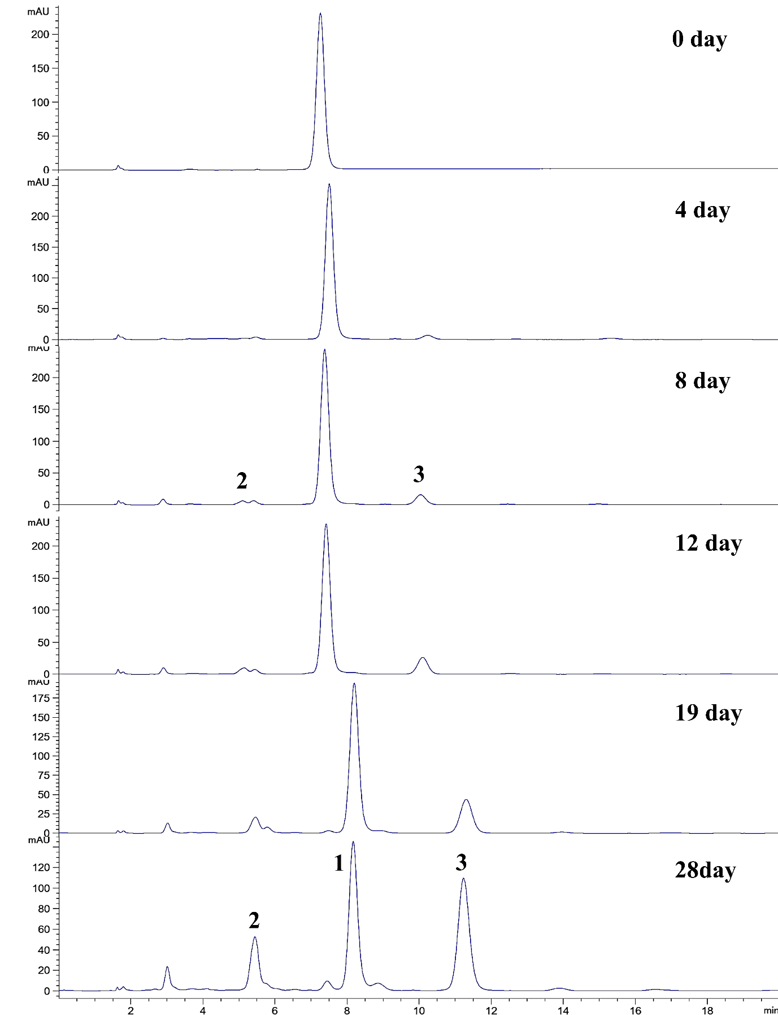
Fig. S1. HPLC chromatograms of degradation products of andrographolide (1) in MeOH at pH 2.0 and 70ºC for 0-28 days.

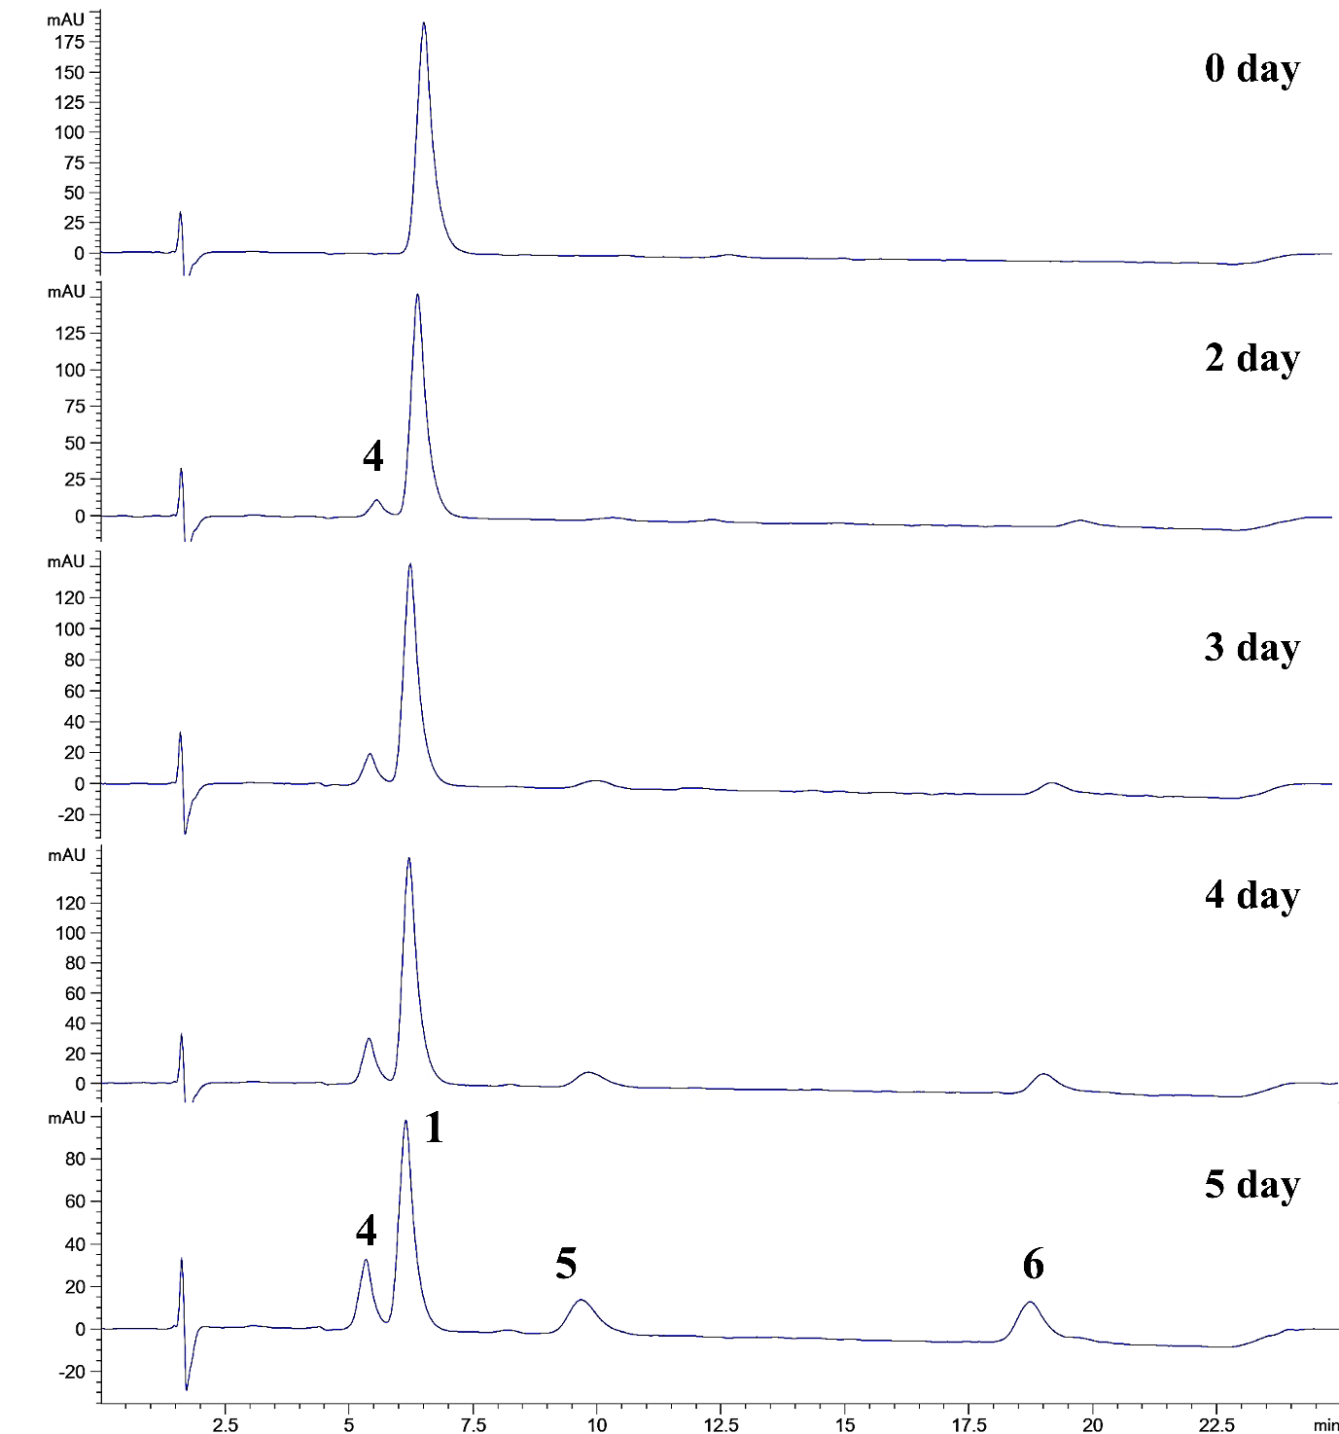
Fig. S2. HPLC chromatograms of the degradation of andrographolide (1) in MeOH at pH 6.0 and 70 ºC for 0-5 days.

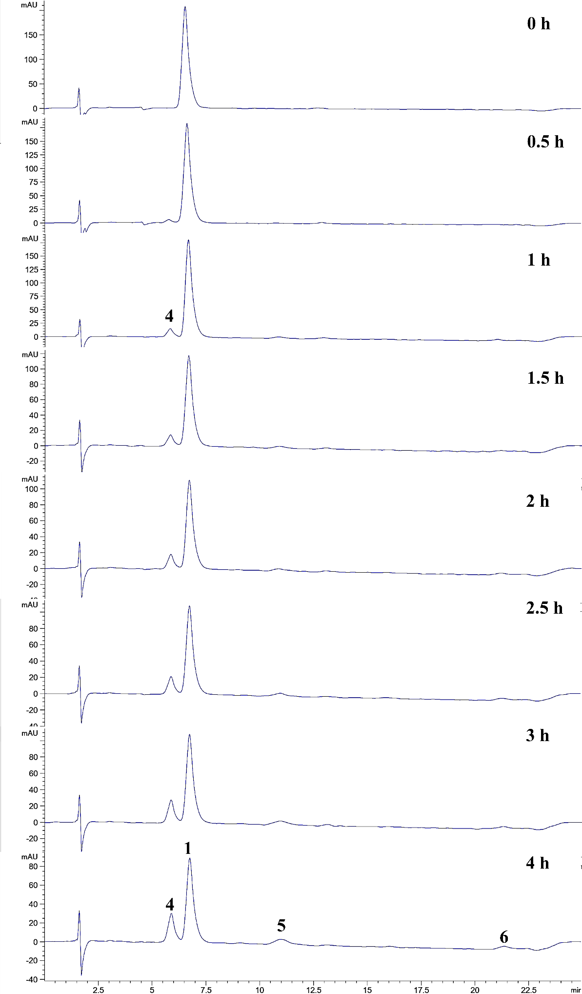
Fig. S3. HPLC chromatograms of the degradation of andrographolide (1) in MeOH at pH 8.0 and 70ºC for 0-4 h.
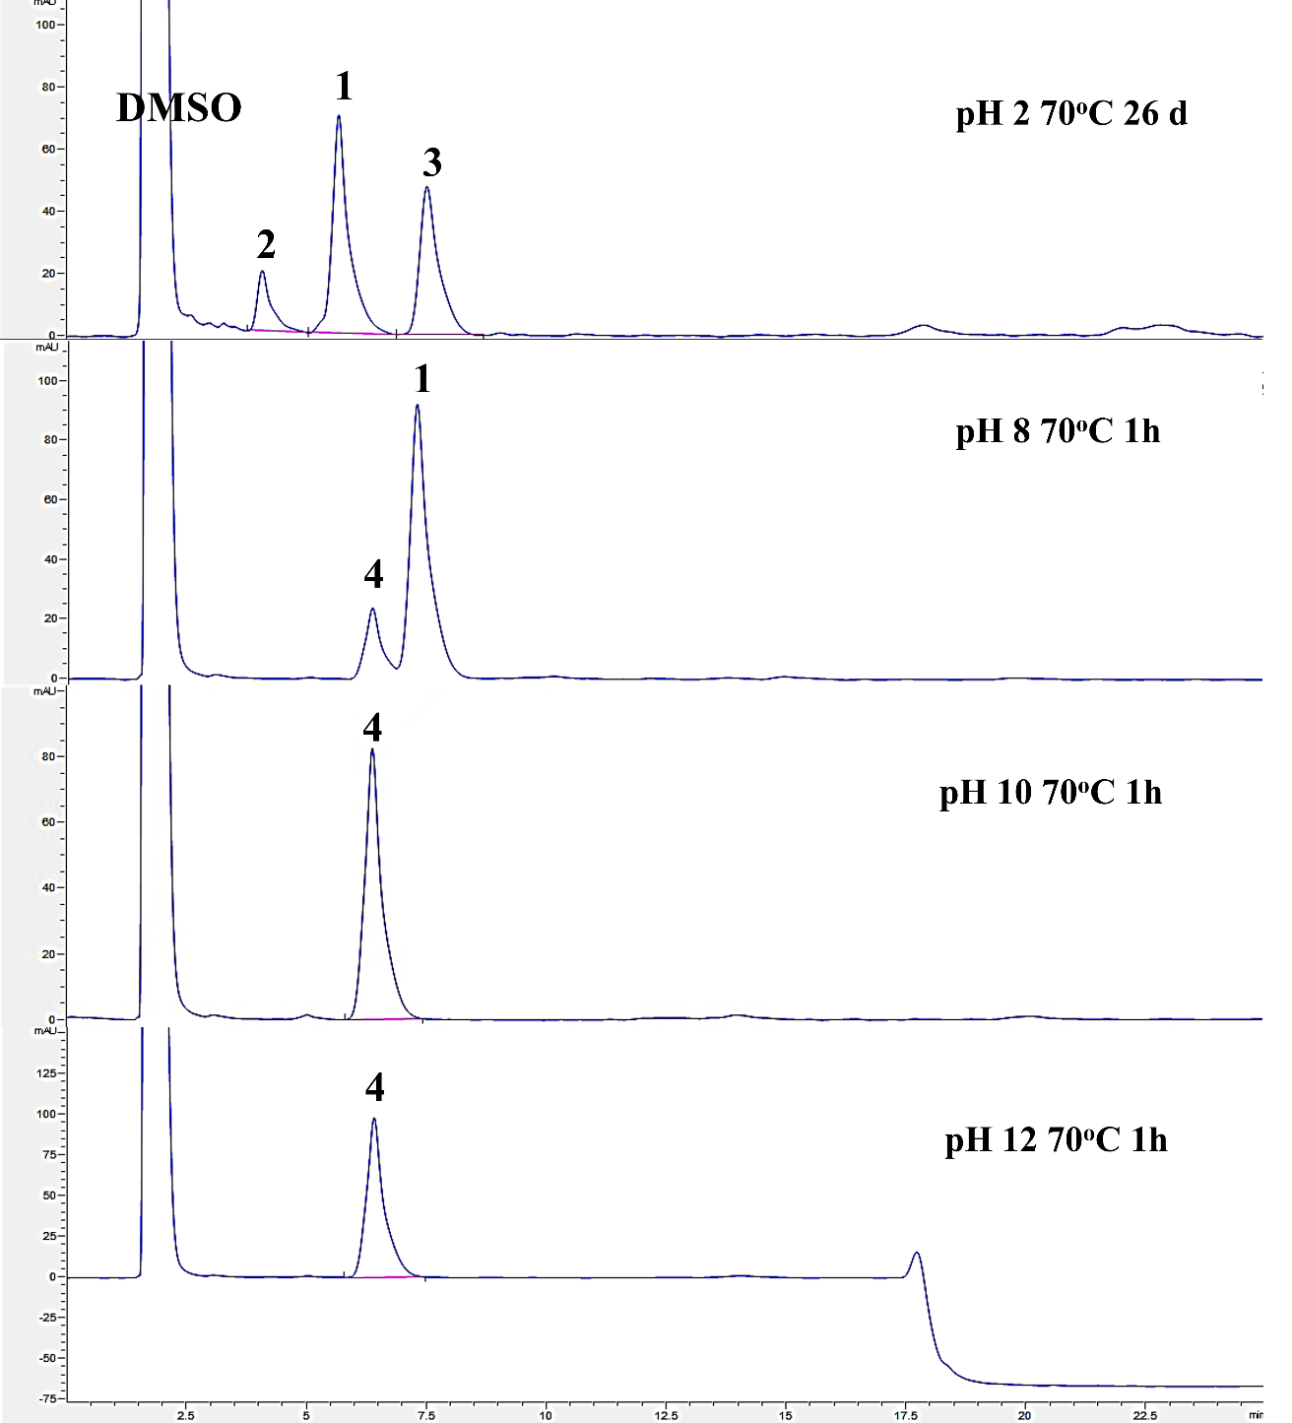
Fig. S4. HPLC chromatograms of the reactions of andrographolide (1) in DMSO at pH 2.0, pH 8.0, pH 10.0, and pH 12.0 at 70ºC.

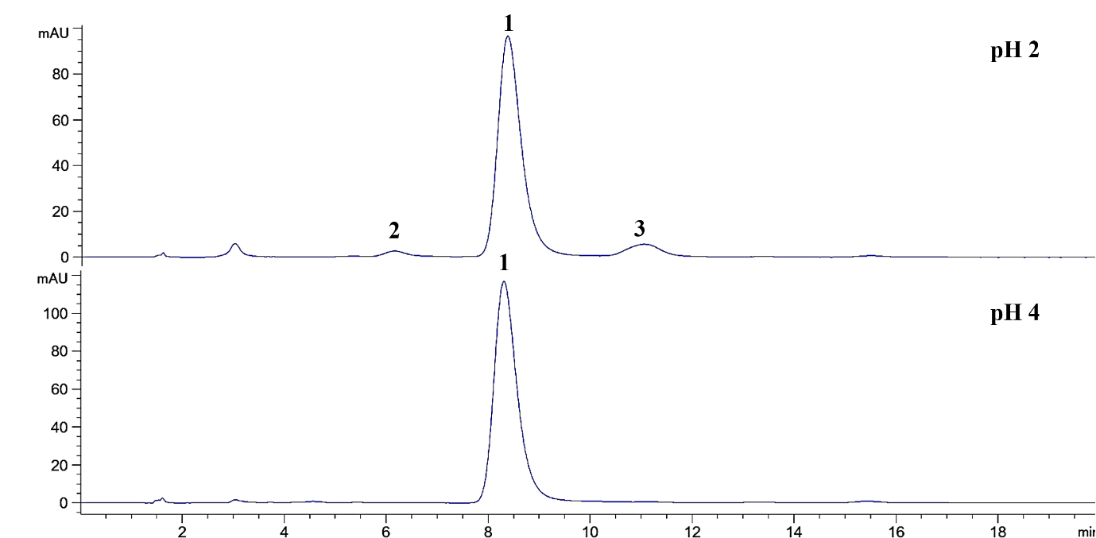
Fig. S5. HPLC chromatograms of the chemical degradation of andrographolide (1) in MeOH at pH 2.0 and pH 4.0 at 70ºC for 7 days.

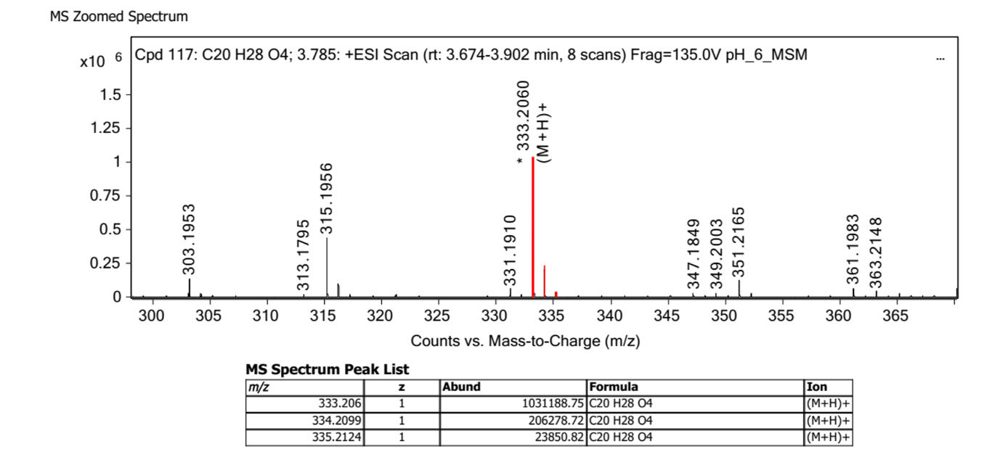
Fig. S6. LC-MS-QTOF spectra of enol lactone intermediate in the positive ion mode.
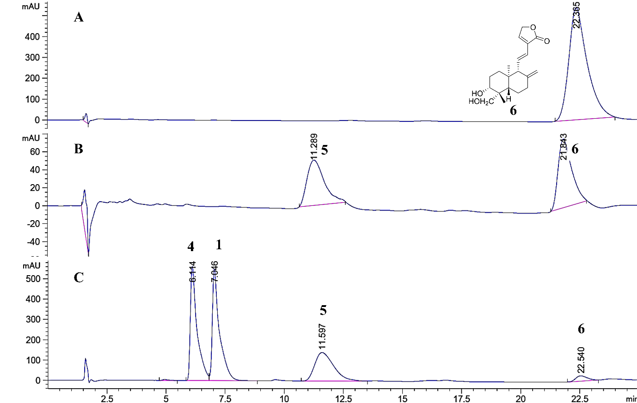
Fig. S7 HPLC chromatograms of (A) compound 6; (B) the reaction of 6 in MeOH at pH 8.0 and 70ºC for 4 h; (C) the reaction of 1 in MeOH pH 8.0 and 70ºC for 4 h.

Fig. S8. ¹H-NMR spectrum of 2 in MeOH-d_{4.} at 500 MHz.
Fig. S9. ¹³C NMR spectrum of 2 in MeOH-d₄ at 500 MHz.

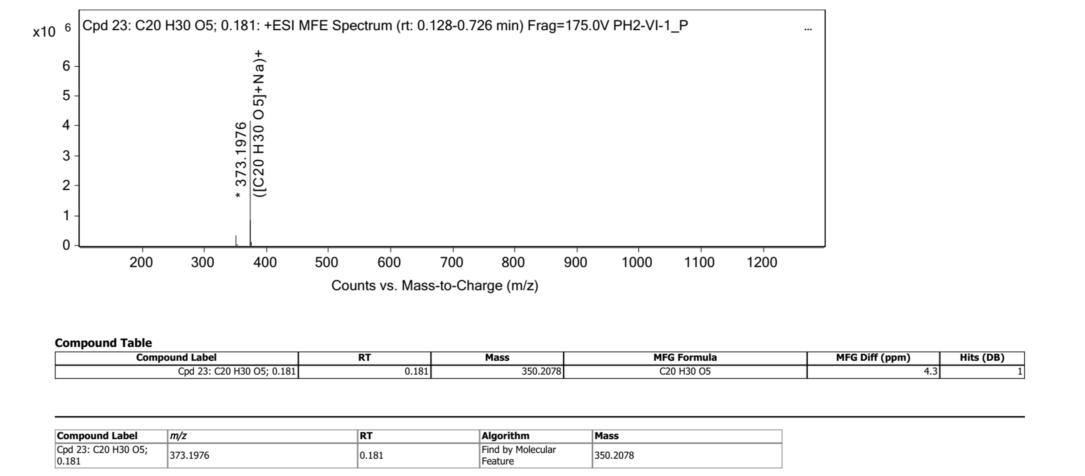
373.1976 [M+Na]⁺
Fig. S10. LC-MS-QTOF positive mode of 2.

Fig. S11. ¹H-NMR spectrum of 3 in MeOH-d₄ at 500 MHz.
Fig. S12. ¹³C NMR spectrum of 3 in MeOH-d₄ at 500 MHz.

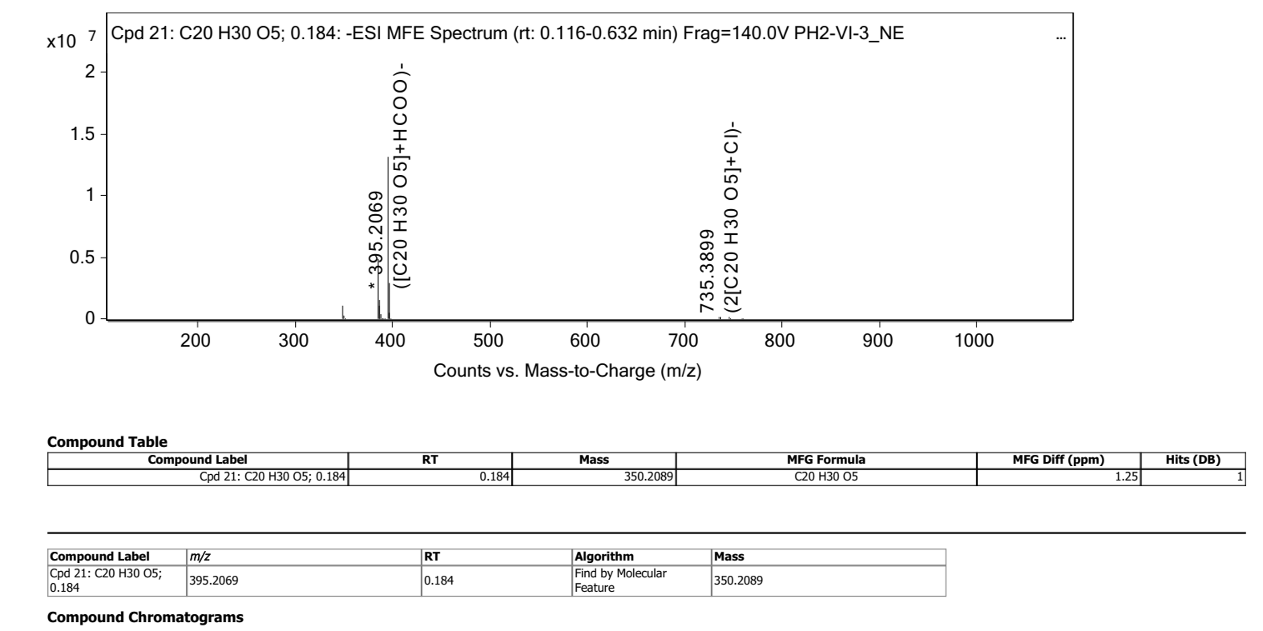
395.2069 [M-HCOO]⁻
Fig. S13. LC-MS-QTOF positive mode of 3.
Fig. S14. ¹H-NMR spectrum of 4 in MeOH-d₄ at 500 MHz.
Fig. S15. ¹³C NMR spectrum of 4 in MeOH-d₄ at 500 MHz.
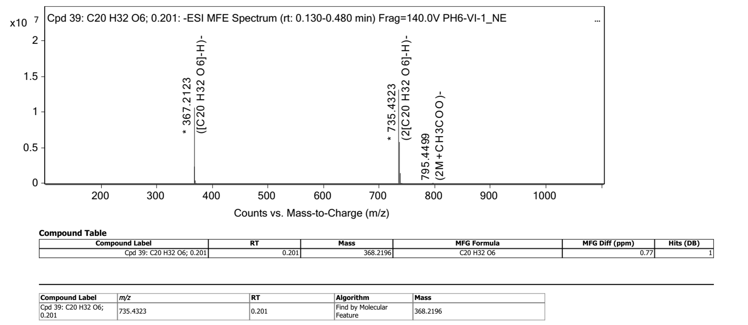
367.2123 [M-H]⁻
Fig. S16. LC-MS-QTOF positive mode of 4.
Fig. S17. ¹H-NMR spectrum of 5 in MeOH-d₄ at 500 MHz
Fig. S18. ¹³C-NMR spectrum of 5 in MeOH-d₄ at 500 MHz

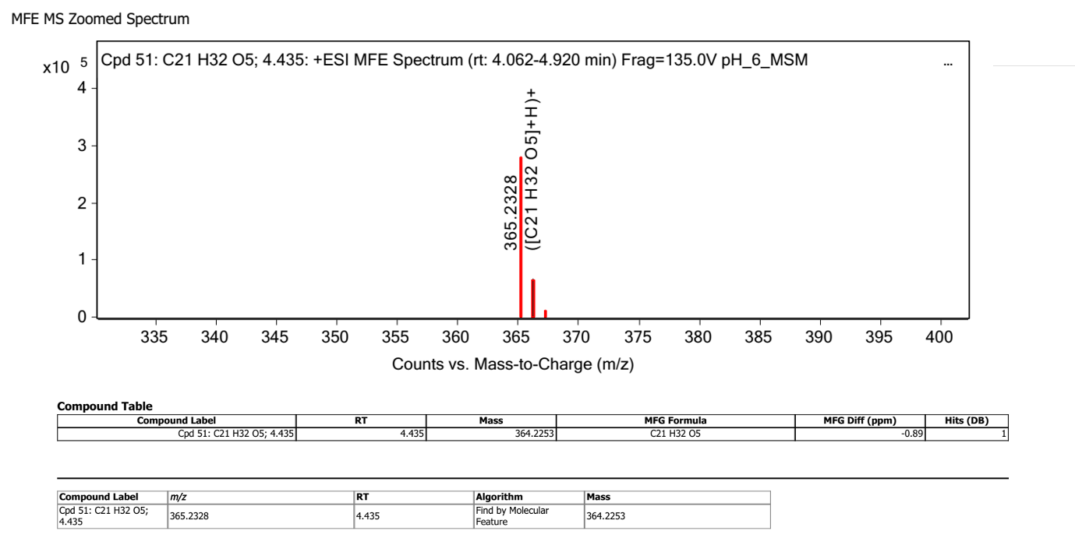
365.2328 [M+H]⁺
Fig. S19. LC-MS-QTOF positive mode of 5.
Fig. S20 ¹H-NMR spectrum of 6 in MeOH-d₄ at 500 MHz

Fig. S21. ¹³C-NMR spectrum of 6 in MeOH-d₄ at 500 MHz
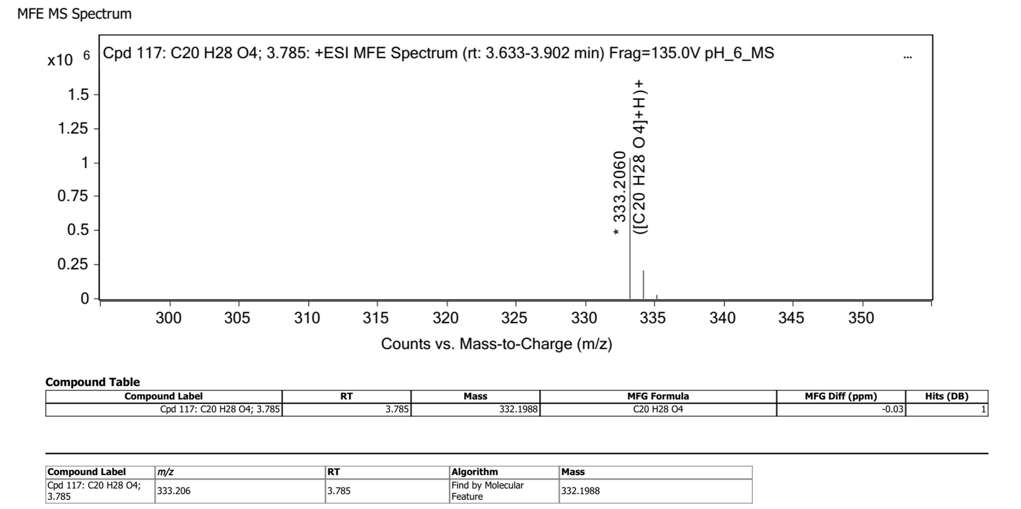
333.2060 [M+H]⁺
Fig. S22. LC-MS-QTOF positive mode of 6.

References
1. Phattanawasin, P., Sotanaphun, U,. Burana-Osot, J. & Piyapolrungroj, N. Isolation and characterization of the acid and base degradation products of andrographolide. Pharmazie 73, 559−562 (2018).
2. Pramanick, S. et al. Andropanolide and isoandrographolide, minor diterpenoids from Andrographis paniculata: structure and X-ray crystallographic analysis, J. Nat. Prod. 69 403−405 (2006).
3. Wang, G. Y. et al. Two new diterpenoid lactones isolated from Andrographis paniculata. Chin. J. Nat. Medicines. 15, 458−462 (2017).

