Table 1: Inclusion and exclusion criteria

Criterion | included | Excluded
Study design | Cohort studies, Randomized Control Trials, Case control, Observational Studies | Editorial s, Commentaries, Reviews
Population | Age >= 18-year-olds who underwent major abdominal surgery | Age <18 years of age
Year of publication | 2010- 2024 | before 2010
Outcomes of interest | MSF diagnosis, organs involved, death rate | Others diagnoses
Accessibility | Abstracts and full text accessible | Abstracts and full text non-accessible
Language | English | Non-English

Table 2: Summary of included studies
Study | Journal | Year | Study Design | Country | Sample size | Age and Gender | Type of surgery
Dong et al²⁰ | PLOS ONE | 2023 | Cohort | Japan | 4171 | Mean Age 66 M/F 2551/1620 | low vs normal Etco2 in Abdominal Surgery
Yang et al²¹ | Asian Journal of Surgery | 2021 | Case-control | China | 150 | Mean Age 39 M/F 6:1 | Pancreatectomy
Gupta et al²² | Ann Hepatobiliary Pancreat Surg | 2019 | Cohort | India | 42 | Mean Age 41.8 M/F 1:4.25 | Cholecystectomy
Bramis et a²³ | The American Surgeon | 2023 | Cohort | Greece | 10 | Median age 64.9 M/F 6:4 | Completion Pancreatectomy
Li et al²⁴ | Frontiers in Oncology | 2023 | Cohort | China | 967 | Mean age 49 M/F 82:20 | ERCP in Liver cancer
Vivian et al²⁴ | The American Surgeon | 2021 | Cohort | Canada | 58 | Median Age 70 M/F 43/15 | pancreaticoduodenectomy,
Smits et al²⁵ | The Lancet | 2022 | RCT | Netherlands | 1748 | Median age 65 M/F 1:1 | Pancreatic Surgery
KE et al²⁶ | Current Medical Science | 2019 | Cohort | China | 241 | Mean age 57 M/F 144/97 | Pancreaticoduodenectomy
Vrba et a²⁷ | Videosurg Min-iinvasive Tech | 2019 | Cohort | Czech | 215 | Median Age 61 M/F 187/28 | Mini Invasive laparoscopic  and thoracoscopic esophagectomy
Narayann et al²⁸ | J Surg Res | 2021 | Cohort | USA | 551 | Median Age 65 M/F 300/151 | pancreaticoduodenectomy
Sohda et al²⁹ | Anticancer Research | 2017 | Cohort | Japan | 40 | Mean age 68M/F 37/3 | Salvage Esophagectomy
Wilson et al³⁰ | Pancreatology | 2016 | Case-control | USA | 46 | Mean age 58.5 M/F 33/13 | cholecystectomy
Kornasiewicz et a³¹ | Clinical Transplantation | 2016 | Cohort | Poland | 15 | Mean age 44 M/F 10/5 | Liver transplant
Lambertz et al³² | World Journal of Surgery | 2016 | Cohort | Germany | 13 | Mean age 57 M/F 11/2 | Ivor-Lewis Esophagectomy
EtCO2: End tidal Carbon Dioxide, M/F: Male/female Ratio, ERCP-Endoscopic Retrograde Cholangiopancreatography
Table 3: Organ Systems Affected by MODS

Organ System | Number of Studies Reporting | Prevalence Among MODS Cases (%)
Liver | 9 | 40%
Circulatory System | 8 | 35%
Coagulation System | 7 | 30%
Pulmonary System | 6 | 25%
Renal System | 5 | 22%
Neurological System | 4 | 18%

Table 4: Risk Factors for MODS Post-Major Abdominal Surgery

Risk Factor | Number of Studies Reporting | Association with MODS
Older Age (>50 years) | 10 | High
Male Gender | 12 | Moderate
Pre-existing Comorbidities | 9 | High
Intraoperative Hypoperfusion | 8 | High
Sepsis | 7 | Very High
Duration of Surgery (>4 hrs) | 6 | Moderate
ICU Admission Delay | 5 | High

Table 5: Mortality Rates Based on Number of Organs Involved
Number of Organs Involved | Mortality Rate (%)
1 Organ | 10%
2 Organs | 25%
3 Organs | 50%
4+ Organs | 70%

Table 6: Age distribution of Multiorgan failure syndrome cases
Age distribution
Mean | 57.61428571
Standard Error | 2.733718981
Median | 59.75
Mode | 65
Standard Deviation | 10.22863982
Sample Variance | 104.6250725
Kurtosis | -0.8438849172
Skewness | -0.7108063723
Range | 30.88
Minimum | 39.12
Maximum | 70
Sum | 806.6
Count | 14
Largest (1) | 70
Smallest (1) | 39.12
Confidence Level (95%) | 5.90584079

Table 7: Number of cases involved in each surgery type
Type of surgery | number of cases
low vs normal eTCO2 in 2 Major Abdominal Surgery under General Anaesthesia | 1
Laparotomy: Pancreatectomy | 1
Cholecystectomy | 2
Completion Pancreatectomy | 1
endoscopic retrograde cholangiopancreatography in Liver cancer | 1
pancreaticoduodenectomy | 3
Pancreatic Surgery | 1
mini-invasive laparoscopic  and thoracoscopic esophagectomy | 1
Salvage Esophagectomy | 1
Liver transplant | 1
Ivor-Lewis Esophagectomy | 1
sum | 14
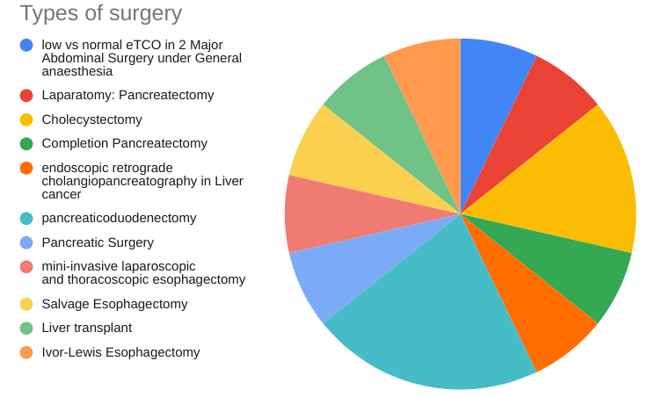

Table 8: Incidence/prevalence per surgery type
Type of surgery | Incidence/prevalence
low eTCO in 2 Major Abdominal Surgery under General Anaesthesia | 498
normal eTCO in 2 Major Abdominal Surgery under General Anaesthesia | 930
Laparotomy: Pancreatectomy | 12
Cholecystectomy | 5
Completion Pancreatectomy | 3
endoscopic retrograde cholangiopancreatography in Liver cancer | 7
Pancreatic Surgery | 131
Pancreaticoduodenectomy | 1
pancreaticoduodenectomy | 17
Salvage Esophagectomy | 1
cholecystectomy | 11
Liver transplant | 5
Ivor-Lewis Esophagectomy | 5
