Supplementary Information
Memristor-based adaptive analog-to-digital conversion for efficient and accurate compute-in-memory
Haiqiao Hong¹, Zhiyuan Du¹, Mingrui Jiang¹, Ruibin Mao¹, Yuan Ren¹, Wei Mao², Muyuan Peng¹, Wei Zhang³, Zhengwu Liu^{1,*}, Can Li^{1,*}, Ngai Wong^{1,*}
¹Department of Electrical and Electronic Engineering, The University of Hong Kong, Hong Kong, China.
²Hangzhou Institute of Technology, Xidian University, Hangzhou, China.
³Department of Electronic and Computer Engineering, The Hong Kong University of Science and Technology, Hong Kong, China.
*Email: zwliu@eee.hku.hk (Z.L.); canl@hku.hk (C.L.); nwong@eee.hku.hk (N.W.).
Note S1 Mathematical framework for Q-cell implementation in n-bit memristor-based ADC
The Q-cell architecture presented in the main text enables efficient voltage quantization through programmable memristor conductance. This section establishes the mathematical foundation for determining the required number of Q-cells in an n-bit ADC implementation, supporting the practical demonstration shown in Fig. 2C-D of the main text.
S1.1 Q-cell count derivation
For an n-bit ADC implementation, the number of required Q-cells can be derived as follows:
Total quantization boundaries required: $2^{n}-1$.
Each Q-cell maps two boundaries (lower and upper thresholds), except the first Q-cell which maps one boundary.
Total boundaries mapped by $m$ Q-cells: $1+2\left(m-1\right)$.
Setting this equal to the required boundaries:
$$1+2(m-1)=2^{n}-1$$
Solving for $m$ yields:
$$\begin{aligned}1+2(m-1)&=2^{n}-1 \\ 2m-1&=2^{n}-1 \\ m&=2^{n-1}\end{aligned}$$
S1.2 Boundary mapping configuration
The boundary index mapping follows this configuration:
Q-cell 1: $[,2^{n-1}]$.
Q-cell i $(1<i≤2^{n-1})$: $[i-1,2^{n-1}+i-1].$
This configuration, as implemented in the 3-bit uniform ADC example (Fig. 2C-D of the main text), shows how $2^{n-1}$ Q-cells can effectively map all $2^{n}-1$ quantization boundaries. The overlapping boundary ranges, enabled by the dual-threshold programmability of each Q-cell, provide the foundation for both uniform and adaptive quantization schemes.

Note S2 Q-cell output decoding
The outputs of the Q-cells are processed by a thermometer-to-binary decoder, which converts the 4-bit thermometer-coded Q-cell outputs into 3-bit binary ADC codes. The decoding logic is defined by the following truth table Table S1. For example: When the Q-cell output is 1110, the decoder produces the binary output 110. When the Q-cell output is 0111, the decoder produces the binary output 000.

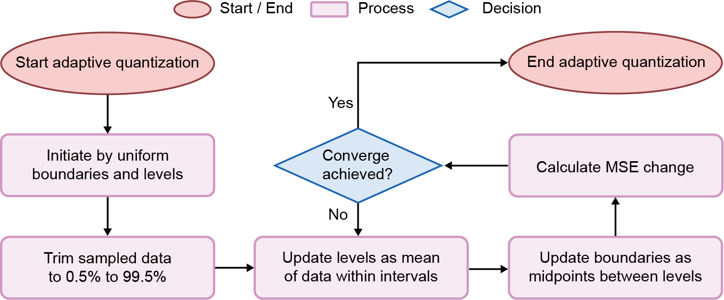
Fig. S1. Flowchart of the memristor-based adaptive quantization process. This process optimizes quantization levels and boundaries to improve the efficiency and accuracy of CIM quantization operations. The algorithm iteratively adjusts quantization parameters until convergence is achieved, as indicated by the minimal change in MSE. The optimization continues until convergence, where the change in MSE between iterations reaches the threshold. This approach fine-tunes the Lloyd-Max quantization scheme to improve performance on CIM array outputs, enhancing both the efficiency and accuracy of the analog-to-digital conversion process.
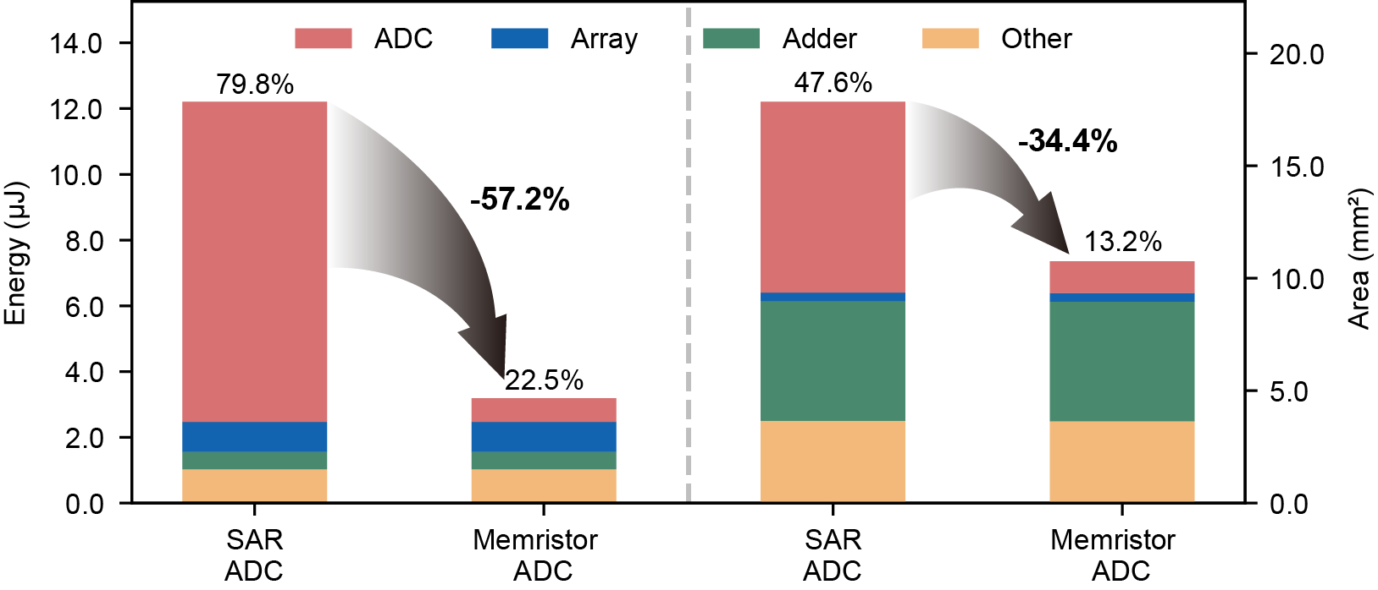
Fig. S2. System-level energy and area analysis of VGG8 implementation. Graphical representation comparing energy consumption and area utilization for the VGG8 network on a CIM system using conventional SAR ADC versus the proposed memristor-based ADC. Stacked bars depict the contributions of different components (ADC, Array, Adder, and Other) to total energy (left y-axis) and area (right y-axis). Arrows indicate the percentage reduction in energy and area for the ADC portion, highlighting the efficiency gains of the memristor-based ADC. Detailed numerical data is provided in Table. S4.
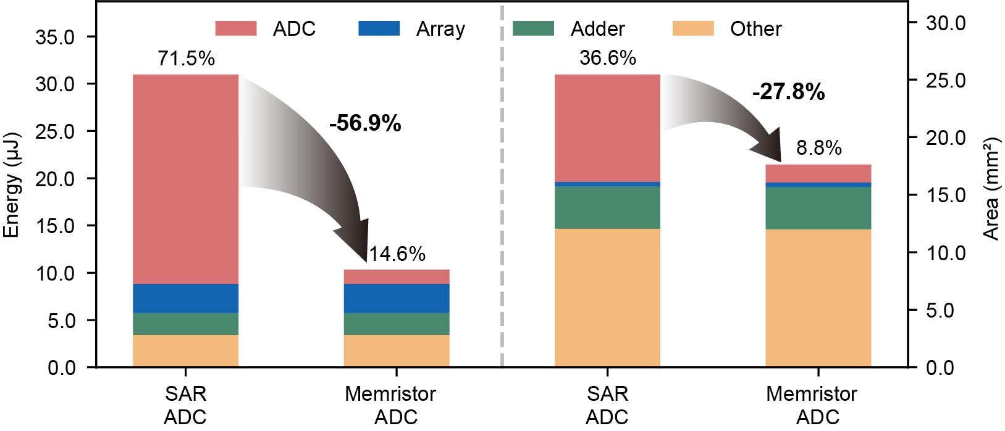
Fig. S3. System-level energy and area analysis of ResNet18 implementation. Graphical representation comparing energy consumption and area utilization for the ResNet18 network on a CIM system using conventional SAR ADC versus the proposed memristor-based ADC. Stacked bars illustrate the contributions of different components (ADC, Array, Adder, and Other) to total energy (left y-axis) and area (right y-axis). Arrows emphasize the percentage reduction in energy and area for the ADC portion, underscoring the advantages of the memristor-based ADC. Detailed numerical data is provided in Table. S5.
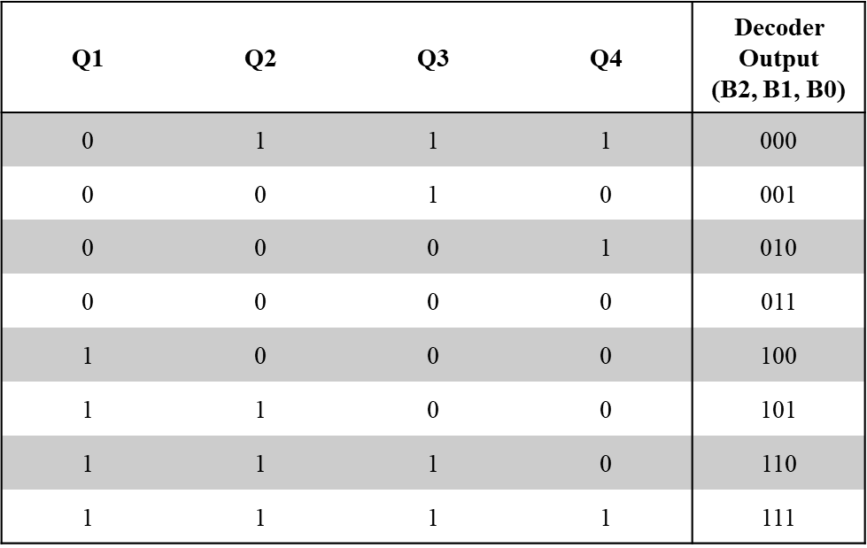
Table S1. Truth table for 3-bit ADC Q-cell output decoding. The decoder maps the 4-bit Q-cell outputs (Q1, Q2, Q3, Q4) to their corresponding 3-bit binary representations (B2, B1, B0).
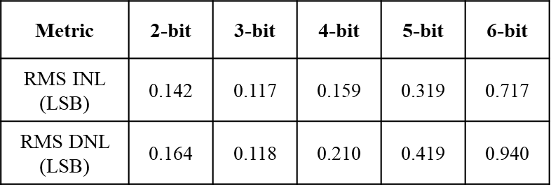
Table S2. Memristor ADC linearity metrics (complementary to Figs. 4C-D). RMS of the maximum INL/DNL values (LSB) for 2–6 bit precisions under experimental variations. Maximum INL = 0.717 LSB (6-bit), DNL = 0.940 LSB (6-bit), all sub-1-LSB.
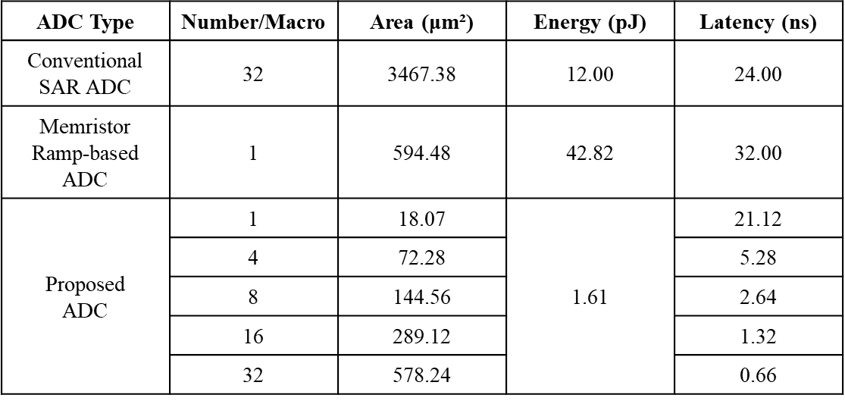
Table S3. Comparison of different ADC architectures at the macro level. Detailed performance metrics comparing the proposed ADC with conventional SAR ADC model and memristor ramp-based ADC, highlighting differences in area, energy, and latency across various solutions.

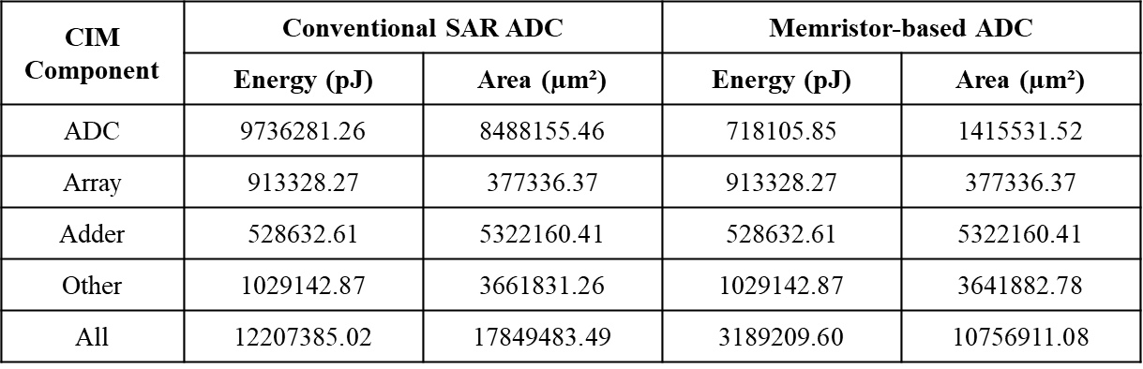
Table S4. Energy and area breakdown for VGG8 implementation. Detailed energy and area comparison data for the VGG8 network on a CIM system, quantifying the improvements achieved by the proposed memristor-based ADC compared to conventional SAR ADC as visualized in Fig. S2.
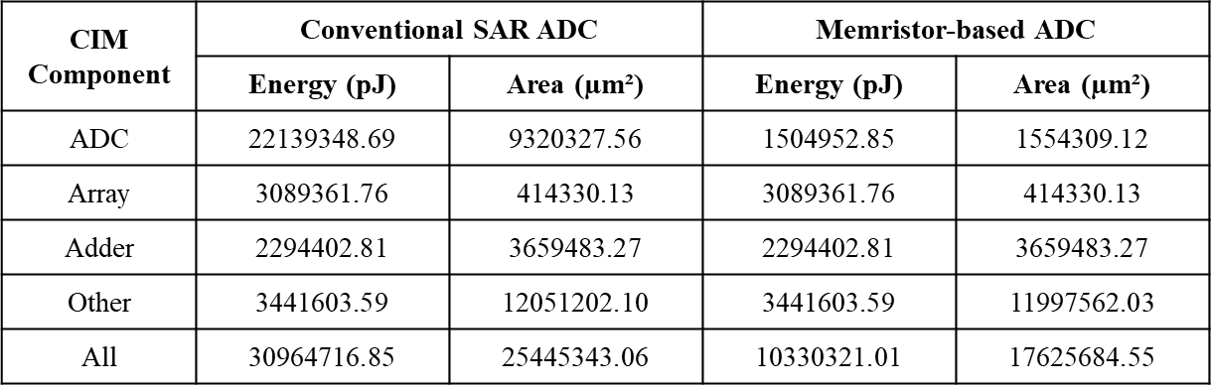
Table S5. Energy and area breakdown for ResNet18 implementation. Detailed energy and area comparison data for the ResNet18 network on a CIM system, quantifying the improvements achieved by the proposed memristor-based ADC compared to conventional SAR ADC as visualized in Fig. S3.

