Supplementary material

Figure S1. Flow diagram for selection of study population.
Figure S2. The incidence estimates for the primary and three secondary outcomes among four subgroups identified by the casual forest model.
Table S1. Baseline characteristics of the excluded and included participants.
Table S2. The 42 variables used for constructing causal forest model.
Table S3. Baseline characteristics of the 4710 individuals before and after imputation of missing data.
Table S4. Baseline characteristics of participants between the ILI and DSE groups.
Table S5. Risk of primary and three secondary outcomes for the ILI vs. DSE groups in overweight or obese participants with type 2 diabetes.
Table S6. Risk of primary and secondary cardiovascular outcomes across four subgroups identified by the causal forest model.
Table S7. Baseline characteristics of participants in the ILI and DSE arms within Subgroups 1 to 3.
Table S8. Risk of primary and three secondary outcomes for ILI vs. DSE within each subgroup identified by the causal forest model after excluding those with a history of CVD at baseline (n=4050).

Figure S1. Flow diagram for selection of study population.
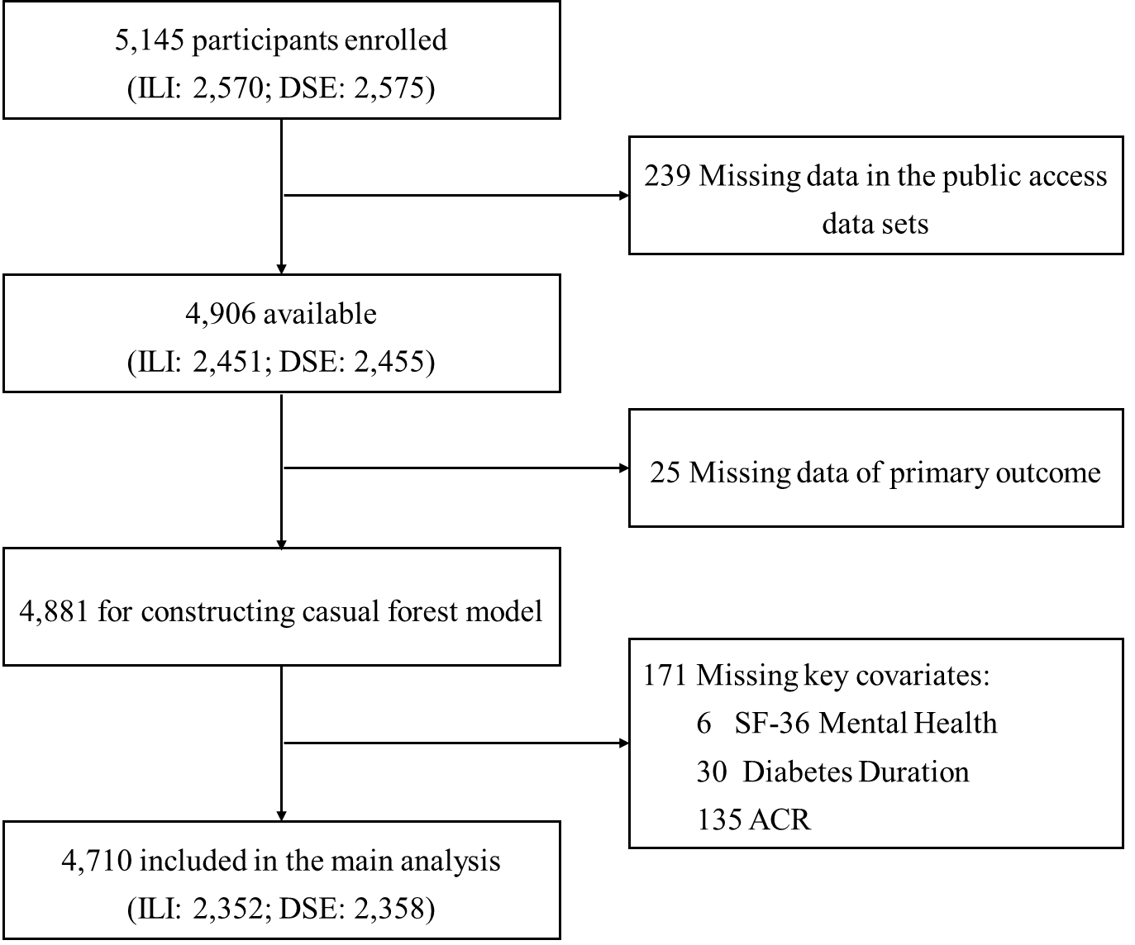
ILI: intensive lifestyle intervention; DSE: diabetes support and education; SF-36: short form (36) health survey; ACR: albumin-creatinine ratio.
Figure S2. The incidence estimates for the primary and three secondary outcomes among four subgroups identified by the casual forest model.
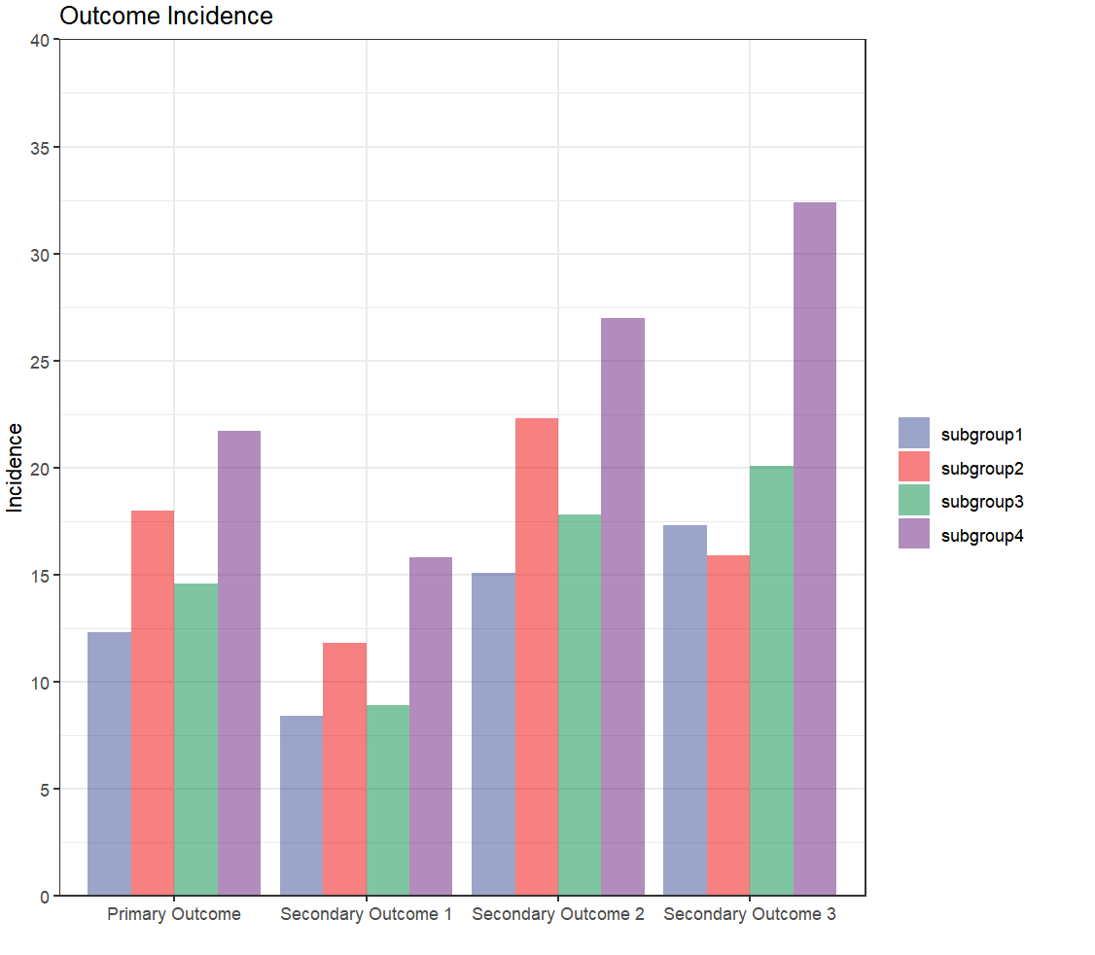
Subgroup 1: SF-36 Mental Health ≤ 55.64 and Diabetes Duration ≤ 4 years; Subgroup 2: SF-36 Mental Health ≤ 55.64 and Diabetes Duration > 4 years; Subgroup 3: SF-36 Mental Health > 55.64 and ACR ≤ 10 mg/g; Subgroup 4: SF-36 Mental Health > 55.64 and ACR > 10 mg/g.

Table S1. Characteristics of the included and excluded participants at baseline.
Variables | Excluded Participants  (N=171) | Included Participants  (N=4710) | P value
Age, years | 60.6 (6.9) | 58.9 (6.8) | 0.001
Female, n (%) | 101 (59.1) | 2757 (58.5) | 0.953
Race, n (%) |  |  | 0.019
White | 125 (73.1) | 3110 (66.0)
Black (not Hispanic) | 28 (16.4) | 770 (16.3)
Hispanic | 10 (5.8) | 664 (14.1)
Other/Mixed | 8 (4.7) | 166 (3.5)
Education, n (%) |  |  | 0.719
＜13 years | 32 (19.2) | 896 (19.4)
13-16 years | 58 (34.7) | 1729 (37.5)
≥16years | 77 (46.1) | 1990 (43.1)
Income, n (%) |  |  | 0.072
< $20K | 20 (14.1) | 481 (11.3)
$20K - $40K | 34 (23.9) | 893 (21.0)
$40K - $60K | 37 (26.1) | 868 (20.4)
$60K - $80K | 22 (15.5) | 706 (16.6)
BMI, kg/m² | 35.4 (5.6) | 36.0(5.9) | 0.302
Waist circumference, cm | 113.1 (13.8) | 114.0 (14.0) | 0.501
SBP, mmHg | 132.1 (19.2) | 129.0 (17.1) | 0.036
DBP, mmHg | 71.3 (10.4) | 70.2 (9.6) | 0.176
Smoking, n (%) |  |  | 0.573
Never | 78 (46.2) | 2340 (49.8)
Former smoker | 82 (48.5) | 2162 (46.0)
Current smoker | 9 (5.3) | 199 (4.2)
Alcohol, n (%) |  |  | 0.976
Never | 115 (67.3) | 3148 (66.8)
≥1g/week | 56 (32.7) | 1562 (33.2)
HbA1c, % | 7.1 (1.2) | 7.3 (1.2) | 0.140
HDL-c, mg/dl | 42.6 (10.2) | 43.5 (11.9) | 0.386
LDL-c, mg/dl | 111.5 (36.8) | 112.7 (32.1) | 0.181
Creatinine, mg/dl | 0.8 (0.2) | 0.8 (0.2) | 0.410
Hypertension, n (%) | 150 (87.7) | 3943 (83.7) | 0.196
CVD, n (%) | 28 (16.4) | 660 (14.0) | 0.447
Dyslipidemia, n (%) | 114 (66.7) | 3325 (70.6) | 0.307
ACR, mg/g | 1.5 (2.1) | 4.3 (20.3) | 0.471
ABI | 1.2 (0.1) | 1.2 (0.1) | 0.920
Diabetes Duration, years | 6.6 (5.9) | 6.7 (6.4) | 0.818
Continuous and categorical variables are presented as mean (SD) and number (%), respectively.
BMI: body mass index; SBP: systolic blood pressure; DBP: diastolic blood pressure; HbA1c: glycosylated hemoglobin; HDL-c: high-density lipoprotein cholesterol; LDL-c: low-density lipoprotein cholesterol; CVD: cardiovascular disease; ACR: albumin-creatinine ratio; ABI: ankle brachial index; SD: standard deviation.

Table S2. The 42 variables used for constructing causal forest model.
Variable type (n) | Detailed variables
Demographic Variables (5) | age, gender, race, education, income
Physiological and Biomarker Variables (10) | BMI, weight, height, mean waist circumstance, SBP, DBP, beck total score, ABI, beck total score (entered at clinic), maximal MET value
Lifestyle Factors (3) | Smoking, alcohol, times per week sweat exercise
Laboratory Test Indicators (10) | blood glucose, HbA1c, total cholesterol, HDL-c, LDL-c, triglycerides, creatinine, urine albumin, urine creatinine, ACR
Medical History (7) | CVD history, HF history, diabetes duration, dyslipidemia, metabolic syndrome, diabetes severity, age diagnosed with diabetes
SF-36 Measurement Scale (7) | SF-36 mental health, SF-36 Reported Health Transition, SF-36 mental component summary, SF-36 general health, SF-36 physical component summary, SF-36 physical functioning, SF-36 social functioning
n = Number of variables; BMI: body mass index; SBP: systolic blood pressure; DBP: diastolic blood pressure; MET: metabolic equivalent of task; ABI: ankle brachial index; HbA1c: glycosylated hemoglobin; HDL-c: high-density lipoprotein cholesterol; LDL-c: low-density lipoprotein cholesterol; ACR: albumin-creatinine ratio; CVD: cardiovascular disease; HF: heart failure; SF-36: short form (36) health survey.

Table S3. Baseline characteristics of the 4710 individuals before and after imputation of missing data.
Variables | Before Imputation | After Imputation | P value
Age, years | 58.9 (6.8) | 58.9 (6.8) | 0.999
Female, n (%) | 2757 (58.5) | 2757 (58.5) | 0.999
Race, n (%) |  |  | 0.999
White | 3110 (66.0) | 3110 (66.0)
Black (not Hispanic) | 770 (16.3) | 770 (16.3)
Hispanic | 664 (14.1) | 664 (14.1)
Other/Mixed | 166 (3.5) | 166 (3.5)
Education, n (%) |  |  | 0.999
＜13 years | 896 (19.4) | 916 (19.4)
13-16 years | 1729 (37.5) | 1758 (37.3)
≥16years | 1990 (43.1) | 2036 (43.2)
Income, n (%) |  |  | 0.963
< $20K | 481 (11.3) | 523 (11.1)
$20K - $40K | 893 (21.0) | 974 (20.7)
$40K - $60K | 868 (20.4) | 975 (20.7)
$60K - $80K | 706 (16.6) | 765 (16.2)
BMI, kg/m² | 36.0 (5.9) | 36.0 (5.9) | 0.999
Waist circumference, cm | 114.0 (14.0) | 114.0 (14.0) | 0.999
SBP, mmHg | 129.0 (17.1) | 129.0 (17.1) | 0.991
DBP, mmHg | 70.2 (9.6) | 70.2 (9.6) | 0.961
Smoking, n (%) |  |  | 0.999
Never | 2340 (49.8) | 2343 (49.7)
Former smoker | 2162 (46.0) | 2168 (46.0)
Current smoker | 199 (4.2) | 199 (4.2)
Alcohol, n (%) |  |  | 0.999
Never | 3148 (66.8) | 3148 (66.8)
≥1g/week | 1562 (33.2) | 1562 (33.2)
HbA1c, % | 7.3 (1.2) | 7.3 (1.2) | 0.999
HDL-c, mg/dl | 43.5 (11.9) | 43.5 (11.9) | 0.993
LDL-c, mg/dl | 112.65 (32.1) | 112.68 (32.1) | 0.963
Creatinine, mg/dl | 0.8 (0.2) | 0.8 (0.2) | 0.999
Hypertension, n (%) | 3943 (83.7) | 3943 (83.7) | 0.999
CVD, n (%) | 660 (14.0) | 660 (14.0) | 0.999
Dyslipidemia, n (%) | 3325 (70.6) | 3325 (70.6) | 0.999
ACR, mg/g | 4.3 (20.3) | 4.3 (20.3) | 0.999
ABI | 1.2 (0.1) | 1.2 (0.1) | 0.968
Diabetes Duration, years | 6.7 (6.4) | 6.7 (6.4) | 0.999
Continuous and categorical variables are presented as mean (SD) and number (%), respectively.
BMI: body mass index; SBP: systolic blood pressure; DBP: diastolic blood pressure; HbA1c: glycosylated hemoglobin; HDL-c: high-density lipoprotein cholesterol; LDL-c: low-density lipoprotein cholesterol; CVD: cardiovascular disease; ACR: albumin-creatinine ratio; ABI: ankle brachial index; SD: standard deviation.

Table S4. Baseline characteristics of participants between the ILI and DSE groups.
Variables | DSE group  (N=2358) | ILI group  (N=2352) | P value
Age, years | 59.0 (6.8) | 58.9 (6.8) | 0.096
Female, n (%) | 1379 (58.5) | 1378 (58.6) | 0.964
Race, n (%) |  |  | 0.936
White | 1560 (66.2) | 1550 (65.9)
Black (not Hispanic) | 386 (16.4) | 384 (16.3)
Hispanic | 333 (14.1) | 331 (14.1)
Other/Mixed | 79 (3.4) | 87 (3.7)
Education, n (%) |  |  | 0.523
＜13 years | 452 (19.2) | 464 (19.7)
13-16 years | 899 (38.1) | 859 (36.5)
≥16years | 1007 (42.7) | 1029 (43.8)
Income, n (%) |  |  | 0.941
< $20K | 258 (10.9) | 265 (11.3)
$20K - $40K | 492 (20.9) | 482 (20.5)
$40K - $60K | 482 (20.4) | 493 (21.0)
$60K - $80K | 378 (16.0) | 387 (16.5)
BMI, kg/m² | 36.0 (5.8) | 36.0 (6.0) | 0.711
Waist circumference, cm | 114.1 (13.6) | 113.9 (14.4) | 0.515
SBP, mmHg | 129.7 (16.7) | 128.4 (17.2) | 0.01
DBP, mmHg | 70.5 (9.6) | 70.0 (9.5) | 0.064
Smoking, n (%) |  |  | 0.726
Never | 1185 (50.3) | 1158 (49.2)
Former smoker | 1077 (45.7) | 1091 (46.4)
Current smoker | 96 (4.1) | 103 (4.4)
Alcohol, n (%) |  |  | 0.780
Never | 1571 (66.6) | 1577 (67.0)
≥1g/week | 787 (33.4) | 775 (33.0)
HbA1c, % | 7.3 (1.2) | 7.2 (1.1) | 0.069
HDL-c, mg/dl | 43.5 (11.9) | 43.6 (12.0) | 0.885
LDL-c, mg/dl | 112.8 (32.2) | 112.6 (32.0) | 0.807
Creatinine, mg/dl | 0.8 (0.2) | 0.8 (0.2) | 0.564
Hypertension, n (%) | 1968 (83.5) | 1975 (84.0) | 0.664
CVD, n (%) | 322 (13.7) | 338 (14.4) | 0.506
Dyslipidemia, n (%) | 1671 (70.9) | 1654 (70.3) | 0.707
ACR, mg/g | 4.5 (22.2) | 4.2 (18.1) | 0.546
ABI | 1.2 (0.1) | 1.2 (0.1) | 0.596
Diabetes Duration, years | 6.8 (6.3) | 6.7 (6.5) | 0.545
Continuous and categorical variables are presented as mean (SD) and number (%), respectively.
ILI: intensive lifestyle intervention; DSE: diabetes support and education; BMI: body mass index; SBP: systolic blood pressure; DBP: diastolic blood pressure; HbA1c: glycosylated hemoglobin; HDL-c: high-density lipoprotein cholesterol; LDL-c: low-density lipoprotein cholesterol; CVD: cardiovascular disease; ACR: albumin-creatinine ratio; ABI: ankle brachial index; SD: standard deviation.

Table S5. Risk of primary and three secondary outcomes for the ILI vs. DSE groups in overweight or obese participants with type 2 diabetes.
Outcomes | No. of events in DSE (%)  (N=2358) | No. of events in ILI (%)  (N=2352) | Unadjusted |  | Fully adjusted
Outcomes | No. of events in DSE (%)  (N=2358) | No. of events in ILI (%)  (N=2352) | HR (95% CI) | P value | HR (95% CI) | P value
Primary outcome | 393 (16.6) | 375 (15.9) | 0.94 (0.82-1.08) | 0.401 | 0.96 (0.83-1.11) | 0.570
Secondary outcome 1 | 266 (11.2) | 249 (10.6) | 0.93 (0.78-1.10) | 0.389 | 0.96 (0.80-1.14) | 0.611
Secondary outcome 2 | 497 (21.1) | 460 (19.6) | 0.91 (0.80-1.04) | 0.158 | 0.93 (0.82-1.06) | 0.276
Secondary outcome 3 | 563 (23.9) | 537 (22.8) | 0.94 (0.84-1.06) | 0.307 | 0.96 (0.85-1.08) | 0.449
The multivariable model was fully adjusted for age, gender, race, body mass index, glycosylated hemoglobin, low-density lipoprotein cholesterol, serum creatinine, smoking status, hypertension, and diabetes duration.
Primary outcome: the first occurrence of death from cardiovascular causes, non-fatal myocardial infarction, non-fatal stroke, or hospitalization for angina. Secondary outcome 1: death from cardiovascular causes, nonfatal myocardial infarction, or nonfatal stroke. Secondary outcome 2: death from any cause, non-fatal myocardial infarction, non-fatal stroke, or hospitalization for angina. Secondary outcome 3: death from any cause, non-fatal myocardial infarction, non-fatal stroke, hospitalization for angina, coronary-artery bypass grafting, percutaneous coronary intervention, hospitalization for heart failure, carotid endarterectomy, or peripheral vascular disease.
ILI: intensive lifestyle intervention; DSE: diabetes support and education; HR: hazard ratio; CI: confidence interval.

Table S6. Risk of primary and secondary cardiovascular outcomes across four subgroups identified by the causal forest model.
Subgroups | No. of events (%) | Unadjusted |  | Fully adjusted
Subgroups | No. of events (%) | HR (95% CI) | P value | HR (95% CI) | P value
Primary outcome: Death from cardiovascular causes, non-fatal myocardial infarction, non-fatal stroke, or hospitalization for angina.
Subgroup 1 | 158/1286 (12.3) | 1.01 (0.74-1.38) | 0.934 | 0.87 (0.69-1.09) | 0.228
Subgroup 2 | 266/1481 (18.0) | 1.18 (0.92-1.50) | 0.187 | 0.87 (0.71-1.05) | 0.143
Subgroup 3 | 160/1095 (14.6) | 0.94 (0.69-1.28) | 0.688 | 0.79 (0.63-0.98) | 0.029
Subgroup 4 | 184/848 (21.7) | Reference | - | Reference | -
Secondary outcome 1: Death from cardiovascular causes, non-fatal myocardial infarction, non-fatal stroke.
Subgroup 1 | 108/1286 (8.4) | 0.94 (0.64-1.37) | 0.733 | 0.85 (0.65-1.12) | 0.250
Subgroup 2 | 175/1481 (11.8) | 1.20 (0.89-1.62) | 0.228 | 0.80 (0.63-1.00) | 0.052
Subgroup 3 | 98/1095 (8.9) | 0.89 (0.60-1.33) | 0.573 | 0.67 (0.51-0.87) | 0.003
Subgroup 4 | 134/848 (15.8) | Reference | - | Reference | -
Secondary outcome 2: Death from any cause, non-fatal myocardial infarction, non-fatal stroke, or hospitalization for angina.
Subgroup 1 | 194/1286 (15.1) | 1.02 (0.77-1.35) | 0.895 | 0.83 (0.68-1.02) | 0.081
Subgroup 2 | 339/1481 (22.9) | 1.11 (0.89-1.37) | 0.352 | 0.89 (0.75-1.06) | 0.202
Subgroup 3 | 195/1095 (17.8) | 0.89 (0.67-1.17) | 0.393 | 0.76 (0.63-0.92) | 0.005
Subgroup 4 | 229/848 (27.0) | Reference | - | Reference | -
Secondary outcome 3: Death from any cause, non-fatal myocardial infarction, non-fatal stroke, or hospitalization for angina, CABG, PCI, hospital admission for heart failure, carotid endarterectomy, or peripheral vascular disease.
Subgroup 1 | 222/1286 (17.3) | 1.03 (0.79-1.34) | 0.823 | 0.78 (0.65-0.95) | 0.012
Subgroup 2 | 383/1481 (25.9) | 1.07 (0.88-1.31) | 0.499 | 0.84 (0.72-0.99) | 0.032
Subgroup 3 | 220/1095 (20.1) | 0.87 (0.67-1.14) | 0.316 | 0.69 (0.58-0.83) | <0.001
Subgroup 4 | 275/848 (32.4) | Reference | - | Reference | -
The multivariable model was adjusted for age, gender, race, body mass index, glycosylated hemoglobin, low-density lipoprotein cholesterol, serum creatinine, smoking status, hypertension, and diabetes duration.
Subgroup 1: SF-36 Mental Health ≤ 55.64 and Diabetes Duration ≤ 4 years; Subgroup 2: SF-36 Mental Health ≤ 55.64 and Diabetes Duration > 4 years; Subgroup 3: SF-36 Mental Health > 55.64 and ACR ≤ 10 mg/g; Subgroup 4: SF-36 Mental Health > 55.64 and ACR > 10 mg/g.
HR: hazard ratio; CI: confidence interval.

Table S7. Baseline characteristics of participants in the ILI and DSE arms within Subgroups 1 to 3.
Variables | Subgroup 1 |  |  | Subgroup 2 |  |  | Subgroup 3
Variables | DSE arm  (n = 615) | ILI arm  (n = 671) | P value | DSE arm  (n = 753) | ILI arm  (n = 728) | P value | DSE arm  (n = 558) | ILI arm  (n = 537) | P value
Age, years | 57.2 (6.5) | 57.3 (6.5) | 0.662 | 59.3 (6.7) | 58.5 (6.6) | 0.019 | 59.4 (6.5) | 59.7 (6.8) | 0.400
Female, n (%) | 403 (63.5) | 432 (64.4) | 0.710 | 438 (58.2) | 440 (60.4) | 0.403 | 320 (57.3) | 302 (56.2) | 0.757
Race, n (%) |  |  | 0.853 |  |  | 0.306 |  |  | 0.776
White | 411 (66.8) | 446 (66.5) |  | 509 (67.6) | 467 (64.1) |  | 360 (64.5) | 356 (66.3)
Black (not Hispanic) | 95 (15.4) | 96 (14.3) |  | 106 (14.1) | 125 (17.2) |  | 111 (19.9) | 101 (18.8)
Hispanic | 86 (14.0) | 104 (15.5) |  | 112 (14.9) | 105 (14.4) |  | 70 (12.5) | 60 (11.2)
Other/Mixed | 23 (3.7) | 25 (3.7) |  | 26 (3.5) | 31 (4.3) |  | 17 (3.0) | 20 (3.7)
Education, n (%) |  |  | 0.377 |  |  | 0.867 |  |  | 0.584
＜13 years | 105 (17.1) | 134 (20.0) |  | 160 (21.2) | 154 (21.2) |  | 97 (17.4) | 96 (17.9)
13-16 years | 229 (37.2) | 248 (37.0) |  | 283 (37.6) | 265 (36.4) |  | 212 (38.0) | 188 (35.0)
≥16years | 281 (45.7) | 289 (43.1) |  | 310 (41.2) | 309 (42.4) |  | 249 (44.6) | 253 (47.1)
Income, n (%) |  |  | 0.184 |  |  | 0.641 |  |  | 0.134
< $20K | 64 (10.4) | 91 (13.6) |  | 97 (12.9) | 86 (11.8) |  | 53 (9.3) | 45 (8.4)
$20K - $40K | 120 (19.5) | 151 (22.5) |  | 169 (22.4) | 156 (21.4) |  | 117 (21.0) | 89 (16.6)
$40K - $60K | 139 (22.6) | 130 (19.4) |  | 158 (21.0) | 160 (22.0) |  | 97 (17.4) | 122 (22.7)
$60K - $80K | 96 (15.6) | 98 (14.6) |  | 106 (14.1) | 121 (16.6) |  | 96 (17.2) | 95 (17.7)
BMI, kg/m² | 36.1 (6.1) | 36.2 (6.1) | 0.714 | 36.1 (5.8) | 36.0 (6.1) | 0.720 | 35.7 (5.4) | 35.1 (5.7) | 0.058
Waist circumference, cm | 113.1 (13.5) | 113.4 (14.6) | 0.769 | 114.8 (13.7) | 114.2 (14.0) | 0.414 | 112.9 (13.1) | 111.7 (13.8) | 0.142
SBP, mmHg | 129.4 (17.0) | 127.7 (16.6) | 0.080 | 130.1 (16.6) | 128.6 (17.8) | 0.083 | 127.0 (16.6) | 126.2 (16.8) | 0.419
DBP, mmHg | 71.5 (9.6) | 70.5 (9.2) | 0.043 | 69.5 (9.7) | 69.3 (9.3) | 0.716 | 70.0 (9.1) | 69.4 (9.7) | 0.297
Smoking, n (%) |  |  | 0.497 |  |  | 0.191 |  |  | 0.978
Never | 318 (51.7) | 325 (48.4) |  | 377 (50.1) | 379 (52.1) |  | 287 (51.4) | 273 (50.8)
Former smoker | 265 (43.1) | 310 (46.2) |  | 351(46.6) | 314 (43.1) |  | 254 (45.5) | 247 (46.0)
Current smoker | 32 (5.2) | 36 (5.4) |  | 25 (3.3) | 35 (4.8) |  | 17 (3.0) | 17 (3.2)
Alcohol, n (%) |  |  | 0.752 |  |  | 0.879 |  |  | 0.752
Never | 399 (64.9) | 442 (65.9) |  | 523 (69.5) | 502 (69.0) |  | 377 (67.6) | 357 (66.5)
≥1g/week | 216 (35.1) | 229 (34.1) |  | 230 (30.5) | 226 (31.0) |  | 181 (32.4) | 180 (33.5)
HbA1c, % | 7.0 (1.1) | 6.9 (1.0) | 0.144 | 7.6 (1.2) | 7.6 (1.1) | 0.820 | 7.1 (1.0) | 7.1 (1.1) | 0.596
HDL-c, mg/dl | 43.8 (11.9) | 44.0 (11.6) | 0.696 | 43.2 (11.6) | 43.2 (12.4) | 0.975 | 44.6 (12.4) | 44.1 (12.0) | 0.555
LDL-c, mg/dl | 117.1 (31.7) | 117.5 (33.1) | 0.819 | 109.5 (31.5) | 111.2 (32.2) | 0.305 | 114.0 (31.2) | 111.6 (29.7) | 0.187
Creatinine, mg/dl | 0.8 (0.2) | 0.8 (0.2) | 0.872 | 0.8 (0.2) | 0.8 (0.2) | 0.910 | 0.8 (0.2) | 0.8 (0.2) | 0.891
Hypertension, n (%) | 491 (79.8) | 533 (79.4) | 0.912 | 662 (87.9) | 637 (87.5) | 0.870 | 434 (77.8) | 434 (80.8) | 0.243
CVD, n (%) | 55 (8.9) | 65 (9.7) | 0.717 | 114 (15.1) | 119 (16.3) | 0.571 | 67 (12.0) | 77 (14.3) | 0.293
Dyslipidemia, n (%) | 409 (66.5) | 455 (67.8) | 0.661 | 539 (71.6) | 523 (71.8) | 0.957 | 407 (72.9) | 369 (68.7) | 0.141
ACR, mg/g | 2.6 (10.1) | 2.8 (11.0) | 0.761 | 6.9 (34.7) | 4.8 (16.8) | 0.142 | 0.6 (0.2) | 0.6 (0.2) | 0.790
ABI | 1.2 (0.1) | 1.2 (0.1) | 0.525 | 1.2 (0.1) | 1.2 (0.1) | 0.362 | 1.2 (0.1) | 1.2 (0.1) | 0.704
Diabetes Duration, years | 2.1 (1.3) | 2.0 (1.3) | 0.081 | 10.8 (6.2) | 10.8 (6.5) | 0.845 | 5.9 (5.5) | 6.5 (6.3) | 0.102
Continuous and categorical variables are presented as mean (SD) and number (%), respectively.
Subgroup 1: SF-36 Mental Health ≤ 55.64 and Diabetes Duration ≤ 4 years; Subgroup 2: SF-36 Mental Health ≤ 55.64 and Diabetes Duration > 4 years; Subgroup 3: SF-36 Mental Health > 55.64 and ACR ≤ 10 mg/g.
ILI: intensive lifestyle intervention; DSE: diabetes support and education; BMI: body mass index; SBP: systolic blood pressure; DBP: diastolic blood pressure; HbA1c: glycosylated hemoglobin; HDL-c: high-density lipoprotein cholesterol; LDL-c: low-density lipoprotein cholesterol; CVD: cardiovascular disease; ACR: albumin-creatinine ratio; ABI: ankle brachial index; SD: standard deviation.

Table S8. Risk of primary and three secondary outcomes for ILI vs. DSE within each subgroup identified by the causal forest model after excluding those with a history of CVD at baseline (n=4050).
Subgroups | No. of events in ILI (%) | No. of events in DSE (%) | Unadjusted |  | Fully adjusted
Subgroups | No. of events in ILI (%) | No. of events in DSE (%) | HR (95% CI) | P value | HR (95%CI) | P value
Primary outcome: Death from cardiovascular causes, non-fatal myocardial infarction, non-fatal stroke, or hospitalization for angina.
Subgroup 1 | 56/560 (10.0) | 54/606 (8.9) | 0.90 (0.62-1.31) | 0.593 | 0.91 (0.62-1.33) | 0.613
Subgroup 2 | 87/609 (14.3) | 84/639 (13.1) | 1.04 (0.77-1.41) | 0.777 | 1.09 (0.81-1.48) | 0.561
Subgroup 3 | 42/460 (9.1) | 58/491 (11.8) | 0.74 (0.50-1.10) | 0.135 | 0.71 (0.48-1.06) | 0.098
Subgroup 4 | 39/339 (11.5) | 61/346 (17.6) | 0.63 (0.42-0.94) | 0.025 | 0.66 (0.44-1.00) | 0.048
Secondary outcome 1: Death from cardiovascular causes, non-fatal myocardial infarction, non-fatal stroke.
Subgroup 1 | 42/560 (7.5) | 35/606 (5.8) | 0.78 (0.50-1.22) | 0.271 | 0.77 (0.49-1.22) | 0.265
Subgroup 2 | 55/609 (9.0) | 53/639 (8.3) | 1.05 (0.72-1.53) | 0.796 | 1.14 (0.78-1.67) | 0.493
Subgroup 3 | 26/460 (5.7) | 37/491 (7.5) | 0.72 (0.44-1.19) | 0.204 | 0.69 (0.42-1.15) | 0.693
Subgroup 4 | 25/339 (7.4) | 42/346 (12.1) | 0.59 (0.36-0.97) | 0.039 | 0.64 (0.39-1.06) | 0.080
Secondary outcome 2: Death from any cause, non-fatal myocardial infarction, non-fatal stroke, or hospitalization for angina.
Subgroup 1 | 72/560 (12.9) | 71/606 (11.7) | 0.92 (0.66-1.28) | 0.628 | 0.94 (0.67-1.30) | 0.693
Subgroup 2 | 115/609 (18.9) | 117/639 (18.3) | 0.99 (0.77-1.28) | 0.952 | 1.04 (0.80-1.35) | 0.771
Subgroup 3 | 53/460 (11.5) | 75/491 (15.3) | 0.72 (0.51-1.02) | 0.068 | 0.69 (0.49-0.99) | 0.044
Subgroup 4 | 54/339 (15.9) | 81/346 (23.4) | 0.66 (0.47-0.93) | 0.017 | 0.68 (0.48-0.97) | 0.031
Secondary outcome 3: Death from any cause, non-fatal myocardial infarction, non-fatal stroke, or hospitalization for angina, CABG, PCI, hospital admission for heart failure, carotid endarterectomy, or peripheral vascular disease.
Subgroup 1 | 79/560 (14.1) | 82/606 (13.5) | 0.97 (0.71-1.33) | 0.860 | 0.99 (0.73-1.36) | 0.962
Subgroup 2 | 129/609 (21.2) | 133/639 (20.8) | 0.98 (0.77-1.25) | 0.879 | 1.03 (0.81-1.31) | 0.811
Subgroup 3 | 61/460 (13.3) | 83/491 (16.9) | 0.75 (0.54-1.04) | 0.086 | 0.73 (0.53-1.03) | 0.070
Subgroup 4 | 79/339 (23.3) | 90/346 (26.0) | 0.88 (0.65-1.19) | 0.413 | 0.90 (0.66-1.22) | 0.496
The multivariable model was adjusted for age, gender, race, body mass index, glycosylated hemoglobin, low-density lipoprotein cholesterol, serum creatinine, smoking status, hypertension, and diabetes duration.
Subgroup 1: SF-36 Mental Health ≤ 55.64 and Diabetes Duration ≤ 4 years; Subgroup 2: SF-36 Mental Health ≤ 55.64 and Diabetes Duration > 4 years; Subgroup 3: SF-36 Mental Health > 55.64 and ACR ≤ 10 mg/g; Subgroup 4: SF-36 Mental Health > 55.64 and ACR > 10 mg/g.
ILI: intensive lifestyle intervention; DSE: diabetes support and education; HR: hazard ratio; CI: confidence interval.

