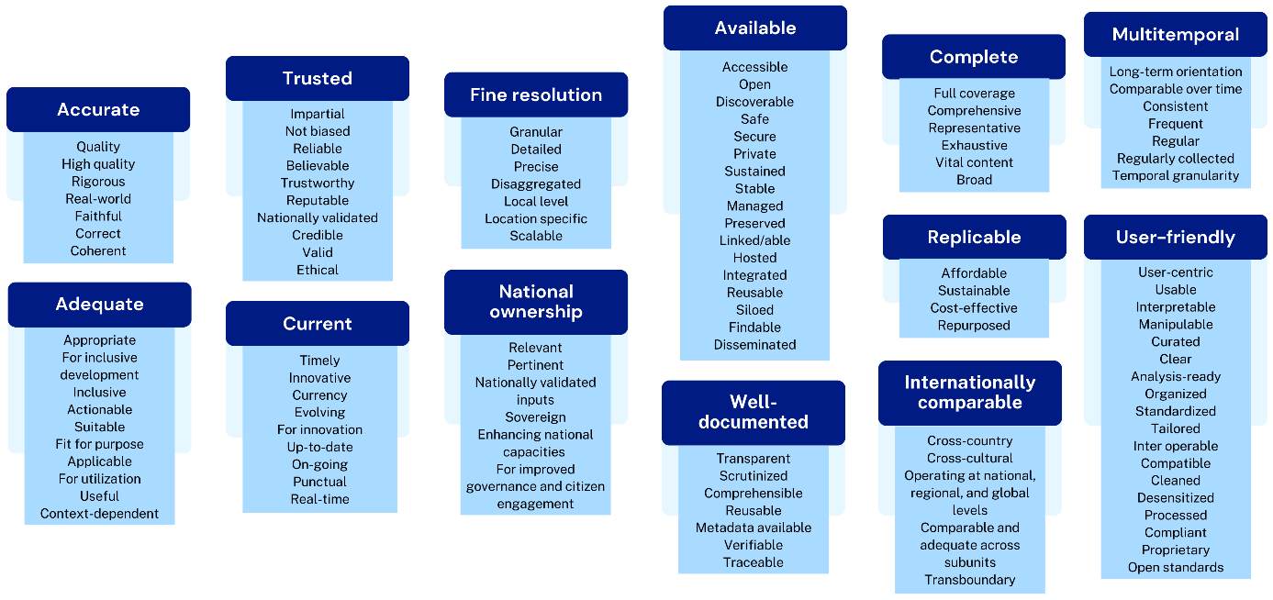
Extended Fig. 1 Affinity diagram of characteristics for SDG indicator data. Individual characteristics are grouped by affinity. Primary characteristics are shown in dark blue boxes.
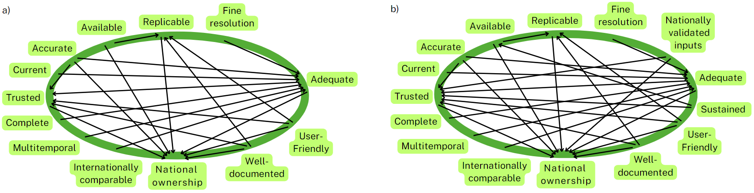
Extended Fig. 2 Interrelationship diagram of data characteristics. Arrows indicate influence direction. Diagrams correspond to a) the first version and b) the revised and definitive version.

Extended Table 1 Dataset scores calculated from the individual criterion values.
Pressure: Datasets* | Original cover loss | Impervious  surface | Not viable habitat /passage | Pollution potential | Dataset score
Pressure: Datasets* | CI=4** | CI=3 | CI=2 | CI=1 | Dataset score
BE: Urban areas | 1 | 1 | 1 | 1 | 10.00
PD: Densely populated areas  EI: Densely illuminated areas | 1 | 1 | 1 | 1 | 10.00
OG: Wells, depots, refineries, stations, filling stations | 1 | 1 | 1 | 1 | 10.00
EI: Power plants, dams, substations, power towers, wind turbines | 1 | 1 | 1 | 0 | 9.00
RR: Primary roads, railways,  BE: Runways | 1 | 1 | 0.75 | 0.25 | 8.75
EI: Solar, power and hydroelectric plants | 1 | 0.75 | 1 | 0 | 8.25
RR: Secondary roads | 1 | 1 | 0.5 | 0.25 | 8.25
BE: Settlements, ports, sparse houses | 1 | 0.75 | 0.5 | 0.25 | 7.50
M: Mining areas | 1 | 0.25 | 0.75 | 1 | 7.25
LU: Artificial water surfaces | 1 | 0 | 1 | 0 | 6.00
RR: Country roads | 1 | 0.5 | 0.25 | 0 | 6.00
LU: Pasture | 1 | 0 | 0.75 | 0 | 5.50
LU: Agriculture | 1 | 0 | 0.5 | 0.25 | 5.25
OG: Pipelines | 1 | 0 | 0.5 | 0.25 | 5.25
EI: Transmission and power lines | 1 | 0 | 0.5 | 0 | 5.00
LU: Tree plantations | 1 | 0 | 0.25 | 0 | 4.50
RR: Trails | 0 | 0.25 | 0.25 | 0 | 1.25
*Pressure corresponding to each dataset. BE: Built environments, LU: Land use, PD: Population density, RR: Roads and railways, EI: Electrical infrastructure, OG: Oil and gas, M: Mining.
**CI: Criterion importance

Extended Table 2 Precedence order and speed calculation according to the transportation means and environmental features.
Transportation means and environmental characteristics in order of precedence | Categories | Average speed (km/h)
1. Roads | Primary | 60
1. Roads | Secondary | 40
1. Roads | Tertiary (country roads) | 30
2. Coastline (navigation) |  | 20
3. Waterways (rivers and lakes) |  | slope (%)
3. Waterways (rivers and lakes) | Elevation* | <5 | 5-10 | 10-15 | 15-25 | >25
3. Waterways (rivers and lakes) | <450 | 15 | 7.5 | 3.8 | 1.9 | 1.4
3. Waterways (rivers and lakes) | 450-700 | 7.5 | 3.9 | 2.7 | 1.9 | 1.4
3. Waterways (rivers and lakes) | 700-1800 | 3.8 | 2.7 | 2.0 | 1.7 | 1.4
3. Waterways (rivers and lakes) | 1800-2800 | 1.9 | 1.9 | 1.7 | 1.4 | 1.3
3. Waterways (rivers and lakes) | >2800 | 1.4 | 1.4 | 1.4 | 1.3 | 1.2
4. Agriculture (walking) |  | $${10.560326*slope (\%)}^{-0.199553}$$
5. Forest, shrubs, and herbaceous vegetation (walking) | Non-flooded | $$-0.975931*ln{(slope \left(\%\right)) + 6.761258}$$
5. Forest, shrubs, and herbaceous vegetation (walking) | Flooded | $$\frac{-0.975931*\ln{(slope \left(\%\right)) + 6.761258}}{2}$$
* Metres above sea level

Extended Table 3 OSM tags of Road types
Dataset | OSM key | OSM values
Primary | highway | living_street, motorway, motorway_link, primary, primary_link, residential, service, trunk, trunk_link
Secondary | highway | secondary, secondary_link
Country roads | highway | bridleway, tertiary, tertiary_link, track, track_grade1, track_grade2, track_grade3, track_grade4, track_grade5, unclassified, unknown
Trail | highway | footway, path, cycleway, pedestrian, steps

Extended Table 4 OSM tags of Electrical Infrastructure datasets.
Dataset | OSM key | OSM values
Power plants | power | plant
Power plants | plant:source | solar
Dams | waterway | dam
Substations | power | substation
Power lines | power | line
Power tower | power | tower
Wind turbines | generator:source | Wind

Extended Table 5 Pressures scoring from visual interpretation
 |  | Areas (direct pressure) | Lines or points (direct pressure) | Indirect pressure
Visual pressures |  | Urban areas, crops, pasture, disturbed vegetation, forestry | Roads (paved, unpaved, private), railways, tracks, human dwellings, navigable waterways, infrastructure, Other | Roads, navigable waterways, settlements
Visual scoring criteria |  | By coverage of the plot | By occurrences within the plot | By occurrence around the plot (~5 km)
Scores | 0 | 0% | 0 | No
Scores | 1 | 1-12% | 1 | Yes
Scores | 2 | 13%-50% | 2 | -
Scores | 3 | >50% | >2 | -

Extended Table 6 Scoring template of the actionable characteristics for Input and Result analysis.
Input-dependent actionable characteristic (IDAC) | Scoring method
Accurate | Input analysis: As accuracy reports vary in context and metric (e.g. confusion matrix, F1 score, overall accuracy, Root mean squared error (RMSE), MAE), we assessed whether any accuracy metrics were available to inform users. A high qualification was assigned if such metrics were available and null if not.  Result analysis: We evaluated accuracy by comparing it across Human Footprint (HF) versions. We compared the validation metrics (RMSE, kappa index and R²) across all HF versions by assigning 0 and 1 to the lowest and highest scores and a proportional score to the intermediate one. In the case of RMSEs, we used the difference of the normalized values from 1 (1 – RMSE). The final score was obtained by adding the three individual scores.
Complete | Input analysis: It was not possible to evaluate spatial or thematic completeness for the input datasets.  Result analysis: Thematic or attribute completeness was assessed by comparing the number of attributes across different HF versions. We calculated the sum of categories within each pressure and the total pressures within each HF version. These sums were normalized across HF versions, multiplied by 1.5, and added.
Nationally validated | Input and result analysis: If the dataset came from a National Statistical System (NSS) source (e.g., the Cartography National Institute, a ministry), it was qualified as high, a non-official dataset knowingly adopted by country users as a medium and a non-NSS source as low. We assumed that datasets produced within the NSS are validated for use at the national level, although we acknowledge this might not always be the case.
Internationally comparable | Input and result analysis: Information allowing for assessing comparability across countries was usually lacking, even if documentation existed. We qualified as high if datasets covered Peru and Ecuador or if high comparability in categories and algorithms existed. Datasets covering only one country qualified as low.
Multitemporal | Input and result analysis: Each dataset update since 2012 received a mark, with minimum and maximum scores of 1 and 3.
Current | Input and result analysis: We calculated the difference between 2024 and the last update of the input dataset and qualified as high if the difference was 3 years or less, medium up to 6, low up to 10 years or less, and null if the difference was higher.
Fine resolution | Input and result analysis: We established a scoring scheme for scales (vector layers) and resolutions (rasters). Bigger scales (e.g. 1:25.000) received higher scores than smaller scales (e.g. 1:500.000). Scales were converted to resolutions in metres by dividing the scale denominator by 2000^{189,190} according to Table S 4.  Specific vector datasets lacked a defined scale, or the scale was deemed irrelevant for this study. A workaround involved comparing a dataset with satellite imagery and other datasets possessing known scales. For instance, the evaluation of nationally produced and OpenStreetMap (OSM) road datasets relied on criteria such as completeness (detectability of roads in high-resolution imagery) and accuracy (alignment of roads in datasets with imagery). OSM outperformed official sources in both countries. Consequently, the largest scale from official road datasets (1:50,000) was assigned. Datasets were excluded from the calculation when this methodology was unfeasible.
IDAC score average | Result analysis: We calculated the IDAC average to evaluate the overall performance of the maps.
Management-dependent actionable characteristic | Scoring method
Sustained | Input analysis: A high qualification was given if the dataset was openly available online, medium if online access was restricted, and low if it was unavailable without a request.
Well-documented | Input analysis: We evaluated whether guidance on proper usage and methods was provided. A high qualification was assigned if both were available, medium if only one was present and null if neither was found.
User friendly | Input analysis: We qualified as high if the documentation was intended for a broad audience (not overly complex) and all information could be accessed from a single source (e.g. website), medium if only one of these criteria was met, and low if neither was fulfilled.

Supplementary information
Table S 1 Input-dependent actionable characteristics scoring in Peru and Ecuador.
HF version | Accurate | Fine-  resolution | Nationally  validated | Internationally  comparable | Multitemporal | Current | Complete | Average
Peru
SDG15 HF | 3.00 | 2.53 | 1.66 | 2.64 | 1.70 | 2.50 | 3.00 | 2.43
Multitemporal HF | 0.92 | 2.03 | 1.67 | 2.80 | 2.80 | 2.80 | 1.38 | 2.06
Official HF | 0.39 | 2.63 | 3.00 | 1.00 | 1.00 | 1.19 | 2.50 | 1.67
Ecuador
SDG15 HF | 3.00 | 2.58 | 2.03 | 1.97 | 1.58 | 2.34 | 3.00 | 2.36
Multitemporal HF | 0.27 | 1.92 | 2.25 | 1.42 | 2.75 | 2.75 | 1.14 | 1.78
Official HF | 0.67 | 2.78 | 3.00 | 1.00 | 1.49 | 2.03 | 2.72 | 1.95

Table S 2 Summary of arrows in and out as indicated in the interrelationship diagram of SDG dataset characteristics.
Characteristics | a) |  |  | b)
Characteristics | In | Out | Level | In | Out | Level
National ownership | 7 | 0 | 1 | 8 | 0 | 1
Trusted | 4 | 1 | 2 | 6 | 1 | 2
Replicable | 3 | 1 | 2 | 3 | 1 | 2
Adequate | 6 | 2 | 2 | 6 | 2 | 2
Available | 0 | 2 | 3 | 1 | 2 | 2
Sustained | - | - | - | 0 | 2 | 3
User-friendly | 0 | 3 | 3 | 0 | 3 | 3
Well-documented | 0 | 3 | 3 | 0 | 3 | 3
Accurate | 0 | 3 | 3 | 0 | 3 | 3
Current | 0 | 1 | 3 | 0 | 1 | 3
Complete | 0 | 1 | 3 | 0 | 1 | 3
Multitemporal | 0 | 1 | 3 | 0 | 1 | 3
Internationally Comparable | 0 | 1 | 3 | 0 | 1 | 3
Fine resolution | 0 | 1 | 3 | 0 | 1 | 3
Nationally validated inputs | - | - | - | 0 | 2 | 3

Table S 3 Validation results of the different versions of Human Footprint maps in Peru and Ecuador.
Country | HF version | RMSE* | Kappa** | R²
Peru | SDG15 | 0.09 | 0.91 | 0.62
Peru | Multitemporal | 0.13 | 0.76 | 0.44
Peru | Official | 0.17 | 0.65 | 0.51
Ecuador | SDG15 | 0.11 | 0.87 | 0.69
Ecuador | Multitemporal | 0.17 | 0.6 | 0.57
Ecuador | Official | 0.17 | 0.5 | 0.65
*Root mean squared error
** The agreement tolerance was 20%.

Table S 4 Fine resolution scores according to scale and resolution.
Scale denominator | Resolution | Score
<= 50.000 | <=25 | 3
50.000 – 100.000 | 25 – 50 | 2.5
100.000 – 250.000 | 50 – 125 | 2
250.000 – 500.000 | 125 – 250 | 1.5
500.000 – 1.000.000 | 250 – 500 | 1
1.000.000 < | 500 < | 0.5

Supplementary files
250215_Datasets_HF_Nat_Sust_Español.docx
Link to code and data will be shared upon acceptance. Please get in touch with the corresponding author for preliminary use.

