Transitional-Tapping AFM: Probing Stochastic Molecular Dynamics at Sub-k_{B}T Precision
Arindam Phani¹, Allegra Behr^{1†}, Balasubramanian Srinivasan¹, Eric Finot², Thomas Thundat³, Seonghwan Kim^{1,*}
¹Department of Mechanical and Manufacturing Engineering, University of Calgary; Calgary, Alberta, Canada.
²Laboratoire Interdisciplinaire Carnot de Bourgogne ICB UMR 6303, Université Bourgogne Europe, CNRS, F-21000 Dijon, France
³Chemical and Biological Engineering, University at Buffalo (SUNY); Buffalo, New York, USA.

†Present address: Biomedical Engineering‚ Technische Hochschule Lübeck, Universität zu Lübeck; Lübeck, Germany.
*Corresponding author Email: sskim@ucalgary.ca

Supplementary Information
Error Analysis and Mean Deformation Analysis:
We determine the mean surface deformations at the tapping amplitude steps that allows decoding the energetics. The correlation length analysis across all pixels justifies the deconvolution scheme explained in text.
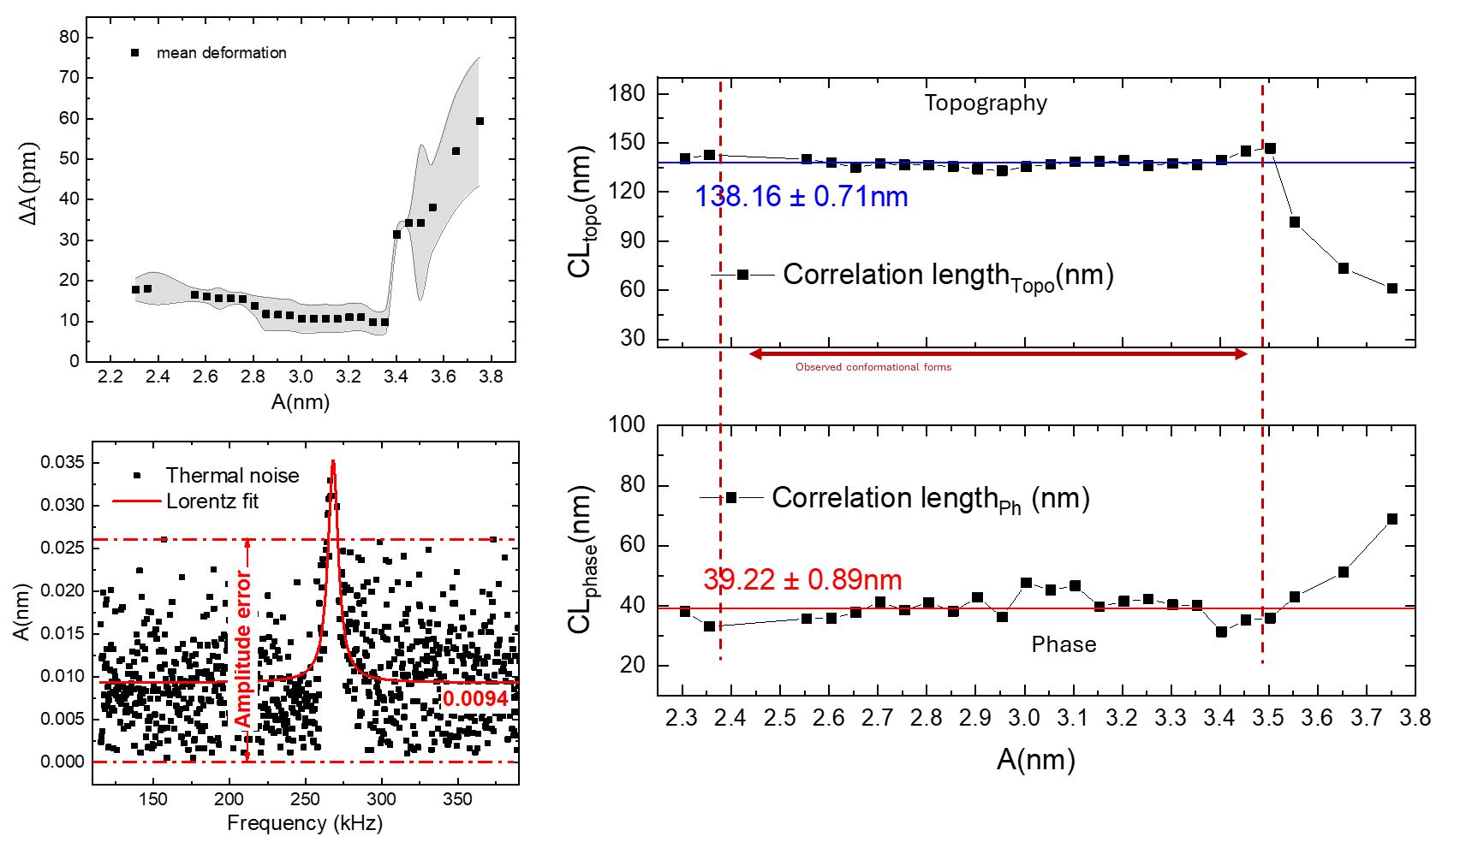
Figure S1. The measured mean deformation and the thermal noise characteristics of the employed cantilever under weak driving conditions as implemented in the transitional tapping mechanism. The correlation length estimations of the topographic and phase channels clearly emphasize the resolvability of the data we present in the manuscript and not noise limited representations. The obtained correlation length also emphasized the fact that the optimization of the folds is progressing through long-range cooperativity.
Deconvoluted Energetics and folding coordinate:
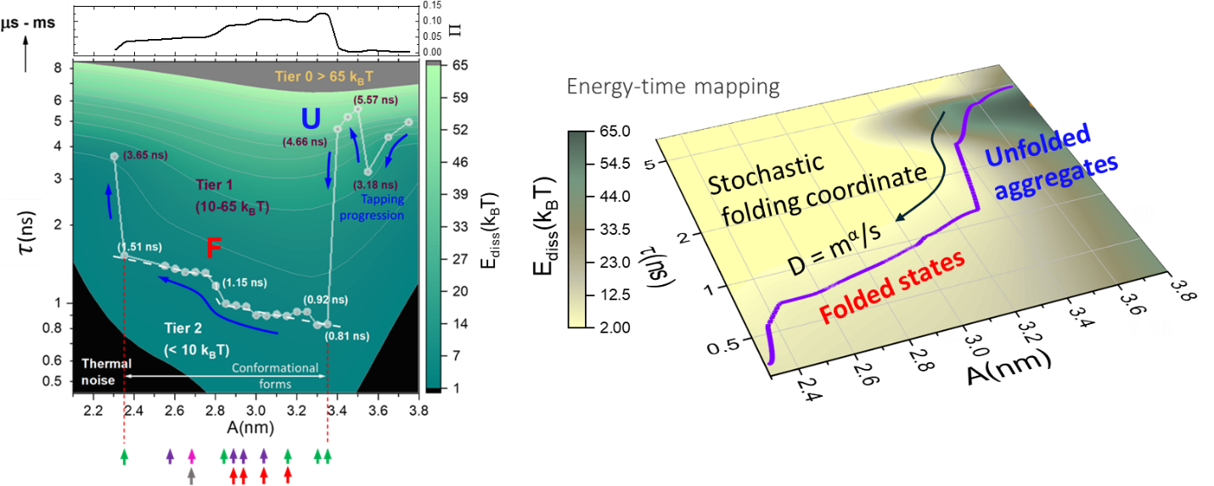
Figure S2. Deconvolution of energetics of the structural forms showing the E_{diss} maps vs the residual timescales $τ$ at each tapping amplitude step as described in main text. The color coded PDB predicted forms generated from https://www.rcsb.org/3d-view/ are detailed in the main manuscript to correspond and represented here in color coded arrows against the tapping amplitude steps. $Π$ denotes the stochastic jump probabilities of forming a metastable conformer. The stochastic folding coordinate is also highlighted which is discussed in detail in Methods in the main manuscript. Unfolded states appear at Tier 1 while folded forms are evident in Tier 2.
Below we give a short summary of the Transitional tapping methodology and the deconvolution scheme of the energetics that entails the key aspect of the work.
A.1 Methodology
Protein and DNA structures have been spatially resolved by atomic force microscopy before²⁻⁴ . However, characterization of their heterogeneities from physical and energy perspectives, especially small proteins, remain unexplored technologically. A 3D time-energy-structure map imitating holography is essential to address this challenging problem. The missing link has been the simultaneous mapping of protein structure and energetics at the nanoscale. In a recent work⁵ we demonstrated a Transitional Tapping Atomic Force Microscopy (Tt-AFM) method (Patent pending – US Patent App. 18/282,136) to decouple heterogeneous energy loss mechanisms at the nanoscale. The method is the first of its kind to image and map thermodynamic heterogeneities at the nanoscale without enforcing surface indentation. This is crucial for imaging biomolecules that are inherently heterogeneous. Here in this work, we demonstrate application of the technique to capture the metastable relaxations of a soft protein surface on small energy perturbations. Capturing metastability is essential to understand the energetics of conformational progressions as discussed in detail in the manuscript. We take this opportunity to expound a short summary of the method that was earlier published in⁵ for the readers to appreciate the importance of new observations and follow the technique.
A.1.1 Short summary of Transitional Tapping AFM (TT-AFM) method
We elucidated in⁵ that phase-contrast in tapping mode AFM results from dynamic tip-surface interaction losses which are constitutive in distinguishing soft and hard features at the nanoscale. Generally, phase-contrast has been explained via equilibrium/steady-state losses that essentially entail homogeneous Boltzmann-like distributions. Tt-AFM revisits the origins of phase-contrast with ultra-light tapping ($A<3 nm$), $A$ being the tapping amplitude. A surprising two-stage distribution response in phase is found when imaging soft molecules like drug clusters. The origin of a secondary heterogeneous phase response in Tt-AFM is explained by considering fluctuational transitions about the 0$°$ phase. This allows decoupling of a heterogeneous loss component, which alludes to metastable viscous relaxations that originate from surface perturbations during the small amplitude tapping operation. The ultra-small amplitude operation records information of the metastable relaxations, since the tip and surface are in continuous interaction during its complete oscillation cycle. The tip essentially traces the energy relaxation basins of the soft surface while it slowly relaxes back to equilibrium over multiple oscillation cycles. Elastic and viscous coefficients are also quantifiable against the resulting strain rate from surface deformations at the fixed tapping frequency. Interestingly, the transitional heterogeneous losses emerge as the dominant loss mechanism, outweighing homogeneous losses for a soft material as the authors concluded. Capturing the heterogeneous phase-contrast from Tt-AFM opens a new domain to gather insights on the bio-physical origins of heterogeneities in soft-bio-matter e.g., proteins, single cancer cell, tumors, and soft-tissues in general, which we employ here.
The operation typically relies on systematic optimization of a dynamic operational tapping amplitude regime $A$ in the order of $1-3 nm$ and a steady-state tip-surface interacting time τ by modulating the AFM control parameters. These parameters are sample dependant and on the resonance dynamics of the cantilever tip employed for imaging. Successful implementation of Tt-AFM relies on systematic determination of an average deformation $α$ of the soft-surface relative to the operational tapping amplitude$A$ and optimizing the steady-state timescale to closely correspond to the relaxation timescale (τ_{surf}) of the surface following the deformations. This is achieved iteratively by changing the P and I parameters of AFM controller in the limit of the average deformation amplitude $α$ ≠ 0 for a set setpoint amplitude $A \sim 1-3 nm$.
A.1.2 Residual timescale $τ$ in Tt-AFM: Fundamentally, from resonance dynamics, phase lag appears as a delay-bandwidth product $Δϕ=Δf⋅τ$ vide $A=A_{0}e^{-i\left(∆f∙τ\right)}$, where $Δf=f-f_{0}$ is the shift in fundamental frequency $f_{0}$ on tip approach and $τ$ is the finite time delay or response timescale from tip-surface interactions. The steady state amplitude $A$ (set point amplitude in this case) evolve from the time dependent interplay of the many microscopic variables or the degrees of freedom (DOFs) at the tip-surface junction with $-iΔϕ$ necessarily capturing the dynamics of the oscillating AFM tip. In principle, $Δϕ$ captures both a steady state and a transient component depending on how DOFs at the tip-surface junction are manipulated. TT-AFM focuses on the transients in the limit $Δϕ_{±}→0$ to understand the effect of heterogeneities.
Now we can derive from frequency identity –
$$f=1/t ⟹ \frac{df}{dt}=-\frac{1}{t^{2}} giving, \frac{ df}{dA}=-\frac{dt}{t^{2}}\frac{1}{dA}$$
$$⟹ \frac{dt}{dA}=-t^{2}\frac{df}{dA} ⟹ ∆t=-\left(t^{2}\frac{df}{dA}\right) ∆A$$
where $∆t$ essentially is the dynamic timescale of the evolving deformations $∆A$. From $∆t$ distribution, the residual time $τ$ is determined as described in the manuscript. $t$ in the final equation becomes the time the tip spends at each pixel based on the set scanning rate. For our set operational parameters $t=2.24ms$for a scan frequency rate of 0.35Hz with 156-pixel resolution scans. The resonance dynamics of the cantilever in this experiment is tuned such that the dynamics as shown in Fig. S2 below gives us a time-deformation constant $τ/〈∆A〉=83.35 ns/nm$ over the operational regime of TT-AFM setpoint amplitudes and optimized dynamic timescale. It is interesting to note here how the tip dynamics change in the transitional tapping mode compared to conventional tapping dynamics.
Tt-AFM operation relies on enforcement of a finite correlation time $τ_{c}→τ_{osc}≈τ_{sur}$, in terms of amplitude setpoint $A$ and integration time of the PI controller. The choice of P and I gains in the AFM controller is critical at our low scanning rates of operation, necessary to ensure that the tip is stationary in time (along scan direction) i.e., at every pixel of the image. In our experiments, we set P and I gain such that the integral timescale is of the order $τ_{i}≡τ_{c}=6.7\text{ m}s$, within 1 order of magnitude of $τ_{osc}=2\sqrt{3}Q/\left(2πf\right)≃0.64 ms$ corresponding to the fundamental mode $291 kHz$ and $Q=340$ of the tapping mode cantilever employed. The data per pixel is thus sampled over $≅658$cycles satisfying the condition of ergodicity making the collected data channels and their probability distributions statistically relevant to the fluctuational transients. From the amplitude images and the computed time-deformation constant we generate time-map images for each setpoint as shown in Fig. S7 of supplementary information.
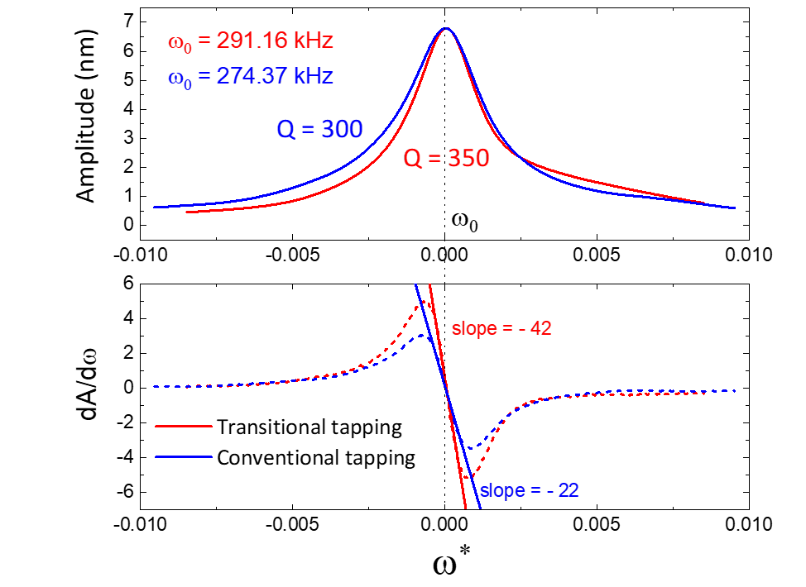
Figure S3. Resonance characteristics of tuned Tt case in comparison to conventional tapping case. The Q factor increases along with increase in the fundamental frequency. The increase in ${dA}/{dω}$ slopes signify the apparent increase in stiffness of the Tt contact resonating mode and amplitude resolvability above the noise floor of $\sim$ 8 pm in the conventional tapping case. The higher harmonic amplitude in Tt increases by an order of magnitude to $\sim$70 pm for the highest observed harmonic (Fig 1 in main text). Appearance of the higher harmonics in the Tt mode densely packs energy in response to higher force gradients as discussed in main text.
The probability distribution widths of the time histograms characterize a measure of the residual timescale from stochastic considerations, for each observed structural conformer as a function of the setpoint amplitudes. The apparent structural similarity but a disparity in residual timescales signify the energetics of the evolving structures as a function of tip-surface interactions in the Tt-AFM.
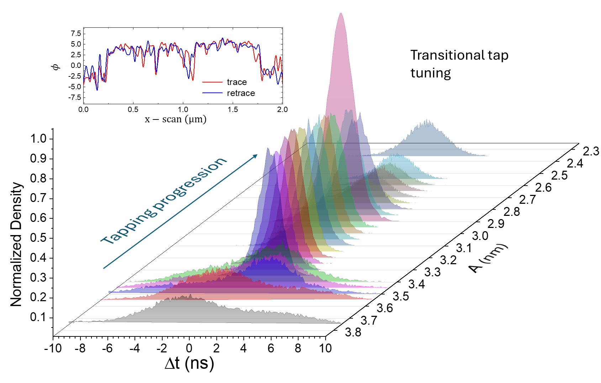
Figure S4. The time histograms at the tapping amplitude steps. Inset shows the phase-retrace transition to non-Gaussian distribution at the tuned Tt condition.
In the manuscript we discuss in detail the significance of transitions between metastable and stable energy conformations that becomes apparent from the nature of the heterogeneous phase component in relation to the residual timescales computed from the dynamic tip-surface interactions.
A1.3 Deconvolution of Heterogeneous phase and corresponding Energy dissipation: Under the fluctuational conditions of Tt-AFM set by optimization of $τ_{c}>τ_{osc}$, it may be inferred that the dynamic amplitude measured at each pixel will be proportional to a phase lag $Δϕ\text{ = }τ_{c}⋅\left(ω-Δ_{ω}\right)$ giving the ensemble averaged amplitude as $A+α=χ\left(f\right)A_{0}e^{-iΔϕ}$, $α$being the mean surface deformation at each amplitude setpoint and $χ\left(f\right)$ signifying the amplitude response function as a function of frequency $f$ as shown in Fig S1. A unique complex probability distribution in the zeroth order of $τ_{c}Δf$ appears, signifying energy losses via both homogenous and heterogeneous mechanisms. To explain the loss mechanisms, authors AP and SK considered how a change in parameter, $A→A+α$ , would effect a change in the average value of its dependent variable $\left\langle Δϕ\right\rangle$. Under a generalized assumption of coupled homogenous and heterogeneous loss mechanisms with considerations of correlation timescales in Tt-AFM operation, the net energy dissipation is given by $ΔE_{dis}≡{\left\langle Δϕ\right\rangle }_{A+α}- {\left\langle Δϕ\right\rangle }_{A}∝\text{ exp}\left(-\frac{{σ_{AG}}^{2}}{{σ_{AL}}^{2}}\right)$ , where $σ_{AG}$ and $σ_{AL}$ are the respective homogenous and heterogeneous standard deviations of $Δϕ_{+}$ & $Δϕ_{-}$ for a surface deformation $α$ at the typical small oscillation amplitude of 1-3 nm. Fig 2 (Steps 2 and 3) in main text shows the decoupling of heterogeneous phase component from obtained phase images giving the dissipation maps for tapping amplitudes in the order of 2.36 – 3.8 nm in Fig 3. Further details on the nature of the heterogeneous phase and the dissipated energy can be referred to in⁵.
We must note here that folding indeed is a cooperative activity, and more experimental tests are required for multiple proteins to establish the relevant scaling property. It is expected to be dependent on the number of amino acids and their sequence that define the respective chain. We will take up this aspect in details in another separate article to do justice to discussions without deviating from the main narrative in this article.

B. Stochastic Dynamics vs Time scaling behavior
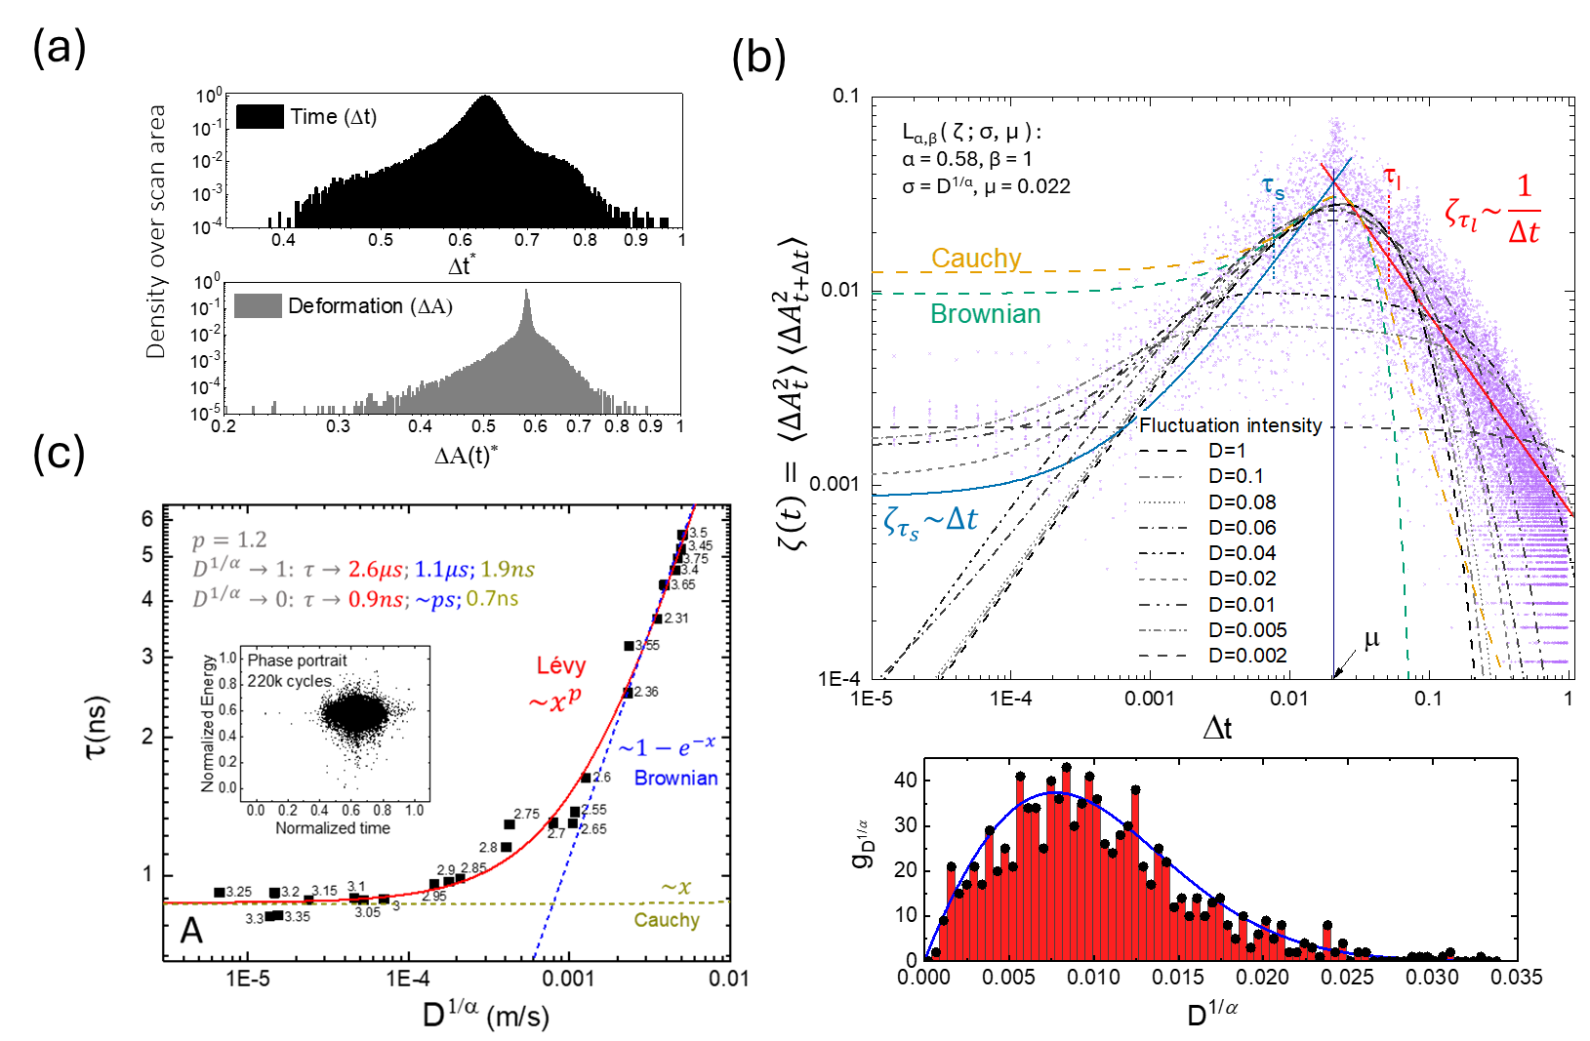
Figure S5. Dynamic scaling of time and stochastic fluctuational scale. A more detailed theoretical exposition explaining the scaling behavior will be reported elsewhere.

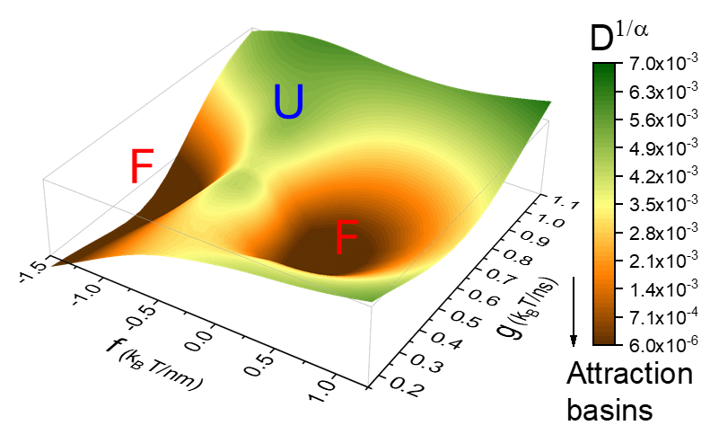
Figure S6. Folding follows the stochastic attraction basins of the $D^{1/α}$.

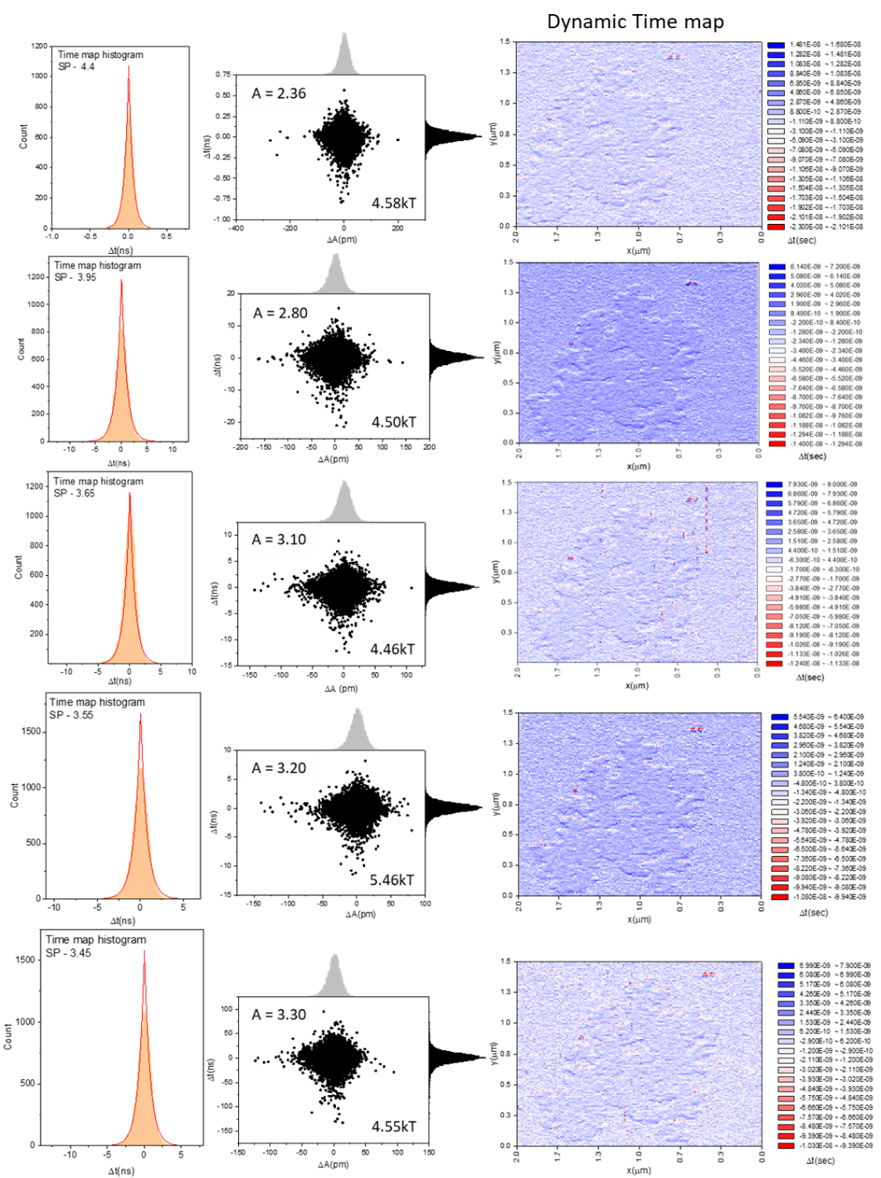

Figure S7. Dynamic time-map from amplitude images considering pixel deformation and the time-deformation constant of the cantilever dynamics in the Tt-AFM operation regime.

C. Alternate consideration of differential Chapman-Kolmogorov equation to explain energetics:
As an alternative approach to derive the master equation, we may consider Chapman-Kolmogorov equation as a differential equation to evaluate the continuity properties of the process under considerations. We can derive a very general formulation of the stochastic process underlying the dynamics of Tt-AFM operation. We start with the assumption that the stochastic dynamics satisfies the general continuity condition,
$$\lim_{∆t→0}{ \frac{1}{∆t}\int{p\left(x,t+∆t|z,t\right) dx}=0 ; \left|x-z\right|>ε (1) }$$
where for any value of $ε>0$ the uniformity in $z,t and ∆t$ holds. In other words, the probability for final position $x$ is distinctly different from that in $z$. Considering the very general results of Tt-AFM imaging (Fig S3 - phase trace-retrace in time) it is convenient to divide the differentiability conditions into parts, one corresponding to continuous motion and the other - discontinuous jumps satisfying conditions:
- $\lim_{∆t→0}{ p\left(x,t+∆t|z,t\right)/∆t=W(x|z,t)}$uniformly in $x,z$ and $t$ for $\left|x-z\right|≥ε$ ;
- $\lim_{∆t→0}{ \frac{1}{∆t}\int_{ \left|x-z\right|<ε}{ \left(x_{i}-z_{i}\right) p\left(x,t+∆t|z,t\right) dx}=X_{i}\left(z,t\right)+O\left(ε\right)}$; and
- $\lim_{∆t→0}{ \frac{1}{∆t}\int_{ \left|x-z\right|<ε}{ \left(x_{i}-z_{i}\right) \left(x_{i}-z_{j}\right) \left(x_{i}-z_{k}\right) p\left(x,t+∆t|z,t\right) dx}=Y_{ij}\left(z,t\right)+O\left(ε\right)}$
with, (ii) and (iii) uniform in $x,z$ and $ε$ .
Following the continuity condition of (1) the process can exhibit discontinuous paths when $W(x|z,t)$ vanishes $∀ x≠z$ suggesting that $W(x|z,t)$ must describe discontinuous motion while $X_{i}\left(z,t\right)$ and $Y_{ij}\left(z,t\right)$ should be connected to continuous motion.
From our obtained energy loss results – the saddle surface in Fig 4(b), that is twice differentiable in parameter space $R∈\left(x,z\right)$, it can be shown from probability analysis⁶ that $W\left(x | z,t\right)$ reduces to Cauchy process with general distribution form $1/\left[π{(x-z)}^{2}\right]$. Now, by our general definition of probability conditions, $W\left(x | z,t\right)=0$ unless the parameter space of integration is contained in $R$ . However, the conditions on $X_{i}\left(z,t\right)$ and $Y_{ij}\left(z,t\right)$ can result in discontinuities in solutions of (ii) and (iii) since their probabilities can change discontinuously while $z$ crosses the $R$ boundary. This reflects the fact, that in general no transitions are allowed from outside $R$ to inside $R$ (the experimental parameter space).
Under the conditions (i), (ii) and (iii) as described above hold true, the energy loss mechanisms as a function of the discrete setpoint amplitudes then can be interpreted as three processes – jump, drift and diffusion on solving the integral functions by parts with appropriate specifications of $X_{i}\left(z,t\right)$ and $Y_{ij}\left(z,t\right)$. We can consider the change in dissipated energy among the setpoint amplitudes as either appearing from a jump process like an impulse change when $X_{i}\left(z,t\right)=Y_{ij}\left(z,t\right)=0$, and a combination of drift process with a constant line or a diffusion process with a linear gradient with the condition that $X_{i}\left(z,t\right)$ and $Y_{ij}\left(z,t\right)$ don’t vanish.
Considering the cases of energy loss changes: ${∆E}_{diss}<0.15 k_{B}T$ (our calculated noise floor equivalent of $20 pm$ oscillations) as jump processes, ${0.15<∆E}_{diss}<1 k_{B}T$ as continuous drift and ${∆E}_{diss}>1 k_{B}T$as a diffusion process with linear gradient, we are able to numerically solve the differential form of the Chapman-Kolmogorov equation generating a plausible transition path as shown from experimentally determined values of heterogenous energy losses. The solution essentially depicts a piecewise continuous path made of pieces which correspond to a diffusion path with a non-zero drift, onto which a fluctuating part is superimposed, while the jumps result in the general piecewise nature of the path. A more rigorous treatment of the differential Chapman-Kolmogorov equation can be attempted. Our analysis however reveals a new view of the rugged landscape from very general stochastic probability considerations explained in some detail in the manuscript.
Figure S8. Illustration of a possible transition pathway in the rugged landscape in presence of discontinuous jumps, drift, and diffusion from solution of C-K equation using fitting results from previous work⁵. Here the free energy change $ΔG$ in residual time $τ,$ $-ΔG\left(τ\right)≡∆E_{diss}$ in $k_{B}T$. Experimental error bars for each data point are smaller than the symbol dimensions. Tier signifies the unfolded states at 50 $k_{B}T$ energy depth while folded states appear at Tier 2 at 4-6 $k_{B}T$ energy depth.

References:

(1) Thundat, T.; Allison, D.P.; Warmack, R.J. Stretched DNA structures observed with atomic force microscope. Nucl. Acid. Res. 1994, 22(20), 4224-4228.
(2) Heath, G. R.; Kots, E.; Robertson, J. L.; Lansky, S.; Khelashvili, G.; Weinstein, H.; Scheuring, S. Localization Atomic Force Microscopy. Nature 2021, 594 (7863), 385–390. https://doi.org/10.1038/s41586-021-03551-x.
(2) Rico, F.; Rigato, A.; Picas, L.; Scheuring, S. Mechanics of Proteins with a Focus on Atomic Force Microscopy. J Nanobiotechnology 2013, 11 Suppl 1. https://doi.org/10.1186/1477-3155-11-S1-S3.
(3) Ruggeri, F. S.; Šneideris, T.; Vendruscolo, M.; Knowles, T. P. J. Atomic Force Microscopy for Single Molecule Characterisation of Protein Aggregation. Archives of Biochemistry and Biophysics. Academic Press Inc. March 30, 2019, pp 134–148. https://doi.org/10.1016/j.abb.2019.02.001.
(4) Yu, H.; Siewny, M. G. W.; Edwards, D. T.; Sanders, A. W.; Perkins, T. T. Hidden Dynamics in the Unfolding of Individual Bacteriorhodopsin Proteins. Science (1979) 2017, 355, 945–950.
(5) Phani, A.; Jung, H. S.; Kim, S. Deconvolution of Dissipative Pathways for the Interpretation of Tapping-Mode Atomic Force Microscopy from Phase-Contrast. Commun Phys 2021, 4 72.
(6) Gardiner Crispin W. Handbook of Stochastic Methods for Physics, Chemistry and the Natural Sciences, 2nd ed.; Haken Hermann, Ed.; Springer: New York, 1997.

