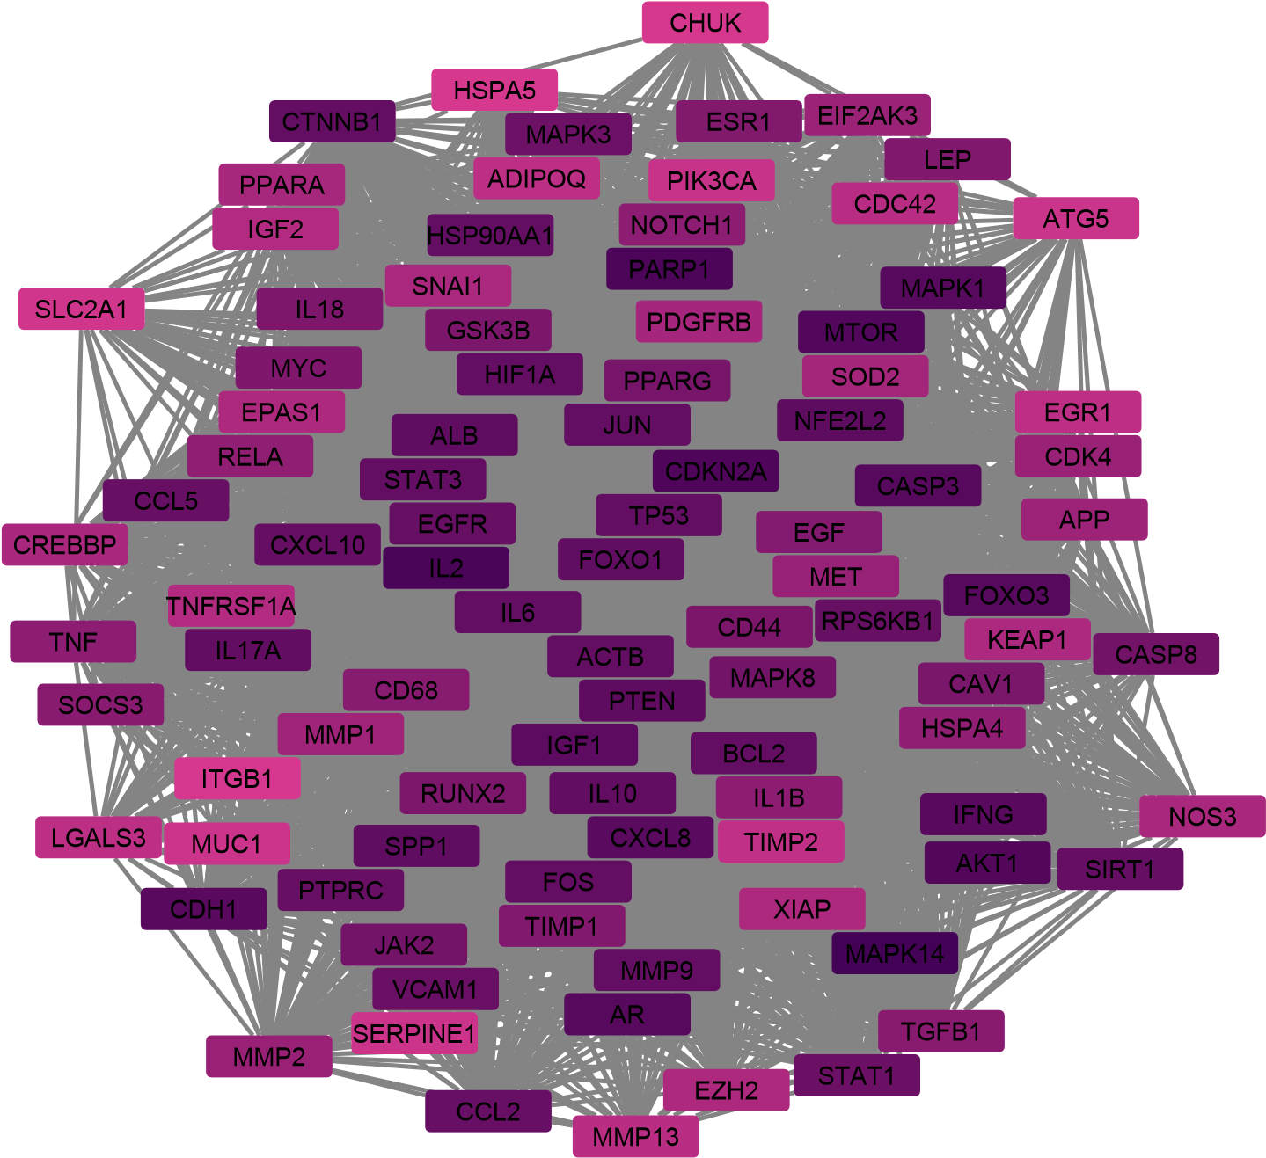
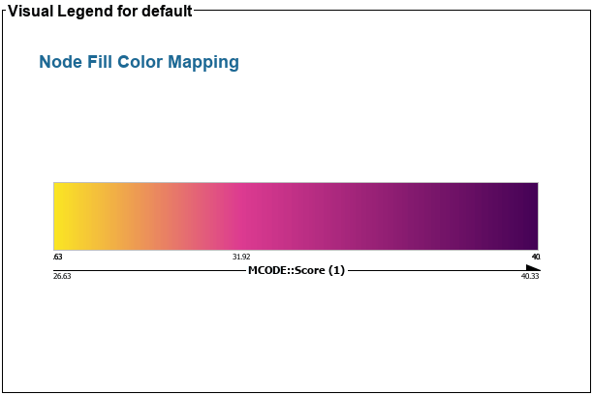
Figure S1. MCODE algorithm analysis in Cytoscape demonstrating Cluster 1

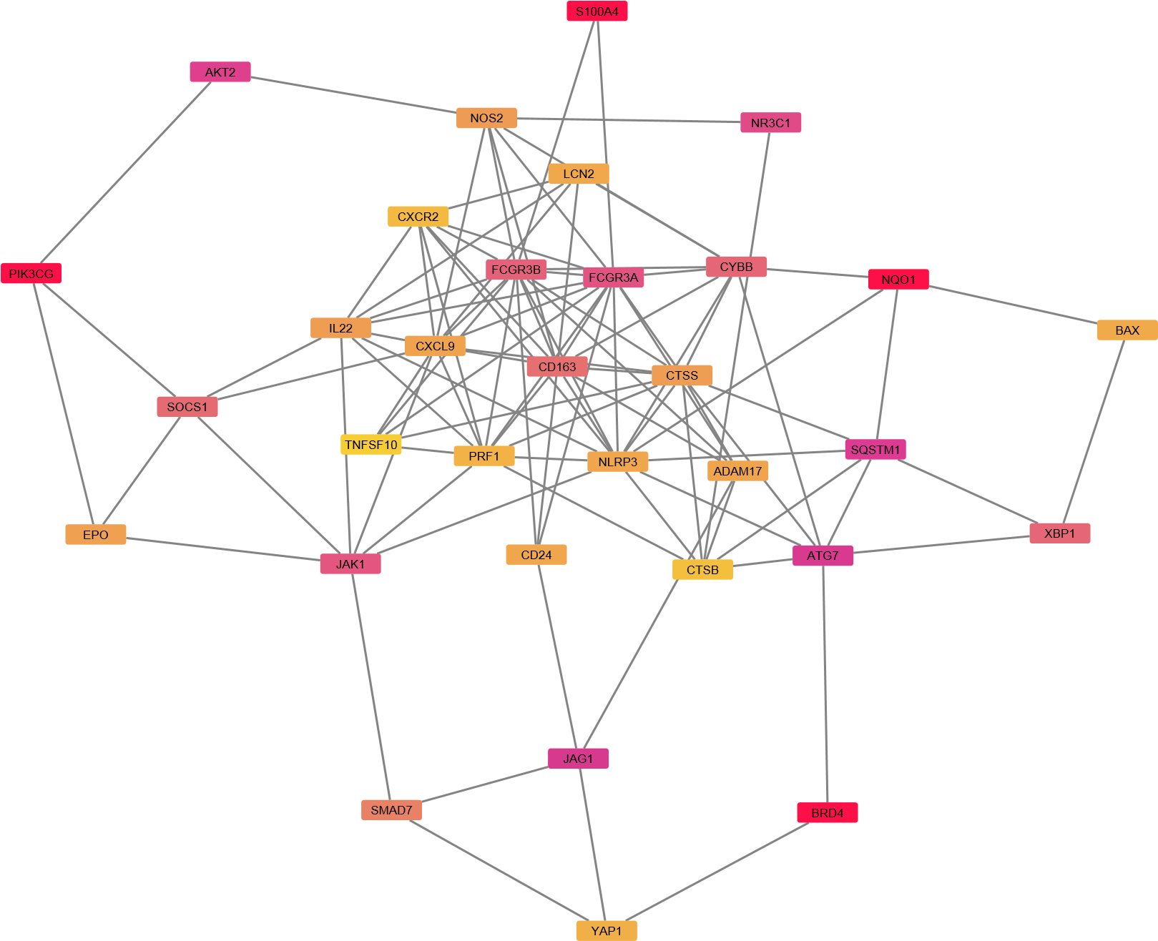
Figure S2. MCODE algorithm analysis in Cytoscape demonstrating Cluster 2

RIPK1
MAP3K7
CTSD
TLR1
FOSL1
H2AX
BNIP3
NR4A1
DNM1L
FOXA1
RARA
TNFAIP3
TNFRSF1B
TBK1

Figure S3. MCODE algorithm analysis in Cytoscape demonstrating Cluster 3
Table S1. Gene ontology annotation of biological process for the MCODE cluster 1 genes.
Term | Count | P Value | Genes | FDR
GO:0002376 | immune system process | 1.35E-34 | ITGB1, APP, CXCL8, SERPINE1, TNF, ACTB, LGALS3, CASP8, MYC, CASP3, AKT1, JAK2, IL10, HSP90AA1, PARP1, CHUK, MMP2, ADIPOQ, IL18, FOS, MMP9, SIRT1, RUNX2, IFNG, PIK3CA, IL1B, PPARG, TP53, CD44, NOTCH1, EPAS1, XIAP, FOXO3, HIF1A, RELA, CDC42, SOCS3, MAPK8, CCL5, CCL2, MAPK1, ATG5, MAPK3, EGR1, JUN, CREBBP, TGFB1, VCAM1, CDKN2A, STAT1, CAV1, STAT3, IGF2, IGF1, MAPK14, SOD2, ESR1, MTOR, IL2, CXCL10, IL6, PTPRC, RPS6KB1, LEP, BCL2, CTNNB1, CD68, IL17A, NFE2L2, EZH2 | 3.11E-33
GO:0051704 | multi-organism process | 2.88E-34 | ITGB1, APP, GSK3B, CXCL8, SERPINE1, PTEN, SLC2A1, TNF, LGALS3, CASP8, MYC, CASP3, AKT1, TIMP1, JAK2, IL10, HSP90AA1, PARP1, CHUK, MMP2, ADIPOQ, IL18, FOS, MMP9, SIRT1, TNFRSF1A, AR, IFNG, IL1B, PPARA, TP53, NOTCH1, FOXO3, HIF1A, EGFR, RELA, CDC42, MAPK8, CCL5, SPP1, CCL2, MAPK1, ATG5, MAPK3, JUN, TGFB1, VCAM1, NOS3, STAT1, CAV1, STAT3, IGF1, MAPK14, SOD2, ESR1, MTOR, CXCL10, IL6, PTPRC, RPS6KB1, CDK4, LEP, BCL2, CTNNB1, CD68, IL17A | 3.32E-33
GO:0032502 | developmental process | 1.86E-32 | ITGB1, APP, GSK3B, CXCL8, SERPINE1, PTEN, SLC2A1, KEAP1, TNF, ACTB, LGALS3, CASP8, CDH1, MYC, CASP3, AKT1, TIMP1, JAK2, IL10, PDGFRB, HSP90AA1, PARP1, CHUK, MMP2, ADIPOQ, IL18, FOS, MMP9, SIRT1, RUNX2, TNFRSF1A, AR, MMP13, IFNG, PIK3CA, IL1B, PPARG, PPARA, MET, TP53, CD44, NOTCH1, EPAS1, FOXO3, HIF1A, FOXO1, EGFR, RELA, CDC42, SOCS3, MAPK8, SPP1, CCL2, MAPK1, ATG5, MAPK3, EGR1, JUN, CREBBP, TGFB1, VCAM1, HSPA5, CDKN2A, EGF, NOS3, STAT1, CAV1, STAT3, IGF2, EIF2AK3, IGF1, MAPK14, SOD2, ESR1, MTOR, IL2, CXCL10, IL6, PTPRC, RPS6KB1, CDK4, LEP, BCL2, SNAI1, CTNNB1, CD68, IL17A, NFE2L2, EZH2 | 1.43E-31
GO:0040011 | locomotion | 2.51E-30 | ITGB1, APP, CXCL8, SERPINE1, PTEN, TNF, ACTB, LGALS3, CDH1, MYC, AKT1, TIMP1, JAK2, IL10, PDGFRB, HSP90AA1, MMP2, ADIPOQ, MMP9, SIRT1, IFNG, PIK3CA, IL1B, PPARG, MET, CD44, NOTCH1, FOXO3, HIF1A, EGFR, CDC42, CCL5, CCL2, MAPK1, MAPK3, JUN, TGFB1, VCAM1, HSPA5, EGF, NOS3, CAV1, STAT3, IGF1, MAPK14, SOD2, MTOR, CXCL10, IL6, PTPRC, RPS6KB1, LEP, BCL2, SNAI1, CTNNB1, IL17A, NFE2L2 | 1.44E-29
GO:0050896 | response to stimulus | 5.70E-30 | ITGB1, APP, GSK3B, CXCL8, SERPINE1, PTEN, SLC2A1, KEAP1, TNF, ACTB, LGALS3, CASP8, CDH1, MYC, CASP3, TIMP2, AKT1, TIMP1, JAK2, IL10, PDGFRB, HSP90AA1, PARP1, CHUK, MMP1, MMP2, ADIPOQ, IL18, FOS, MMP9, SIRT1, RUNX2, TNFRSF1A, AR, MMP13, IFNG, PIK3CA, IL1B, PPARG, PPARA, MET, TP53, CD44, NOTCH1, EPAS1, XIAP, FOXO3, HIF1A, FOXO1, EGFR, RELA, CDC42, SOCS3, MAPK8, MUC1, CCL5, SPP1, CCL2, MAPK1, ATG5, MAPK3, EGR1, JUN, CREBBP, TGFB1, VCAM1, HSPA5, CDKN2A, EGF, HSPA4, NOS3, STAT1, CAV1, STAT3, IGF2, EIF2AK3, IGF1, MAPK14, SOD2, ESR1, MTOR, IL2, CXCL10, IL6, PTPRC, RPS6KB1, CDK4, LEP, ALB, BCL2, SNAI1, CTNNB1, CD68, IL17A, NFE2L2, EZH2 | 2.62E-29
GO:0023052 | signaling | 1.44E-28 | ITGB1, APP, GSK3B, CXCL8, SERPINE1, PTEN, TNF, LGALS3, CASP8, CDH1, MYC, CASP3, AKT1, TIMP1, JAK2, IL10, PDGFRB, HSP90AA1, PARP1, CHUK, MMP2, ADIPOQ, IL18, FOS, MMP9, SIRT1, RUNX2, TNFRSF1A, AR, IFNG, PIK3CA, IL1B, PPARG, PPARA, MET, TP53, CD44, NOTCH1, EPAS1, XIAP, FOXO3, HIF1A, FOXO1, EGFR, RELA, CDC42, SOCS3, MAPK8, MUC1, CCL5, SPP1, CCL2, MAPK1, MAPK3, EGR1, JUN, CREBBP, TGFB1, VCAM1, HSPA5, CDKN2A, EGF, NOS3, STAT1, CAV1, STAT3, IGF2, EIF2AK3, IGF1, MAPK14, SOD2, ESR1, MTOR, IL2, CXCL10, IL6, PTPRC, RPS6KB1, CDK4, LEP, BCL2, SNAI1, CTNNB1, IL17A, NFE2L2, EZH2 | 5.50E-28
GO:0032501 | multicellular organismal process | 7.88E-26 | ITGB1, APP, GSK3B, CXCL8, SERPINE1, PTEN, SLC2A1, KEAP1, TNF, ACTB, CASP8, CDH1, MYC, CASP3, AKT1, TIMP1, JAK2, IL10, PDGFRB, HSP90AA1, PARP1, CHUK, MMP1, MMP2, ADIPOQ, IL18, FOS, MMP9, SIRT1, RUNX2, TNFRSF1A, AR, MMP13, IFNG, PIK3CA, IL1B, PPARG, PPARA, MET, TP53, CD44, NOTCH1, EPAS1, XIAP, FOXO3, HIF1A, FOXO1, EGFR, RELA, CDC42, SOCS3, SPP1, CCL2, MAPK1, ATG5, MAPK3, EGR1, JUN, CREBBP, TGFB1, VCAM1, HSPA5, CDKN2A, EGF, NOS3, STAT1, CAV1, STAT3, IGF2, EIF2AK3, IGF1, MAPK14, SOD2, ESR1, MTOR, IL2, CXCL10, IL6, PTPRC, RPS6KB1, CDK4, LEP, ALB, BCL2, SNAI1, CTNNB1, IL17A, NFE2L2, EZH2 | 2.59E-25
GO:0040007 | growth | 7.65E-22 | ITGB1, APP, GSK3B, NOTCH1, PTEN, FOXO3, HIF1A, EGFR, CDC42, CDH1, SPP1, AKT1, PDGFRB, HSP90AA1, TGFB1, CDKN2A, STAT3, IGF2, IGF1, MAPK14, ESR1, SIRT1, IL2, MTOR, AR, MMP13, PIK3CA, RPS6KB1, CDK4, LEP, BCL2, CTNNB1, PPARG, PPARA, TP53, EZH2 | 2.20E-21
GO:0051179 | localization | 2.21E-20 | ITGB1, APP, GSK3B, CXCL8, SERPINE1, PTEN, SLC2A1, KEAP1, TNF, ACTB, LGALS3, CDH1, MYC, AKT1, TIMP1, JAK2, IL10, PDGFRB, HSP90AA1, PARP1, MMP2, ADIPOQ, MMP9, SIRT1, TNFRSF1A, AR, IFNG, PIK3CA, IL1B, PPARG, PPARA, MET, TP53, CD44, NOTCH1, FOXO3, HIF1A, FOXO1, EGFR, CDC42, MAPK8, MUC1, CCL5, SPP1, CCL2, MAPK1, ATG5, MAPK3, JUN, CREBBP, TGFB1, VCAM1, HSPA5, CDKN2A, EGF, HSPA4, NOS3, CAV1, STAT3, EIF2AK3, IGF1, MAPK14, SOD2, ESR1, MTOR, CXCL10, IL6, PTPRC, RPS6KB1, LEP, ALB, BCL2, SNAI1, CTNNB1, CD68, IL17A, NFE2L2, EZH2 | 5.65E-20
GO:0022610 | biological adhesion | 3.44E-20 | ITGB1, APP, GSK3B, NOTCH1, SERPINE1, PTEN, FOXO3, TNF, RELA, EGFR, ACTB, CDC42, LGALS3, MUC1, CDH1, CASP3, CCL5, SPP1, CCL2, AKT1, JAK2, IL10, TGFB1, VCAM1, CDKN2A, CAV1, MMP2, ADIPOQ, IL18, IGF2, IGF1, IL2, IL6, PTPRC, IFNG, PIK3CA, IL1B, LEP, BCL2, CTNNB1, PPARA, CD44 | 7.90E-20

Table S2. Gene ontology annotation of cellular component for the MCODE cluster 1 genes
Term | Count | P Value | Genes | FDR
GO:0031974 | membrane-enclosed lumen | 4.69E-12 | APP, GSK3B, SERPINE1, PTEN, KEAP1, ACTB, LGALS3, CASP8, MYC, CASP3, TIMP2, AKT1, TIMP1, JAK2, PDGFRB, HSP90AA1, PARP1, CHUK, FOS, MMP9, SIRT1, RUNX2, AR, PPARG, PPARA, TP53, NOTCH1, EPAS1, XIAP, FOXO3, HIF1A, FOXO1, EGFR, RELA, MAPK8, MUC1, SPP1, MAPK1, MAPK3, EGR1, JUN, CREBBP, TGFB1, HSPA5, CDKN2A, EGF, STAT1, STAT3, IGF2, IGF1, MAPK14, SOD2, ESR1, MTOR, IL6, RPS6KB1, CDK4, ALB, BCL2, SNAI1, CTNNB1, NFE2L2, EZH2 | 4.22E-11
GO:0005576 | extracellular region | 1.80E-09 | ITGB1, APP, CXCL8, SERPINE1, PTEN, SLC2A1, TNF, ACTB, LGALS3, CDH1, TIMP2, TIMP1, IL10, HSP90AA1, MMP1, MMP2, ADIPOQ, IL18, MMP9, TNFRSF1A, MMP13, IFNG, IL1B, MET, CD44, NOTCH1, EGFR, CDC42, MUC1, CCL5, SPP1, CCL2, MAPK1, TGFB1, VCAM1, HSPA5, EGF, HSPA4, IGF2, IGF1, MAPK14, SOD2, IL2, CXCL10, IL6, PTPRC, LEP, ALB, CTNNB1, IL17A | 5.51E-09
GO:0044421 | extracellular region part | 1.84E-09 | ITGB1, APP, CXCL8, SERPINE1, SLC2A1, TNF, EGFR, ACTB, CDC42, LGALS3, MUC1, CDH1, CCL5, TIMP2, SPP1, CCL2, TIMP1, IL10, HSP90AA1, TGFB1, VCAM1, HSPA5, MMP1, EGF, HSPA4, MMP2, ADIPOQ, IL18, IGF2, IGF1, SOD2, MMP9, IL2, TNFRSF1A, CXCL10, IL6, PTPRC, MMP13, IFNG, IL1B, LEP, ALB, CTNNB1, CD44, IL17A | 5.51E-09
GO:0032991 | macromolecular complex | 7.94E-09 | ITGB1, APP, GSK3B, SERPINE1, KEAP1, TNF, ACTB, LGALS3, CASP8, CDH1, MYC, CASP3, AKT1, TIMP1, JAK2, PDGFRB, HSP90AA1, PARP1, CHUK, MMP1, ADIPOQ, FOS, SIRT1, RUNX2, TNFRSF1A, AR, PIK3CA, PPARG, MET, TP53, CD44, NOTCH1, EPAS1, FOXO3, HIF1A, EGFR, RELA, CDC42, SOCS3, ATG5, JUN, CREBBP, TGFB1, VCAM1, HSPA5, CDKN2A, STAT1, CAV1, STAT3, IGF1, ESR1, MTOR, IL6, CDK4, ALB, BCL2, CTNNB1, NFE2L2, EZH2 | 1.79E-08
GO:0030054 | cell junction | 1.71E-07 | PDGFRB, ITGB1, APP, NOTCH1, HSPA5, CAV1, SLC2A1, EGFR, ACTB, CDC42, PTPRC, PIK3CA, CDH1, CDK4, AKT1, MAPK1, CTNNB1, JAK2, CD44, MAPK3 | 3.08E-07
GO:0044422 | organelle part | 3.41E-07 | ITGB1, APP, GSK3B, SERPINE1, PTEN, SLC2A1, KEAP1, ACTB, LGALS3, CASP8, CDH1, MYC, CASP3, TIMP2, AKT1, TIMP1, JAK2, PDGFRB, HSP90AA1, PARP1, CHUK, MMP2, FOS, MMP9, SIRT1, RUNX2, TNFRSF1A, AR, PPARG, PPARA, TP53, CD44, NOTCH1, EPAS1, XIAP, FOXO3, HIF1A, FOXO1, EGFR, RELA, CDC42, MAPK8, MUC1, SPP1, MAPK1, ATG5, MAPK3, EGR1, JUN, CREBBP, TGFB1, VCAM1, HSPA5, CDKN2A, EGF, NOS3, STAT1, CAV1, STAT3, IGF2, EIF2AK3, IGF1, MAPK14, SOD2, ESR1, MTOR, IL6, PTPRC, RPS6KB1, CDK4, ALB, BCL2, SNAI1, CTNNB1, CD68, NFE2L2, EZH2 | 5.12E-07
GO:0045202 | synapse | 4.85E-04 | ITGB1, GSK3B, APP, PTEN, SLC2A1, MAPK14, RELA, ACTB, CDC42, MAPK8, RPS6KB1, CDH1, AKT1, MAPK1, CTNNB1, JAK2, EZH2, MAPK3 | 6.23E-04
GO:0044456 | synapse part | 0.008969 | CDC42, ITGB1, GSK3B, APP, RPS6KB1, CDH1, PTEN, SLC2A1, CTNNB1, AKT1, JAK2, ACTB | 0.01009
GO:0016020 | membrane | 0.014599 | ITGB1, APP, GSK3B, SERPINE1, PTEN, SLC2A1, TNF, ACTB, LGALS3, CASP8, CDH1, MYC, CASP3, AKT1, JAK2, PDGFRB, HSP90AA1, PARP1, CHUK, MMP2, FOS, SIRT1, TNFRSF1A, AR, MMP13, PIK3CA, MET, TP53, CD44, NOTCH1, FOXO3, EGFR, CDC42, SOCS3, MUC1, MAPK1, ATG5, MAPK3, JUN, TGFB1, VCAM1, HSPA5, EGF, NOS3, CAV1, STAT3, EIF2AK3, IGF1, ESR1, MTOR, CXCL10, IL6, PTPRC, RPS6KB1, CDK4, BCL2, CTNNB1, CD68, IL17A, NFE2L2 | 0.014599
GO:0043226 | organelle | 0.014743 | ITGB1, APP, GSK3B, SERPINE1, PTEN, SLC2A1, KEAP1, TNF, ACTB, LGALS3, CASP8, CDH1, MYC, CASP3, TIMP2, AKT1, TIMP1, JAK2, PDGFRB, HSP90AA1, PARP1, CHUK, MMP2, ADIPOQ, FOS, MMP9, SIRT1, RUNX2, TNFRSF1A, AR, IL1B, PPARG, PPARA, TP53, CD44, NOTCH1, EPAS1, XIAP, FOXO3, HIF1A, FOXO1, EGFR, RELA, CDC42, MAPK8, MUC1, SPP1, MAPK1, ATG5, MAPK3, EGR1, JUN, CREBBP, TGFB1, VCAM1, HSPA5, CDKN2A, EGF, HSPA4, NOS3, STAT1, CAV1, STAT3, IGF2, EIF2AK3, IGF1, MAPK14, SOD2, ESR1, MTOR, IL6, PTPRC, RPS6KB1, CDK4, ALB, BCL2, SNAI1, CTNNB1, CD68, NFE2L2, EZH2 | 0.014743

Table S3. KEGG pathways analysis for shared pathways of MCODE cluster 1 genes
Term | Count | P Value | Genes | FDR
hsa05200 | Pathways in cancer | 2.15E-40 | ITGB1, GSK3B, CXCL8, PTEN, SLC2A1, KEAP1, CASP8, CDH1, MYC, CASP3, AKT1, JAK2, PDGFRB, HSP90AA1, CHUK, MMP1, MMP2, FOS, MMP9, AR, IFNG, PIK3CA, PPARG, MET, TP53, NOTCH1, EPAS1, XIAP, HIF1A, FOXO1, EGFR, RELA, CDC42, MAPK8, MAPK1, MAPK3, JUN, CREBBP, TGFB1, CDKN2A, EGF, STAT1, STAT3, IGF2, IGF1, ESR1, MTOR, IL2, IL6, RPS6KB1, CDK4, BCL2, CTNNB1, NFE2L2 | 1.35E-38
hsa05417 | Lipid and atherosclerosis | 2.54E-34 | GSK3B, CXCL8, TNF, RELA, CDC42, MAPK8, CASP8, CASP3, CCL5, CCL2, AKT1, MAPK1, JAK2, MAPK3, JUN, HSP90AA1, VCAM1, HSPA5, CHUK, MMP1, HSPA4, NOS3, STAT3, IL18, EIF2AK3, FOS, MAPK14, SOD2, MMP9, TNFRSF1A, IL6, PIK3CA, IL1B, BCL2, PPARG, TP53, NFE2L2 | 8.01E-33
hsa04933 | AGE-RAGE signaling pathway in diabetic complications | 7.06E-30 | CXCL8, SERPINE1, TNF, FOXO1, RELA, CDC42, MAPK8, CASP3, CCL2, AKT1, MAPK1, JAK2, MAPK3, EGR1, JUN, TGFB1, VCAM1, NOS3, STAT1, MMP2, STAT3, MAPK14, IL6, PIK3CA, CDK4, IL1B, BCL2 | 1.48E-28
hsa04657 | IL-17 signaling pathway | 3.61E-24 | GSK3B, JUN, HSP90AA1, CXCL8, CHUK, MMP1, FOS, MAPK14, TNF, MMP9, RELA, CXCL10, IL6, MAPK8, MMP13, CASP8, IFNG, IL1B, CASP3, CCL2, MAPK1, IL17A, MAPK3 | 5.69E-23
hsa05142 | Chagas disease | 2.55E-23 | IL10, JUN, TGFB1, CXCL8, CHUK, SERPINE1, FOS, MAPK14, TNF, IL2, RELA, TNFRSF1A, IL6, MAPK8, CASP8, IFNG, PIK3CA, IL1B, CCL5, CCL2, AKT1, MAPK1, MAPK3 | 3.22E-22
hsa05418 | Fluid shear stress and atherosclerosis | 5.87E-23 | KEAP1, TNF, RELA, ACTB, MAPK8, CCL2, AKT1, JUN, HSP90AA1, VCAM1, CHUK, NOS3, CAV1, MMP2, FOS, MAPK14, MMP9, TNFRSF1A, IFNG, PIK3CA, IL1B, BCL2, CTNNB1, TP53, NFE2L2 | 6.17E-22
hsa04668 | TNF signaling pathway | 3.51E-22 | JUN, VCAM1, CHUK, XIAP, FOS, MAPK14, TNF, MMP9, RELA, TNFRSF1A, CXCL10, SOCS3, IL6, MAPK8, CASP8, PIK3CA, IL1B, CASP3, CCL5, CCL2, AKT1, MAPK1, MAPK3 | 3.16E-21
hsa05205 | Proteoglycans in cancer | 2.64E-21 | ITGB1, HIF1A, TNF, EGFR, ACTB, CDC42, MYC, CASP3, AKT1, MAPK1, MAPK3, TGFB1, CAV1, MMP2, STAT3, IGF2, IGF1, MAPK14, MMP9, ESR1, MTOR, PIK3CA, RPS6KB1, CTNNB1, MET, TP53, CD44 | 2.08E-20
hsa05215 | Prostate cancer | 8.17E-21 | PDGFRB, GSK3B, CREBBP, HSP90AA1, CHUK, EGF, PTEN, IGF1, MMP9, FOXO1, EGFR, MTOR, RELA, AR, PIK3CA, BCL2, AKT1, MAPK1, CTNNB1, TP53, MAPK3 | 5.72E-20
hsa05167 | Kaposi sarcoma-associated herpesvirus infection | 1.17E-20 | GSK3B, CXCL8, HIF1A, RELA, MAPK8, CASP8, MYC, CASP3, AKT1, MAPK1, JAK2, MAPK3, JUN, CREBBP, CHUK, STAT1, STAT3, FOS, MAPK14, MTOR, TNFRSF1A, IL6, PIK3CA, CDK4, CTNNB1, TP53 | 7.39E-20

Table S4. Gene ontology annotation of molecular function for MCODE cluster 1 genes
Term | Count | P Value | Genes | FDR
GO:0098772 | molecular function regulator | 1.26E-09 | APP, NOTCH1, SERPINE1, XIAP, TNF, EGFR, LGALS3, SOCS3, MAPK8, CASP3, CCL5, TIMP2, AKT1, TIMP1, JUN, HSP90AA1, TGFB1, PARP1, CDKN2A, EGF, CAV1, IGF2, ESR1, SIRT1, IL2, CXCL10, PIK3CA, CDK4, BCL2, TP53 | 8.79E-09
GO:0004871 | signal transducer activity | 1.54E-05 | PDGFRB, ITGB1, APP, NOTCH1, CHUK, EGF, STAT3, IGF2, MAPK14, ESR1, TNF, EGFR, TNFRSF1A, AR, MAPK8, CASP8, PTPRC, CASP3, MAPK1, PPARG, PPARA, MET, CD44, MAPK3 | 5.38E-05
GO:0005488 | binding | 7.06E-05 | ITGB1, APP, GSK3B, CXCL8, SERPINE1, PTEN, SLC2A1, KEAP1, TNF, ACTB, LGALS3, CASP8, CDH1, MYC, CASP3, TIMP2, AKT1, TIMP1, JAK2, IL10, PDGFRB, HSP90AA1, PARP1, CHUK, MMP1, MMP2, ADIPOQ, IL18, FOS, MMP9, SIRT1, RUNX2, TNFRSF1A, AR, MMP13, IFNG, PIK3CA, IL1B, PPARG, PPARA, MET, TP53, CD44, NOTCH1, EPAS1, XIAP, FOXO3, HIF1A, FOXO1, EGFR, RELA, CDC42, SOCS3, MAPK8, MUC1, CCL5, SPP1, CCL2, MAPK1, ATG5, MAPK3, EGR1, JUN, CREBBP, TGFB1, VCAM1, HSPA5, CDKN2A, EGF, HSPA4, NOS3, STAT1, CAV1, STAT3, IGF2, EIF2AK3, IGF1, MAPK14, SOD2, ESR1, MTOR, IL2, CXCL10, IL6, PTPRC, RPS6KB1, CDK4, LEP, ALB, BCL2, SNAI1, CTNNB1, CD68, IL17A, NFE2L2, EZH2 | 1.65E-04
GO:0001071 | nucleic acid binding transcription factor activity | 3.20E-04 | EGR1, JUN, EPAS1, STAT1, STAT3, FOS, FOXO3, HIF1A, ESR1, FOXO1, RELA, RUNX2, AR, MYC, SNAI1, PPARG, PPARA, TP53, NFE2L2 | 5.59E-04
GO:0042056 | chemoattractant activity | 0.001134 | LGALS3, CXCL10, APP, CCL5 | 0.001588
GO:0003824 | catalytic activity | 0.010121 | APP, GSK3B, PTEN, XIAP, EGFR, ACTB, CDC42, MAPK8, CASP8, CASP3, CCL5, CCL2, AKT1, MAPK1, JAK2, ATG5, MAPK3, PDGFRB, CREBBP, HSP90AA1, VCAM1, PARP1, HSPA5, CHUK, CDKN2A, MMP1, HSPA4, NOS3, MMP2, EIF2AK3, MAPK14, SOD2, MMP9, SIRT1, MTOR, PTPRC, MMP13, PIK3CA, RPS6KB1, CDK4, MET, TP53, EZH2 | 0.011808
GO:0000988 | transcription factor activity, protein binding | 0.061176 | MUC1, CREBBP, NOTCH1, CTNNB1, FOXO3, SIRT1, EZH2 | 0.061176

