Table 1. Camera trap sampling effort and observed number of broods in wetlands occupied by Eastern Black Rails (Laterallus jamaicensis jamaicensis) during 2017, 2018 and 2019 in Colleton and Georgetown Counties, South Carolina represented by camera trap days (number of days camera was active) and number of photographs (number of photographs overall and containing Eastern Black Rails).

Year | Wetland | Array | Area (m²) | Date Range within Year | Camera Trap Days | Total Photographs | Black Rail Photographs | No. Broods
Bear Island Wildlife Management Area
2017 | 1 | 1a | 593 | 07 Jan - 28 Aug | 972 | 29,076 | 1,668 | 1
 | 1 | 1b | 7,450 | 30 Mar - 31 Dec | 1,944 | 93,329 | 1,780 | 4
 | 1 | 1c | 232 | 11 Aug - 06 Sep | 182 | 3,055 | 0 | 0
 | 2 | 2a | 1,718 | 07 Jan - 07 Sep | 2,673 | 96,555 | 5,019 | 3
 | 2 | 2b | 436 | 14 Apr - 01 Aug | 409 | 45,536 | 192 | - ¹
 | 2 | 2c | 3,093 | 06 Oct - 31 Dec | 430 | 33,058 | 94 | - ¹
2018 | 1 | 1a | 1,445 | 01 Jan - 31 Dec | 2,171 | 139,926 | 254 | 1
 | 1 | 1b | 2,136 | 01 Jan - 31 Dec | 2,541 | 74,894 | 3,106 | 2
 | 1 | 1c | 480 | 09 Mar - 10 Sep | 1,277 | 36,653 | 153 | 0
 | 2 | 2a | 2,485 | 01 Jan - 31 Dec | 3,750 | 132,709 | 1,368 | 3
 | 2 | 2c | 3,093 | 01 Mar - 31 Dec | 2,082 | 164,720 | 1,075 | - ¹
 | 2 | 2d | 760 | 14 Mar - 31 Dec | 1,438 | 67,297 | 1,658 | 1
 | 2 | 2e | 162 | 16 Mar - 31 Dec | 1,647 | 80,114 | 110 | 1
 | 2 | 2f | 1,569 | 22 Mar - 10 Sep | 2,367 | 46,072 | 1,170 | 0
2019 | 1 | 1a | 1,458 | 01 Jan - 31 Aug | 1,242 | 60,101 | 605 | 1
 | 1 | 1b | 3,111 | 01 Jan - 31 Dec | 3,410 | 138,311 | 7,180 | 4
 | 1 | 1c | 115 | 13 Feb - 29 Aug | 985 | 19,813 | 215 | 2
 | 1 | 1d | 94 | 16 May - 31 Aug | 531 | 15,373 | 377 | 1
 | 1 | 1e | 2,059 | 22 Mar - 29 Aug | 800 | 43,079 | 177 | 0
 | 1 | 1f | 1,948 | 26 Mar - 14 May | 445 | 36,037 | 11 | 0
 | 2 | 2a | 1,761 | 01 Jan - 31 Dec | 3,428 | 95,933 | 1,712 | 1
 | 2 | 2c | 430 | 01 Jan - 31 Dec | 1,229 | 90,960 | 846 | - ¹
 | 2 | 2d | 181 | 01 Jan - 29 Aug | 966 | 56,978 | 1,635 | 1
 | 2 | 2e | 764 | 01 Jan - 29 Aug | 4,411 | 239,013 | 145 | 0
 | 2 | 2f | 833 | 01 Jan - 24 Jan | 46 | 932 | 84 | 0
 | 3 | 3a | 103 | 05 May - 29 Aug | 1,508 | 24,918 | 25 | 1
Tom Yawkey Wildlife Center
2018 | 4 | 4a | 2,956 | 27 Apr - 11 Sep | 1,128 | 43,786 | 51 | 1
 | 5 | 5a | 727 | 25 Jan - 11 Sep | 1,140 | 82,807 | 0 | 0
2019 | 4 | 4a | 9,262 | 11 Mar - 01 Sep | 870 | 49,501 | 131 | 2
Total |  |  |  |  | 46,022 | 2,040,536 | 30,841 | 30
¹ Broods appeared to move between Arrays 2a and 2b/2c and were only counted in Array 2a.
Table 2. Observed physical and behavioral changes in chick development of the Eastern Black Rail (Laterallus jamaicensis jamaicensis) from days 1 through 25 post-hatching in Colleton and Georgetown Counties, South Carolina.
Image | Developmental Description
Day 1-10  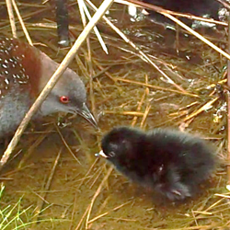 | Physical  Dense black natal down initially had green sheen. Legs thick and dark compared to adults. Head large relative to body. Bill predominantly pale pink with black tip. Egg tooth at tip of upper mandible lost by day 7. Eyes dark brown.
Behavioral
Frequently brooded and fed by both adults. Unsteady when standing and walking, spread their wings for balance, and closely followed adults. Began to exhibit preening and pecking behaviors.
Day 11-15  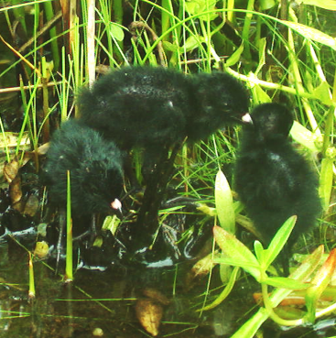 | Physical  Skin and ear opening visible through thinning down. Papilla began to emerge throughout feather tracts. Wrist typically held at 90 degree angle.
Behavioral
Remained in close proximity to adult(s) and siblings. Frequently preened themselves. Began to peck at food items on the ground.
Day 16-20  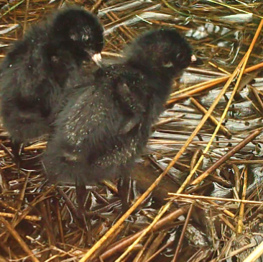 | Physical  Opening sheaths of body feathers appeared through thinning down. Capital, humeral, ventral, and spinal tracts visible. Spotting and barring patterns began to emerge. Asynchronous development became apparent within some broods.
Behavioral
Ventured farther from adult(s) while apparently maintaining visual or auditory contact. Began exhibiting wing flapping behavior, foraged independently, were occasionally brooded. Preened frequently.
Day 21-25  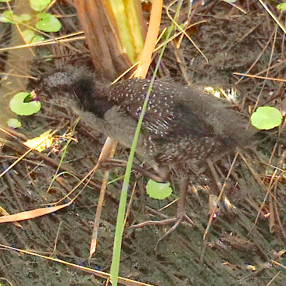 | Physical  Barring and spotting visible as body contour feathers continued to unfurl. Supercillium, auricular, and throat regions emerged before crown and eyestripe, temporarily resulting in striping pattern on head. Patches of down remained in caudal tract, middorsal region of spinal tract, and lateral sides of neck. Remiges in sheaths with down at tips.
Behavioral
Foraged without parent, were brooded infrequently. Began leaping while flapping wings.

Table 3. Observed physical and behavioral changes in chick development of the Eastern Black Rail (Laterallus jamaicensis jamaicensis) from days 26 through 40 post-hatching in Colleton and Georgetown Counties, South Carolina.
Image | Developmental Description
Day 26-30  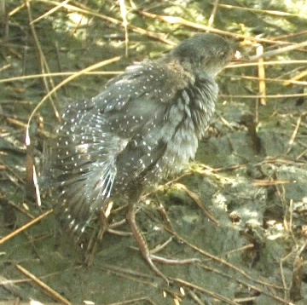 | Physical  Legs attained mature length and coloration. Down nearly absent. Chestnut nape color visible. Feathers in alar and caudal tracts began to unfurl from sheaths, associated spotting and barring became visible. Alula ½ unfurled and primaries ⅓ unfurled. Bill predominately dark with thinning pink band or spot present at nares.
Behavioral
No longer received parental care but occasionally associated with siblings. Frequently engaged in flapping and leaping behaviors.
Day 31-35  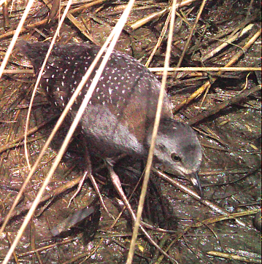 | Physical  Attained adult size. Body contour feathers complete. Spotting and barring patterns similar to adult. Alar and caudal tract flight feathers over ½ unfurled. Natal down remained at tips of unfurling retrices. Eye color light brown.
Behavioral
Continued foraging independently. Continued frequently leaping while flapping wings.
Day 31-35  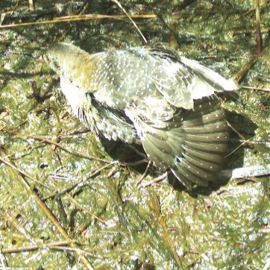 | Physical  Alar and caudal tracts completely or nearly fully developed. Alula and secondaries completely unfurled. Primaries ¾ unfurled. Bill completely or predominately dark with thin pink band or spot at nares still present. Eye color hazel to amber.
Behavioral
Engaged in prolonged sessions of preening and flapping. Began flying briefly while flapping and leaping.
Day 36-40  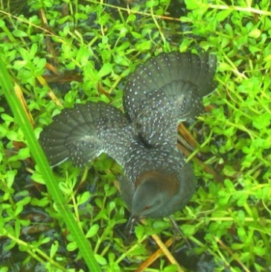 | Physical  Full juvenile plumage achieved at approximately 40 days. Outer primaries were last feathers to completely unfurl. Bill completely dark in most individuals. Eye color transitioned to amber or orange, with variability in timing. Discernable from adult females in photographs by fresh plumage until adults replace remiges and retrices during August – October.
Behavioral
Continued to preen and flap wings frequently. Capable of flight. Some fledglings present in natal territory 50 days or longer post-hatching.
Table 4. Estimated hatch dates and brood size of Eastern Black Rail (Laterallus jamaicensis jamaicensis) documented using camera traps in Colleton (Wetlands 1, 2, and 3) and Georgetown (Wetland 4) Counties, South Carolina. Age estimate accuracy is likely higher in instances when the age at initial detection is lower and where broods were photographed multiple times. Vegetation in Arrays 1a, 1b, and 1d was burned on 28 February 2018 and again on 26 February 2019 during prescribed fires.
 |  | Hatch | Minimum | Age First | Age Last | No. Dates
Wetland | Array | Date | Brood Size | Detected (Days) | Detected (Days) | Photographed
Pilot Study: Bear Island Wildlife Management Area
1 | None | 26-Jul-2015 | 1 | 15 | 15 | 1
1 | None | 16-Jun-2016 | 1 | 33 | 33 | 1
2 | None | 12-Jun-2016 | 2 | 7 | 15 | 6
2 | None | 6-Aug-2016 | 1 | 26 | 38 | 3
Bear Island Wildlife Management Area
1 | 1a | 26-Jun-2017 | 7 | 6 | 13 | 3
1 | 1a | 10-Aug-2018 | 2 | 16 | 32 | 8
1 | 1a | 8-Jun-2019 | 1 | 34 | 37 | 2
1 | 1b | 16-May-2017 | 1 | 35 | 43 | 2
1 | 1b | 27-May-2017 | 1 | 24 | 36 | 5
1 | 1b | 2-Jul-2017 | 6 | 6 | 32 | 15
1 | 1b | 22-Jun-2018 | 5 | 6 | 40 | 5
1 | 1b | 30-Jul-2018 | 4 | 12 | 40 | 19
1 | 1b | 25-Jun-2019 | 5 | 6 | 34 | 21
1 | 1b | 18-Jul-2019 | 1 | 22 | 40 | 11
1 | 1b | 7-Aug-2019 | 4 | 2 | 49 | 18
1 | 1b | 21-Aug-2019 | 4 | 10 | 48 | 14
1 | 1c | 14-May-2019 | 1 | 18 | 39 | 4
1 | 1c | 3-Jun-2019 | 1 | 2 | 28 | 4
1 | 1d | 18-Jul-2019 | 1 | 6 | 26 | 5
2 | 2a/2b | 29-May-2017 | 3 | 4 | 27 | 8
2 | 2a/2b | 9-Jul-2017 | 5 | 10 | 14 | 2
2 | 2a/2b | 12-Aug-2017 | 3 | 4 | 15 | 2
2 | 2a/2c | 9-Jun-2018 | 2 | 24 | 38 | 8
2 | 2a/2c | 19-Jun-2018 | 3 | 6 | 19 | 5
2 | 2a/2c | 17-Aug-2018 | 2 | 14 | 23 | 3
2 | 2a/2c | 9-Jul-2019 | 2 | 6 | 27 | 5
2 | 2d | 9-Jun-2018 | 1 | 25 | 53 | 6
2 | 2d | 3-Jul-2019 | 1 | 38 | 40 | 2
2 | 2e | 4-Jul-2018 | 2 | 8 | 23 | 3
3 | 3a | 21-May-2019 | 1 | 21 | 37 | 2
Tom Yawkey Wildlife Center
4 | 4a | 20-Aug-2018 | 3 | 15 | 20 | 2
4 | 4a | 26-May-2019 | 2 | 9 | 13 | 3
4 | 4a | 13-Jun-2019 | 1 | 23 | 23 | 1

Table 5. Flightless periods of definitive prebasic molt in adult Eastern Black Rails (Laterallus jamaicensis jamaicensis) in Colleton County, South Carolina. Initiation dates were estimated based on plumage characteristics observed in photographs by camera traps, and completion dates are based on an approximately 21 day flightless period. Accuracy of estimated molt timing is likely higher in instances when individuals were photographed on multiple dates. Vegetation in Arrays 1a and 1b was burned on 28 February 2018 and again on 26 February 2019 during prescribed fires.

 |  |  | Molt Initiation | Molt Completion | No. Dates
Wetland | Array | Sex | Date | Date | Photographed
1 | 1a | female | 30-Aug-2018 | 20-Sep-2018 | 2
1 | 1a | female | 20-Sep-2018 | 11-Oct-2018 | 2
1 | 1b | male | 27-Aug-2018 | 17-Sep-2018 | 4
1 | 1b | male | 16-Sep-2019 | 7-Oct-2019 | 13
1 | 1b | female | 18-Sep-2019 | 9-Oct-2019 | 1
2 | None | male | 17-Aug-2016 | 7-Sep-2016 | 4
2 | None | female | 20-Aug-2016 | 10-Sep-2016 | 3
2 | 2a/c | male | 15-Aug-2019 | 5-Sep-2019 | 9
2 | 2a/c | female | 17-Aug-2019 | 7-Sep-2019 | 5
2 | 2d | male | 1-Sep-2018 | 22-Sep-2018 | 1

