Table 3. Pearson Correlation Analysis of Tibial Nutrient Artery Parameters 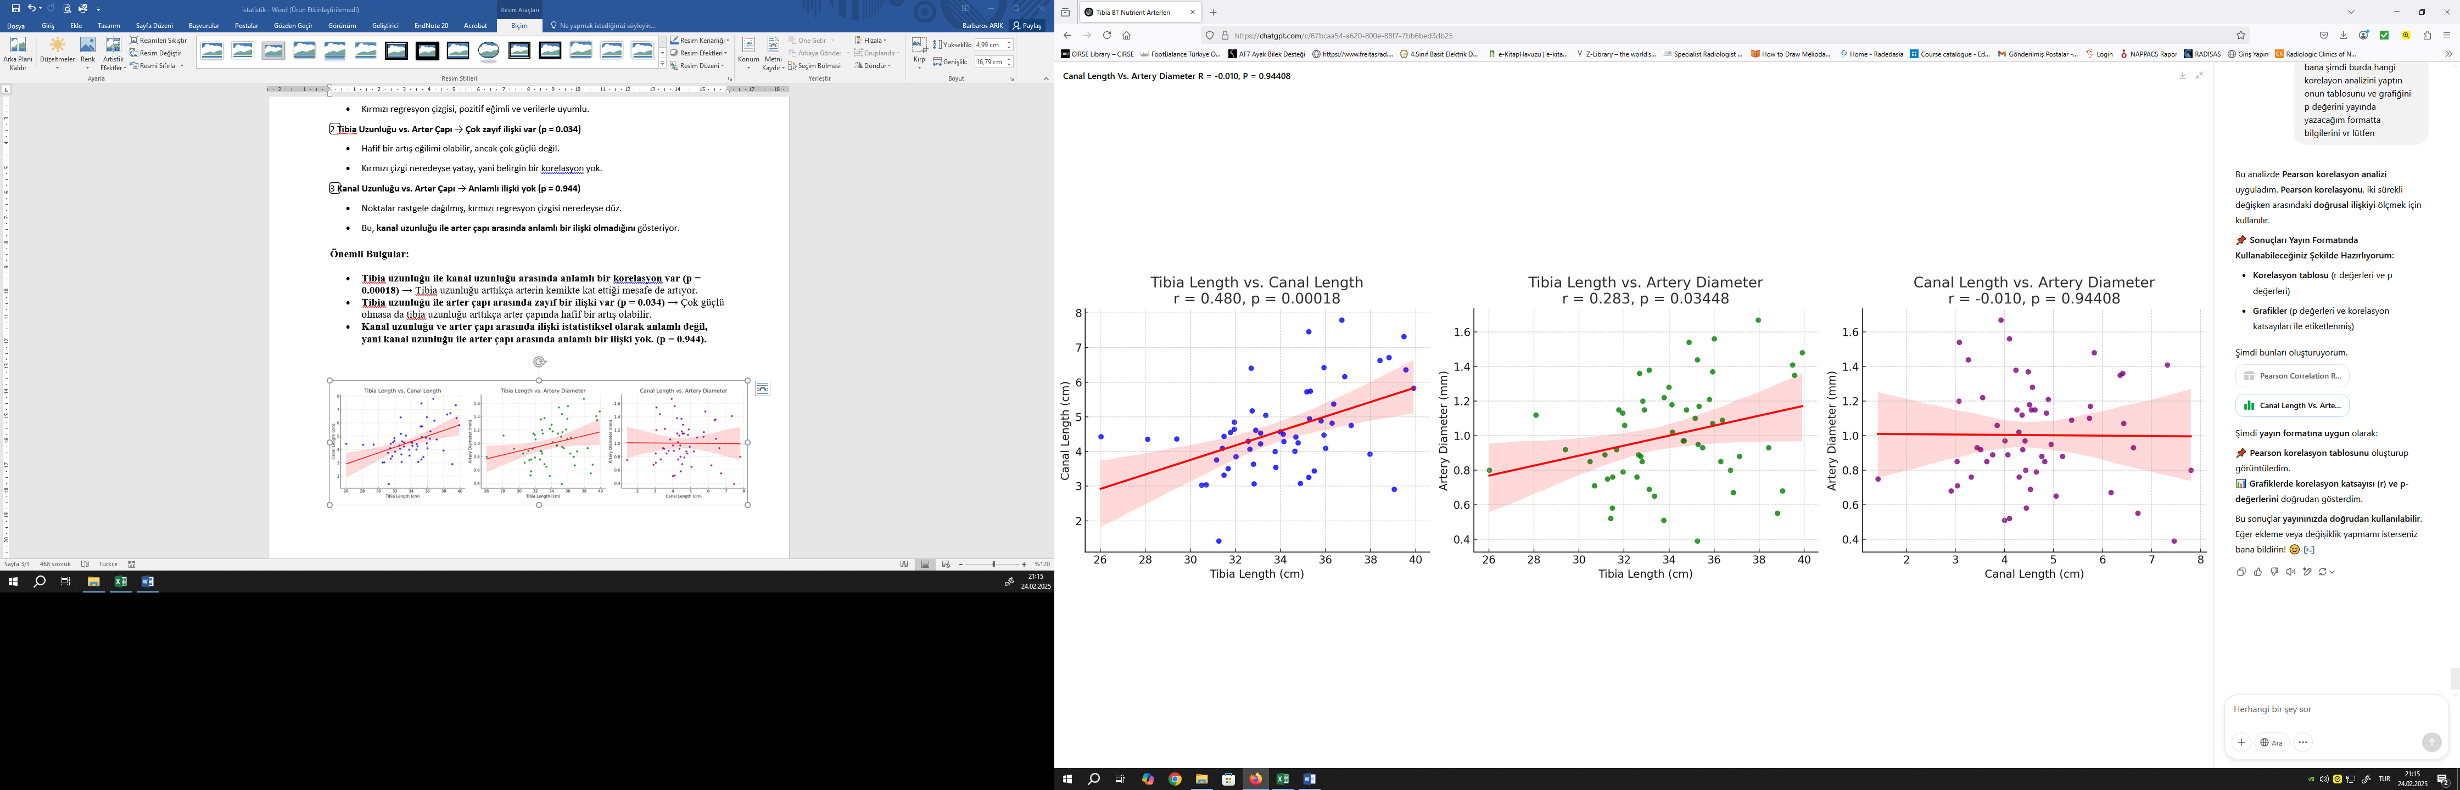
Variable 1 | Variable 2 | Pearson r | p-value | 95% CI
Tibia length (cm) | Nutrient artery length (cm) | 0.48 | 0.00018 | (0.248–0.660)
Tibia length (cm) | Nutrient artery diameter (mm) | 0.283 | 0.03448 | (0.022–0.508)
Nutrient artery length (cm) | Nutrient artery diameter (mm) | -0.01 | 0.94408 | (-0.272–0.254)

Table 4. Comparison of Nutrient Artery Parameters Between Right and Left Tibiae Using the Mann-Whitney U Test
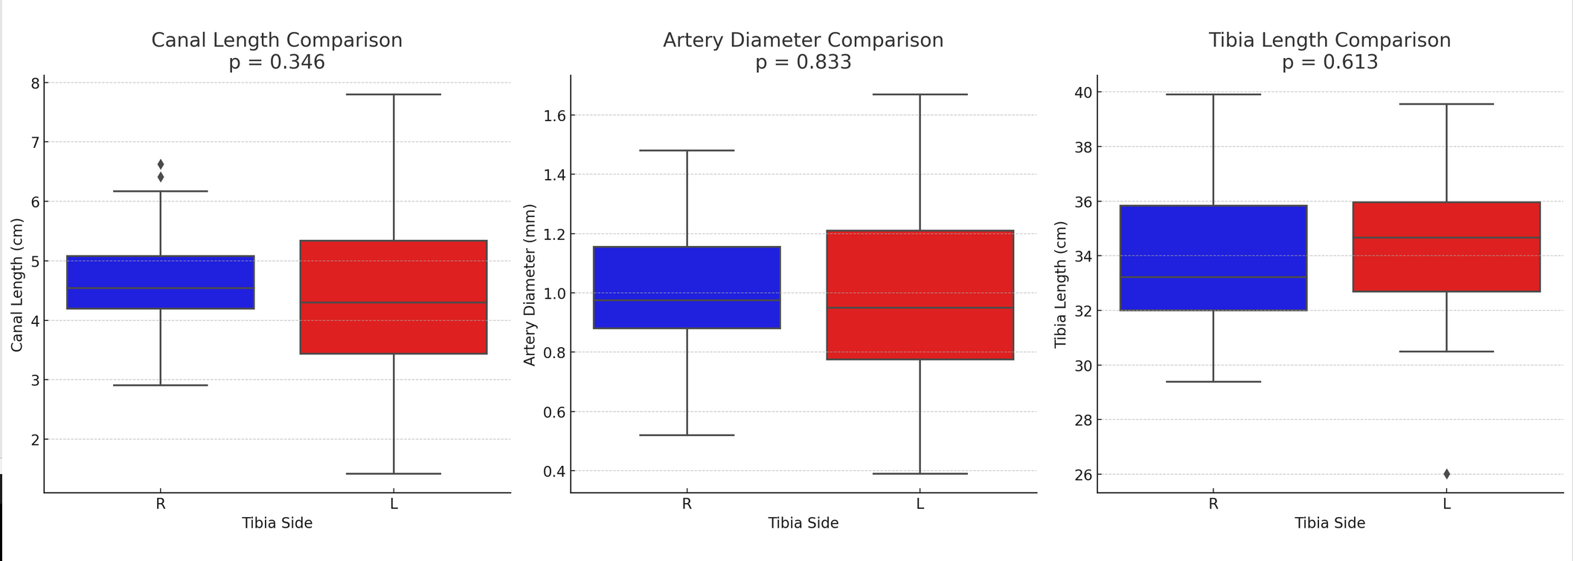
Variable | U Statistic | p-value
Tibia length (cm) | 347.5 | 0.61349
Nutrient artery length (cm) | 434.5 | 0.34577
Nutrient artery diameter (mm) | 391.0 | 0.83327

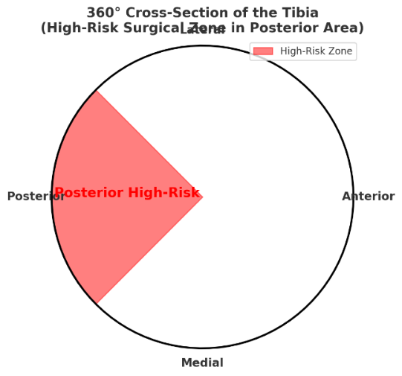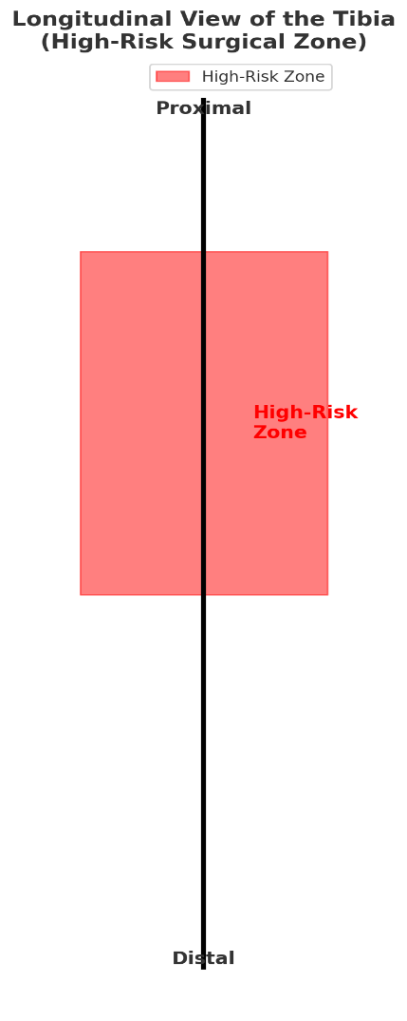
Table 5. High risk zone spans from 6.96 cm to 22.75 cm along the bone and corresponds to the 135°–225° arc in a 360° cross-sectional view—encompassing the posterolateral, posterior, and posteromedial aspects—where nutrient arteries are densely concentrated

