Machine Learning-Driven FT-ICR MS Analysis of Leachate DOM Ozonation and Membrane Fouling

Nature Chemical Engineering
March 8, 2025

Feng Zhou ª, Yinglong Su ª, Yunho Lee ^{b}, Seungkwan Hong ^{c}, Chuyang Y. Tang ^{d}, Hongqiang Ren ^{e}, Bing Xie ^{a*}, and Min Zhan ^{a, c, *}

ª Shanghai Engineering Research Center of Biotransformation of Organic Solid Waste, School of Ecological and Environmental Sciences, East China Normal University, Shanghai 200241, China
^{b} School of Environment and Energy Engineering, Gwangju Institute of Science and Technology (GIST), Gwangju 61005, Republic of Korea
^{c} Department of Civil, Environmental and Architectural Engineering, Korea University, 145 Anam-ro, Seongbuk-gu, Seoul 02841, Republic of Korea
^{d} Department of Civil Engineering, The University of Hong Kong, Hong Kong, Hong Kong SAR 999077, China
^{e} State Key Laboratory of Pollution Control and Resources Reuse, School of Environment, Nanjing University, Nanjing 210023, China

* Corresponding author: E-mail: pobabyzhan@korea.ac.kr; bxie@des.ecnu.edu.cn

Contents
Text:
Text S1 Lab-scale FO experiments.
Text S2 Ozone pretreatment methods and ozone dosages set up.
Text S3 Quantitative analysis of the membrane fouling of FO.
Text S4 Multiple fouling model.
Text S5 DOM extraction, FT-ICR MS parameters and data analysis.
Text S6 Cutoffs for DOM compound classes based on Van Krevelen diagram.
Text S7 Classifications explanation and data analysis.
Text S8 Kendrick mass defect (KMD) analysis.
Text S9 Mass difference and network analysis.
Text S10 The detailed description of SHAP value.
Text S11 Fluorescence spectral analysis methods.
Text S12 Humic substances (HS), extracellular polymeric substances (EPS), and amino acids analysis methods.
Text S13 EPR and probe analysis methods.

Table:
Table S1. Main characteristics of two landfill leachate wastewaters.
Table S2. The number of molecular formulas for compound classes and formula classes in DOM of two pretreated leachates.
Table S3. Number and RI of molecular formulas for compound classes and formula classes in DOM of precursors and products.
Table S4. Summary of the reactions considered in the linkage analysis.
Table S5. Sign of each cross-peak in the synchronous (Φ) and asynchronous (Ψ) 2DCOS maps generated from the FTIR spectra of L1 under different pre-ozonation dosages.
Table S6. Sign of each cross-peak in the synchronous (Φ) and asynchronous (Ψ) 2DCOS maps generated from the FTIR spectra of L2 under different pre-ozonation dosages.

Figure:
Fig. S1. (a)-(b) COD and DOC, (c)-(b) TN, NH₄⁺-N, NO₃⁻-N, NO₂⁻-N and TP concentration changes in two types of leachates with continuous ozone pretreatment.
Fig. S2. EPS, LB-EPS and TB-EPS for L1 and L2 change a under different pre-ozonation dosages.
Fig. S3. Correlation coefficients between DOM and pre-ozonation dosage for (a) L1 and (b) L2, and correlation coefficients were obtained using Spearman’s coefficient.
Fig. S4. Mass spectra of DOM with mass-to-charge ratios ranging from 100 to 800 in (a) L1 and (b) L2 treated by different pre-ozonation dosages.
Fig. S5. Upsets diagram showing the overall difference of DOM composition in (a) L1 and (b) L2.
Fig. S6. Van Krevelen and marginal distribution diagrams of in (a) L1 and (b) L2 under different pre-ozonation dosages. Points in blue represent precursor, points in red represent product, and points in blue denote resistant.
Fig. S7. Van Krevelen diagrams for the precursors of CHONS and the products of CHON in (a) L1 and (b) L2 under different pre-ozonation dosages. (c) Number molecular formulas for the precursors of CHONS and the products of CHON in L1 and L2.
Fig. S8. ROC Curve and AUC for Random Forest algorithm with (a) L1 and (b) L2.
Fig. S9. The RI of MW, O/C, O, and DBE–O of precursors and products in (a) L1 and (b) L2.
Fig. S10. The (DBE–O)/C-NOSC plots of DOM after ozone treatment in (a) L1 and (b) L2. (c) Formular distribution of four classes of saturation and oxidation states.
Fig. S11. (a) PMD-based network indicating some of the possible reactions for the major classes at 1.0 g O₃·(g DOC)⁻¹ in L1. (b) Distribution of reactions (paired mass difference) in CHO, CHONS, CHOS, and CHO formulas.
Fig. S12. (a) PMD-based network indicating some of the possible reactions for the major classes at 1.0 g O₃·(g DOC)⁻¹ in L2. (b) Distribution of reactions (paired mass difference) in CHO, CHONS, CHOS, and CHO formulas.
Fig. S13. KMD plots for series of (a) +3O, (b) +2O, (c) +H2O2, (d) –C2H2, (e) –C3H4, (f) –C3H6, (g) –S, and (h) –SH2 for the possible precursor-product pairs at 1.0 g O₃·(g DOC)⁻¹ in L1. X-axis corresponds to m/z, O/C, O, and DBE-O.
Fig. S14. KMD plots for series of (a) +3O, (b) +2O, (c) +H2O2, (d) –C2H2, (e) –C3H4, (f) –C3H6, (g) –S, and (h) –SH2 for the possible precursor-product pairs at 1.0 g O₃·(g DOC)⁻¹ in L2. X-axis corresponds to m/z, O/C, O, and DBE–O.
Fig. S15. Free radicals produced for (a) L1 and (b) L2 under different pre-ozonation dosages.
Fig. S17. Abatement efficiency of para-chlorobenzoic acid (pCBA), and metronidazole (MDE) for (a) L1 and (b) L2. Evolution of •OH, ¹O₂, and O₃ exposures for (c) L1 and (e) L2.
Fig. S17. The normalized water flux (J/J₀) decline curve for (a) L1 and (b) L2 and NH₄⁺-N, TN, DOC, and TP removal for (c) L1 and (d) L2 change in the FO process under different pre-ozonation dosages.
Fig. S18. The relative abundance of negative and positive DOM composition according to compound classes (a), and formula classes (b).
Fig. S19. The plot of the distribution of the four main molecular properties for (a) L1 and (b) L2 in negative (r<0) and positive (r>0).
Fig. S20. SEM images of membranes of (a) L1 and (b) L2. Atomic force microscopy (AFM) images of surface morphologies of (c) L1 and (d) L2. (e) S-EPS, and (f) Fmax of each fluorescence compound of membrane surface under different pre-ozonation dosages.
Fig. S21. EPS, LB-EPS and TB-EPS of membrane surface for L1 and L2 change under different pre-ozonation dosages.
Fig. S22. Effect of pre-ozonation on the zeta potential of EPS of (a) L1 and (b) L2.
Fig. S23. Impact of ozonation on the MW distribution of DOM in (a) L1 and (b) L2 as determined by GPC.
Fig. S24. XPS spectra of C1s in for (a) L1 and (b) L2 under different pre-ozonation dosages.
Fig. S25. FTIR of (a) L1, and (d) L2 under different pre-ozonation dosages (0.5 L1: 0.5 g O₃·(g DOC)⁻¹ L1; 0.8 L1: 0.8 g O₃·(g DOC)⁻¹ L1; 1 L1: 1 g O₃·(g DOC)⁻¹ L1;0.5 L2: 0.5 g O₃·(g DOC)⁻¹ L2; 0.8 L2: 0.8 g O₃·(g DOC)⁻¹ L2; 1 L2: 1 g O3·(g DOC)⁻¹ L2)..
Fig. S26. Synchronous 2DCOS of membrane surface for (a) L1 and (b) L2 under different pre-ozonation dosages.
Fig. S27. KMD plots for series of COO for the possible precursor-product pairs in in (a) 1.0 g O₃·(g DOC)⁻¹ L1 and (b) 1.0 g O₃·(g DOC)⁻¹ L2. X-axis corresponds to m/z, O/C, O, and DBE–O.
Fig. S28. Schematic of the lab-scale ozonation pretreatment system.
Fig. S29. Schematic of the lab-scale FO system.
Fig. S30. The normalized water flux (J/J0) decline curve in lab-scale FO using in-situ ozone treatment. The draw solution used 2M NaCl and the feed solutions were 5.8 g·L⁻¹ NaCl (8 h ozone treatment), L2, and L2 (8 h ozone treatment), respectively.
Fig. S31. SEM images of (a) original FO membrane, (b) membrane fouled by treated with in suit 8 h ozone.
Fig. S32. Three fluorescent components identified by the PARAFAC applied to the entire EEM data set of L1 with pre-ozonation. (a) C1: fulvic-like component, (b) C2: protein-like component and (c) C3: soluble microbial by-product-like component1. The loading plots of C1 (d), C2 (e) and C3 (f). (g) Fmax of each fluorescence compound after different ozone pretreatment time.
Fig. S33. Two fluorescent components identified by the PARAFAC applied to the entire EEM data set of L2 with pre-ozonation. (a) C1: fulvic-like component and (b) C2: protein- like component1. The loading plots of C1 (b), C2 (c). (e) Fmax of each fluorescence compound under different pre-ozonation dosages.
Fig. S34. NH₄⁺-N, TN, DOC, and TP for L1 and L2 change in the FO process under different pre-ozonation dosages.

Text S1 Lab-scale FO experiments.
The commercially available flat-sheet FO membrane employed in the fouling runs was purchased from Porifera, Inc. (PFO-100, USA). The temperature of both the feed and draw solutions was maintained at 20 ± 1.0℃ with a cross-flow velocity of 8.54 cm·s⁻¹ and the membrane area was 20 cm² in the FO cell (rectangular channels: 7.7 cm in length, 2.6 cm in width and 0.3 cm in depth). Variable-speed gear pumps (CT3001S, LEADFLUID, China) were used for the recirculation of 1 L of both the feed and draw solutions in FO.

Text S2 Ozone pretreatment methods and ozone dosages set up.
The initial approach in this study involved in situ ozone pretreatment, which entailed the direct ozonation of the draw solution during the operational phase of the FO process. As depicted in Fig. S30, the 8 h ozone treatment of the 5.8 g·L⁻¹ NaCl solution exhibited a near-zero J/J₀ value at the 2 h, and the L2 solution under 8-h ozone treatment displayed flux declines around the 14th hour of operation. Furthermore, SEM analysis of both original and 8 h ozone-treated 5.8 g·L⁻¹ NaCl membranes indicated that in situ ozone pretreatment led to membrane rupture (Fig.S31). Consequently, ex-situ ozone pretreatment was adopted for the experiment, involving the regular ozonation of both leachates before their introduction into the FO process.
To further elucidate the impact of ozone pretreatment on DOM control and membrane fouling in the two leachates, continuous ozonation was applied for 20 h to L1 and 8 h to L2. Samples were collected at hourly intervals to measure COD, DOC, TN, NH₄⁺-N, NO₃⁻-N, NO₂⁻-N and TP concentrations (Fig.S1). These samples were also analyzed using EEM-PARAFAC (Fig.S32-S33). Fig. S32 illustrates that in L1, the three principal components identified were C1 (Ex/Em: 240/425 nm), indicative of a fulvic acid-like substance; C2 (Ex/Em: 225/345 nm), characteristic of a protein-like substance; and C3 (Ex/Em: 295/325 nm), associated with the soluble microbial by-product-like substance.¹ The Fmax of these components was observed to diminish, with parallel trends noted in COD and DOC measurements. Consequently, Consequently, the ozone pretreatment durations were selected as 0, 7, 13, and 20 h, which corresponded to pre-ozonation dosages categorized as 0, 0.5, 0.8, 1.0 g O₃·(g DOC)⁻¹. Similarly, for L2, the two fractions identified were C1 (Ex/Em: 250/450 nm), corresponding to the fulvic acid-like component, and C2 (Ex/Em: 230/360 nm), representing the protein-like component (Fig.S33). Both fractions exhibited a decreasing trend, leading to the selection of ozone pretreatment durations of 0, 2, 5, and 8 h, respectively.¹ Similarly, the ozone dosages corresponding to the pretreatment time for L2 was categorized as 0, 0.5, 0.8, 1.0 g O₃·(g DOC)⁻¹.

Text S3 Quantitative analysis of the membrane fouling of FO.
Continuous FO testing was carried out for each treatment group without any cleaning procedures. Upon achieving 65% and 50% water recovery for L1 and L2 treatment groups, respectively, the operation was halted, and high-frequency backwashing with deionized water was conducted for 30 minutes to elevate the cross-flow velocity to 25.62 cm·s⁻¹ Thereafter, the feed and discharge solutions were replaced in the inlet and outlet tanks to assess the flux recovery through physical cleaning.
In the FO process, the interaction between the membrane and inorganic or organic components in the feedwater leads to membrane fouling, which in turn results in a reduction of the membrane flux. Reversible fouling, which is amenable to physical cleaning, is defined as the portion of fouling that can be removed through such cleaning methods. Consequently, fouling reversibility (FR) is calculated as the percentage ratio of the water flux recovered by physical cleaning to the initial flux.² The variation in FR is determined using Equation (1).
 | $$\text{Fouling reversibility }\left(\text{FR}\right) \left(\text{\%}\right) \text{=} \frac{{\text{J}}_{\text{xr}}\text{-}{\text{J}}_{\text{xf}}}{{\text{J}}_{\text{xi}}\text{-}{\text{J}}_{\text{xf}}} \text{×} \text{100}$$ | (1)
where J_{xi} is the initial water flux before fouling (original membrane) (LMH), J_{xf} is defined as the final fluxes of each operational cycle (LMH), and J_{xr} indicates the flux recovered by physical cleaning (LMH).
The resistance-in-series model was used to calculate the different fouling resistances of the FO membrane, as shown in Eqns. (2)–(4).
 | $$\text{J} \text{=} \frac{\text{1}}{\text{A}} \text{×} \frac{\text{dV}}{\text{dt}} \text{=} \frac{{\text{π}}_{\text{d}}\text{-}{\text{π}}_{\text{f}}}{\text{μ} \text{×} {\text{R}}_{\text{t}}}$$ | (2)
 | $\text{J} \text{=}{ \text{R}}_{\text{t}} \text{=} \frac{{\text{π}}_{\text{d}}\text{-}{\text{π}}_{\text{f}}}{\text{J×μ}}$ | (3)
 | $${\text{R}}_{\text{t}} \text{=} {\text{R}}_{\text{m}} \text{+} {\text{R}}_{\text{r}} \text{+} {\text{R}}_{\text{i}\text{r}}$$ | (4)
where R_{m}, R_{r}, and R_{ir} are the intrinsic, reversible, and irreversible resistances of the FO membrane calculated from the flux J_{v}, J_{p}, and J_{c}, respectively. $μ$is the dynamic viscosity of the fluid (Pa s). $π_{d}$and $π_{f}$refer to the osmotic pressure (Pa) of the draw solute and feed solute, respectively.
The osmotic pressure of the landfill leachate was calculated using the following equation³:
 | $$\text{π} \text{=} \text{i} \text{×} \text{∅} \text{×} \text{C} \text{×} \text{R} \text{×} \text{T}$$ | (5)
where i is the number of ions, Ø is the osmosis coefficient, C is the sum of total solute concentrations in the liquid, R is the universal gas constant, and T is the absolute temperature. The values of total solute C in the landfill leachate were taken from the ionic composition, as shown in Table S1.

Text S4 Multiple fouling model.
To better understand the membrane fouling mechanisms of algal pollutants at different growth stages and the trends in membrane flux over time, the Hermia model (6), (7) and the dual membrane pore blocking-filter cake blocking filtration model (8) and (9) were used to further analyze the transition of membrane fouling mechanisms in UF experiments.⁴ The Hermia model is expressed as follows:
$$\begin{aligned}\frac{d^{2}t}{dV^{2}} = k{\left(\frac{dt}{dV}\right)}^{n}\#\left(6\right)\end{aligned}$$
$$\begin{aligned}n = \frac{d\left[\log\left(\frac{d^{2}t}{dV^{2}}\right)\right]}{d\left[\log\left(\frac{dt}{dV}\right)\right]}\#\left(7\right)\end{aligned}$$
Where V (m³) is the filtration volume, t (s) is the filtration time, and k is the resistance coefficient. The n value is used to determine the membrane fouling mechanism, obtained by differentiating the logarithm of the second derivative of t-V and the first derivative. n=0 indicates cake filtration; n=1 indicates intermediate blocking; n=1.5 indicates standard blocking; n=2 indicates complete blocking.
$$\begin{aligned}\frac{\text{dt}}{\text{dV}} \text{=} \frac{\text{1}}{\text{JA}}\#\left(\text{8}\right)\end{aligned}$$
$$\begin{aligned}\frac{{\text{D}}^{\text{2}}\text{t}}{\text{d}{\text{V}}^{\text{2}}} \text{=} \text{-}\frac{\text{1}}{{\text{J}}^{\text{3}}{\text{A}}^{\text{2}}} \frac{\text{dJ}}{\text{dt}}\#\left(\text{9}\right)\end{aligned}$$
To calculate dJ/dt, the membrane pore blocking-filter cake filtration dual fouling model equation proposed by Zydney (10) is used for fitting.⁵
$$\begin{aligned}\frac{\text{J}}{{\text{J}}_{\text{0}}} \text{= }{\text{e}}^{\text{-}{\text{k}}_{\text{1}}\text{t}} \text{+} \frac{{\text{k}}_{\text{2}}}{\sqrt{\text{1+}{\text{k}}_{\text{3}}\text{t}}}\text{(1} -{ \text{e}}^{\text{-}{\text{k}}_{\text{1}}\text{t}}\text{)}\#\left(\text{10}\right)\end{aligned}$$
It is important to note that k₁, k₂, and k₃ are fitting parameters in the equations. Discrete data of J/J₀–t is processed using the Numpy package in Python, and the fitting parameters k₁, k₂, and k₃ are optimized using either the steepest descent optimization method or the Levenberg-Marquardt algorithm. The first derivative dJ/dt is then calculated. It is worth mentioning that k₁, k₂, and k₃ have their own physical meanings, as shown in equations (11), (12), and (13):
$$\begin{aligned}{\text{k}}_{\text{1}} \text{=} \frac{\text{αΔp}{\text{C}}_{\text{b}}}{\text{μ}{\text{R}}_{\text{m}}}\#\left(\text{11}\right)\end{aligned}$$
$$\begin{aligned}{\text{k}}_{\text{2} }\text{=} \frac{{\text{R}}_{\text{m}}}{{\text{R}}_{\text{m}} \text{+ }{\text{R}}_{\text{p0}}}\#\left(\text{12}\right)\end{aligned}$$
$$\begin{aligned}{\text{k}}_{\text{3 }} \text{=} \frac{\text{2}{\text{f}}^{\text{'}}{\text{R}}^{\text{'}}{\text{C}}_{\text{b}}\text{Δp}}{\text{μ(}{\text{R}}_{\text{m}} \text{+} {\text{R}}_{\text{p0}}{\text{)}}^{\text{2}}}\#\left(\text{13}\right)\end{aligned}$$
Where α represents the membrane pore blocking coefficient (m²·kg⁻¹); C_{b} is the concentration of pollutants in the feed solution (kg·m⁻³); R_{m} is the intrinsic resistance of the membrane (m⁻¹); R_{p0} is the initial resistance of the deposit (m⁻¹); f’ is the proportionality coefficient for the formation of the filter cake layer; R’ is the resistance coefficient of the cake layer (m·kg⁻¹).
Moreover, based on equation (6), a fifth-order polynomial fit was applied to dt/dV and d²t/dV², resulting in a continuous distribution of n values to determine changes in fouling mechanisms.

Text S5 DOM extraction, FT-ICR MS parameters and data analysis.
DOM was extracted using solid-phase extraction (SPE) cartridges (Agilent Bond Elut-PPL, 1 g, 6 mL) prior to FT-ICR MS analysis. The PPL cartridge is a widely accepted medium for DOM isolation from natural water bodies due to its high recovery rates and suitability for both polar and nonpolar organic compounds.⁶ The extraction procedures followed the method described by Zhang et al.⁷ and were as follows: (1) Water samples were pre-filtered through 0.45 μm cellulose triacetate filters (Advantec, Tokyo, Japan) and the pH was adjusted to 2 with hydrochloric acid. (2) The cartridges were activated with 12 mL of methanol (HPLC grade) and 12 mL of 1 N HCl. (3) Samples were passed through the PPL cartridge at a flow rate of 5 mL·min⁻¹, with the volume adjusted to concentrate the DOM to approximately 100 mg·L⁻¹. (4) The cartridges were rinsed with 18 mL of 1 N HCl to minimize salt interference in the signal. (5) After drying with N₂, the cartridges were eluted with 12 mL of methanol, and the eluent was collected. (6) The eluent was concentrated to 0.2 mL and stored at -20°C. Before FT-ICR MS analysis, samples were diluted with 1 mL of a methanol and water mixture (1:1).
FT-ICR-MS was conducted in negative ion mode with an electrospray ionization source. Key experimental parameters were as follows: a continuous infusion rate of 120 μL·h⁻¹, a capillary inlet voltage of 4 kV, a capillary column end voltage of -500 V, and ion accumulation in the collision chamber for 0.03 seconds prior to transfer to the ICR chamber with a time of flight of 0.7 milliseconds. The mass range was set to 100–1200 Da, with data acquisition at 4 million 32-bit data points and an average of 300 time-domain signals to enhance the signal-to-noise ratio. The instrument was calibrated using a 10 mmol·L⁻¹ sodium formate solution before analysis. To ensure data integrity, suwannee river natural organic matter (SRNOM) served as a reference standard for mass axis calibration. Post-calibration mass accuracy was within 1 ppm.
Mass spectrometry data were internally calibrated against known CHO compounds within the DOM, followed by analysis with specific parameters for molecular formula determination: mass range 100–800, signal-to-noise ratio (S/N) > 10, and elemental composition constraints as follows: ¹²C₀₋₆₀,¹³C₀₋₁,¹H₀₋₁₂₀,¹⁶O₀₋₅₀,¹⁴N₀₋₅,³²S₀₋₂，³¹P₀₋₂，³⁵Cl₀₋₃³⁷Cl₀₋₁，⁷⁹Br₀₋₃⁸¹Br₀₋₁，¹²⁹I₀₋₃. Potential molecular formulas were derived from these parameters. In cases where multiple formulas corresponded to a single m/z value, homologous rules and the principle of minimum heteroatom count were utilized to discern the correct molecular formula, ensuring over 90% accuracy in identification. Additionally, all formulas were subject to the following criteria:^{8,9} O/C ≤ 1.0, 0.33 ≤ H/C ≤ 2.25, N/C < 0.5, S/C < 0.2, N < O, S < O. The double bond equivalent (DBE) was confined to non-negative integer values, and the sum of H and N atoms was required to be even, adhering to the nitrogen rule.
The molecular properties are calculated using the molecular formula as follows:¹⁰
$$\begin{aligned}\text{RI} \text{=} \frac{{\text{I}}_{\text{i}}}{\sum{{\text{I}}_{\text{i}}}}\#（\text{14}）\end{aligned}$$
$$\begin{aligned}\text{DBE} \text{=} \frac{\text{2C} \text{+}\text{+} \text{N} \text{+} \text{P}- \text{H} \text{+} \text{2}}{\text{2}}\#（\text{15}）\end{aligned}$$
$$\begin{aligned}\text{A}{\text{I}}_{\text{mod}}{ \text{=} }\frac{\text{1} \text{+} \text{C} - \text{0.5O} - \text{S} - \text{0.5H}}{\text{C} - \text{0.5O} - \text{N} - \text{S}}\#（\text{1}\text{6}）\end{aligned}$$
$$\begin{aligned}\text{NOSC} \text{=} \text{4} - \frac{\text{4C} \text{+} \text{H} - \text{2O} - \text{3N} - \text{2S}}{\text{C}}\#（\text{1}\text{7}）\end{aligned}$$
where I_{i} is the absolute strength of each molecular formula response peak and RI is the relative strength of each molecular formula response peak; C, H, O, N, S and P are the number of carbon, hydrogen, oxygen, nitrogen, sulfur, and phosphorus atoms in a given molecular formula. AI_{mod} is the abbreviation of modified aromatic index. NOSC is the abbreviation of nominal oxidation states of carbon. DBE is the abbreviation of double bond equivalence. For a given molecular formula, the larger the value of DBE, the higher the degree of molecular unsaturation, and the larger the positive value of NOSC, the higher the oxidation state.

Text S6 Cutoffs for DOM compound classes based on Van Krevelen diagram.
In this study, the Van Krevelen diagrams were divided into seven plates matching seven classes of substances based on the previous studies^{11,12} details as follows:
Lipids, H/C = 1.52.0, O/C = 0‒0.3;
Aliphatic/proteins, H/C = 1.5‒2.2, O/C = 0.3‒0.67;
Lignin/arboxyl-rich alicyclic (CRAM)-like structures, H/C=0.7‒1.5, O/C=0.1‒0.67;
Carbohydrates, H/C = 1.5‒2.4, O/C = 0.67‒1.2;
Unsaturated hydrocarbons, H/C = 0.7‒1.5, O/C = 0‒0.1;
Aromatic structures, H/C = 0.2‒0.7, O/C = 0‒0.67;
Tannin, H/C = 0.6‒1.5, O/C = 0.67‒1.0

Text S7 Classifications explanation and data analysis.
To investigate the molecular transformation of DOM, the compounds were classified into three categories based on the FT-ICR MS results: precursors, products, and resistants¹³. The precursors represent the formulae found in landfill leachates and disappeared after ozonation based on formula assignment criteria, as well as those both existing in the samples before and after ozonation with the fold change (fc = intensity after/ intensity before < 0.5).¹⁴ The products refer to those that were not found in landfill leachates and newly formed in ozonated effluents, as well as those both existing in the samples before and after ozonation with fc > 2.0.¹⁴ The resistants represent those that existed simultaneously in the samples before and after ozonation with 0.5 ≤ fc ≤ 2.0.¹⁴ Therefore, the compounds with fc < 0.5 and fc > 2.0 should be involved in the reactions during ozonation.¹⁰
Double bond equivalent minus oxygen per carbon ((DBE–O)/C) and nominal oxidation state of carbon (NOSC) were used to reflect the degree of saturation and oxidation state, respectively.^{10,15} Based on these two parameters, the molecules can be divided into four distinct states: (1) unsaturated and oxidized, (2) unsaturated and reduced, (3) saturated and reduced, (4) saturated and oxidized.

Text S8 Kendrick mass defect (KMD) analysis.
Kendrick mass defect (KMD) analysis was visually used to reflect the changes between possible precursors and products, and a pair of precursor-product has the same KMD value scattering in the same horizontal line. The corresponding equations based on Kendrick mass (KM) were listed below.
KM (+3O) = IUPAC Mass × (48/47.9982)
KMD (+3O) = Nominal mass – KM (+3O)
KM (+2O) = IUPAC Mass × (32/31.9988)
KMD (+2O) = Nominal mass – KM (+2O)
KM (+H2O2) = IUPAC Mass × (34/34.01468)
KMD (+H2O2) = Nominal mass – KM (+H2O2)
KM (–C2H2) = IUPAC Mass × (26/26.0373)
KMD (–C2H2) = Nominal mass – KM (–C3H6)
KM (–C3H4) = IUPAC Mass × (40/40.0639)
KMD (–C3H4) = Nominal mass – KM (–C3H4)
KM (–C3H6) = IUPAC Mass × (42/42.0797)
KMD (–C3H6) = Nominal mass – KM (–C3H6)
KM (–S) = IUPAC Mass × (32/32.0650)
KMD (–S) = Nominal mass – KM (–S)
KM (–SH2) = IUPAC Mass × (34/34.0809)
KMD (–SH2) = Nominal mass – KM (-SH2)
KM (COO) = IUPAC Mass × (44/44.0095)
KMD (COO) = Nominal mass – KM (COO)
where IUPAC is international union of pure and applied chemistry of each element (C, H, O, N, S, and P); Nominal mass is the integer value of the observed mass.

Text S9 Mass difference and network analysis.
The PMD network was constructed based on potential transformations identified during the ozonation process, as detailed in Table S4. To minimize false positive reaction pairs, we selectively identified parents from formulas present in untreated samples, categorizing them as reactive and resistant formulas, while the products were the newly formed formulas. Parent-product pairs were determined based on both mass and atom differences to prevent misidentification. These formula pairs were stored as network nodes, with edges representing their transformations. Following the identification of precursor-product pairs, the reaction network was visualized using Gephi,¹⁶ a tool for network analysis and visualization. The Force Atlas layout algorithm was employed for network arrangement. Network degree calculations and hub identification were also performed using Gephi. Network degree indicates the number of connections linked to a node, with higher degrees signifying more connections. Network hubs, which are nodes with the highest degree, represent the most reactive formulas that produce the greatest number of product formulas. For more information on Gephi software, please refer to the official website (https://gephi.org/users/).

Text S10 The detailed description of SHAP value.
The SHAP value is represented by Eq. (18):
${\text{∅}}_{\text{i}}\text{(}\text{f,x}\text{)} \text{=} \sum_{\text{s}\text{∈}{\text{S}}_{\text{i}}}{\frac{\left(\left|\text{S}\right|\text{-1}\right)\text{!}\left(\text{n-}\left|\text{S}\right|\right)\text{!}}{\text{n!}}}\text{(f}\left(\text{s}\right) - \text{f}\left(\text{s\backslash i}\right)\text{)}$ (18)
where $∅_{i}(f,x)$ stands for the SHAP value of feature i, f is the model trained by a set of features x, S_{i} is the set of possible combinations with feature i, $\left|\text{S}\right|$ is the number of features of one combination in Si, n is the set of all features, and f(s) and f(s\i) are the predictions by the model trained on s with and without i, respectively. SHAP values can be positive or negative, in which a positive value means the feature can increase the target while a negative one can decrease the target. The larger the absolute SHAP values of one feature, the more important it is to the target.
The Shapley value is calculated to measure their individual contribution to the model. For average impact on model output, the feature importance is calculated by the mean |SHAP| value. It is the absolute mean value of SHAP values of the i_{th} variable for all molecules, which is defined as
mean |SHAP| =$\sum_{\text{k=1}}^{{\text{N}}_{\text{s}}}{\left|{\text{∅}}_{\text{i}}^{\text{(k)}}\right|\text{/}{\text{N}}_{\text{s}}}$ (19)
where ${\text{N}}_{\text{s}}$ is the number of molecula. The index mean|SHAP| is used to measure the average contribution of the input features on the model's categorization.

Text S11 Fluorescence spectral analysis methods.
The EEM spectra of DOM in ozone-oxidized leachate and on FO membrane surfaces were acquired using a fluorescence spectrophotometer (F-7000, Hitachi). The emission wavelength was scanned from 280 to 600 nm at 5 nm intervals, while the excitation wavelength ranged from 200 to 400 nm at 5 nm intervals. The applied voltage was 700 V, and the scan speed was set at 12000 nm·min⁻¹. Parallel factor analysis (PARAFAC) was conducted utilizing the DOMFluor toolbox to discern the principal fluorescent compounds.¹⁷ The maximum fluorescence intensity (Fmax), expressed in relative units (R.U.), served as a metric for the content of these compounds.¹⁸

Text S12 Humic substances (HS) and extracellular polymeric substances (EPS) analysis methods.
For the extraction of humic substances (HS),¹⁹ 50 mL of landfill leachate was treated with Na₄P₂O₇ and NaOH to achieve a concentration of 0.1 M, agitated for 24 hours, and then passed through a 0.45 µm membrane filter. The solution's pH was lowered to 1 with 6 M HCl to facilitate the precipitation of humic acids (HA). The supernatant was centrifuged at 12,000 rpm for 20 minutes, and fulvic acid (FA) was isolated using Amberlite XAD-8 resin. The carbon content of both HA and FA was measured using a total organic carbon (TOC) analyzer.
The EPS extraction process to obtain the soluble EPS (S-EPS), loosely bound EPS (LB-EPS), and tightly bound substances (TB-EPS) following the procedures outlined in a previous study.²⁰ The concentration of protein (PN) and the polysaccharide (PS), as the main component of EPS, were analyzed using the modified Lowry method and the phenol‑sulfuric acid method.²¹

Text S13 EPR and probe analysis methods.
EPR spectra were monitored using an MS5000 spectrometer (Magnettech, Germany). Measurement settings were: modulation frequency, 100 kHz; modulation width, 0.2 mT; magnetic field, 330–345 mT; sweep time, 60 s; microwave power, 10 mW; and microwave frequency, 9.46 GHz. Using 5,5-dimethyl-1-pyrroline-N-oxide (DMPO), 2,2,6,6-tetramethyl-4-piperidone (TEMP), and 5-tert-butoxycarbonyl 5-methyl-1-pyrroline N-oxide (BMPO) as trapping agents for ·OH, ¹O₂, and ·O₂⁻, respectively.
Given that EPR identification confirmed the ROS to be·OH and singlet oxygen (¹O₂), our focus shifted to studying the exposure levels of these specific ROS.²² For this purpose, para-chlorobenzene acid (pCBA) and metronidazole (MDE) were employed as probe compounds for ·OH and ¹O₂, respectively.²³ $\text{∫[}{\text{O}}_{\text{3}}\text{]dt}$ is the O₃ exposure and is determined from the time-integrated O₃ concentration over the treatment time Eq.(20).The exposures of ROS were calculated using Eq. (21)–(22) based on the observed abatement efficiency of pCBA and MDE by ozone. All tests were performed at least twice.
$$\begin{aligned}{\text{O}}_{\text{3,exp}} \text{=} \text{∫[}{\text{O}}_{\text{3}}\text{]dt } \text{(}\text{20}\text{)} \\ \text{&}\end{aligned}$$
$$\begin{aligned}\text{ln}\left(\frac{{\left[\text{pCBA}\right]}_{\text{0}}}{{\left[\text{pCBA}\right]}_{\text{t}}}\right) \text{=} \text{k}{\text{∙}}_{\text{OH, pCBA}}\text{∫}{\text{[}}^{\text{∙}}\text{OH]dt} \text{+} {\text{k∙}}_{{\text{O}}_{\text{2}}^{\text{-}}\text{, pCBA}}\text{∫[∙}{\text{O}}_{\text{2}}^{\text{-}}\text{]dt} \text{+}{ \text{k}}_{{\text{O}}_{\text{2}}\text{, pCBA}}\text{∫}{\text{[}}^{\text{1}}{\text{O}}_{\text{2}}\text{]dt } \text{ (}\text{21}\text{)} \\ \text{&}\end{aligned}$$
$$\begin{aligned}\text{ln}\left(\frac{\text{[MDE}{\text{]}}_{\text{0}}}{{\text{[MDE]}}_{\text{t}}}\right) \text{=} \text{k}{\text{∙}}_{\text{OH, MDE}}\text{∫}{\text{[}}^{\text{∙}}\text{OH]dt} \text{+} {\text{k∙}}_{{\text{O}}_{\text{2}}^{\text{-}}\text{, MDE}}\text{[∙}{\text{O}}_{\text{2}}^{\text{-}}\text{]dt} \text{+} {\text{k}}_{{\text{O}}_{\text{2}}\text{, MDE}}\text{∫}{\text{[}}^{\text{1}}{\text{O}}_{\text{2}}\text{]dt} \\ \text{&}\end{aligned} \text{ (}\text{22}\text{)}$$

Table S1. Main characteristics of two landfill leachate wastewaters.
Constituent | Unit | Concentration
Constituent | Unit | Leachate1 (L1) | Leachate2 (L2)
Type | - | Medium | Aged
Age | years | 5–10 | 25–30
pH | - | 8.4 ± 0.2 | 7.8 ± 0.2
TDS | mg·L⁻¹ | 13500 ± 50 | 5800 ± 50
SS | mg·L⁻¹ | 4684 ± 110 | 702 ± 20
COD | mg·L⁻¹ | 4919 ± 148 | 2886 ± 132
BOD₅ | mg·L⁻¹ | 679 ± 30 | 287± 15
DOC | mg·L⁻¹ | 1026 ± 25 | 190 ± 10
TN | mg·L⁻¹ | 5257 ± 70 | 1326 ± 58
NH₄⁺-N | mg·L⁻¹ | 2248 ± 36 | 628 ± 2
NO₃⁻-N | mg·L⁻¹ | 18.4 ± 2.7 | 5.6 ± 1.5
NO₂⁻-N | mg·L⁻¹ | 8.6 ± 0.6 | 0.4 ± 0.05
DON | mg·L⁻¹ | 2982 ± 15 | 692 ± 8
TP | mg·L⁻¹ | 30.5 ± 3.0 | 6.7 ± 0.3
Cl⁻ | mg·L⁻¹ | 3005 ± 121 | 1431 ± 28
SO₄²⁻ | mg·L⁻¹ | 263 ± 10 | NA
Na⁺ | mg·L⁻¹ | 3068.6 ± 11.5 | 1676.6 ± 6.5
Ca²⁺ | mg·L⁻¹ | 120 ± 6.5 | 74.2 ± 2.3
Mg²⁺ | mg·L⁻¹ | 176.4 ± 7.5 | 127.7 ± 4.5
DON (mg N·L⁻¹) = TN – NH₄⁺-N – NO₃⁻-N – NO₃⁻-N²⁴

Table S2. The number of molecular formulas for compound classes and formula classes in DOM of two pretreated leachates.
Samples | Lipids | Aliphatic/proteins | Lignin/CRAM-like structures | Carbohydrates | Unsaturated hydrocarbons | Aromatic structures | Tannin | CHO | CHON | CHONS | CHOS
0 g O₃·  (g DOC)⁻¹ L1 | 865 | 2518 | 4782 | 128 | 85 | 110 | 174 | 2535 | 2475 | 1650 | 1961
0.5 g O₃·  (g DOC)⁻¹ L1 | 654 | 2696 | 4240 | 185 | 49 | 62 | 235 | 2335 | 3322 | 1224 | 1217
0.8 g O₃·  (g DOC)⁻¹ L1 | 524 | 2615 | 4205 | 280 | 35 | 41 | 439 | 2228 | 3757 | 1186 | 945
1 g O₃·  (g DOC)⁻¹ L1 | 404 | 2367 | 3820 | 363 | 29 | 50 | 706 | 2003 | 3720 | 1058 | 785
0 g O₃·  (g DOC)⁻¹ L2 | 547 | 1733 | 5254 | 146 | 89 | 127 | 261 | 2404 | 3231 | 1310 | 1111
0.5 g O₃·  (g DOC)⁻¹ L2 | 381 | 1750 | 5785 | 143 | 68 | 162 | 349 | 2330 | 4254 | 1153 | 748
0.8 g O₃·  (g DOC)⁻¹ L2 | 355 | 1795 | 4562 | 176 | 53 | 97 | 325 | 2102 | 3886 | 674 | 596
1 g O₃·  (g DOC)⁻¹ L2 | 308 | 1771 | 4111 | 199 | 40 | 80 | 346 | 1906 | 3731 | 593 | 548

Table S3. Number and RI of molecular formulas for compound classes and formula classes in DOM of precursors and products.
Samples |  | Lipids |  | Aliphatic/  proteins | Lignin/CRAM-like structures | Carbohydrates | Unsaturated hydrocarbons | Aromatic structures | Tannin |  | CHO | CHON | CHONS | CHOS
0.5 L1  precursor | RI (%) | 5.37 |  | 8.88 | 21.1 | 0.161 | 0.14 | 0.224 | 0.251 |  | 13.5 | 2.19 | 3.9 | 13.6
0.5 L1  precursor | Number | 533 |  | 851 | 2406 | 52 | 50 | 81 | 91 |  | 959 | 542 | 1070 | 1422
0.5 L1  product | RI (%) | 2.09 | 17.1 |  | 11.3 | 0.479 | 0.0634 | 0.0262 | 0.643 |  | 11.8 | 13.2 | 2.18 | 4.38
0.5 L1  product | Number | 149 | 1224 |  | 1426 | 120 | 8 | 14 | 143 |  | 547 | 1751 | 449 | 312
0.8 L1  precursor | RI (%) | 7.9 | 16.7 |  | 25.8 | 0.0231 | 0.175 | 0.242 | 0.177 |  | 22.1 | 3.16 | 4.45 | 18.9
0.8 L1  precursor | Number | 661 | 1219 |  | 2803 | 61 | 64 | 92 | 74 |  | 1305 | 751 | 1224 | 1642
0.8 L1  product | RI (%) | 0.49 | 22.7 |  | 21.6 | 1.34 | 0.0447 | 0.011 | 2.46 |  | 21.6 | 20.9 | 2.82 | 3.12
0.8 L1  product | Number | 128 | 1401 |  | 1977 | 237 | 10 | 9 | 367 |  | 739 | 2415 | 599 | 324
1 L1  precursor | RI (%) | 9.64 | 24 |  | 30.4 | 0.301 | 0.186 | 0.238 | 0.138 |  | 30.6 | 5.04 | 5.1 | 21.5
1 L1  precursor | Number | 761 | 1597 |  | 3252 | 70 | 73 | 89 | 59 |  | 1626 | 1088 | 1635 | 1772
1 L1  product | RI (%) | 0.3392 | 20.3 |  | 25.8 | 2.44 | 0.0398 | 0.0314 | 6.08 |  | 23.1 | 24.6 | 3.19 | 2.9
1 L1  product | Number | 115 | 1339 |  | 1971 | 335 | 10 | 24 | 645 |  | 730 | 2520 | 652 | 346
0.5 L2  precursor | RI (%) | 2.1 | 3.71 |  | 9.91 | 0.256 | 0.0988 | 0.0812 | 0.282 |  | 4.55 | 1.38 | 2.41 | 6.63
0.5 L2  precursor | Number | 292 | 492 |  | 1300 | 64 | 33 | 26 | 81 |  | 515 | 384 | 640 | 702
0.5 L2  product | RI (%) | 0.144 | 3.22 |  | 12.5 | 0.227 | 0.0034 | 0.104 | 0.692 |  | 4.33 | 9.9 | 1.19 | 0.806
0.5 L2  product | Number | 34 | 506 |  | 1985 | 62 | 5 | 63 | 183 |  | 390 | 1787 | 387 | 170
0.8 L2  precursor | RI (%) | 3.29 | 5.88 |  | 20.6 | 0.276 | 0.13 | 0.201 | 0.374 |  | 11.7 | 3.87 | 4.34 | 9.3
0.8 L2  precursor | Number | 378 | 618 |  | 2639 | 67 | 52 | 69 | 108 |  | 1006 | 856 | 1079 | 937
0.8 L2  product | RI (%) | 0.181 | 7.26 |  | 11.4 | 0.395 | 0.00186 | 0.123 | 0.843 |  | 5.61 | 12.1 | 0.926 | 1.08
0.8 L2  product | Number | 46 | 686 |  | 459 | 405 | 2 | 25 | 184 |  | 348 | 1671 | 223 | 193
1 L2  precursor | RI (%) | 4.22 | 8.45 |  | 26.5 | 0.405 | 0.155 | 0.243 | 0.369 |  | 18.3 | 6.09 | 4.58 | 9.82
1 L2  precursor | Number | 442 | 718 |  | 3133 | 73 | 66 | 84 | 112 |  | 1281 | 1175 | 1138 | 978
1 L2  product | RI (%) | 0.0782 | 8.43 |  | 11.7 | 0.547 | 0.00251 | 0.209 | 1.13 | 4.54 |  | 15.2 | 0.988 | 1.8
1 L2  product | Number | 56 | 749 |  | 1327 | 132 | 2 | 29 | 211 | 303 |  | 1717 | 233 | 205
0.5 L1: 0.5 g O₃·(g DOC)⁻¹ L1; 0.8 L1: 0.8 g O₃·(g DOC)⁻¹ L1; 1 L1: 1 g O₃·(g DOC)⁻¹ L1;0.5 L2: 0 g O₃·(g DOC)⁻¹ L2; 0.8 L2: 0 g O₃·(g DOC)⁻¹ L2; 1 L2: 1 g O₃·(g DOC)⁻¹ L2.

Table S4. Summary of the reactions considered in the linkage analysis.
No | Reaction |  | Mass difference | Formula difference | Example reactions | Ref
1 | Dealkylation | Demethylation | -14.027 | –CH2 | 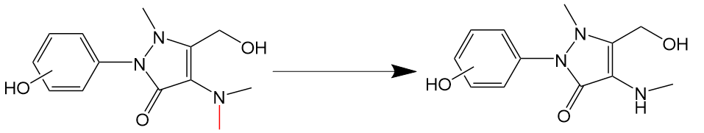 | ²⁵
2 | Dealkylation | Dealkylation | -26.038 | –C2H2 | 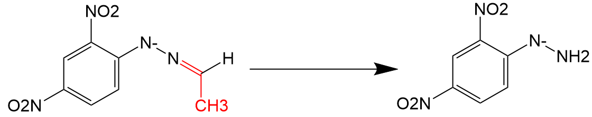 | ²⁶
3 | Dealkylation | Di-demethy or Deethylation | -28.054 | –C2H4 | 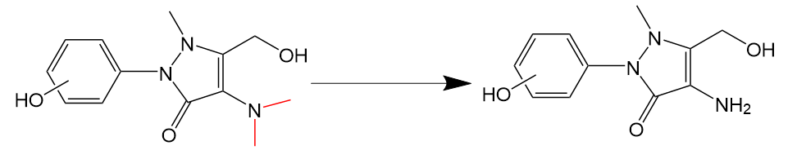 | ²⁵
4 | Dealkylation | Dealkylation | -30.07 | –C2H6 | combination of deethylation and dehydrogenation (–C2H4 and –2H) | ²⁷
5 | Dealkylation | De-cyclopropyl | -40.065 | –C3H4 | 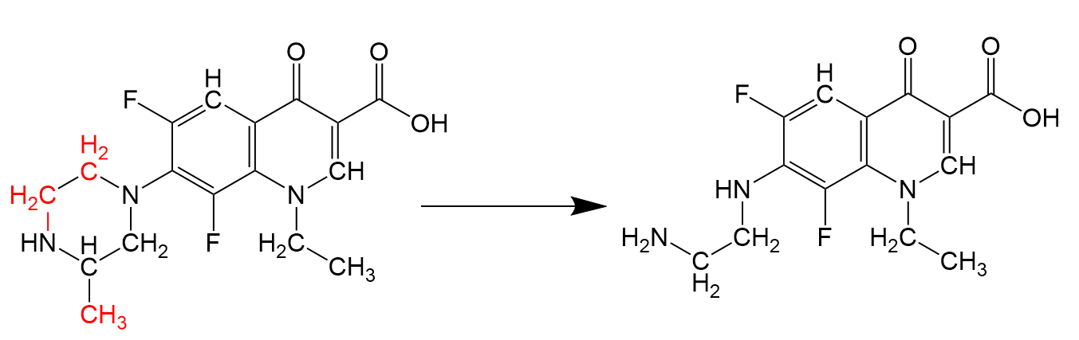 | ²⁸
6 | Dealkylation | De-isopropyl | -42.081 | –C3H6 | 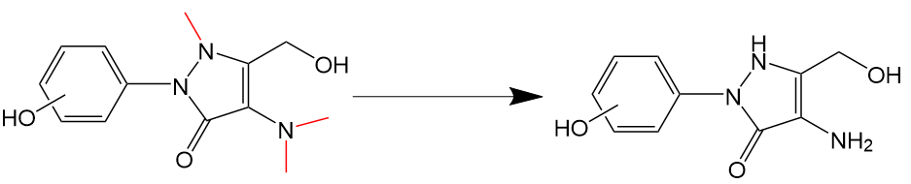 | ²⁵
7 | Oxygen addition | Hydroxylation/N or S-oxidation | 15.999 | +O | 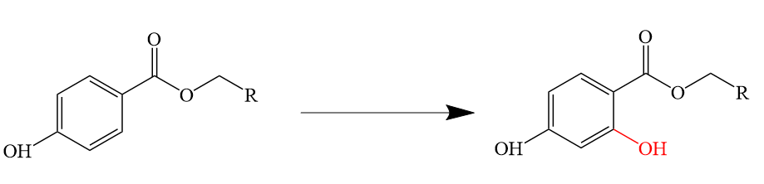  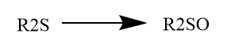 | ²⁹
8 | Oxygen addition | Carbonylation/Methyl to aldehyde/Alcohol to carboxylic acid | 13.983 | +O–H2 | 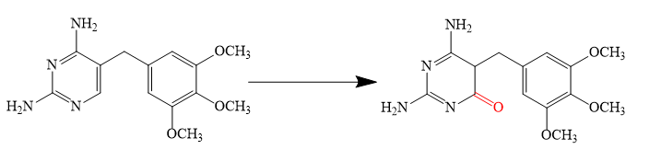 | ³⁰
9 | Oxygen addition | Hydration | 18.015 | +H2O | 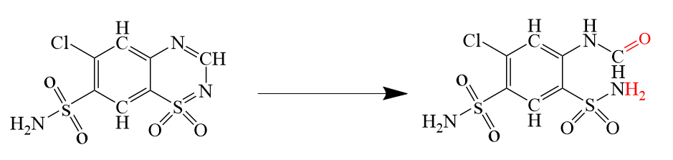 | ³¹
10 | Oxygen addition | Methyl to carboxylic acid | 29.982 | +O2–H2 | 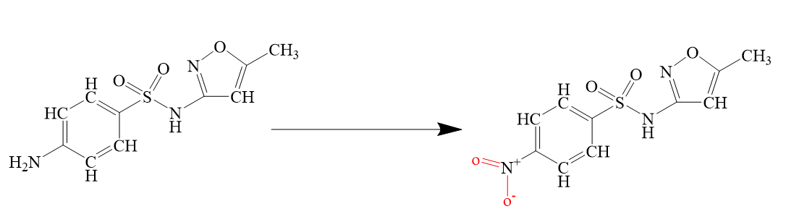 | ³²
11 | Oxygen addition | Oxygen addition | 31.998 | +2O | 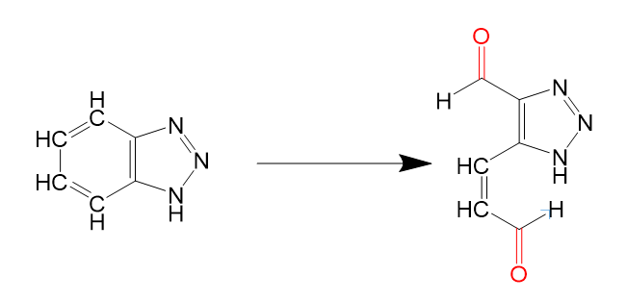 | ³³
12 | Oxygen addition | di-hydroxylation | 34.014 | +H2O2 | 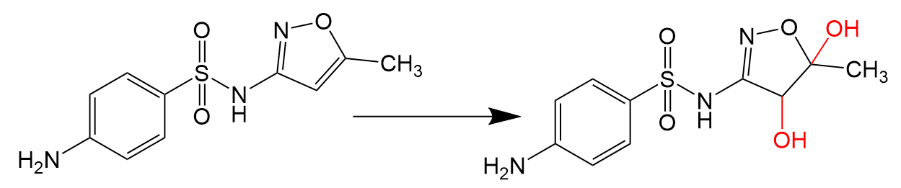 | ³⁴
13 | Oxygen addition | Oxygen addition | 47.997 | +3O | 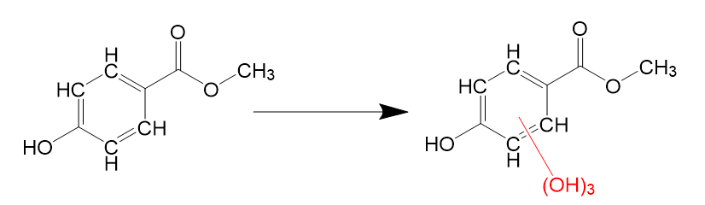 | ²⁹
14 | Decarboxylation | Reductive displacement of  carboxylic acid | -28.01 | –CO | 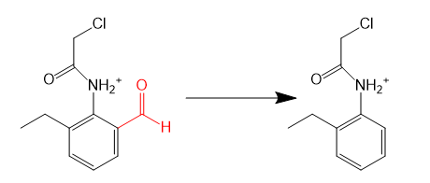 | ³⁵
15 | Decarboxylation | Decarboxylation | -44.009 | –CO2 | 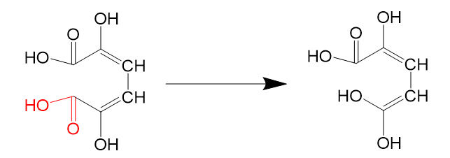 | ³⁶
16 | Decarboxylation | Loss of methanol | -30.026 | –CH2O | 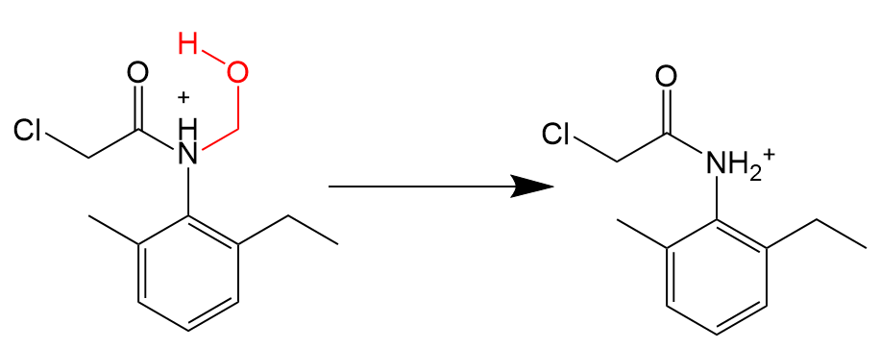 | ³⁵
17 | Decarboxylation | Loss of acetic acid | -58.036 | –C2H2O2 | 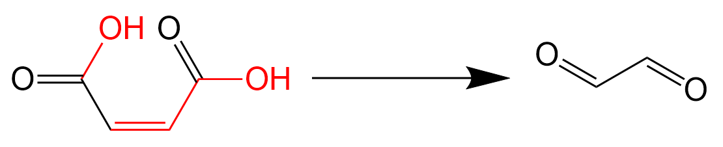 | ³⁷
18 | Decarboxylation | Loss of acrylic acid | -70.047 | –C3H2O2 | 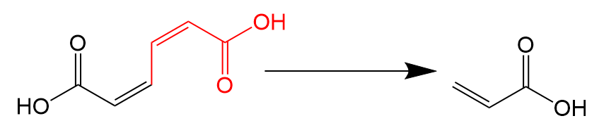 | ³⁷
19 | Decarboxylation | Loss of maleic acid | -114.056 | –C4H2O4 | 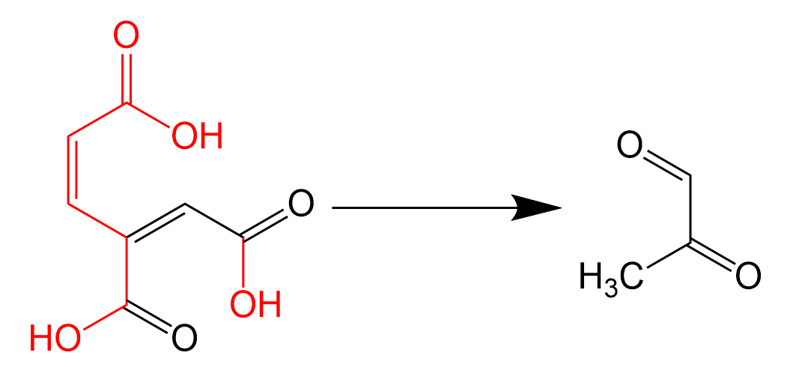 | ³⁸
20 | Deamination | Loss of N atom | -10.983 | –N+3H | 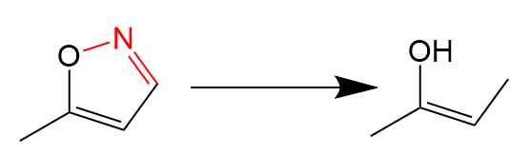 | ³⁹
21 | Deamination | Oxydative displacement of amine | 0.984 | –NH2+OH | 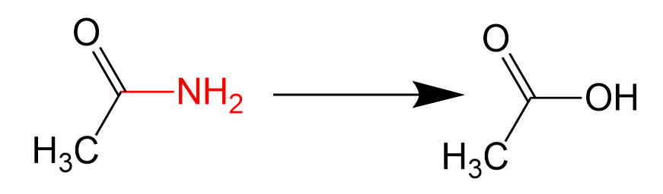  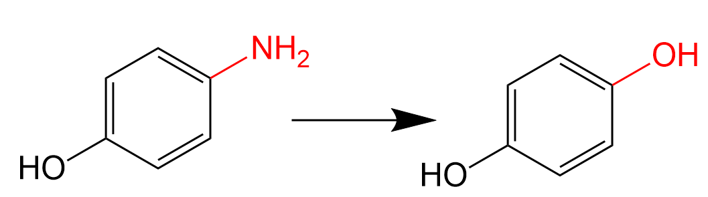 | ⁴⁰
22 | Deamination | The amino group was substituted by a methyl group | -0.988 | –NH2+CH3 | 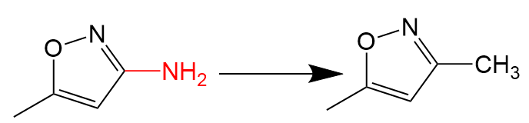 | ³⁹
23 | Deamination | Nitration of  the amine group | 29.982 | –NH2+NO2 | 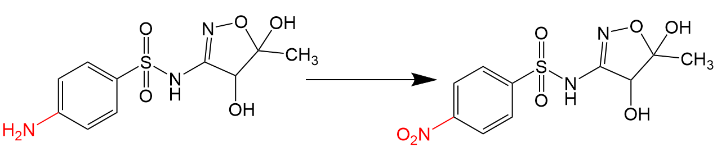 | ³⁴
24 | Deamination | Oxidative deamination | 14.967 | –NH3+2O | Deamination to ketone, followed by oxidation | ²⁷
25 | Deamination | Cleavage of triazine | -56.024 | –2N–CO | 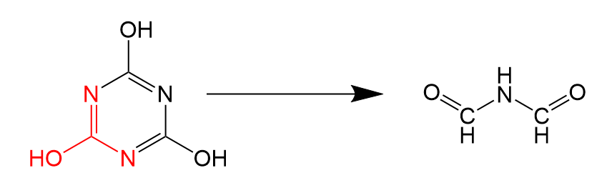 | ⁴¹
26 | Desulfonation | Oxidative  de-sulfonation | -34.076 | –SH2 | 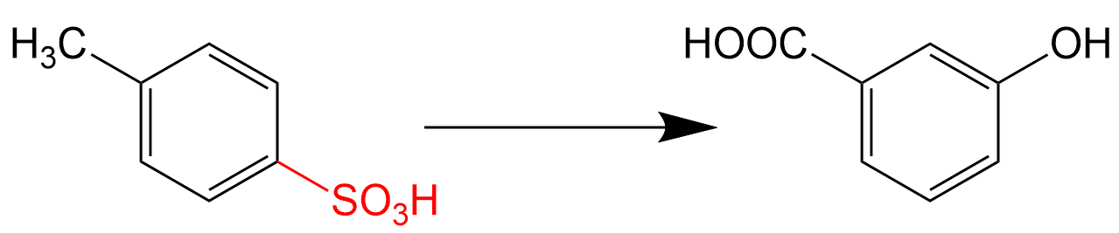 | ⁴²
27 | Desulfonation | De-sulfonation | -48.059 | –SO | 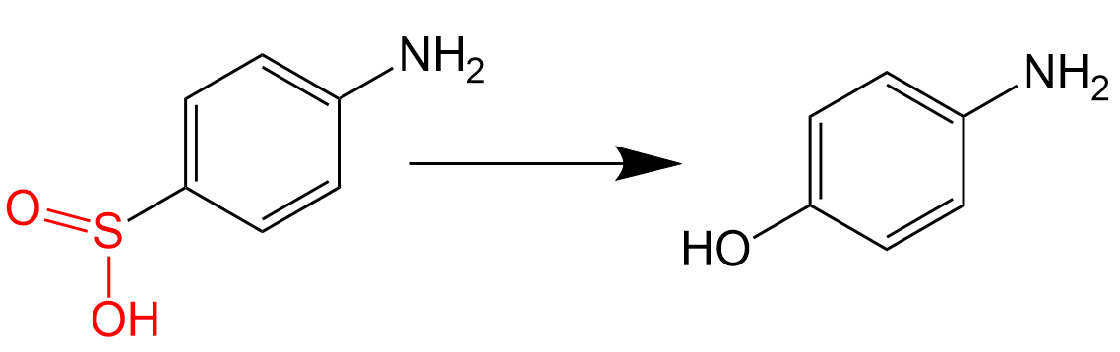 | ³⁹
28 | Desulfonation | De-sulfonation | -80.057 | –SO3 | RSO₃⁻+HO•→HSO₄⁻+R•→H⁺+SO₄²⁻+R• | ⁴³
29 | Desulfonation | De-sulfonation | -64.066 | –SO2 | RSO₂-+HO•→HSO₃⁻+R•→H++SO₃²⁻+R• | ⁴⁴
30 | Desulfonation | Oxidative  de-sulfonation | -31.972 | –S | 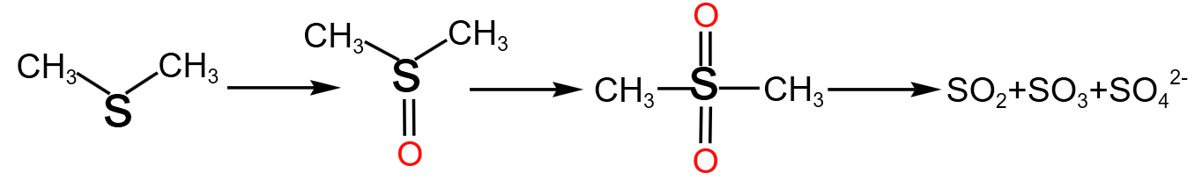 | ⁴⁵
31 | Desulfonation | De-sulfonation | -63.944 | –S2 | 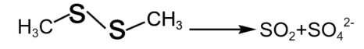 | ⁴⁶
32 | Desulfonation | Oxidative  de-sulfonation | -32.065 | –SH | RSH+O₃→ROH+SO2 | ⁴⁷
33 | Other reactions | Dehydrogenation | -2.016 | –H2 | 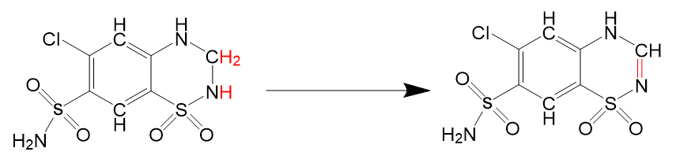 | ³¹
34 | Other reactions | Dehydration | -18.015 | –H2O | 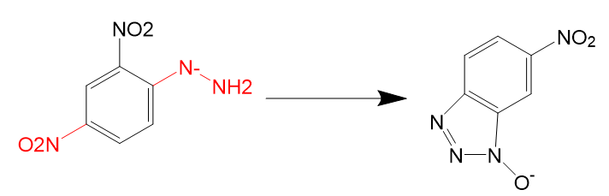 | ²⁶
35 | Other reactions | Loss of oxygen | -31.998 | –O2 | 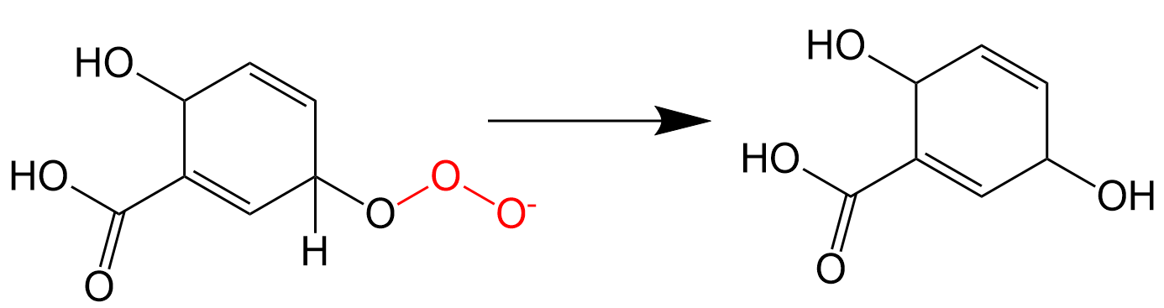 | ³⁷
36 | Other reactions | Deacetylation | -42.037 | –C2H2O | 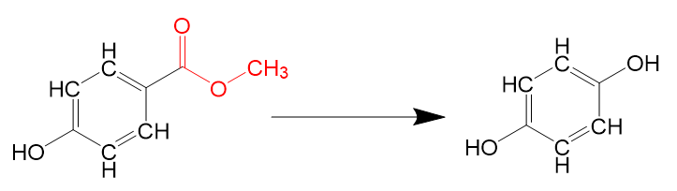 | ²⁹

Table S5. Sign of each cross-peak in the synchronous (Φ) and asynchronous (Ψ) 2DCOS maps generated from the FTIR spectra of L1 under different pre-ozonation dosages
Position (cm⁻¹) | Assignment | sign^{α}
Position (cm⁻¹) | Assignment | 1650 | 1540 | 1430 | 990
1650 | Amide I (C=O)/aromatic C=C | + | +(+) | +(+) | +(-)
1540 | Amide II N-H |  | + | +(+) | +(-)
1430 | Carboxyl COOH |  |  | + | +(-)
990 | Polysaccharide C−O |  |  |  | +
(sign^{α} were obtained in the upper-left corner of the maps: +, positive; -, negative.)

Table S6. Sign of each cross-peak in the synchronous (Φ) and asynchronous (Ψ) 2DCOS maps generated from the FTIR spectra of L2 under different pre-ozonation dosages
Position (cm⁻¹) | Assignment | sign^{α}
Position (cm⁻¹) | Assignment | 1650 | 1590 | 1380 | 1070
1650 | Amide I (C=O)/ aromatic C=C | + | +(+) | +(+) | +(-)
1590 | imidazole C=C |  | + | +(+) | +(-)
1380 | Carboxyl COOH |  |  | + | +(-)
1070 | Polysaccharide C−O |  |  |  | +
(sign^{α} were obtained in the upper-left corner of the maps: +, positive; -, negative.)

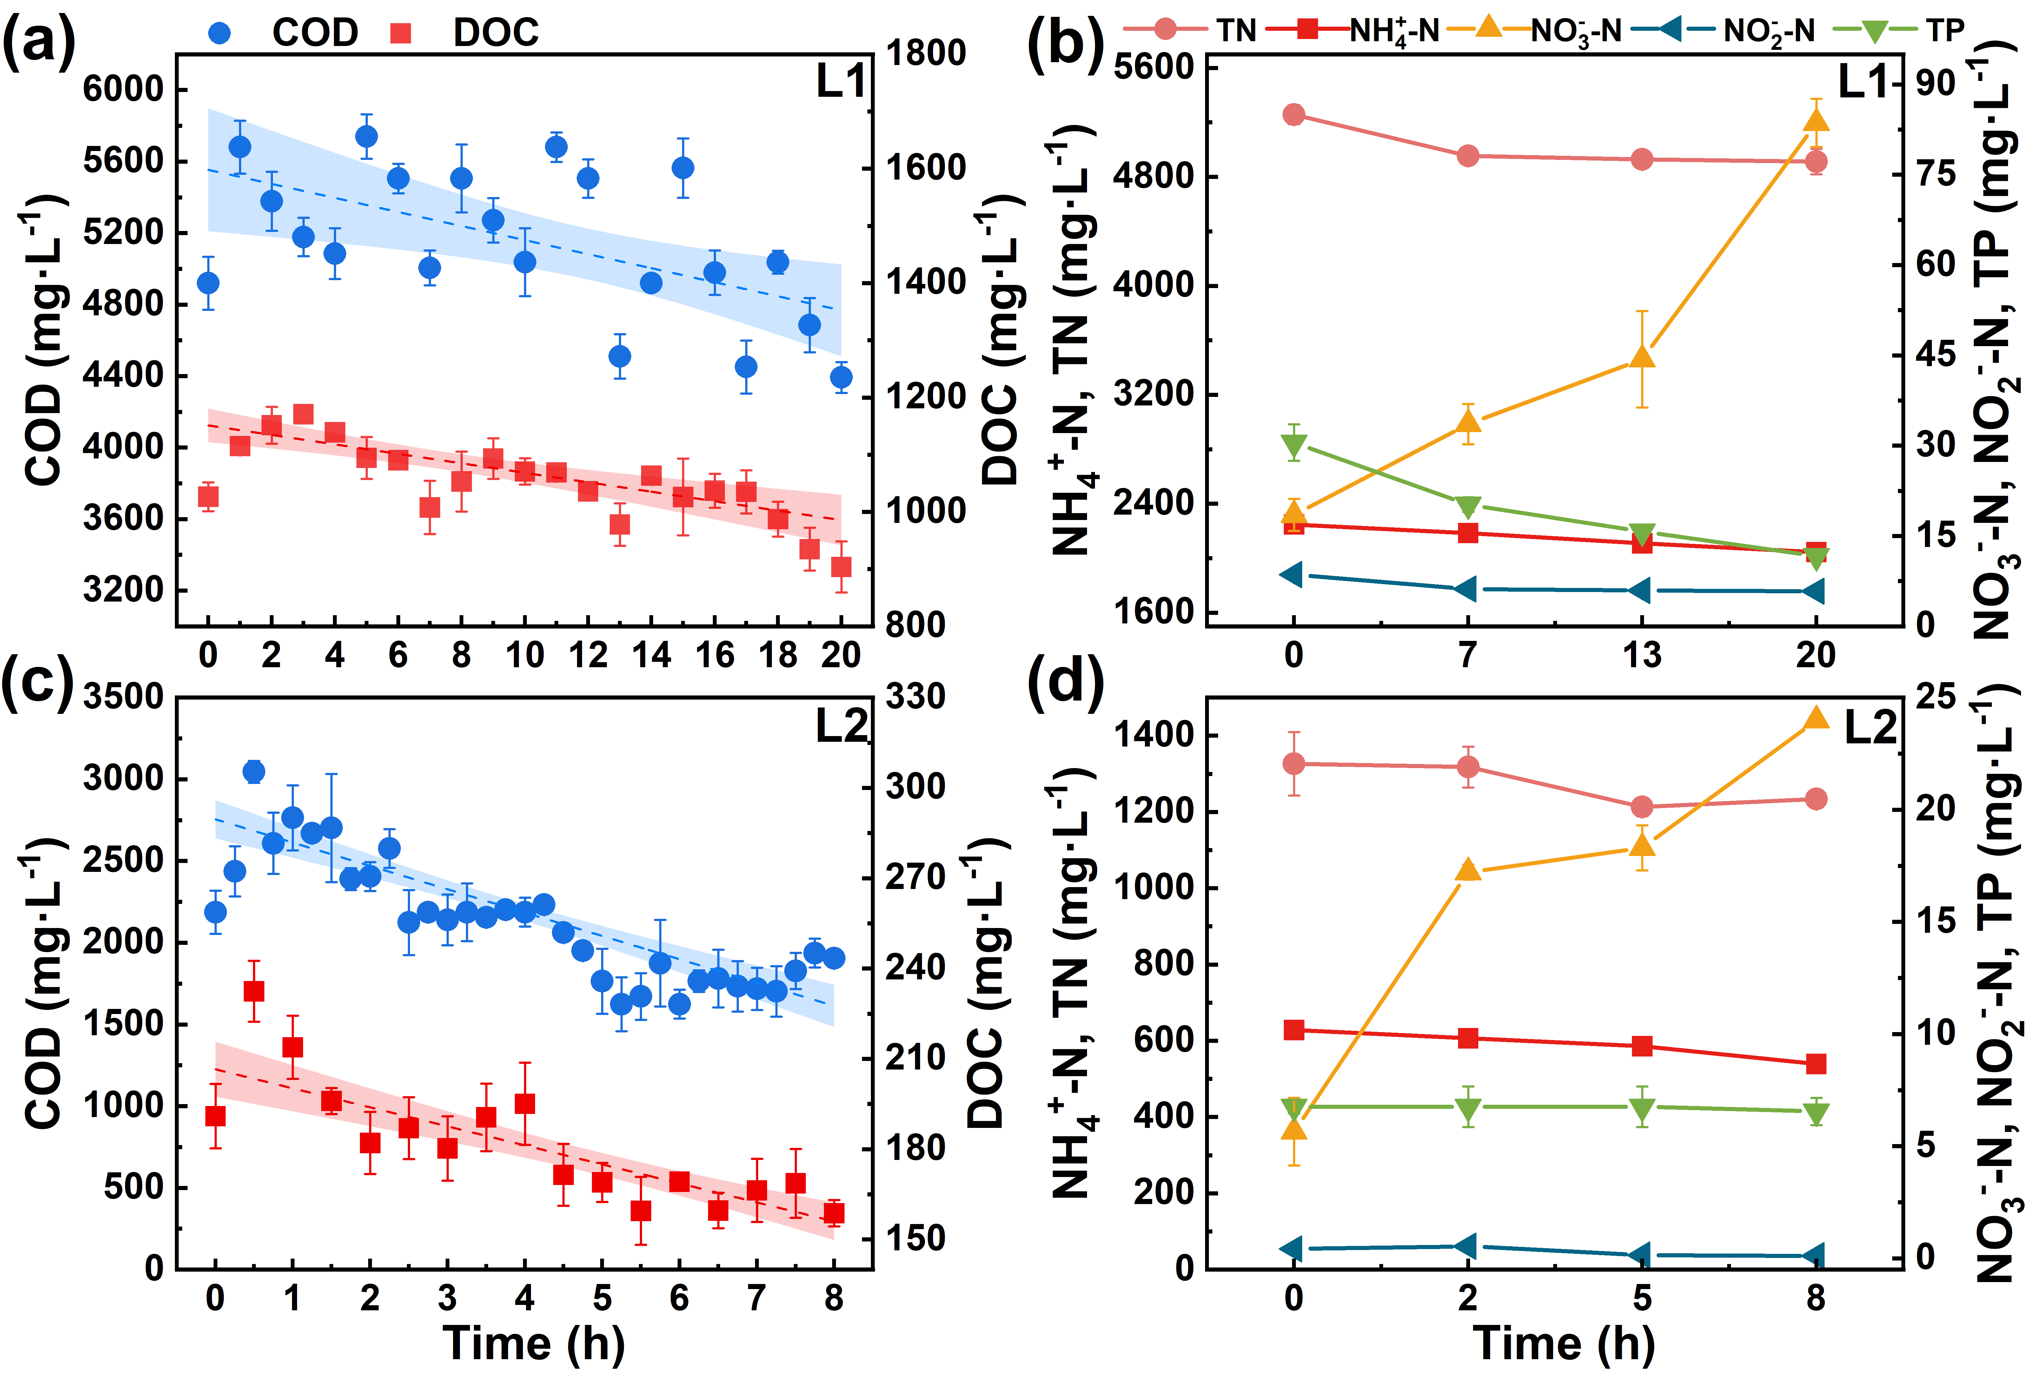

Fig. S1. (a)-(b) COD and DOC, (c)-(b) TN, NH₄⁺-N, NO₃⁻-N, NO₂⁻-N, and TP concentration changes in two types of leachates with continuous ozone pretreatment.

Fig. S2. EPS, LB-EPS and TB-EPS for L1 and L2 change under different pre-ozonation dosages.

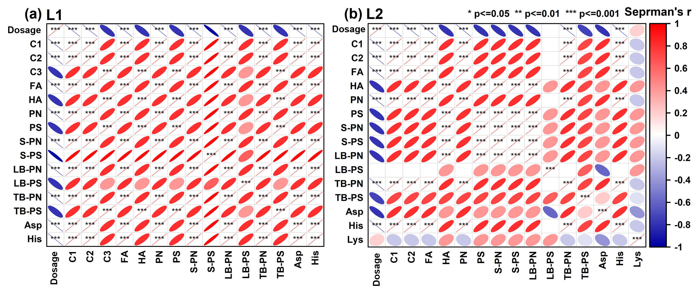

Fig. S3. Correlation coefficients between DOM and pre-ozonation dosage for (a) L1 and (b) L2, and correlation coefficients were obtained using Spearman’s coefficient.
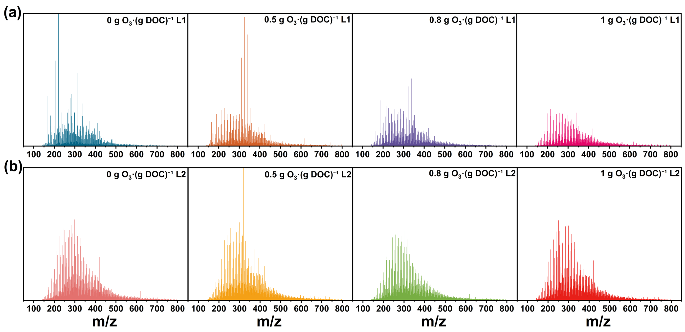

Fig. S4. Mass spectra of DOM with mass-to-charge ratios ranging from 100 to 800 in (a) L1 and (b) L2 treated by different pre-ozonation dosages.

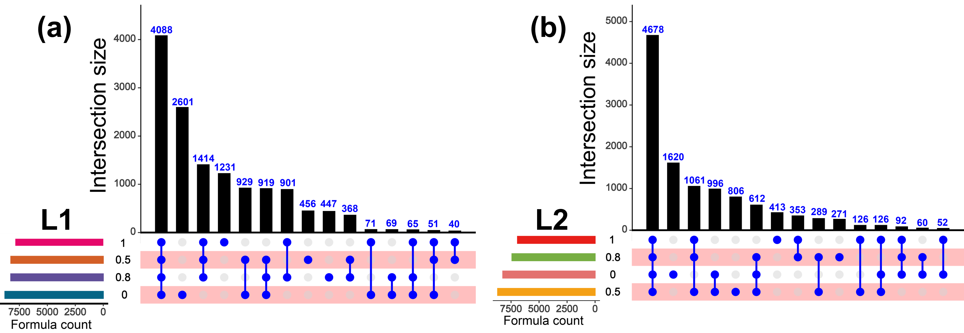

Fig. S5. Upsets diagram showing the overall difference of DOM composition in (a) L1 and (b) L2.

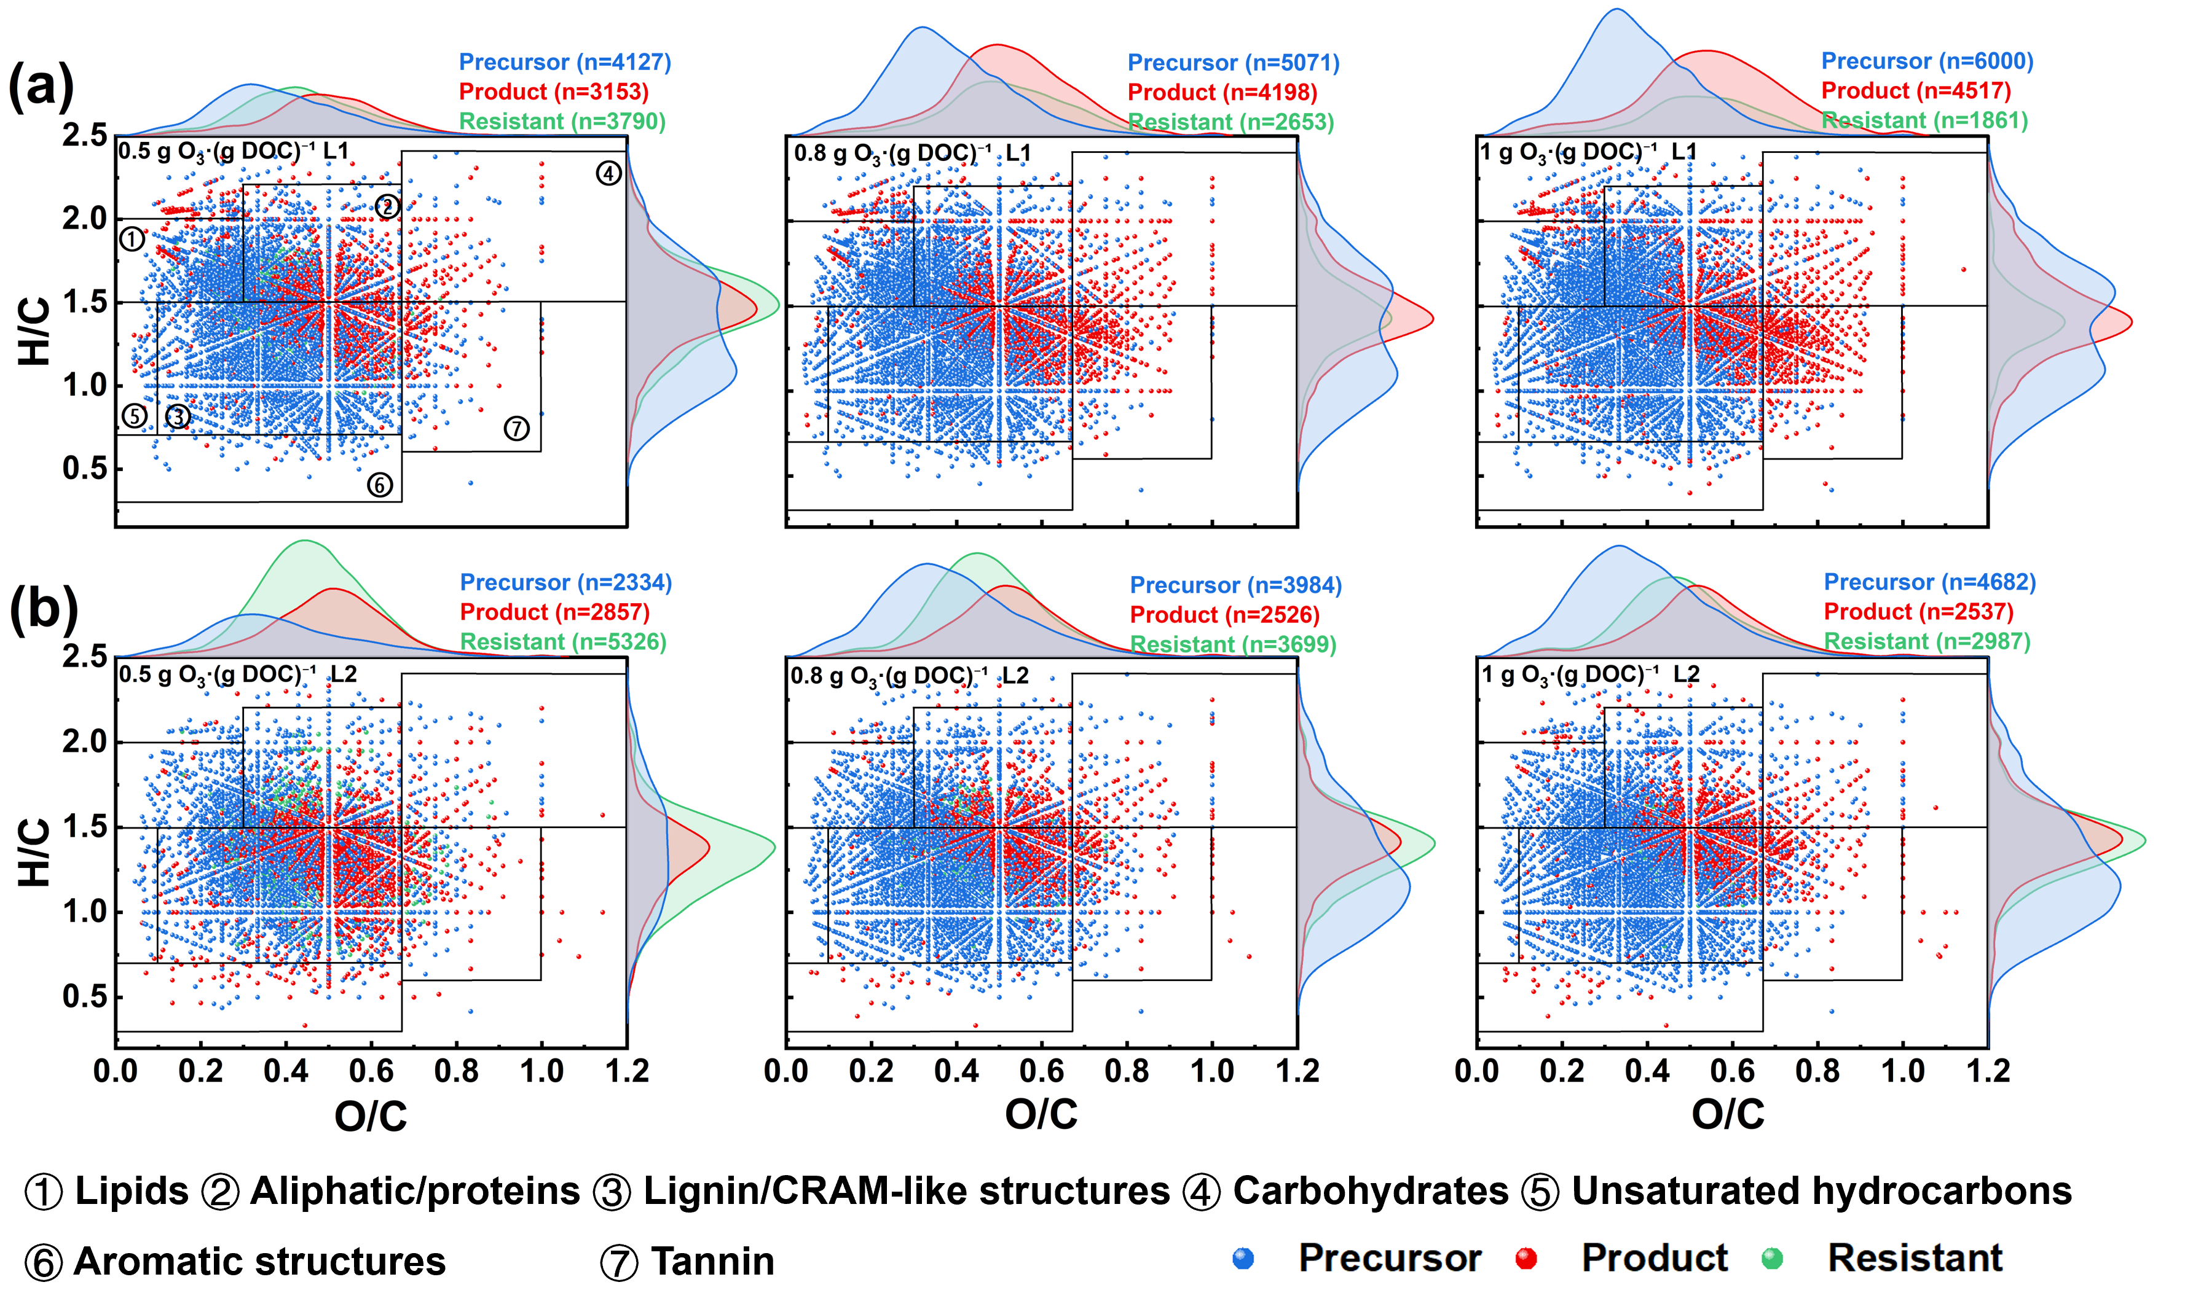

Fig. S6. Van Krevelen and marginal distribution diagrams of in (a) L1 and (b) L2 under different pre-ozonation dosages. Points in blue represent precursor, points in red represent product, and points in blue denote resistant.
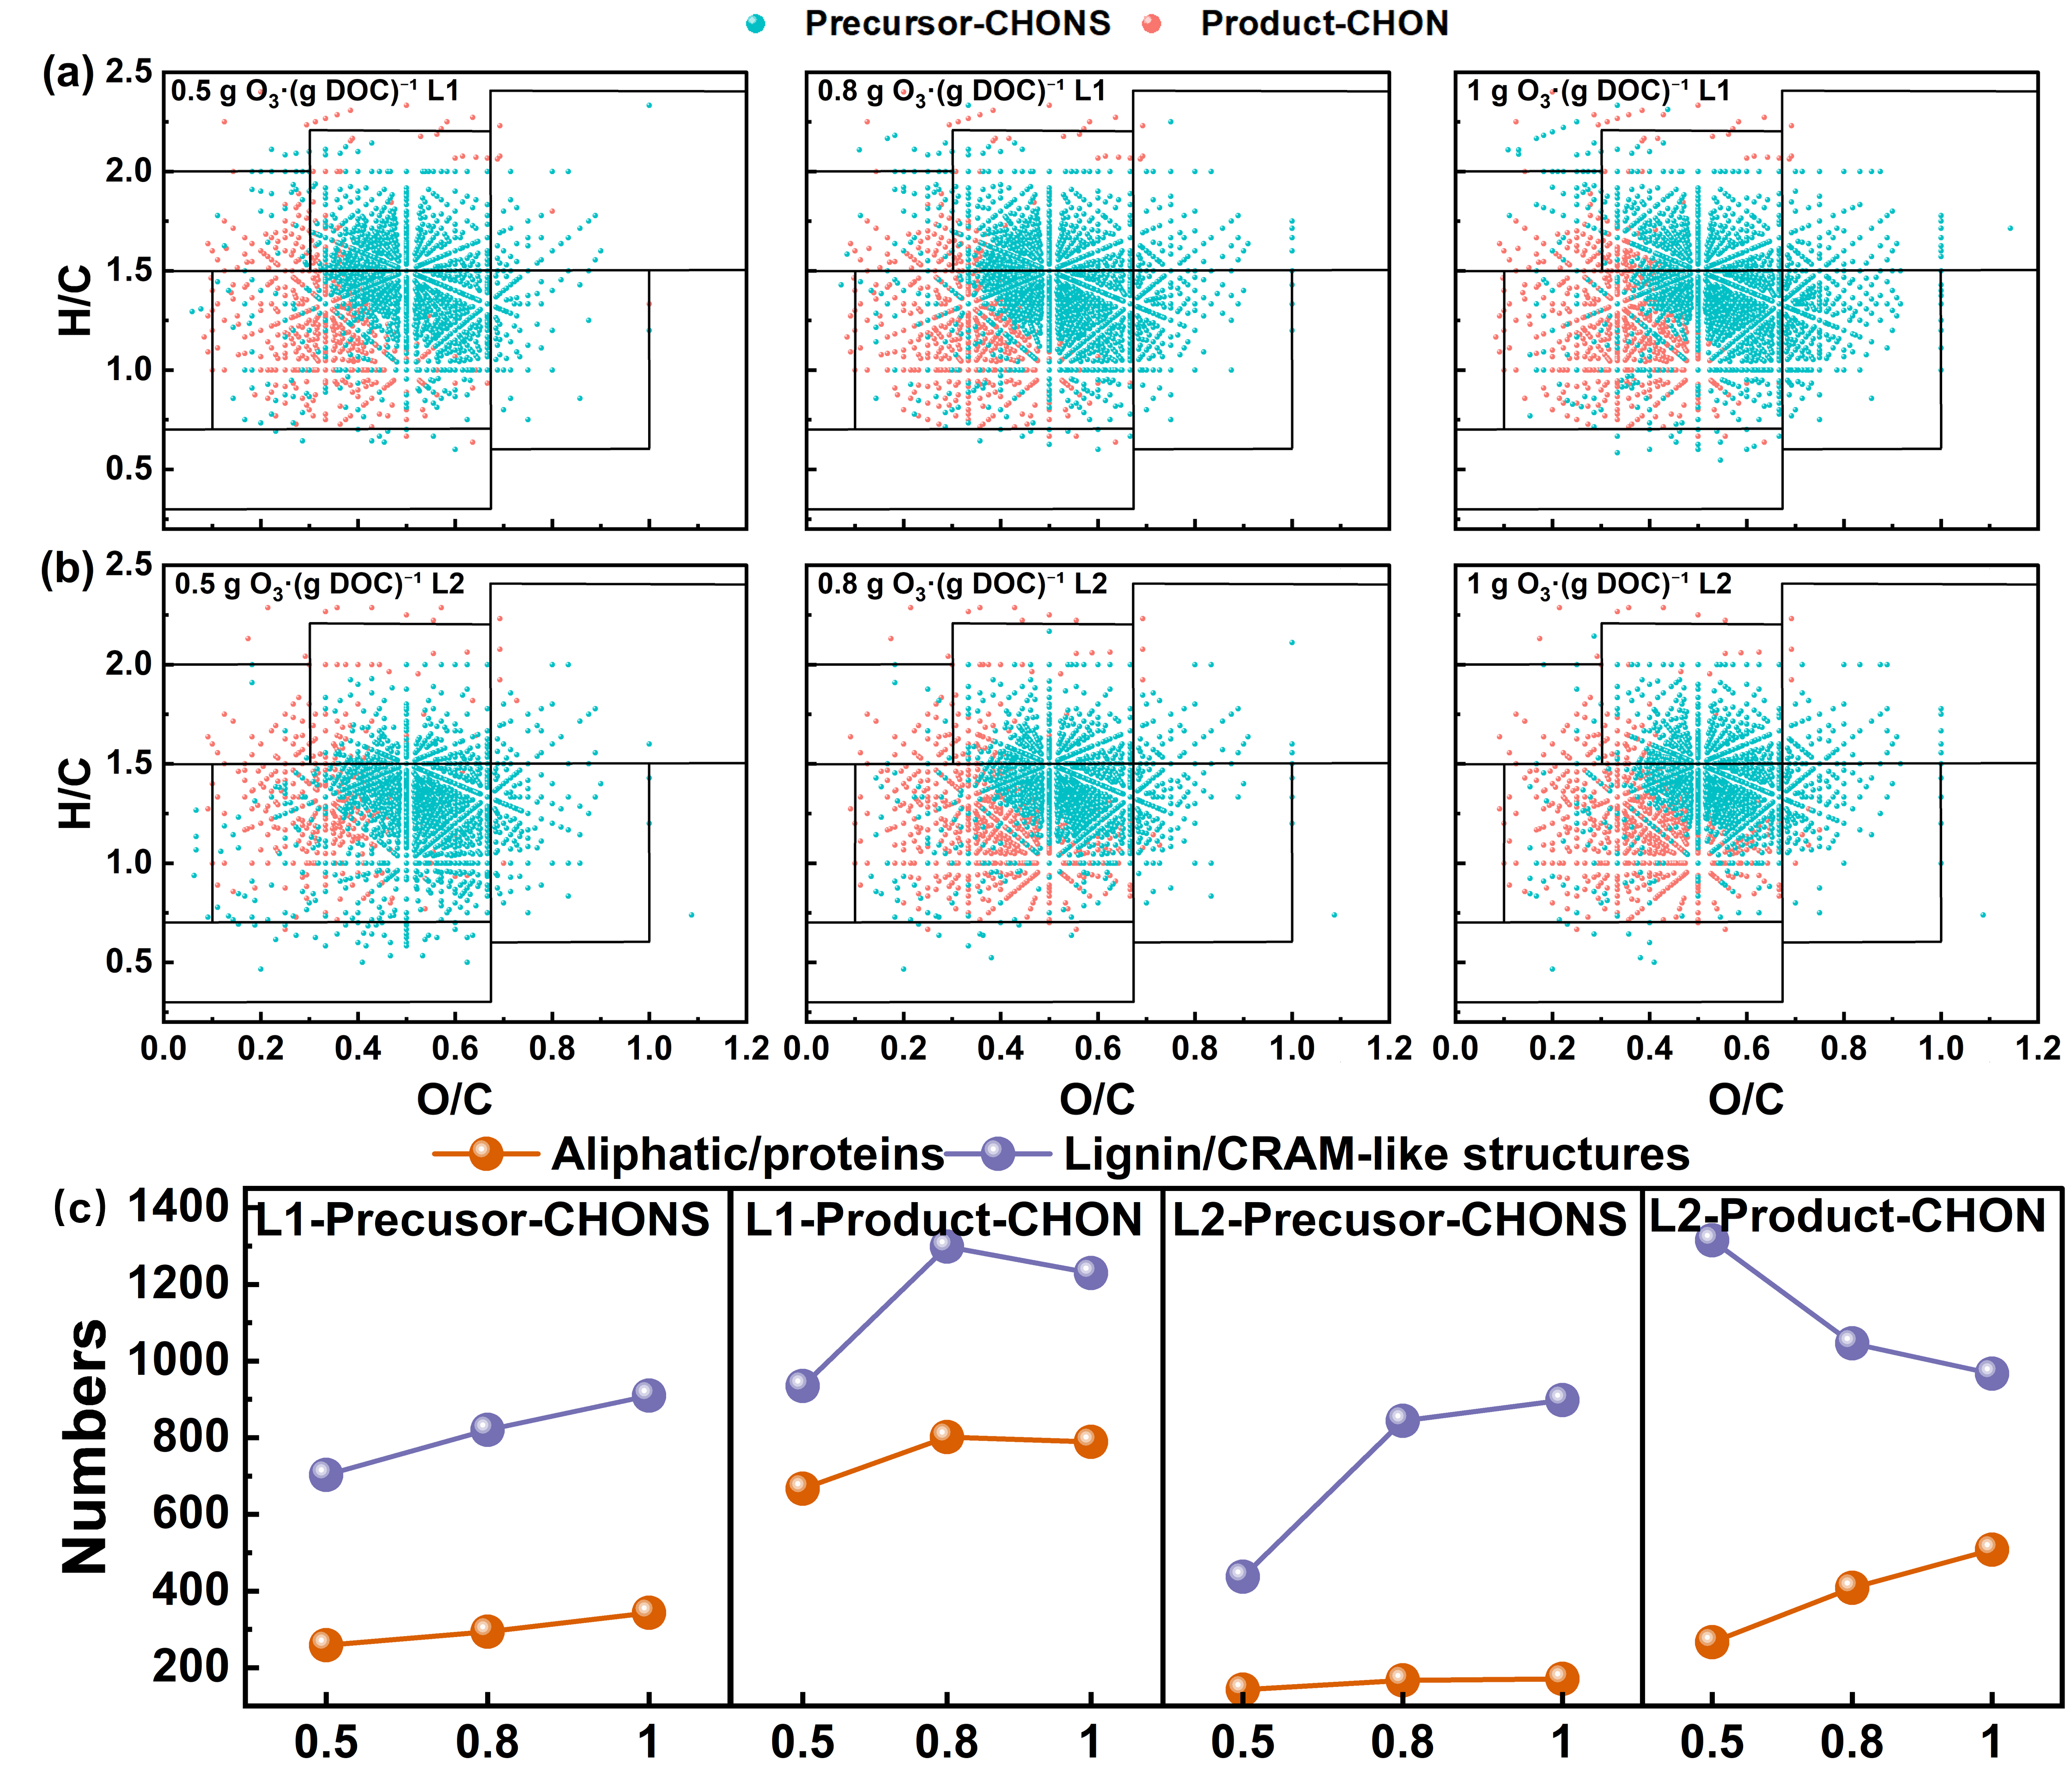

Fig. S7. Van Krevelen diagrams for the precursors of CHONS and the products of CHON in (a)L1 and (b) L2 under different pre-ozonation dosages. (c) Number molecular formulas for the precursors of CHONS and the products of CHON in L1 and L2.

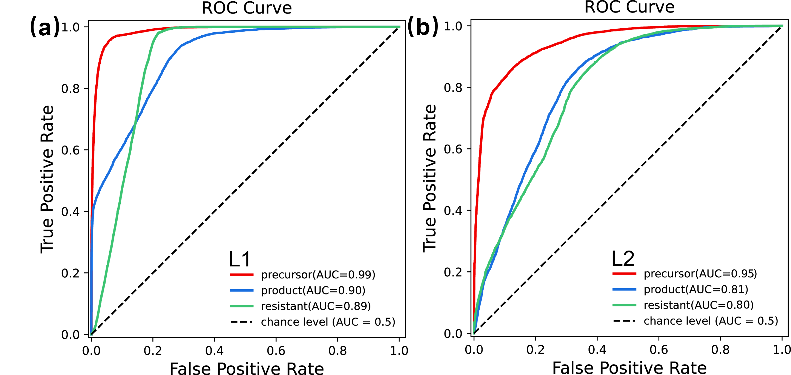

Fig. S8. ROC Curve and AUC for Random Forest algorithm with (a) L1 and (b) L2.

Fig. S9. The RI of MW, O/C, O, and DBE-O of precursors and products in (a) L1 and (b) L2.

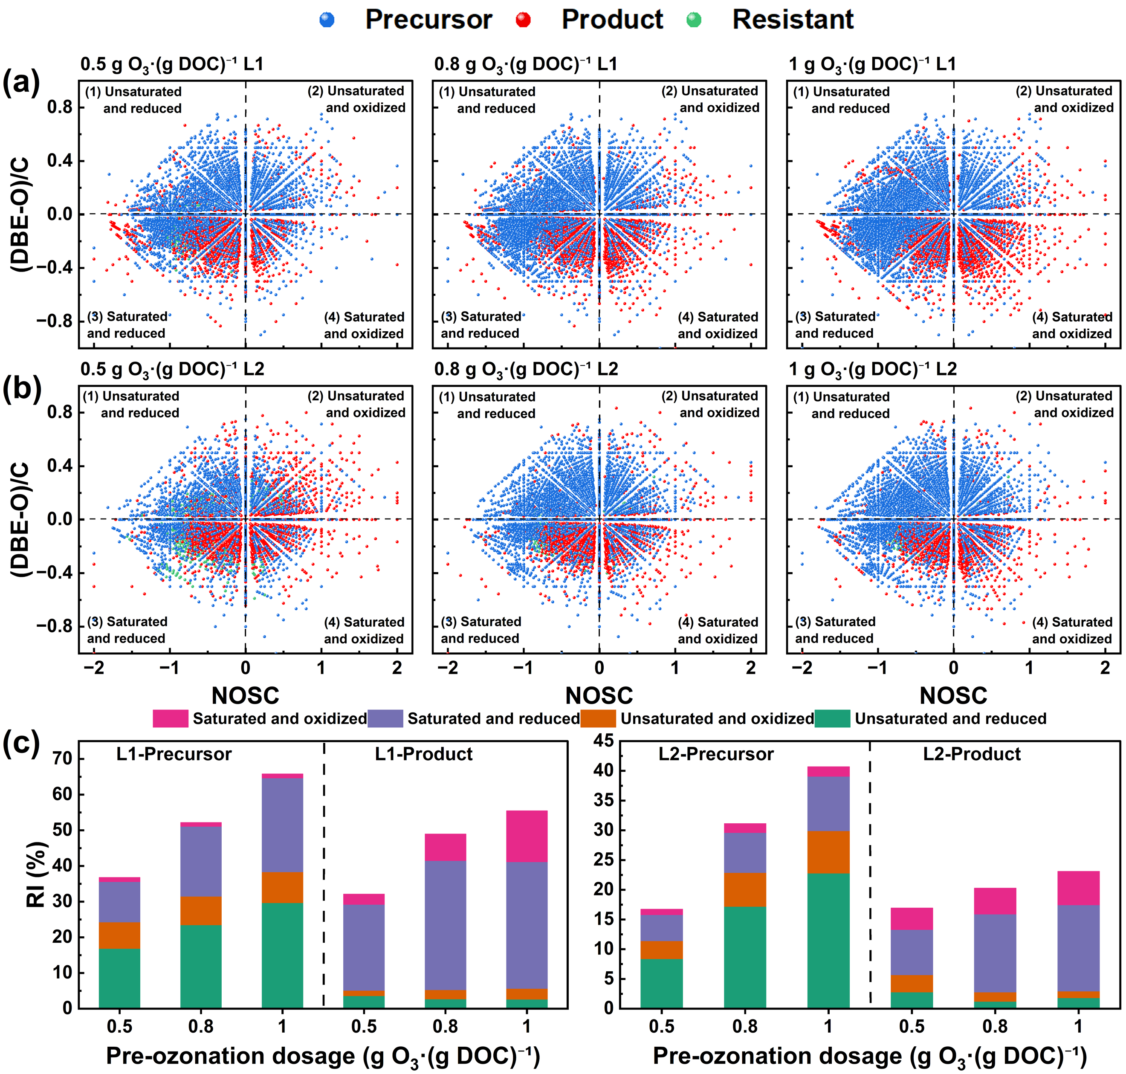

Fig. S10. The (DBE–O)/C-NOSC plots of DOM after ozone treatment in (a) L1 and (b) L2. (c) Formular distribution of four classes of saturation and oxidation states.

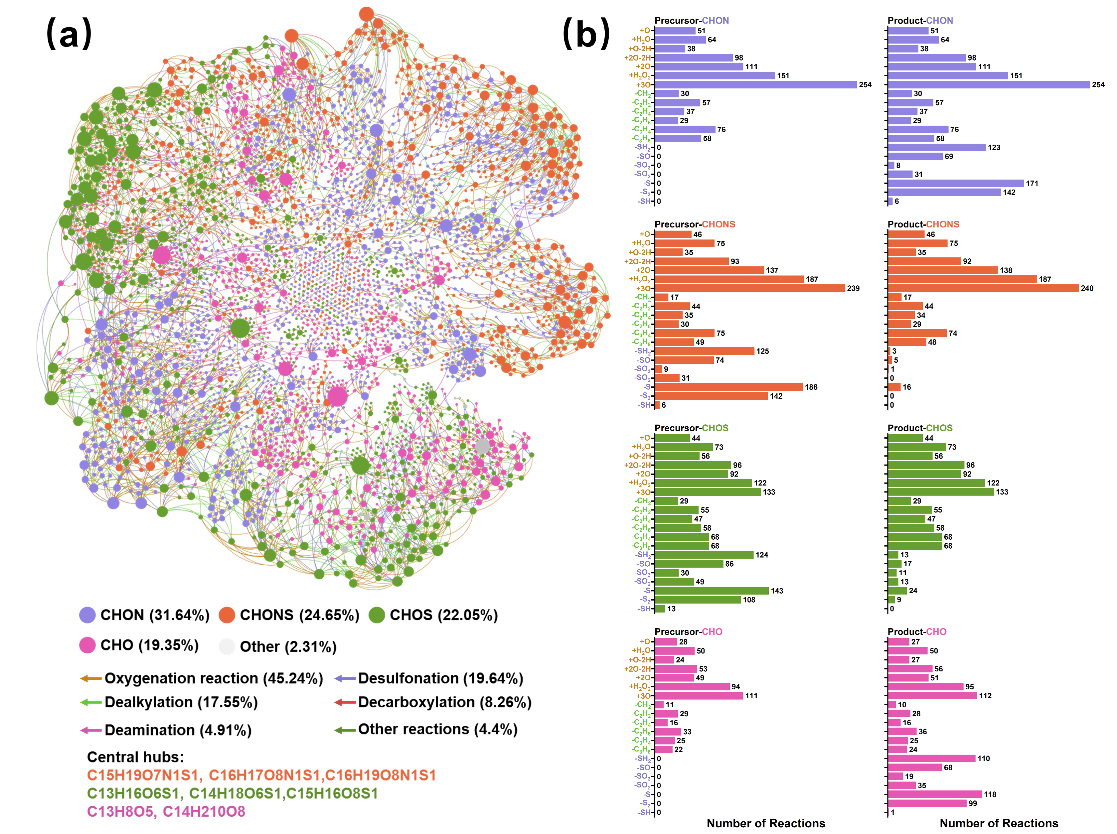

Fig. S11. (a) PMD-based network indicating some of the possible reactions for the major classes at 1.0 g O₃·(g DOC)⁻¹ in L1. (b) Distribution of reactions (paired mass difference) in CHO, CHONS, CHOS, and CHO formulas.

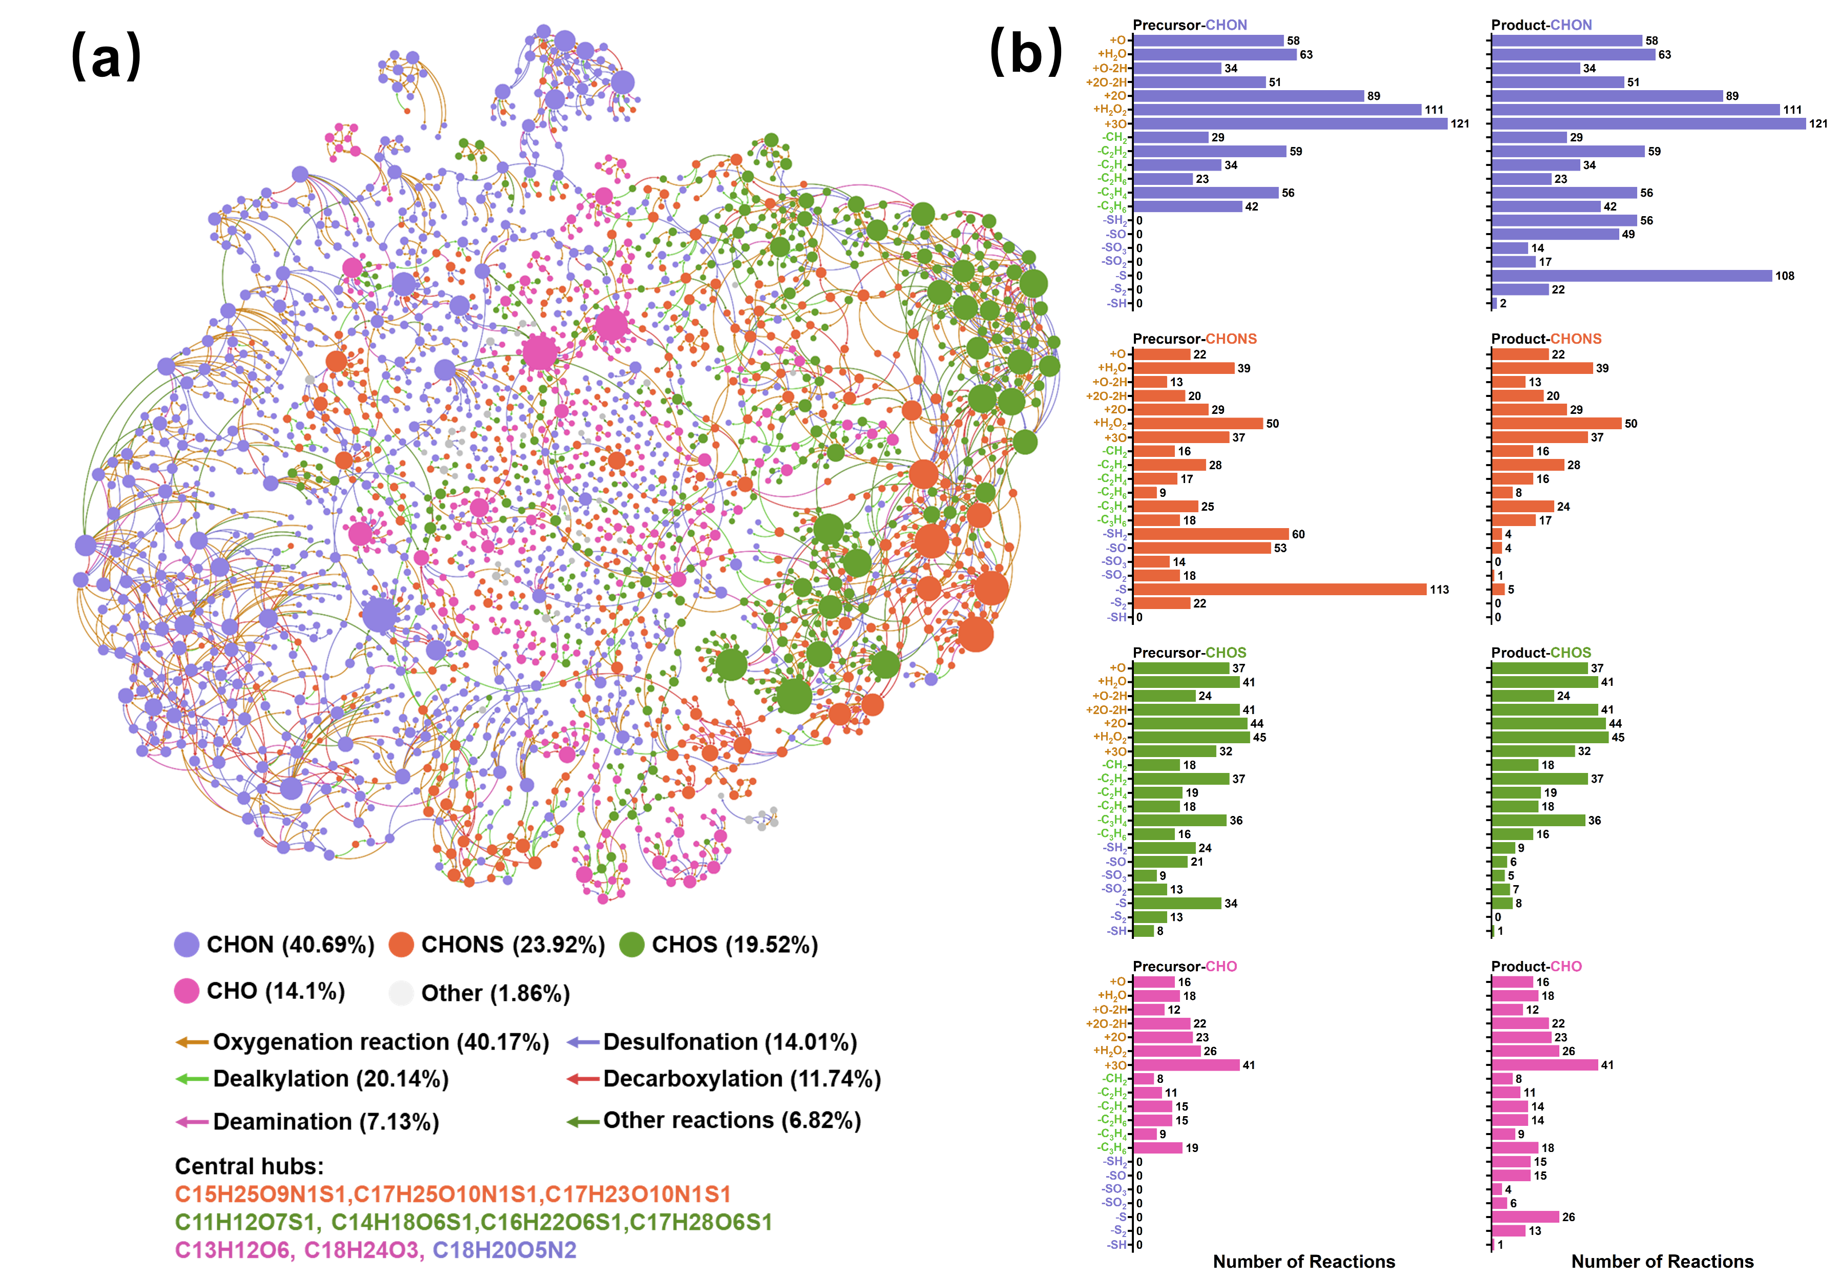

Fig. S12. (a) PMD-based network indicating some of the possible reactions for the major classes at 1.0 g O₃·(g DOC)⁻¹ in L2. (b) Distribution of reactions (paired mass difference) in CHO, CHONS, CHOS, and CHO formulas.

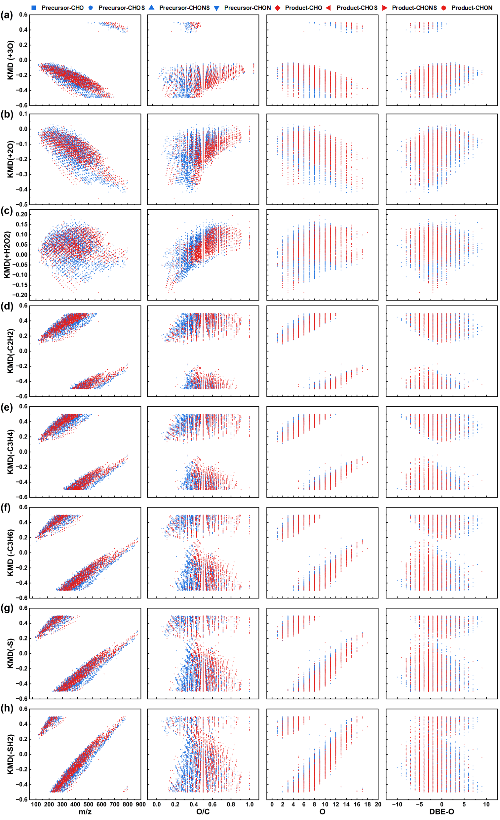

Fig. S13. KMD plots for series of (a) +3O, (b) +2O, (c) +H2O2, (d) –C2H2, (e) –C3H4, (f) –C3H6, (g) –S, and (h) –SH2 for the possible precursor-product pairs at 1.0 g O₃·(g DOC)⁻¹ in L1. X-axis corresponds to m/z, O/C, O, and DBE–O.
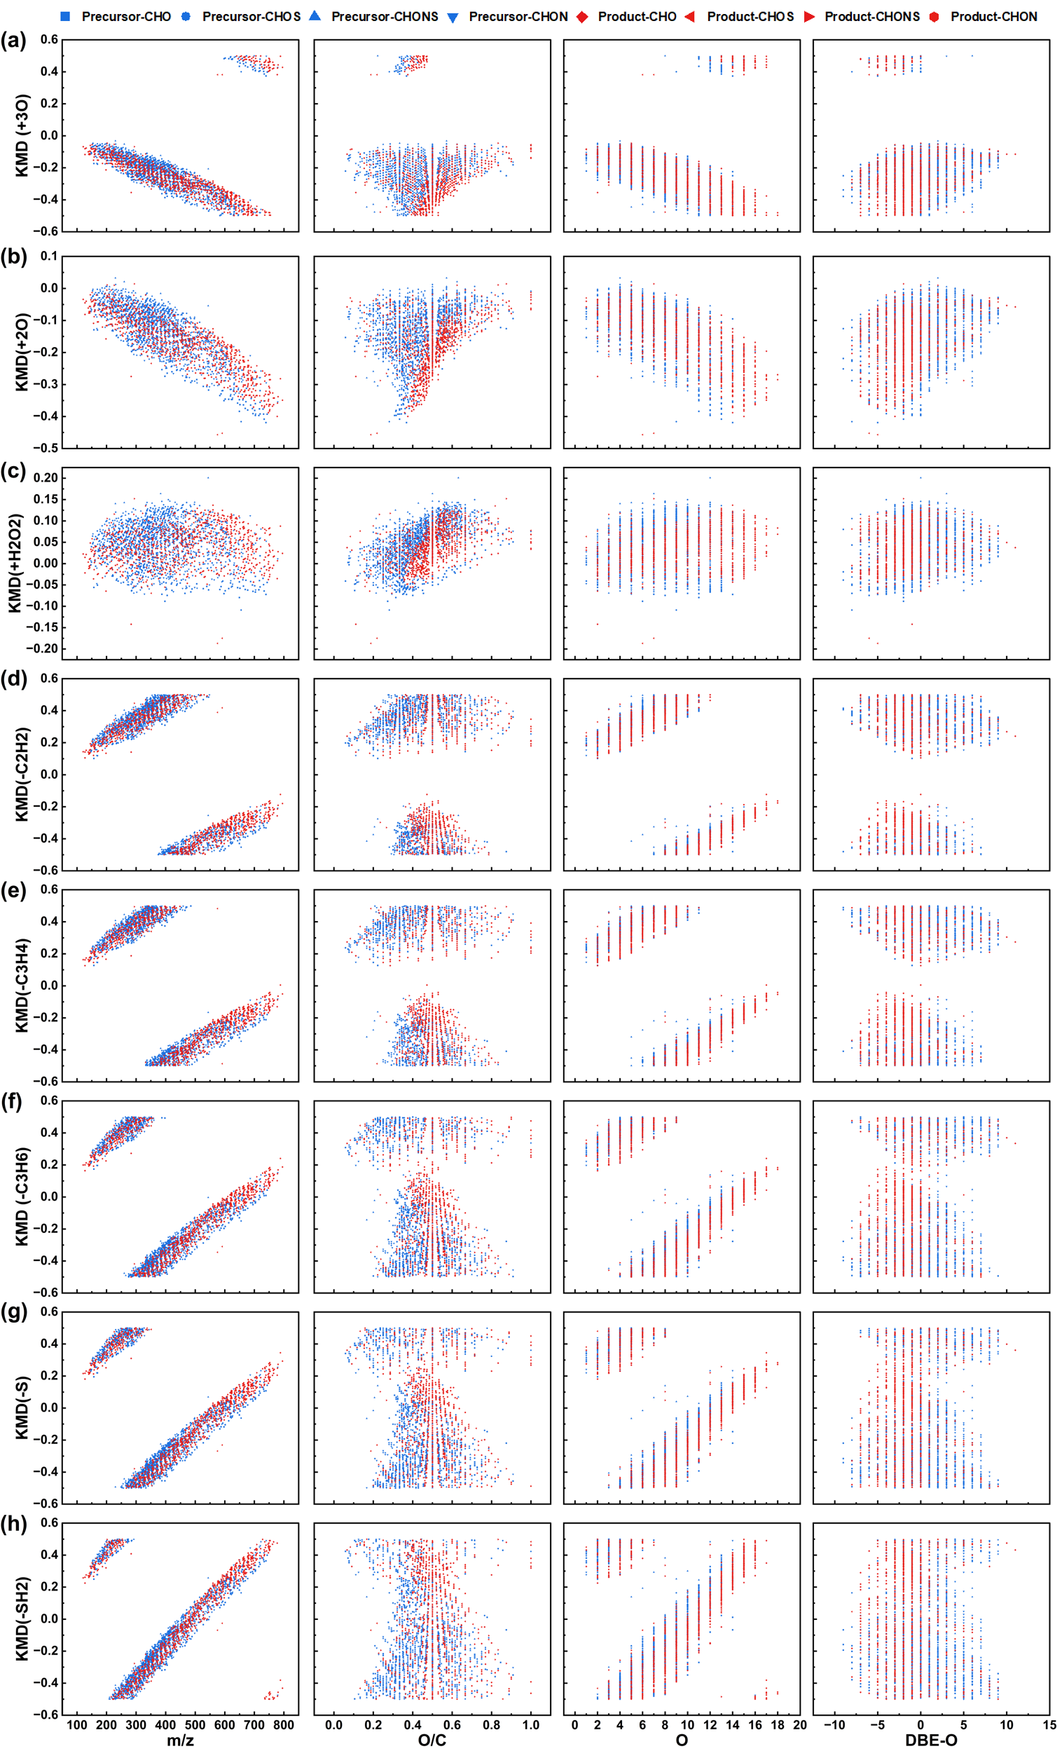

Fig. S14. KMD plots for series of (a) +3O, (b) +2O, (c) +H2O2, (d) –C2H2, (e) –C3H4, (f) –C3H6, (g) –S, and (h) –SH2 for the possible precursor-product pairs at 1.0 g O₃·(g DOC)⁻¹ in L2. X-axis corresponds to m/z, O/C, O, and DBE–O.

Fig. S15. Free radicals produced for (a) L1 and (b) L2 under different pre-ozonation dosages.

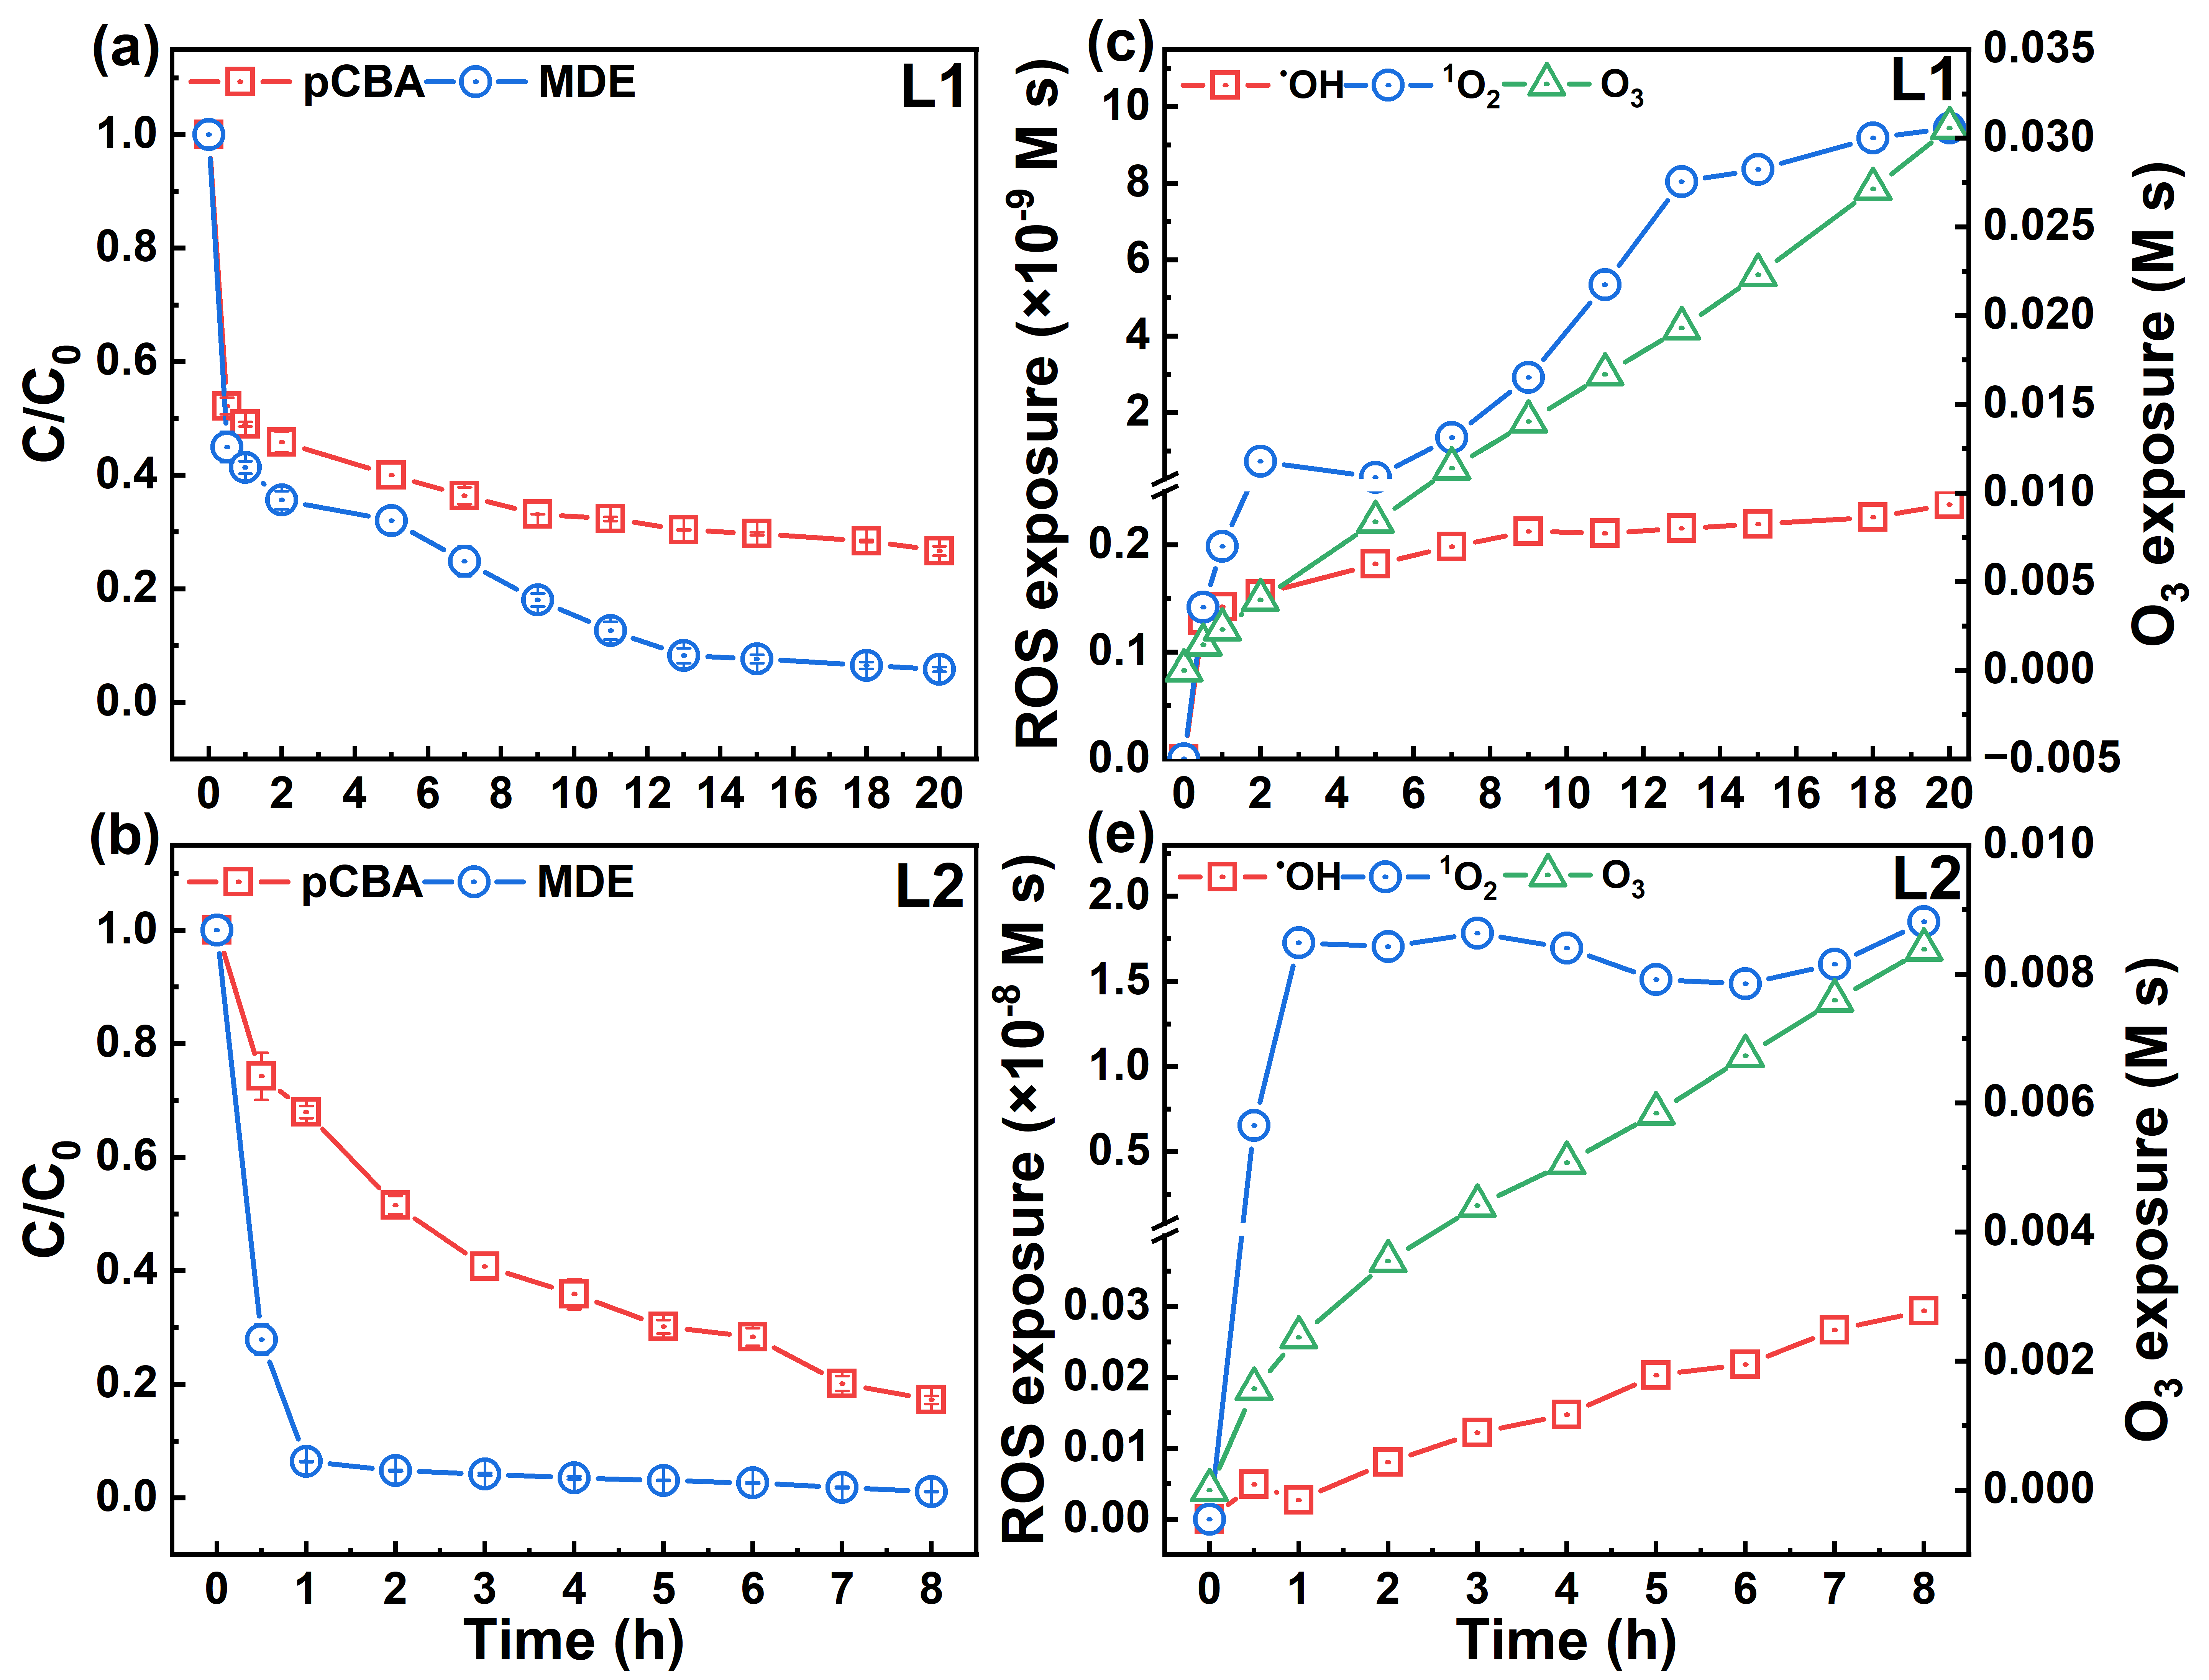

Fig. S16. Abatement efficiency of para-chlorobenzoic acid (pCBA), and metronidazole (MDE) for (a) L1 and (b) L2. Evolution of •OH, ¹O₂, and O₃ exposures for (c) L1 and (e) L2.

Fig. S17. The normalized water flux (J/J₀) decline curve for (a) L1 and (b) L2 and NH₄⁺-N, TN, DOC, and TP removal for (c) L1 and (d) L2 change in the FO process under different pre-ozonation dosages.

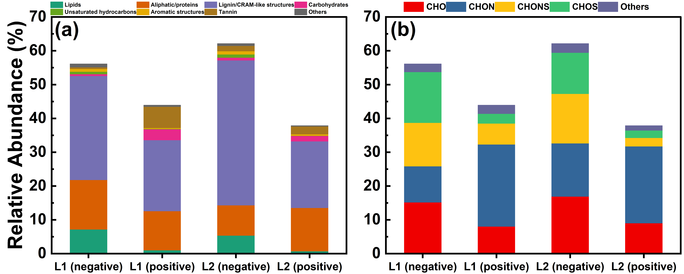

Fig. S19. The relative abundance of negative and positive DOM composition according to (a) compound classes, and (b) formula classes.

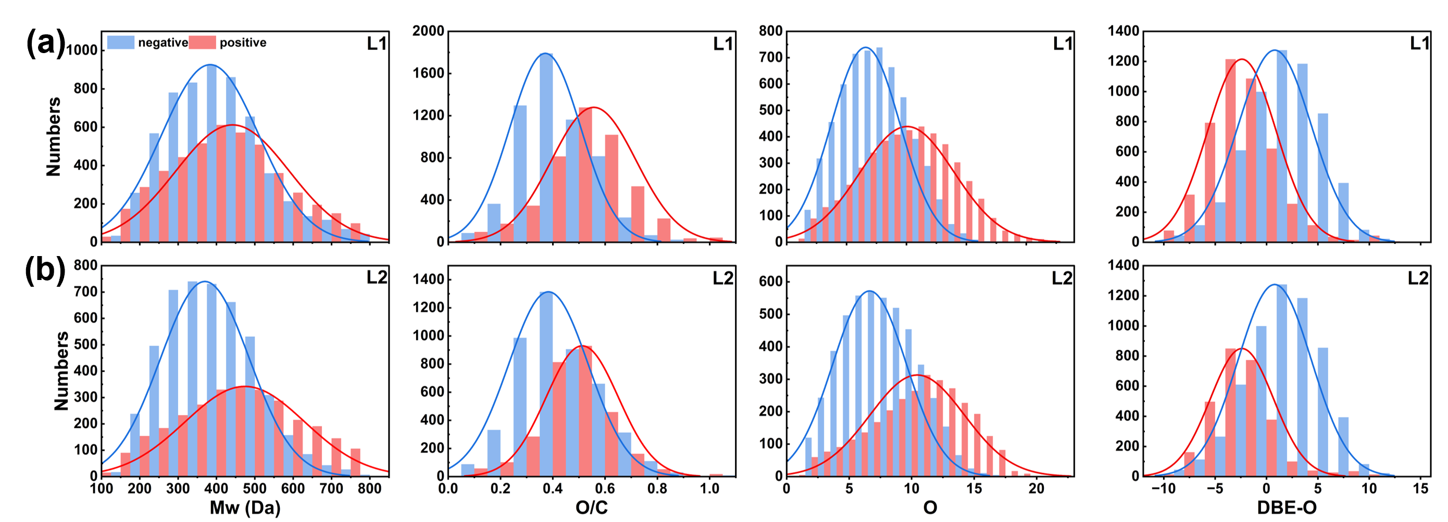

Fig. S20. The plot of the distribution of the four main molecular properties for (a) L1 and (b) L2 in negative (r<0) and positive (r>0).

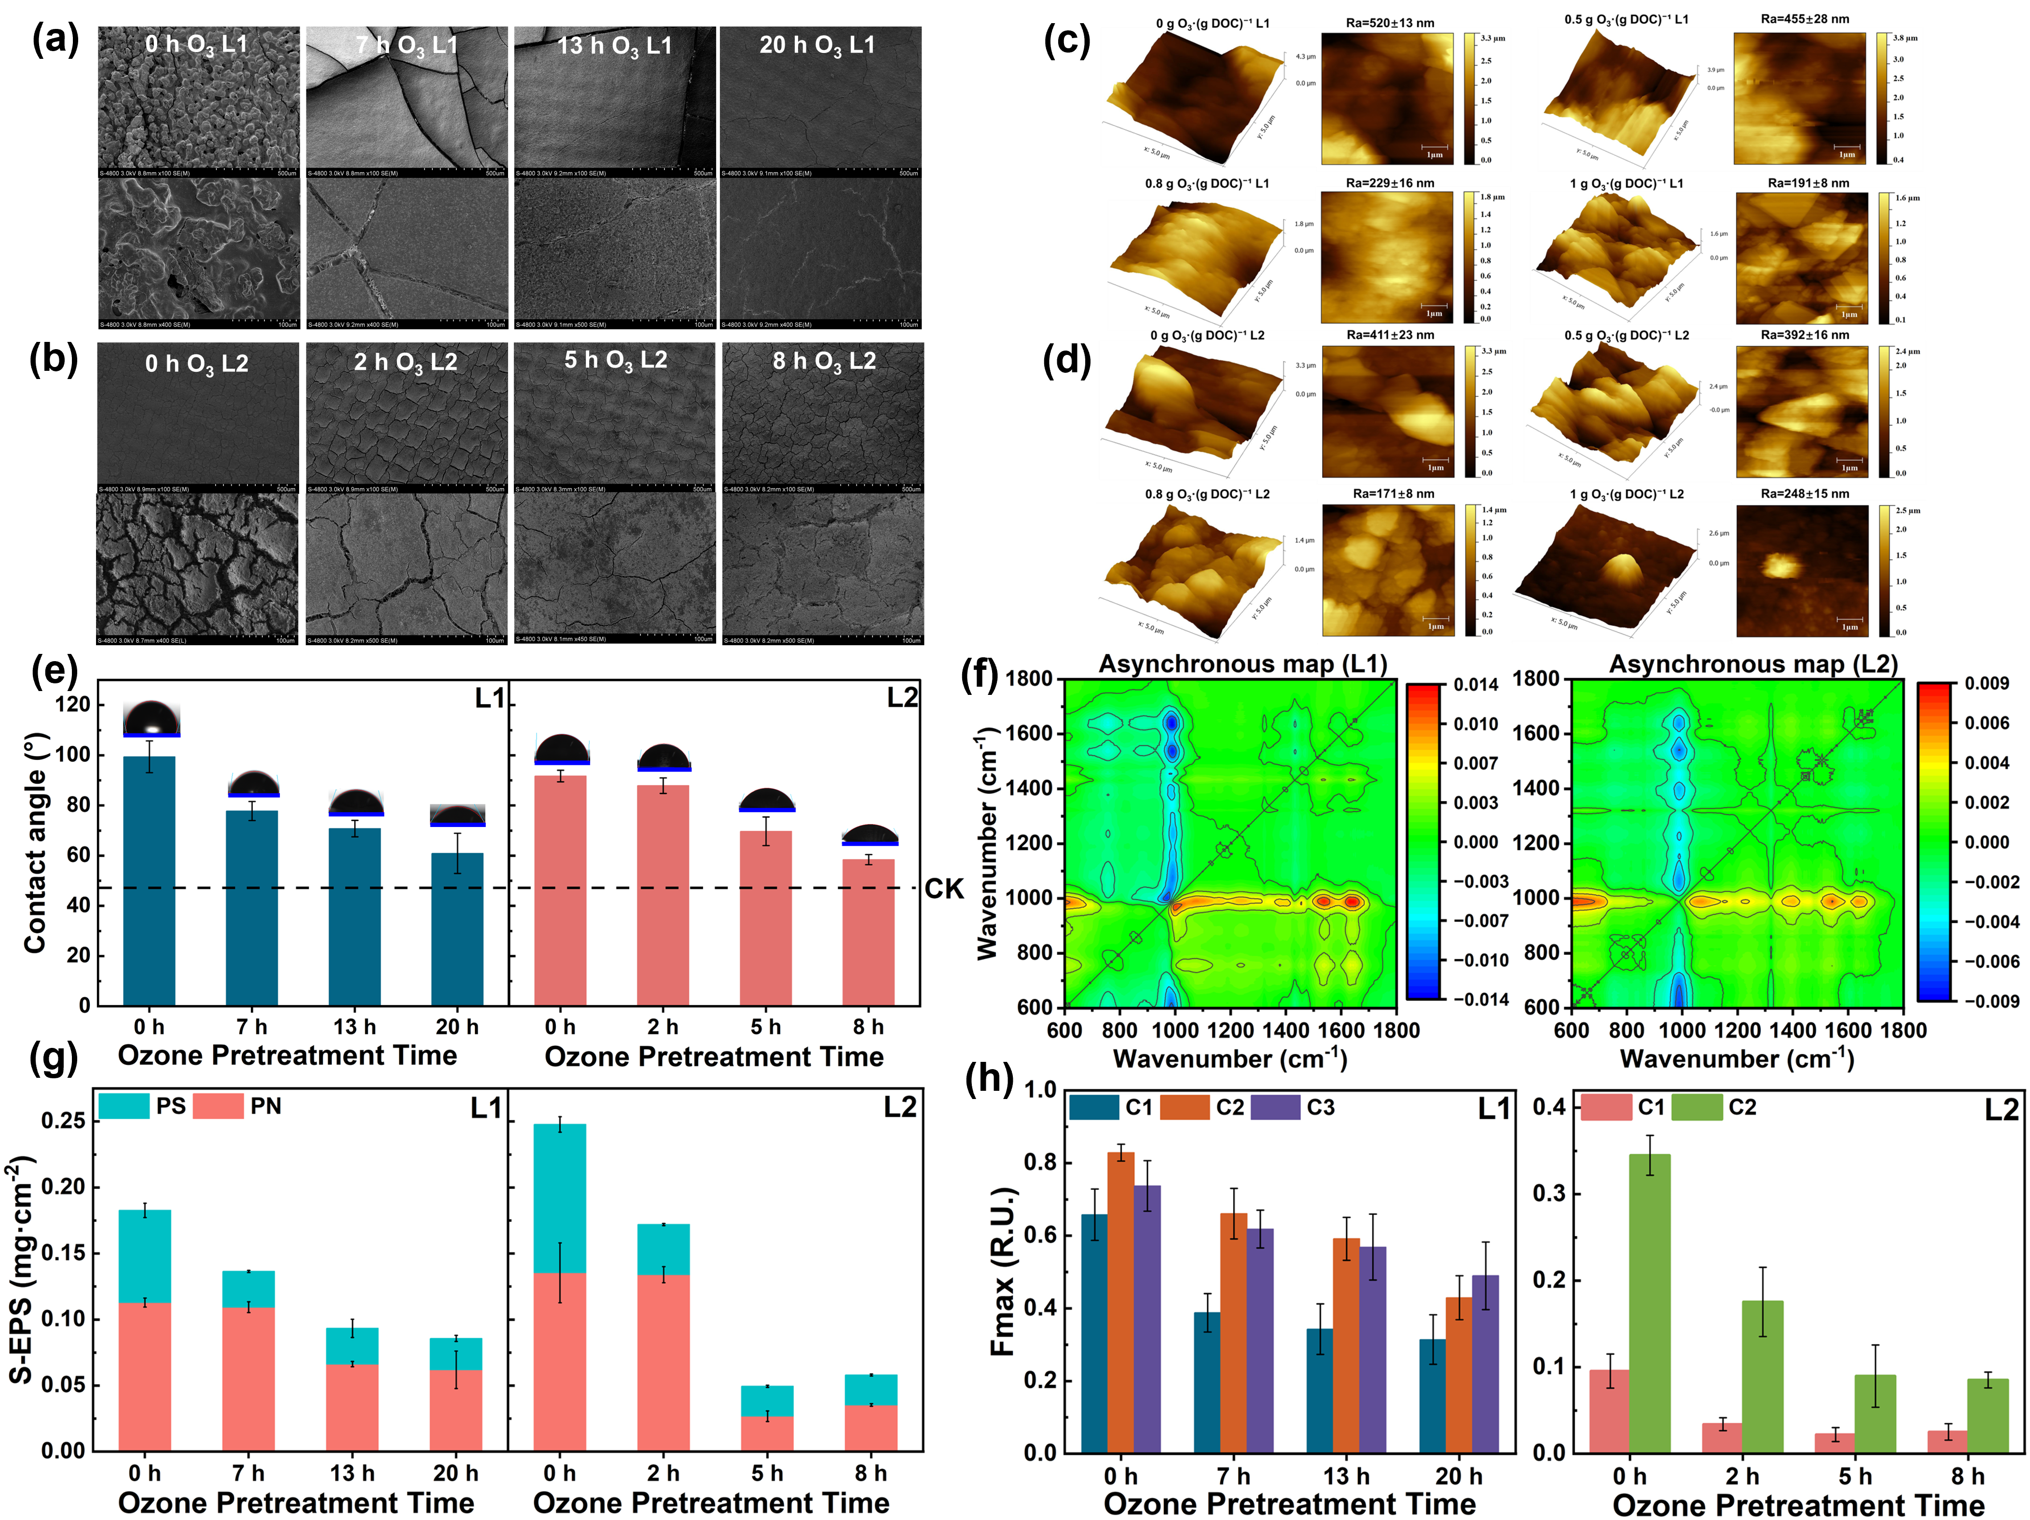

Fig. S21. SEM images of membranes of (a) L1 and (b) L2. Atomic force microscopy (AFM) images of surface morphologies of (c) L1 and (d) L2. (e) S-EPS, and (f) Fmax of each fluorescence compound of membrane surface under different pre-ozonation dosages.

Fig. S22. EPS, LB-EPS and TB-EPS of membrane surface for L1 and L2 change under different pre-ozonation dosages.

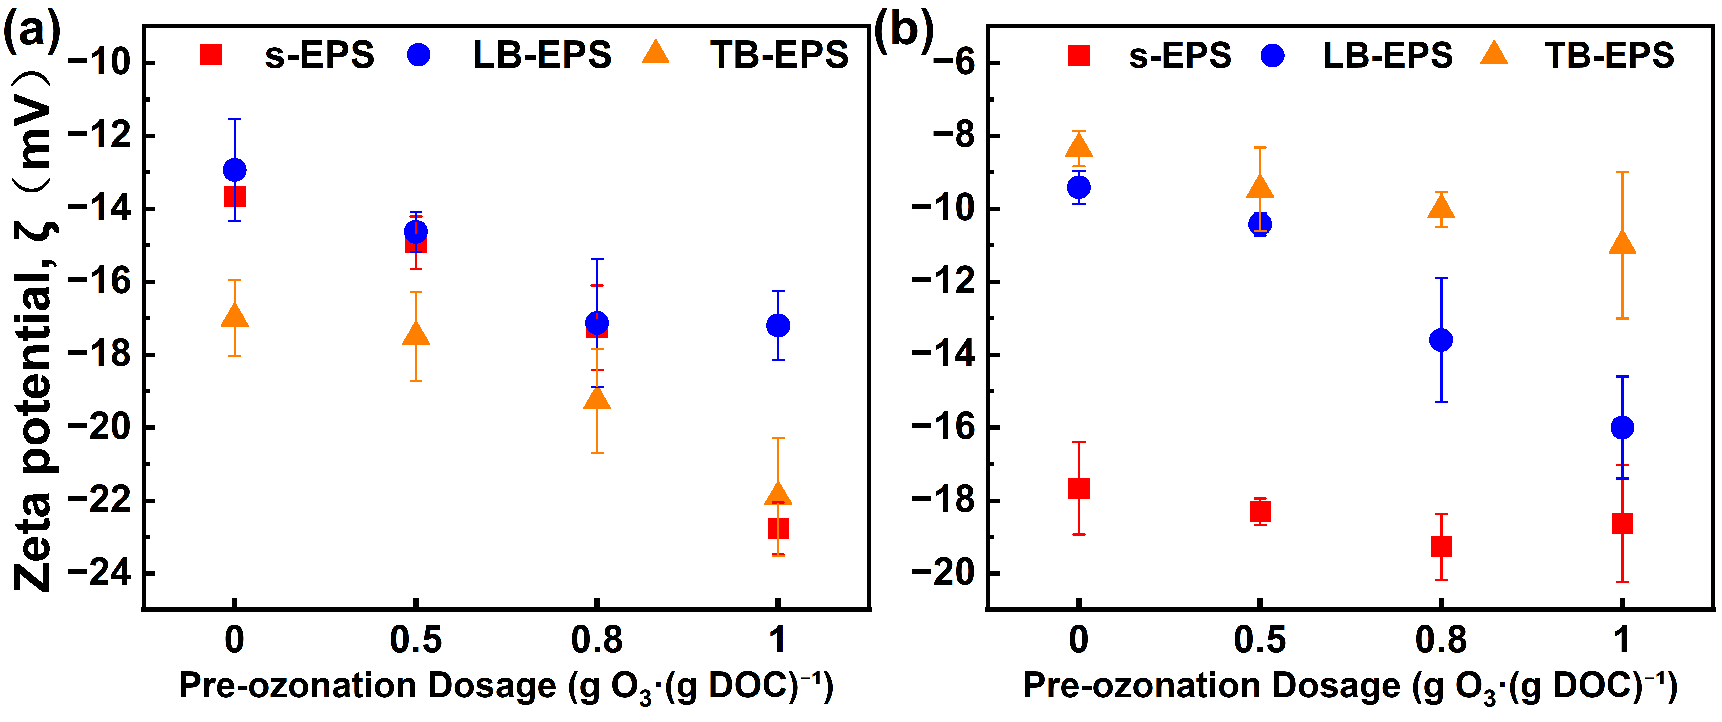

Fig. S23. Effect of pre-ozonation on the zeta potential of EPS of (a) L1 and (b) L2.

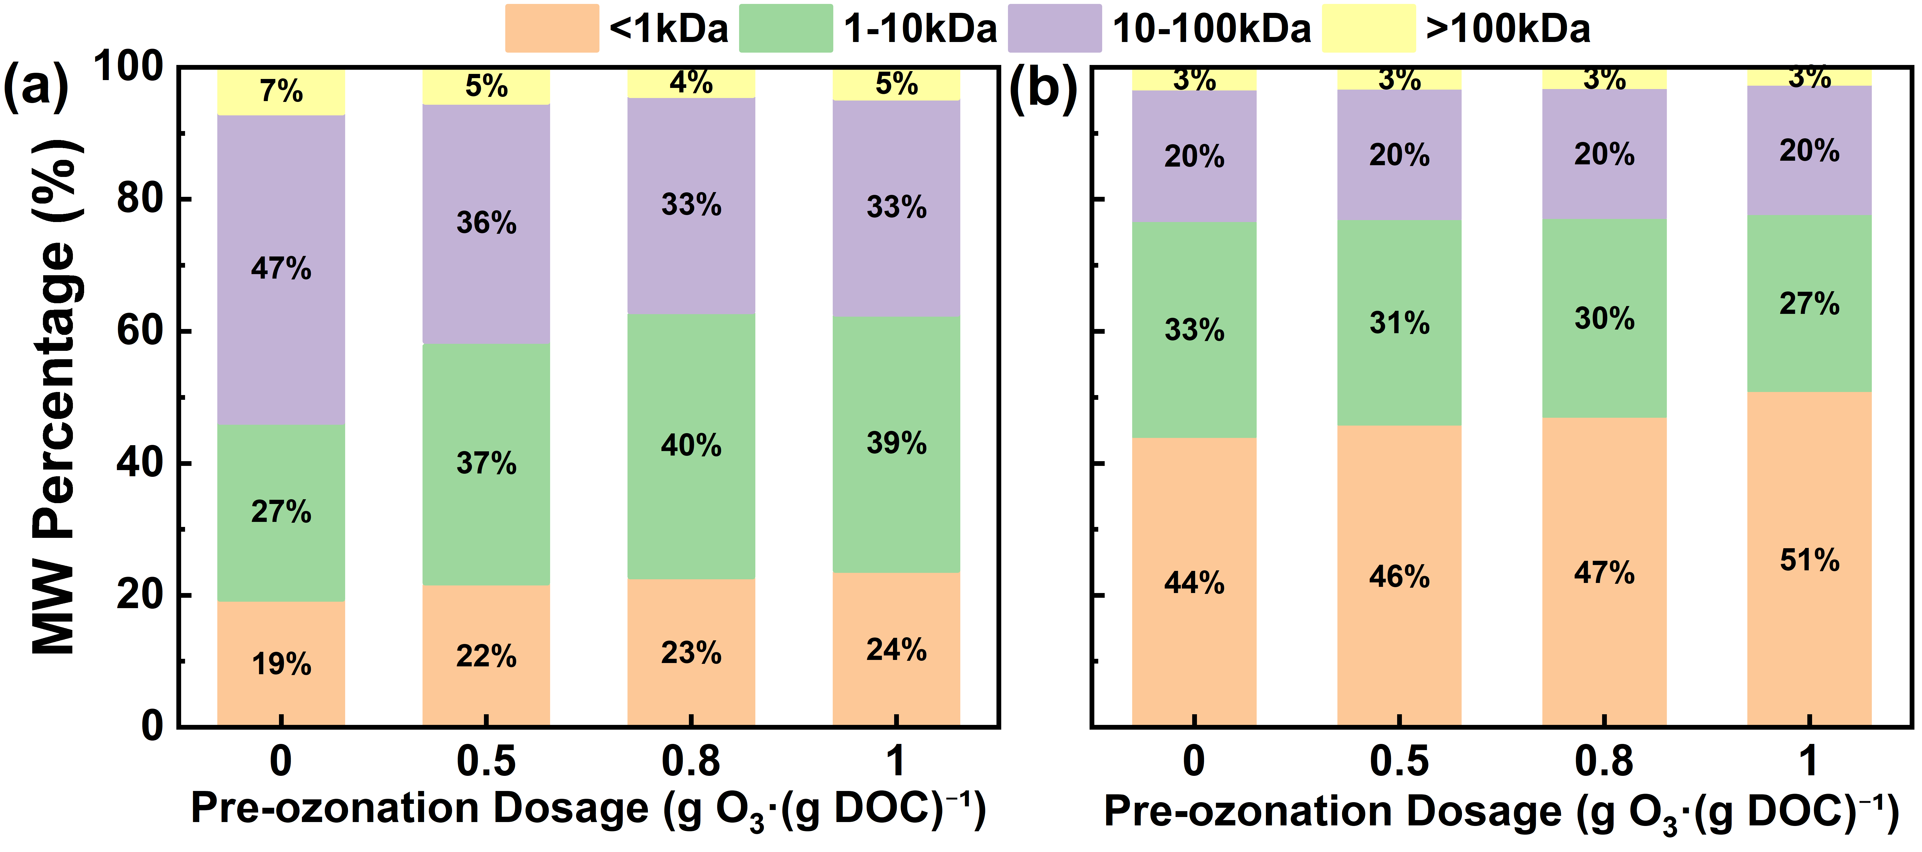

Fig. S24. Impact of ozonation on the MW distribution of DOM in (a) L1 and (b) L2 as determined by GPC.

Fig. S25. XPS spectra of C1s in for (a) L1 and (b) L2 under different pre-ozonation dosages.

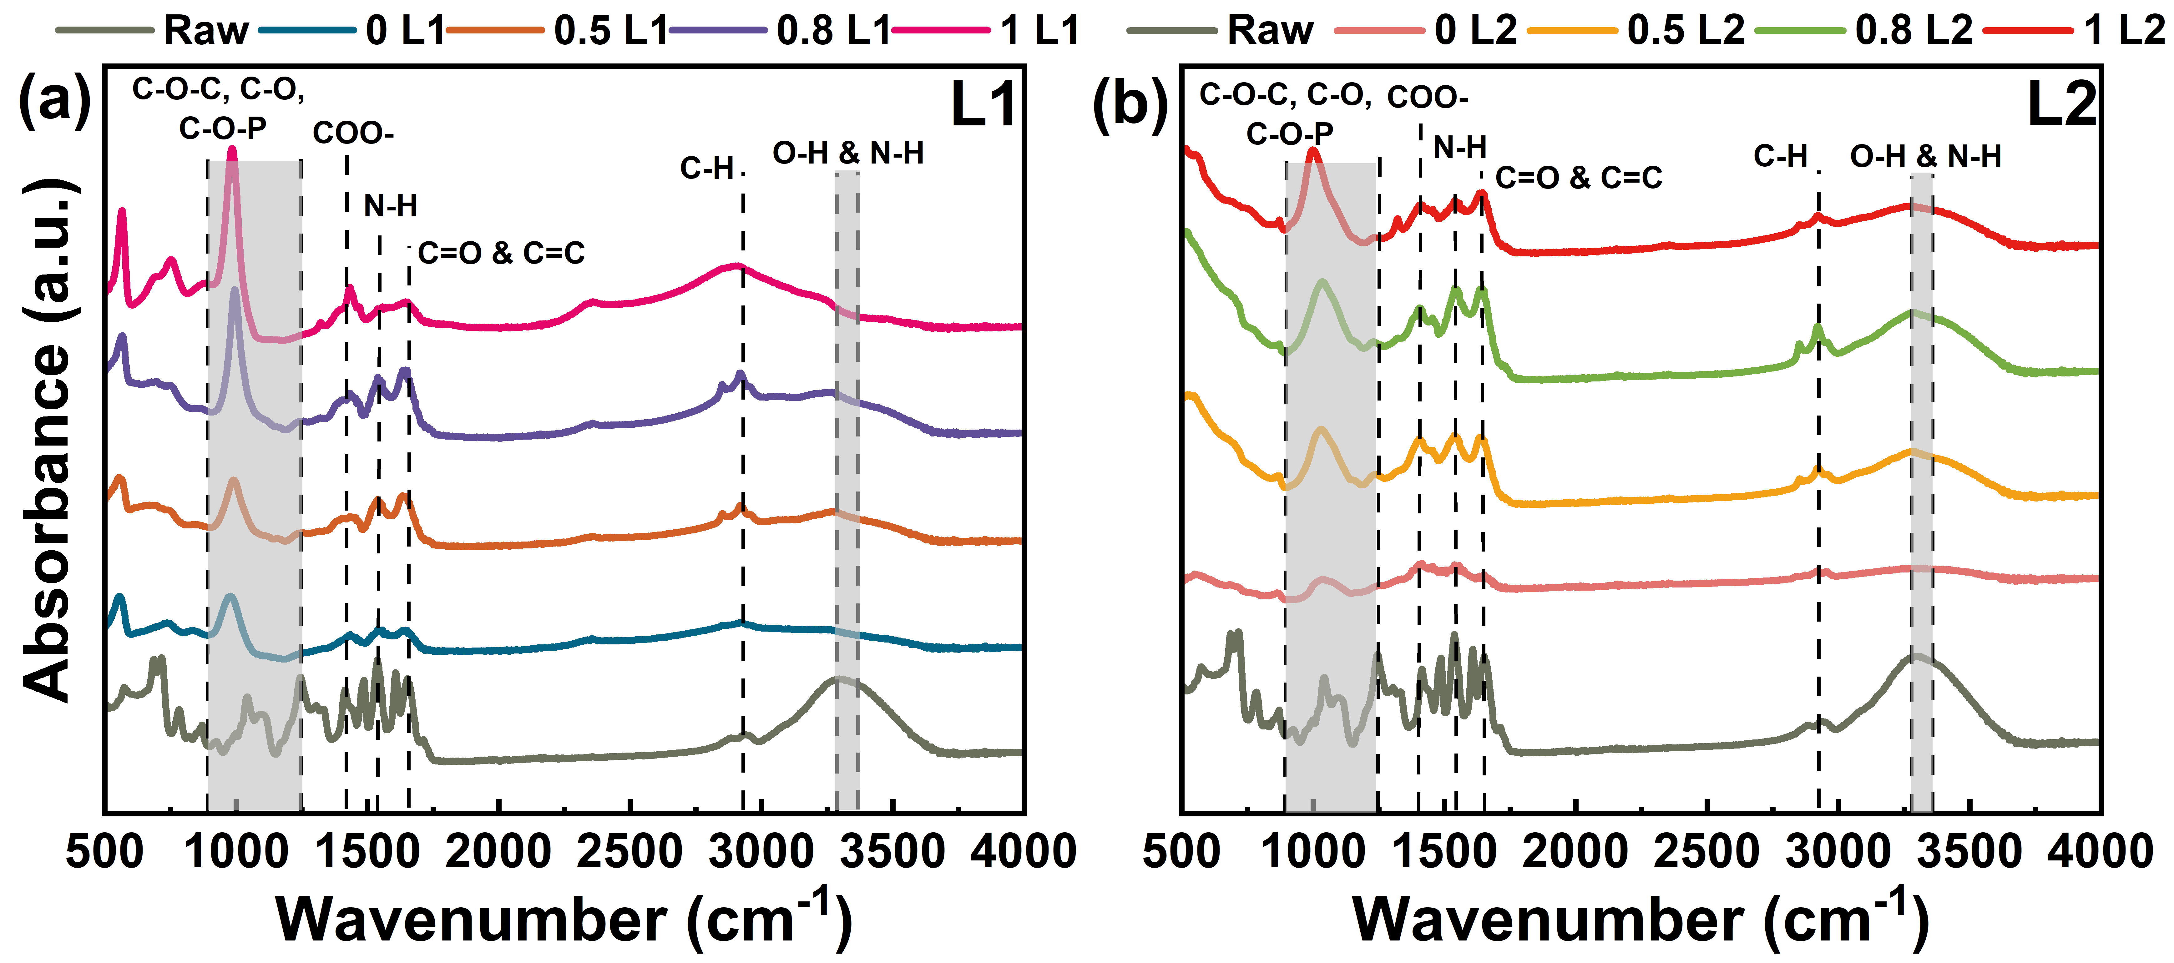

Fig. S25. FTIR of (a) L1, and (d) L2 under different pre-ozonation dosages (0.5 L1: 0.5 g O₃·(g DOC)⁻¹ L1; 0.8 L1: 0.8 g O₃·(g DOC)⁻¹ L1; 1 L1: 1 g O₃·(g DOC)⁻¹ L1;0.5 L2: 0.5 g O₃·(g DOC)⁻¹ L2; 0.8 L2: 0.8 g O₃·(g DOC)⁻¹ L2; 1 L2: 1 g O3·(g DOC)⁻¹ L2).

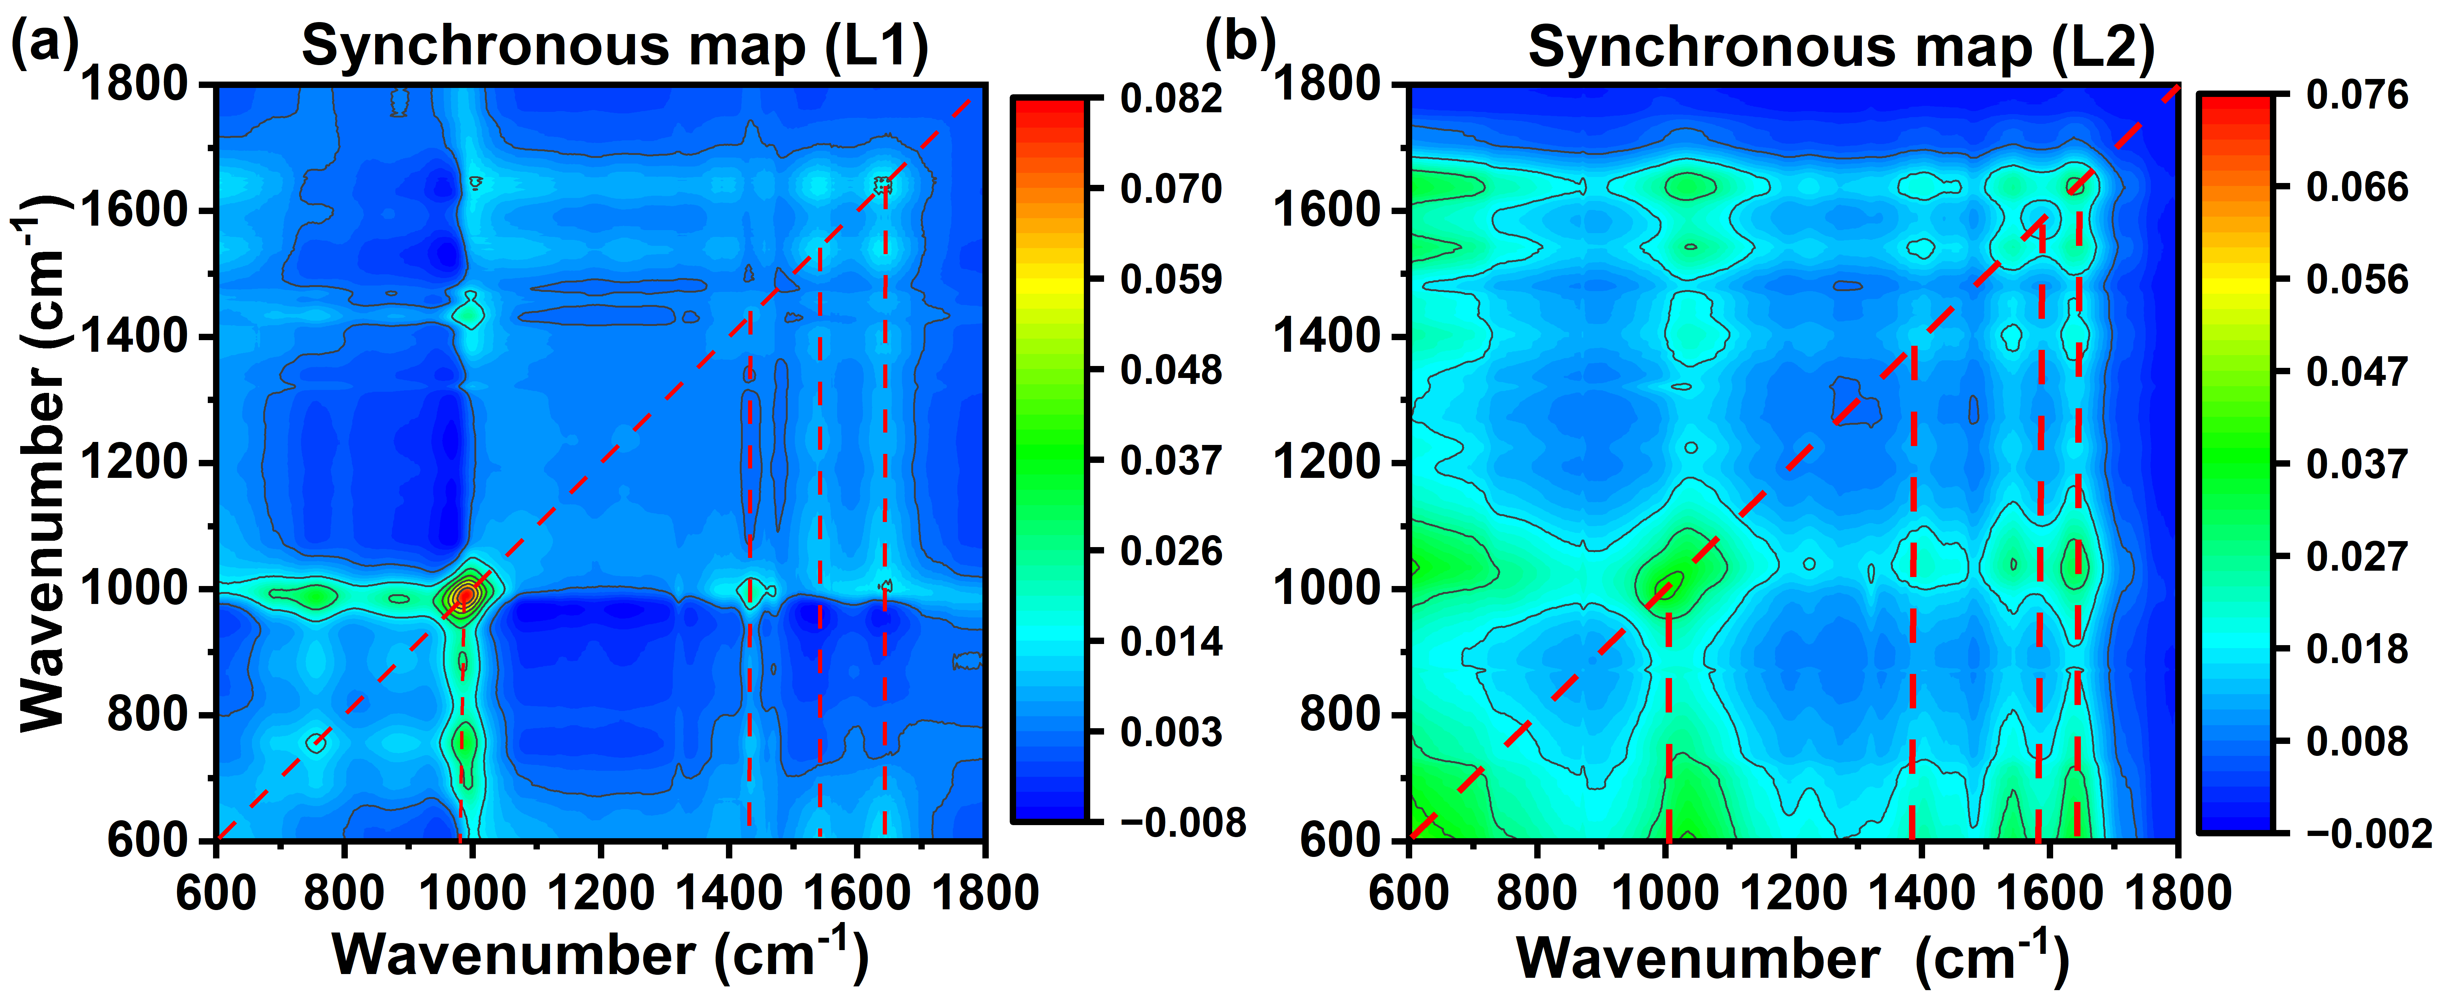

Fig. S26. Synchronous 2DCOS of membrane surface for (a) L1 and (b) L2 under different pre-ozonation dosages.

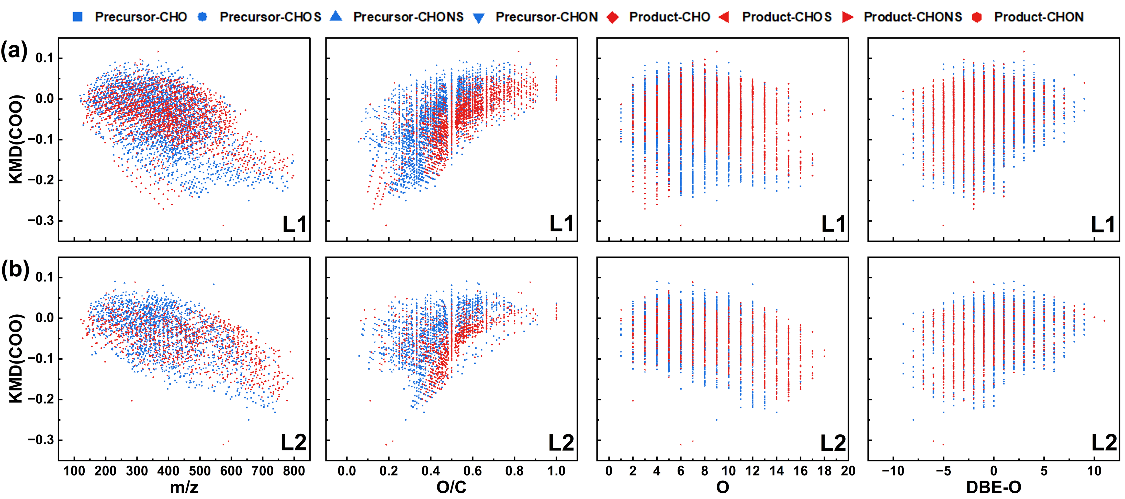

Fig. S27. KMD plots for series of COO for the possible precursor-product pairs in (a) 1.0 g O₃·(g DOC)⁻¹ L1 and (b) 1.0 g O₃·(g DOC)⁻¹ L2. X-axis corresponds to m/z, O/C, O, and DBE–O.

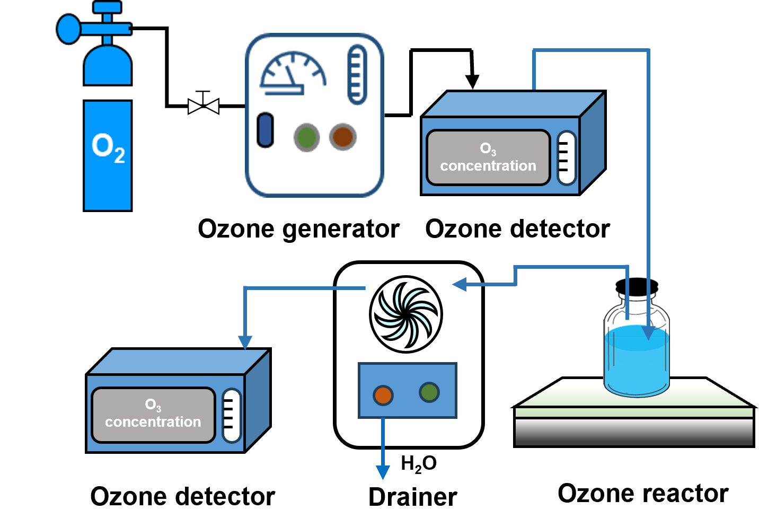

Fig. S28. Schematic of the lab-scale ozonation pretreatment system.
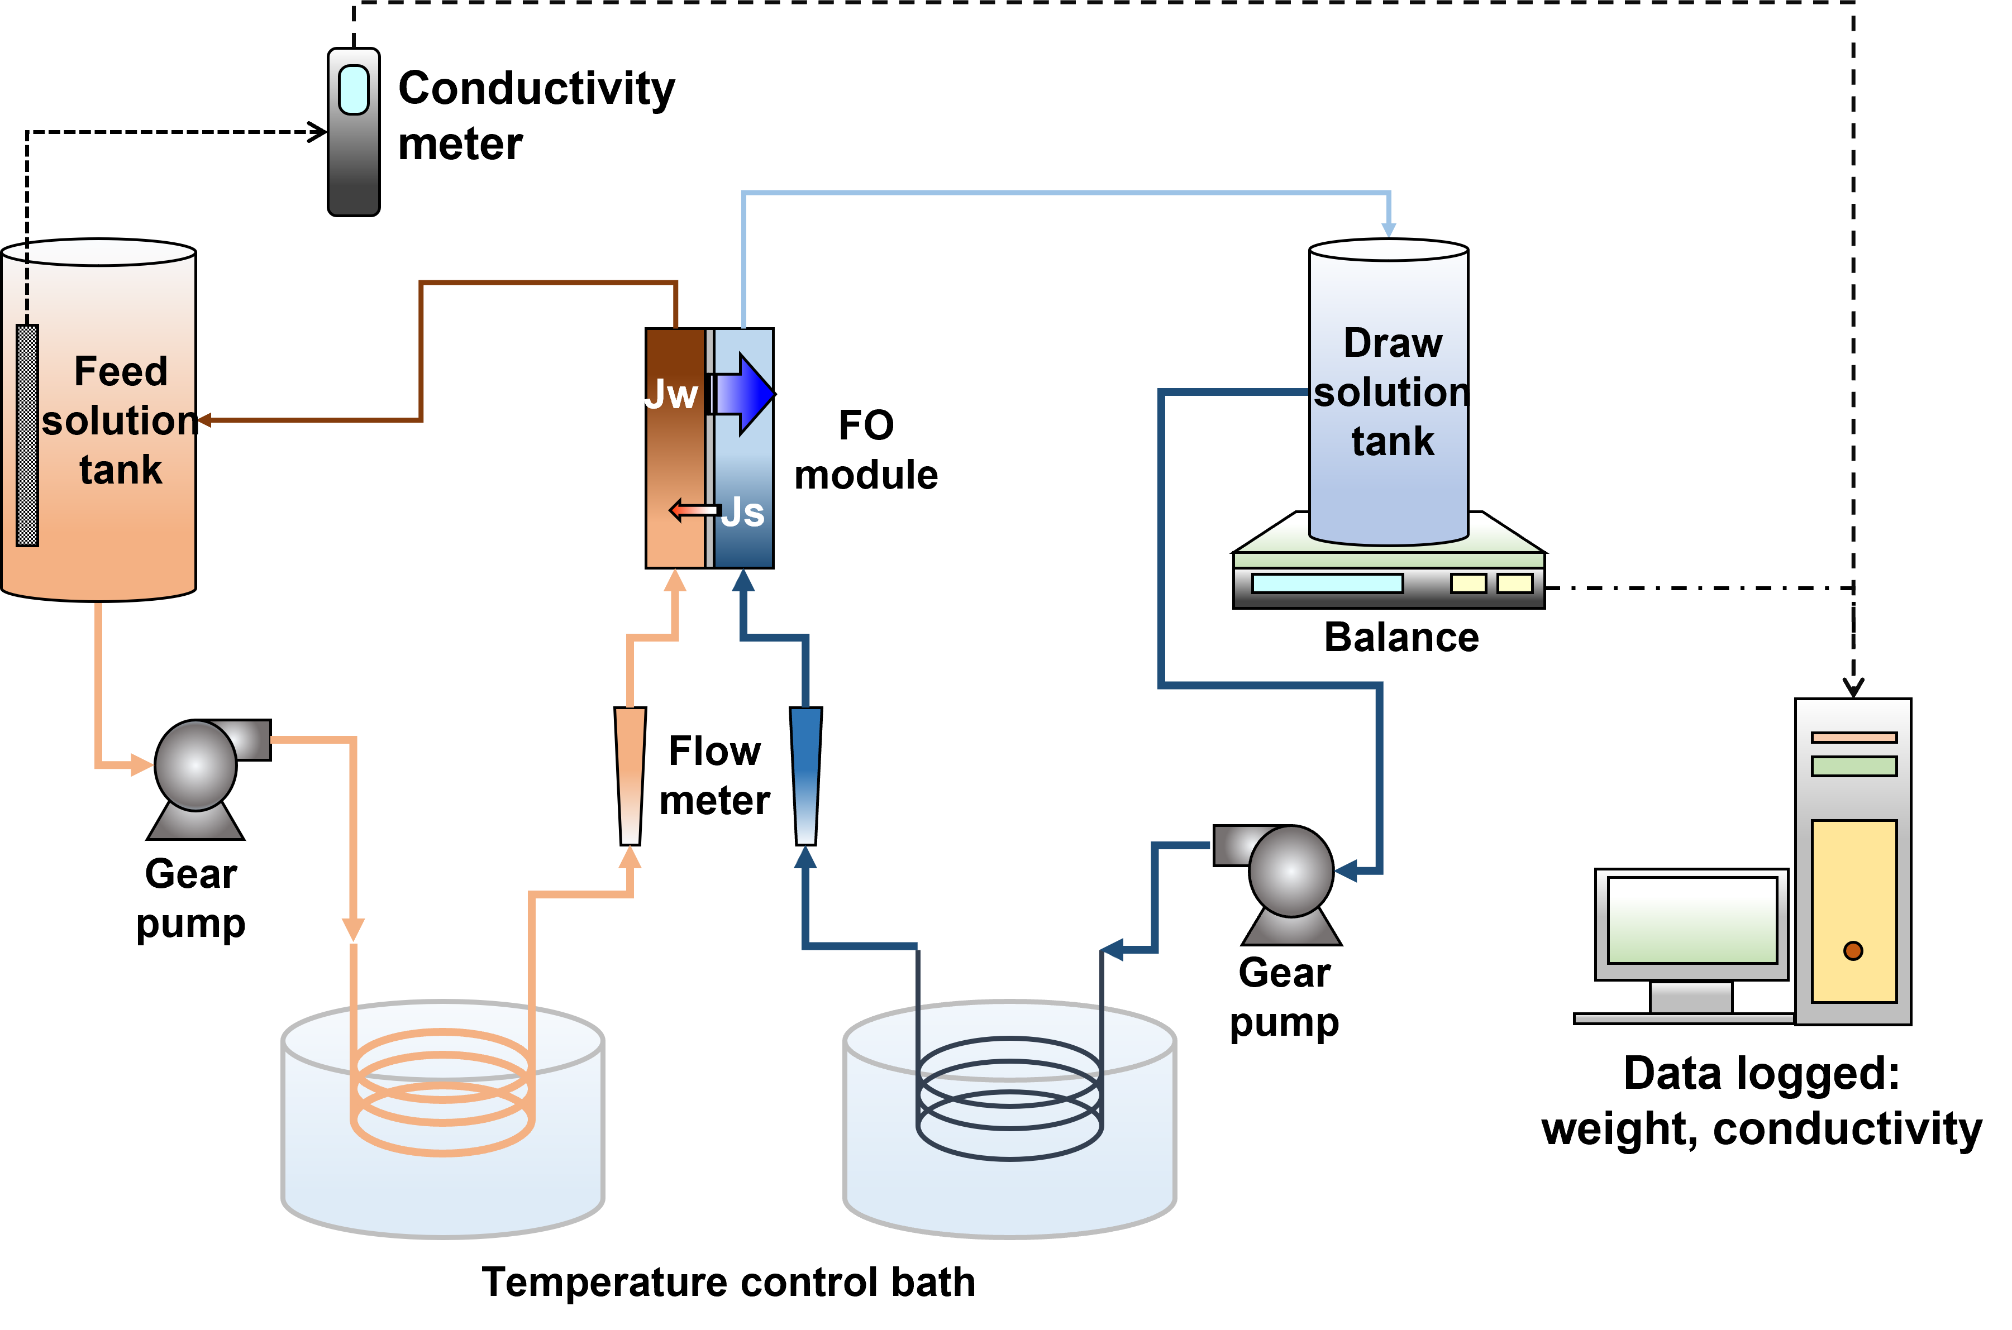

Fig. S29. Schematic of the lab-scale FO system.

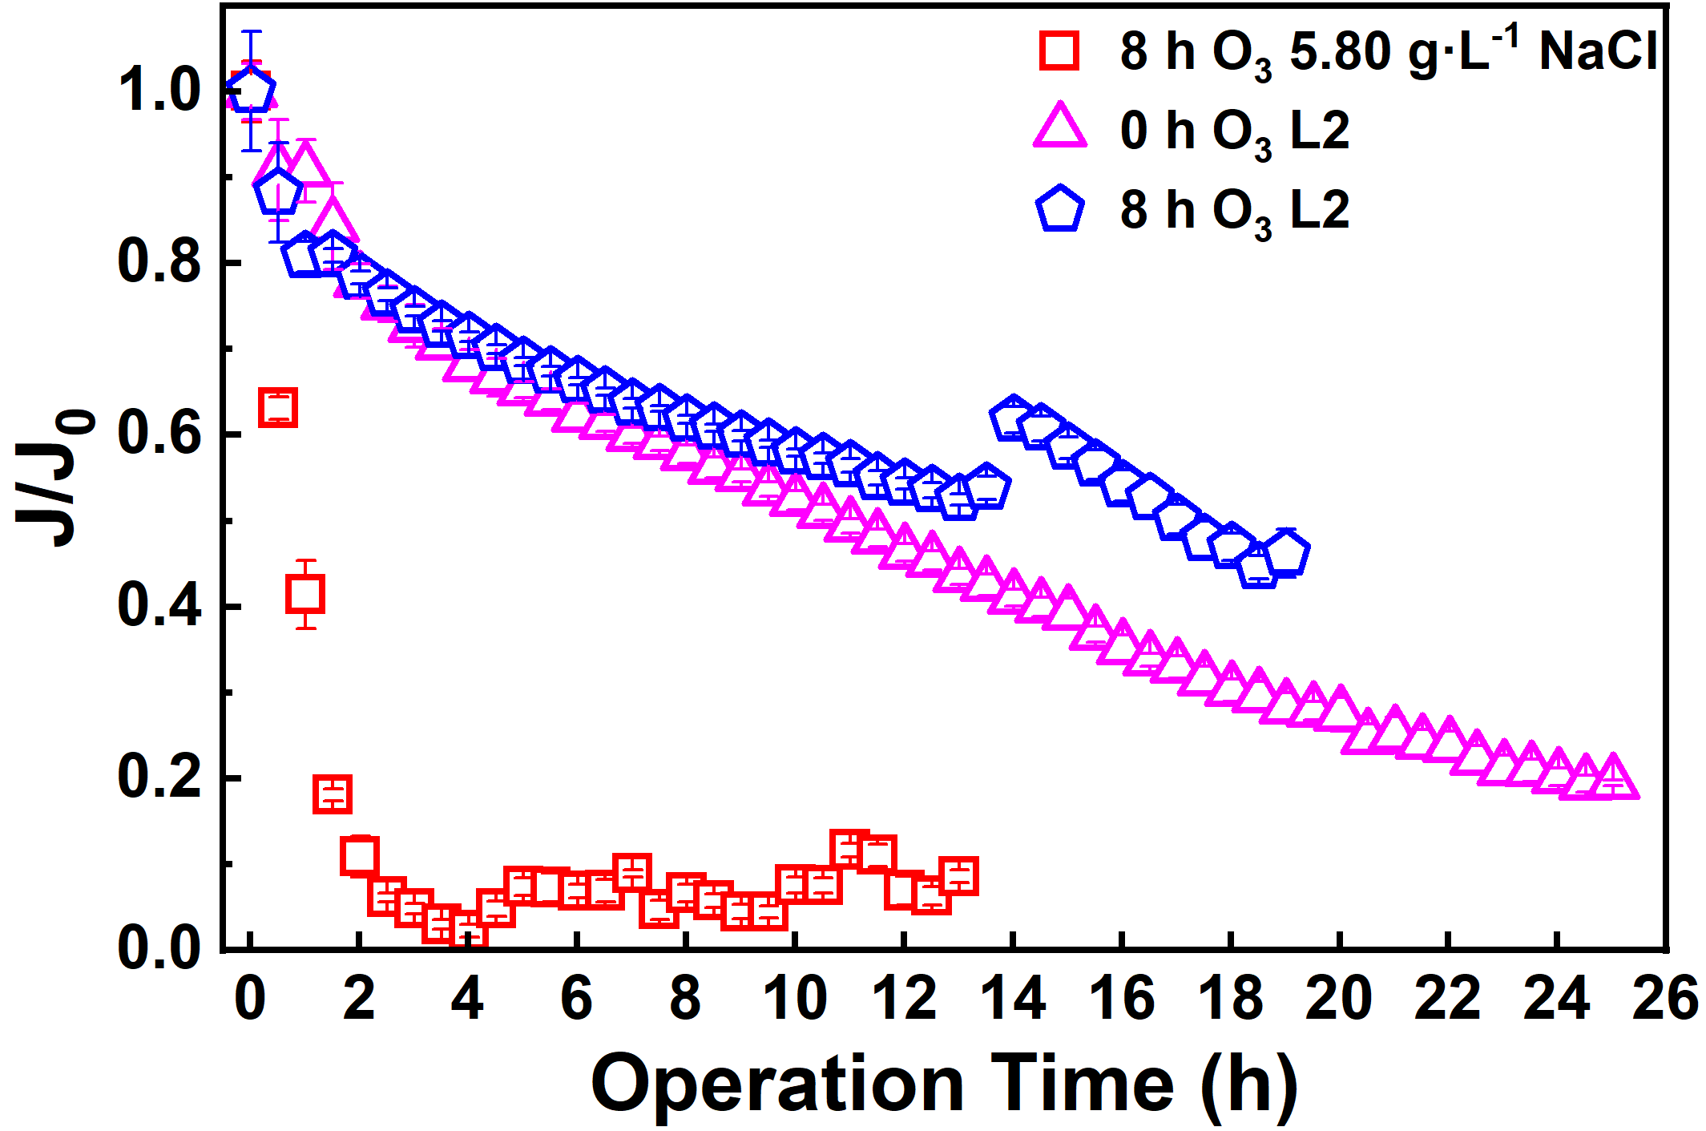

Fig. S30. The normalized water flux (J/J0) decline curve in lab-scale FO using in-situ ozone treatment. The draw solution used 2M NaCl and the feed solutions were 5.8 g·L⁻¹ NaCl (8 h ozone treatment), L2, and L2 (8 h ozone treatment), respectively.

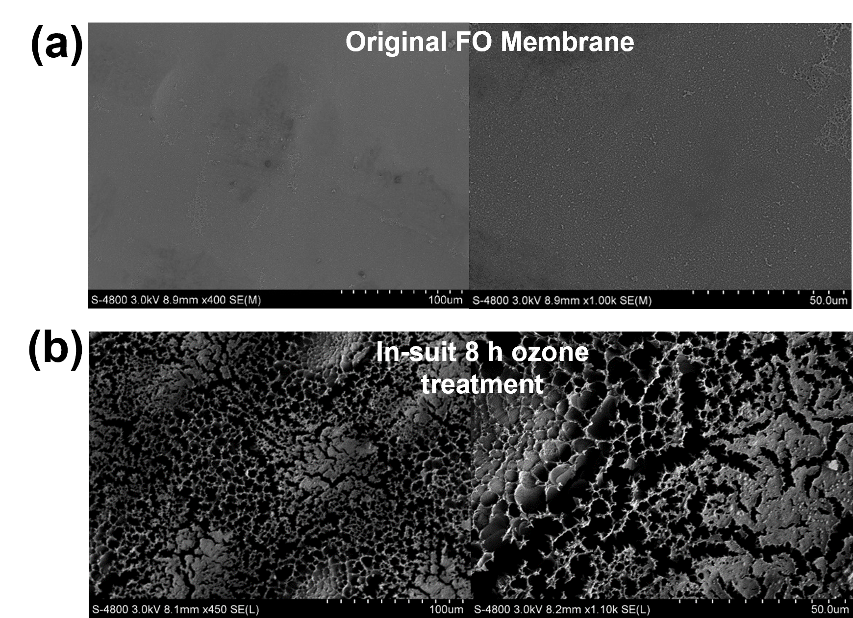

Fig. S31. SEM images of (a) original FO membrane, (b) membrane fouled by treated with in suit 8 h ozone.

Fig. S32. Three fluorescent components identified by the PARAFAC applied to the entire EEM data set of L1 with pre-ozonation. (a) C1: fulvic-like component, (b) C2: protein- like component and (c) C3: soluble microbial by-product-like component¹. The loading plots of C1 (d), C2 (e) and C3 (f). (g) Fmax of each fluorescence compound after different ozone pretreatment times.

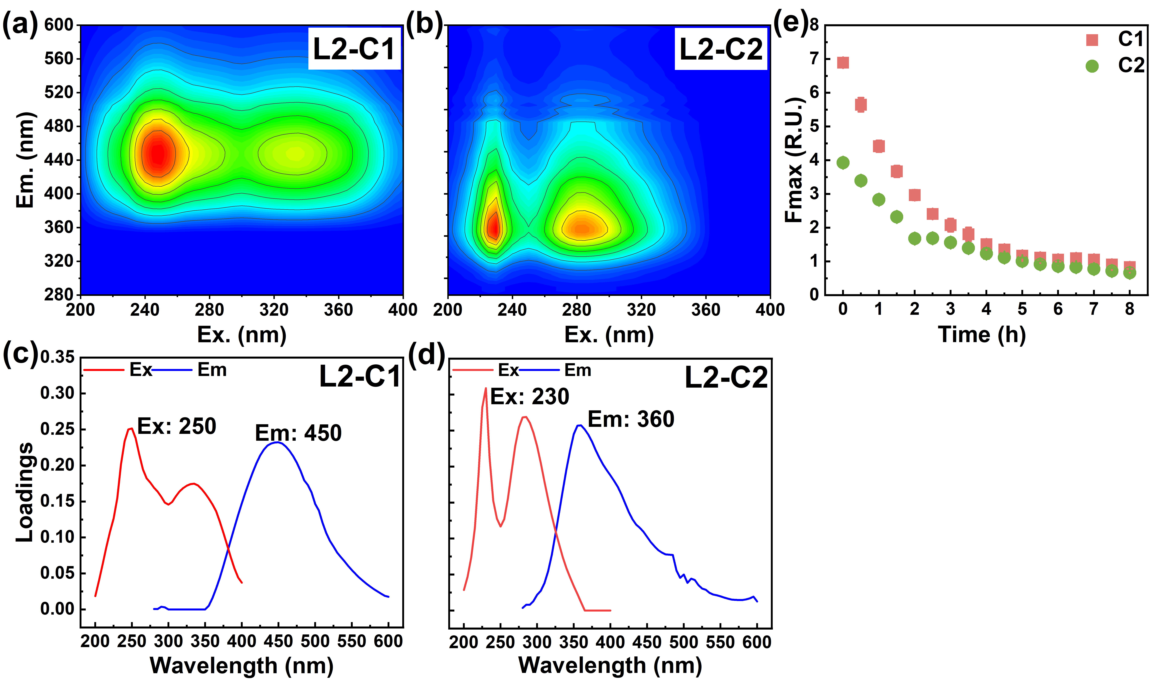

Fig. S33. Two fluorescent components identified by the PARAFAC applied to the entire EEM data set of L2 with pre-ozonation. (a) C1: fulvic-like component and (b) C2: protein- like component¹. The loading plots of C1 (b), C2 (c). (e) Fmax of each fluorescence compound after different ozone pretreatment times.

Fig. S34. NH₄⁺-N, TN, DOC, and TP for L1 and L2 change in the FO process under different pre-ozonation dosages.

References
1. Chen, W., Westerhoff, P., Leenheer, J. A. & Booksh, K. Fluorescence Excitation−Emission Matrix Regional Integration to Quantify Spectra for Dissolved Organic Matter. Environ. Sci. Technol. 37, 5701–5710 (2003).
2. Zhan, M., Gwak, G., Kim, D. I., Park, K. & Hong, S. Quantitative analysis of the irreversible membrane fouling of forward osmosis during wastewater reclamation: Correlation with the modified fouling index. Journal of Membrane Science 597, 117757 (2020).
3. Aftab, B., Cho, J. & Hur, J. Intermittent osmotic relaxation: A strategy for organic fouling mitigation in a forward osmosis system treating landfill leachate. Desalination 482, 114406 (2020).
4. Hermia, J. Constant pressure blocking filtration laws - application to power-law NON-Newtonian fluids. Chem. Eng. Res. Des. 60, 183–187 (1982).
5. Ho, C.-C. & Zydney, A. L. A Combined Pore Blockage and Cake Filtration Model for Protein Fouling during Microfiltration. Journal of Colloid and Interface Science 232, 389–399 (2000).
6. Lv, J., Zhang, S., Luo, L. & Cao, D. Solid-phase extraction-stepwise elution (SPE-SE) procedure for isolation of dissolved organic matter prior to ESI-FT-ICR-MS analysis. Analytica Chimica Acta 948, 55–61 (2016).
7. Zhang, B. et al. Transformation of dissolved organic matter during full-scale treatment of integrated chemical wastewater: Molecular composition correlated with spectral indexes and acute toxicity. Water Research 157, 472–482 (2019).
8. Stubbins, A. et al. Illuminated darkness: Molecular signatures of Congo River dissolved organic matter and its photochemical alteration as revealed by ultrahigh precision mass spectrometry. Limnology & Oceanography 55, 1467–1477 (2010).
9. Chance, R. J. et al. Water-Soluble Organic Composition of the Arctic Sea Surface Microlayer and Association with Ice Nucleation Ability. Environ. Sci. Technol. 52, 1817–1826 (2018).
10. Zhang, B., Shan, C., Wang, S., Fang, Z. & Pan, B. Unveiling the transformation of dissolved organic matter during ozonation of municipal secondary effluent based on FT-ICR-MS and spectral analysis. Water Research 188, 116484 (2021).
11. Shao, L. et al. DOM chemodiversity pierced performance of each tandem unit along a full-scale “MBR+NF” process for mature landfill leachate treatment. Water Research 195, 117000 (2021).
12. Yuan, Z. et al. Molecular Insights into the Transformation of Dissolved Organic Matter in Landfill Leachate Concentrate during Biodegradation and Coagulation Processes Using ESI FT-ICR MS. Environ. Sci. Technol. 51, 8110–8118 (2017).
13. Cai, S. et al. Dissolved organic matter transformation mechanisms and process optimization of wastewater sludge hydrothermal humification treatment for producing plant biostimulants. Water Research 235, 119910 (2023).
14. Bai, L. et al. Toward Quantitative Understanding of the Bioavailability of Dissolved Organic Matter in Freshwater Lake during Cyanobacteria Blooming. Environ. Sci. Technol. 51, 6018–6026 (2017).
15. Brooker, M. R., Longnecker, K., Kujawinski, E. B., Evert, M. H. & Mouser, P. J. Discrete Organic Phosphorus Signatures are Evident in Pollutant Sources within a Lake Erie Tributary. Environ. Sci. Technol. 52, 6771–6779 (2018).
16. Bastian, M., Heymann, S. & Jacomy, M. Gephi: An Open Source Software for Exploring and Manipulating Networks. ICWSM 3, 361–362 (2009).
17. Stedmon, C. A. & Bro, R. Characterizing dissolved organic matter fluorescence with parallel factor analysis: a tutorial. Limnology & Ocean Methods 6, 572–579 (2008).
18. Murphy, K. R., Stedmon, C. A., Graeber, D. & Bro, R. Fluorescence spectroscopy and multi-way techniques. PARAFAC. Anal. Methods 5, 6557–6566 (2013).
19. Qi, H. et al. Effect of MnO2-biochar composites on promoting humification during chicken manure composting. Biochar 6, 32 (2024).
20. Tang, S., Li, J., Zhang, Z., Ren, B. & Zhang, X. Comparison of long-term ceramic membrane bioreactors without and with in-situ ozonation in wastewater treatment: Membrane fouling, effluent quality and microbial community. Science of The Total Environment 652, 788–799 (2019).
21. Fr/olund, B., Griebe, T. & Nielsen, P. H. Enzymatic activity in the activated-sludge floc matrix. Appl Microbiol Biotechnol 43, 755–761 (1995).
22. Wang, Y. & Yu, G. Challenges and pitfalls in the investigation of the catalytic ozonation mechanism: A critical review. Journal of Hazardous Materials 436, 129157 (2022).
23. Guo, Y., Long, J., Huang, J., Yu, G. & Wang, Y. Can the commonly used quenching method really evaluate the role of reactive oxygen species in pollutant abatement during catalytic ozonation? Water Research 215, 118275 (2022).
24. Hu, H. et al. Effect of coagulation on dissolved organic nitrogen (DON) bioavailability in municipal wastewater effluents. Journal of Environmental Chemical Engineering 4, 2536–2544 (2016).
25. Miao, H.-F. et al. Transformation of aminopyrine during ozonation: Characteristics and pathways. Chemical Engineering Journal 279, 156–165 (2015).
26. Amorisco, A., Locaputo, V. & Mascolo, G. Characterization of carbonyl by‐products during Uniblu‐A ozonation by liquid chromatography/hybrid quadrupole time‐of‐flight/mass spectrometry. Rapid Comm Mass Spectrometry 25, 1801–1811 (2011).
27. Schollée, J. E., Bourgin, M., von Gunten, U., McArdell, C. S. & Hollender, J. Non-target screening to trace ozonation transformation products in a wastewater treatment train including different post-treatments. Water Research 142, 267–278 (2018).
28. Liu, C., Nanaboina, V., Korshin, G. V. & Jiang, W. Spectroscopic study of degradation products of ciprofloxacin, norfloxacin and lomefloxacin formed in ozonated wastewater. Water Research 46, 5235–5246 (2012).
29. Tay, K. S., Rahman, N. Abd. & Abas, Mhd. R. B. Ozonation of parabens in aqueous solution: Kinetics and mechanism of degradation. Chemosphere 81, 1446–1453 (2010).
30. Kuang, J. et al. Ozonation of trimethoprim in aqueous solution: Identification of reaction products and their toxicity. Water Research 47, 2863–2872 (2013).
31. Borowska, E. et al. Oxidation of cetirizine, fexofenadine and hydrochlorothiazide during ozonation: Kinetics and formation of transformation products. Water Research 94, 350–362 (2016).
32. Abellán, M. N., Gebhardt, W. & Schröder, H. Fr. Detection and identification of degradation products of sulfamethoxazole by means of LC/MS and −MSn after ozone treatment. Water Science and Technology 58, 1803–1812 (2008).
33. Mawhinney, D. B., Vanderford, B. J. & Snyder, S. A. Transformation of 1 H -Benzotriazole by Ozone in Aqueous Solution. Environ. Sci. Technol. 46, 7102–7111 (2012).
34. di Luca, C. et al. On disclosing the role of mesoporous alumina in the ozonation of sulfamethoxazole: Adsorption vs. Catalysis. Chemical Engineering Journal 412, 128579 (2021).
35. Bouchonnet, S. et al. GC‐MS^{n} and LC‐MS/MS couplings for the identification of degradation products resulting from the ozonation treatment of Acetochlor. J. Mass. Spectrom. 47, 439–452 (2012).
36. Andreozzi, R., Caprio, V., Marotta, R. & Vogna, D. Paracetamol oxidation from aqueous solutions by means of ozonation and H2O2/UV system. Water Research 37, 993–1004 (2003).
37. Hu, R., Zhang, L. & Hu, J. Study on the kinetics and transformation products of salicylic acid in water via ozonation. Chemosphere 153, 394–404 (2016).
38. Zhong, X., Cui, C. & Yu, S. Exploring the pathways of aromatic carboxylic acids in ozone solutions. RSC Adv. 7, 34339–34347 (2017).
39. Guo, H. et al. Promoted elimination of antibiotic sulfamethoxazole in water using sodium percarbonate activated by ozone: Mechanism, degradation pathway and toxicity assessment. Separation and Purification Technology 266, 118543 (2021).
40. Xiong, Z., Lai, B. & Yang, P. Insight into a highly efficient electrolysis-ozone process for N,N-dimethylacetamide degradation: Quantitative analysis of the role of catalytic ozonation, fenton-like and peroxone reactions. Water Research 140, 12–23 (2018).
41. Wu, G., Qin, W., Sun, L., Yuan, X. & Xia, D. Role of peroxymonosulfate on enhancing ozonation for micropollutant degradation: Performance evaluation, mechanism insight and kinetics study. Chemical Engineering Journal 360, 115–123 (2019).
42. Dai, Q., Wang, J., Chen, J. & Chen, J. Ozonation catalyzed by cerium supported on activated carbon for the degradation of typical pharmaceutical wastewater. Separation and Purification Technology 127, 112–120 (2014).
43. Fónagy, O., Szabó-Bárdos, E., Horváth, O. & Kiss, G. Application of ozonation and silveration for heterogeneous photocatalytic degradation of an aromatic surfactant. Journal of Photochemistry and Photobiology A: Chemistry 366, 152–161 (2018).
44. Tian, Y. et al. Ab initio study of the reaction of OH radical with methyl sulfinic acid (MSIA). Chemical Physics 335, 133–140 (2007).
45. Devulapelli, V. G. & Sahle-Demessie, E. Catalytic oxidation of dimethyl sulfide with ozone: Effects of promoter and physico-chemical properties of metal oxide catalysts. Applied Catalysis A: General 348, 86–93 (2008).
46. Sahle-Demessie, E. & Devulapelli, V. G. Vapor phase oxidation of dimethyl sulfide with ozone over V2O5/TiO2 catalyst. Applied Catalysis B: Environmental 84, 408–419 (2008).
47. Vahedpour, M., Karami, F. & Shirazi, J. Theoretical study on the mechanism and thermodynamic of methanethiol and ozone reaction. Computational and Theoretical Chemistry 1042, 41–48 (2014).

