Research Paper

Title:
RRM2 as a Key Biomarker and Therapeutic Target in Letrozole-Resistant ER+ Breast Cancer: Insights from Bioinformatics and Molecular Docking

Running Title:
RRM2-Mediated Letrozole Resistance in ER+ Breast Cancer

Authors:
Wan-Yu Hung, M.D.^{1,2,3}
Shih-Chun Huang, M.S.²
Cheng-Chan Yu, M.D.^{1,4}
Shou-Tung Chen, M.D.⁵
Chi-Chen Lin, Ph.D.^{3,6}*
Ming-Hon Hou, Ph.D.^{2,3,6}*
Breast Cancer Genomics and Therapy Consortium⁷
* Chi-Chen Lin and Ming-Hon Hou contributed equally as corresponding authors

Author Affiliations:
- Department of General Surgery of Taichung Tzu Chi Hospital, Buddhist Tzu Chi Medical Foundation, Taichung, Taiwan.
- Graduate Institute of Genomics and Bioinformatics, National Chung-Hsing University, Taiwan.
- Ph.D. Program in translational medicine, National Chung Hsing University, Taichung, Taiwan.
- Graduate Institute of Integrated Medicine, China Medical University, Taichung, Taiwan.
- Comprehensive Breast Cancer Center, Changhua Christian Hospital, Changhua, Taiwan.
- Graduate Institute of Biomedical Science, National Chung-Hsing University, Taichung, Taiwan.
- Breast Cancer Genomics and Therapy Consortium: Wan-Yu Hung, Shih-Chun Huang, Cheng-Chan Yu, Shou-Tung Chen, Chi-Chen Lin, Ming-Hon Hou

*Corresponding Authors:
Ming-Hon Hou, Ph.D. (Dr. Hou is the nominated representative for the consortium)
Institute of Genomics and Bioinformatics, National Chung-Hsing University, Taiwan.
40227No.145 Xingda Rd., South Dist., Taichung, Taiwan, R.O.C. 402
Email: mhho@nchu.edu.tw
Phone: +886(4)22840338 ext. 7011

Chi-Chen Lin, Ph.D.
Institute of Biomedical Science, National Chung-Hsing University, Taichung, Taiwan.
40227No.145 Xingda Rd., South Dist., Taichung, Taiwan, R.O.C. 402(College of Life Sciences,National Chung Hsing University)
Email: chichenlin1@gmail.com
Phone: +886(4)22840896 ext. 132

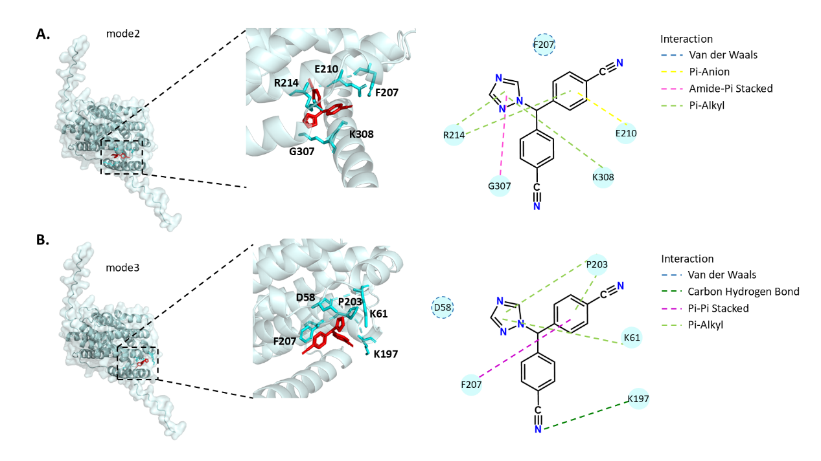
Figure Supplementary 1. The detailed interactions with RRM2 and Letrozole were analyzed using Discovery Studio. (A) The interactions of top 2. (B)The interactions of top 3.

