Table 3: Quantitative Compounds Identified from CSF-ME by GC-MS/MS Analysis.
No | Compound | MW (g/mol) | RT | Area % | Structure
01 | Tetradecanal | 212.37 | 13.301 | 0.14
02 | Methyl tetradecanoate | 242.40 | 13.366 | 0.08 | 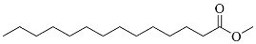
03 | Tridecanoic acid, 12-methyl, methyl ester | 242.40 | 14.312 | 0.15 | 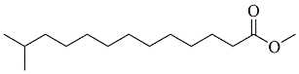
04 | 2-Pentadecanone, 6,10,14-trimethyl | 268.5 | 14.975 | 0.08 | 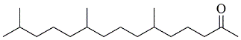
05 | Sulfurous acid, octadecyl 2-propyl ester | 376.6 | 15.956 | 0.06 | 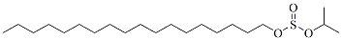
06 | Pentadecanoic acid, 14-methyl, methyl ester | 270.5 | 16.205 | 3.18 | 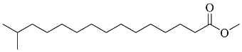
07 | Tetradecanoic acid, 12-methyl, methyl ester | 256.42 | 17.329 | 0.2 | 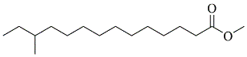
08 | Heptadecanoic acid, methyl ester | 284.5 | 17.794 | 0.07 | 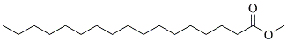
09 | 9,11-Octadecadienoic acid, methyl ester | 294.5 | 18.945 | 2.83 | 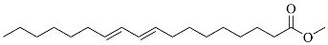
10 | 9-Octadecenoic acid, methyl ester | 296.5 | 19.046 | 3.28 | 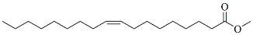
11 | 10-Octadecenoic acid, methyl ester | 296.5 | 19.132 | 0.23 | 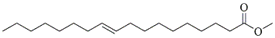
12 | Phytol | 296.5 | 19.205 | 0.11 | 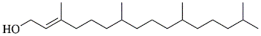
13 | Methyl stearate | 298.5 | 19.455 | 1.58 | 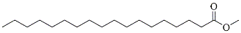
14 | Hexadecanamide | 255.44 | 20.409 | 0.12 | 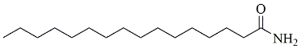
15 | Eicosanoic acid, methyl ester | 326.6 | 22.81 | 0.21 | 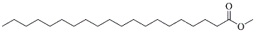
16 | 4,8,12,16-Tetramethylheptadecan-4-olide | 324.5 | 23.212 | 0.18 | 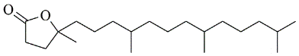
17 | 9,12-Octadecadien-1-ol | 266.5 | 23.335 | 0.11
18 | 9-Octadecenamide | 281.5 | 23.44 | 2.46 | 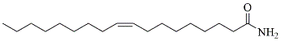
19 | Hexadecanoic acid, 2-hydroxy-1-(hydroxymethyl)ethyl ester | 330.5 | 25.85 | 0.12 | 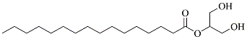
20 | Docosanoic acid, methyl ester | 354.6 | 26.071 | 0.16 | 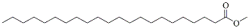
21 | (2-ethylhexyl) phthalate | 390.6 | 26.154 | 0.19 | 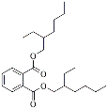
22 | Tricosanoic acid, methyl ester | 368.6 | 27.635 | 0.09 | 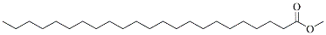
23 | 1,6,9-Tetradecatriene | 192.34 | 28.605 | 0.06
24 | 2-Methyltetracosane | 352.7 | 28.682 | 0.12
25 | Tetracosanoic acid, methyl ester | 382.7 | 29.153 | 0.19 | 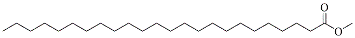
26 | Squalene | 410.7 | 30.384 | 0.21 | 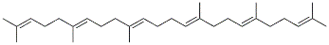
27 | Octadecanoic acid, 2-hydroxy, methyl ester | 314.5 | 31.131 | 0.2 | 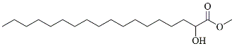
28 | 1-Pentacosanol | 368.7 | 31.361 | 0.12
29 | delta.Tocopherol | 430.7 | 32.301 | 1.67 | 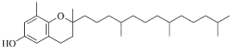
30 | 3,21-Bis(heptafluorobutyriloxy)-3,5,10-pregnatrien-20-one | 720.5 | 32.628 | 0.58 | 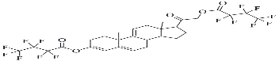
31 | 6-Methoxy-2,8-dimethyl-2-4,8,12-trimethyltridecyl)chroman | 416.7 | 33.612 | 40.65 | 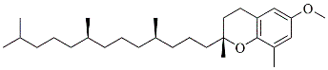
32 | 1,6,10,14,18,22-Tetracosahexaen-3-ol, 2,6,10,15,19,23-hexamethyl | 426.7 | 33.854 | 0.47 | 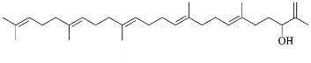
33 | 2,8-Dimethyl-2-[-4,8,12-trimethyltrideca-3,7,11-trienyl]-3,4-dihydrochromen-6-ol, methyl ether | 396.6 | 34.161 | 0.19 | 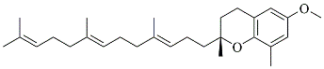
34 | Cholest-5-en-3-ol,propanoate | 442.7 | 34.986 | 0.41 | 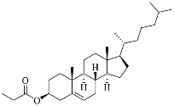
35 | Campesterol | 400.7 | 36.835 | 0.55 | 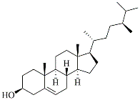
36 | Stigmasterol | 412.7 | 37.35 | 1.29 | 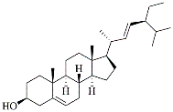
37 | Diosgenin | 414.6 | 38.139 | 30.88 | 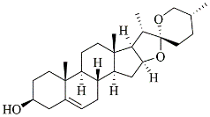
38 | beta.-Sitosterol | 414.7 | 38.606 | 2.41 | 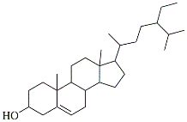
39 | Kauran-18-al, 17-(acetyloxy) | 346.5 | 39.155 | 0.28 | 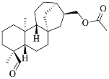
40 | 9,19-Cyclolanostan-3-ol, acetate | 470.8 | 39.475 | 1.58 | 