Supplemental Data
Supplementary Figure 1: Abnormal Changes in the Middle Cerebral Arteries of Moyamoya Disease Patients.
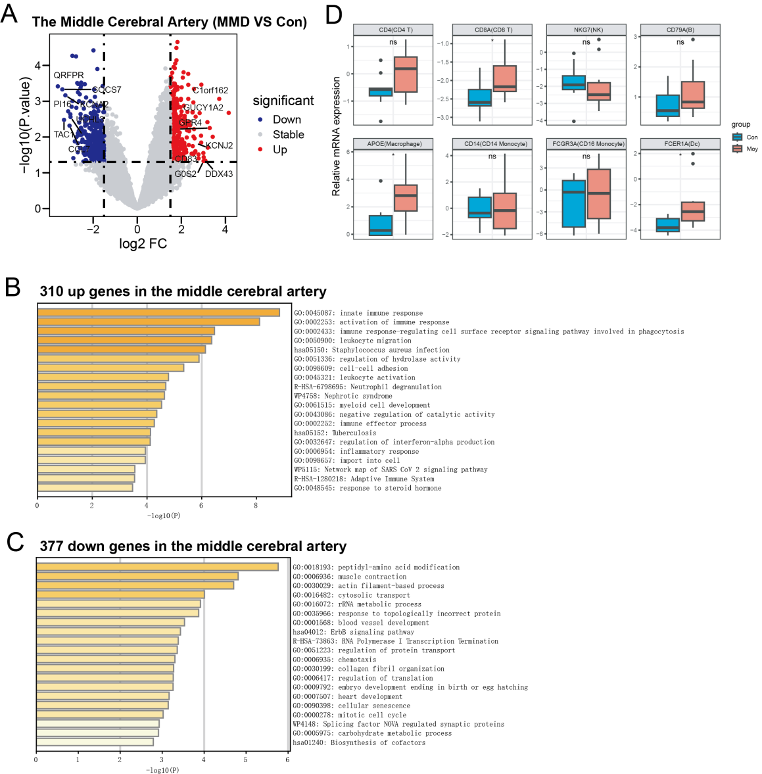
(A) A comparative differential expression analysis between the middle cerebral arteries of moyamoya disease patients and normal controls. (B) Functional enrichment analysis of the 310 upregulated genes in the middle cerebral arteries of moyamoya disease patients. (C) Functional enrichment analysis of the 377 downregulated genes in the middle cerebral arteries of moyamoya disease patients. (D) Differential expression of various immune cell markers between the middle cerebral arteries of moyamoya disease patients and controls.

Supplementary Figure 2: Peripheral Blood Single-Cell Data Preprocessing and Overview of Information.
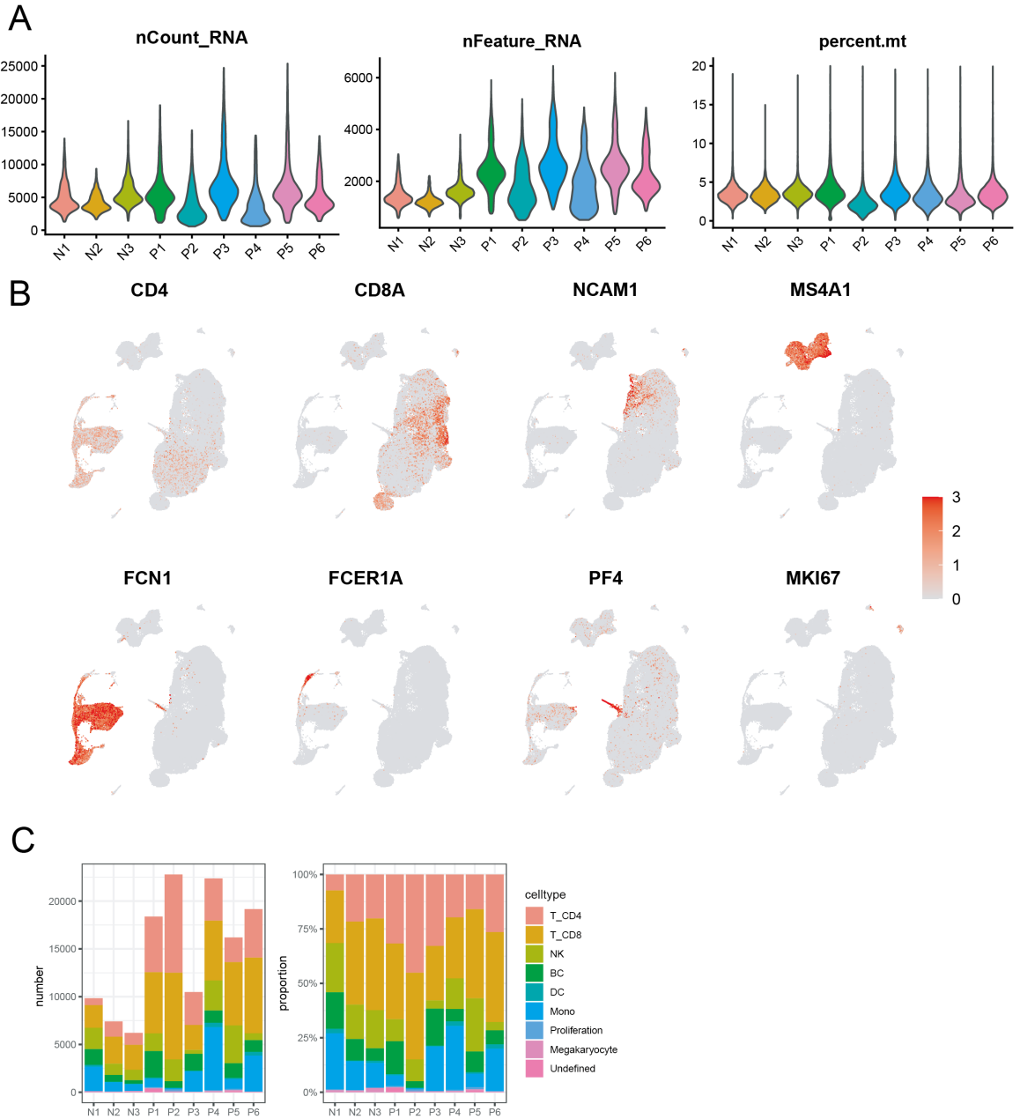
(A) Violin plots display the expression levels of UMI, Feature, and mitochondrial gene expression after quality control for each sample. (B) Feature plots illustrate the annotation markers for various cell types. (C) Absolute and relative proportions of various cell types across samples.

Supplementary Figure 3: Analysis of Monocytes in Peripheral Blood in Pulmonary Artery Hypertension and Atherosclerosis.
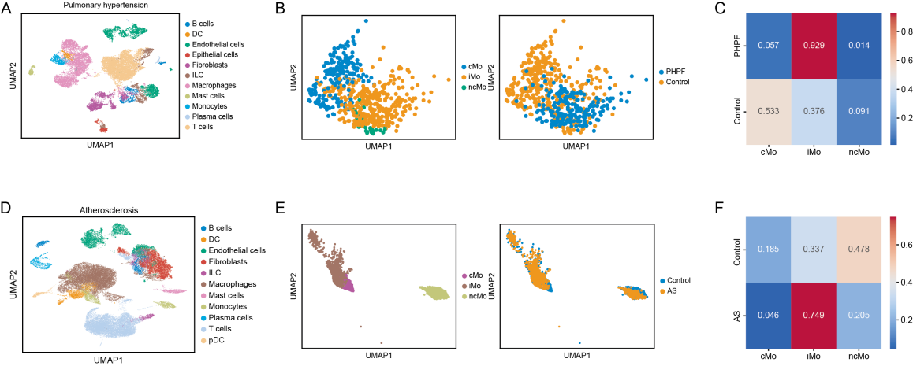
(A) and (D) Single-cell transcriptomic data from peripheral blood in patients with pulmonary artery hypertension and atherosclerosis. (B) and (E) Identification of heterogeneity in monocytes from peripheral blood in pulmonary artery hypertension and atherosclerosis. (C) and (F) Relative proportions of various monocyte subtypes in control and disease groups, including pulmonary artery hypertension or atherosclerosis.

Supplementary Figure 4: Single-Cell Analysis of Peripheral Blood T/NK Cells in Normal Controls and Moyamoya Disease Patients.
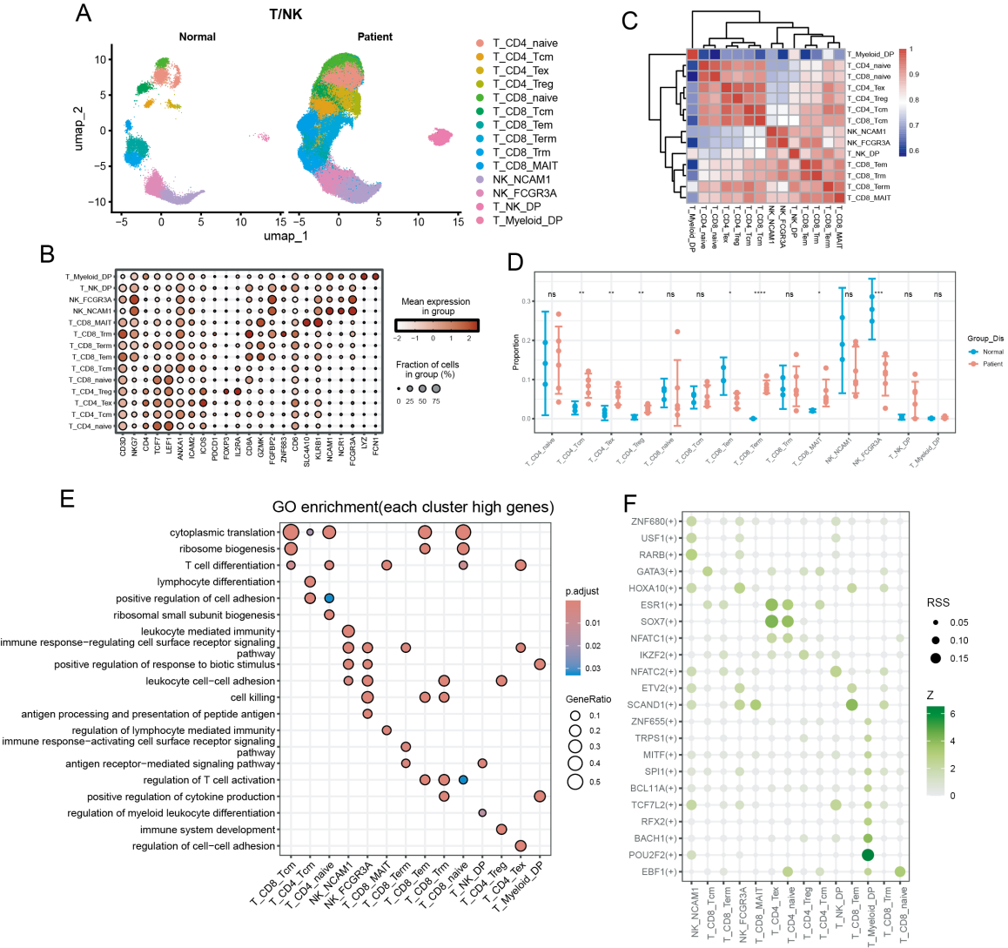
(A)UMAP visualization of T/NK cell clustering in peripheral blood from normal and moyamoya disease groups. (B) Highly expressed genes across various T/NK cell subsets. (C) Heatmap of transcriptional pattern correlations among T/NK cell subsets. (D) Relative quantity differences of T/NK cell subsets between normal and moyamoya disease groups. (E) GO enrichment analysis for highly expressed genes specific to each T/NK cell subset. (F) Specific activated transcription factors characteristic of various T/NK cell subsets.

Supplementary Figure 5: Single-Cell Analysis of Peripheral Blood B Cells in Normal and Moyamoya Disease Groups.
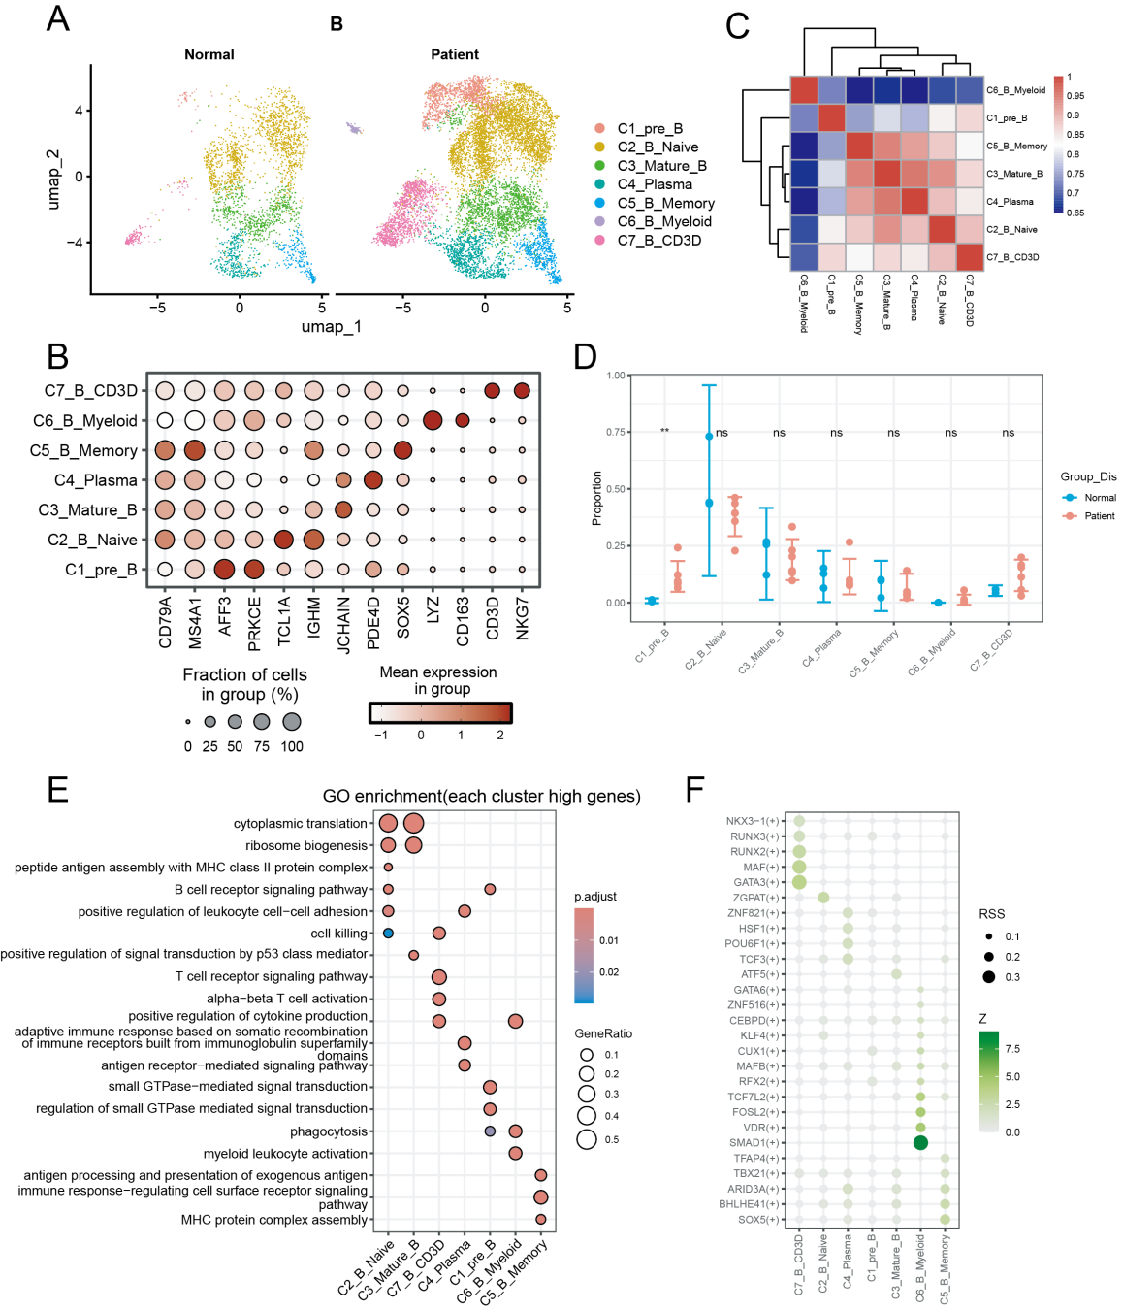
(A)UMAP visualization of peripheral blood B cell clustering in normal and moyamoya disease groups. (B) Highly expressed genes in various B cell subsets. (C) Heatmap of transcriptional pattern correlations across B cell subsets. (D) Relative quantity differences of various B cell subsets between normal and moyamoya disease groups. (E) GO enrichment analysis of highly expressed genes specific to each B cell subset. (F) Specific activated transcription factors in various B cell subsets.

Supplementary table 1: Characteristics of the study population of 6 patients with MMD patients
ID | Gender | Age
P1 | male | 53
P2 | male | 58
P3 | male | 37
P4 | female | 48
P5 | male | 18
P6 | female | 59

