Supporting Information for
Silicon-containing conductive polyurethane-imide elastomers: Unique microstructure, heat resistance, mechanical property, and conductivity

Shuai Yuan¹ • Jian Hu¹ • Jin Yang¹

¹ School of Light Industry and Engineering, South China University of Technology, Guangzhou, Guangdong 510641, People’s Republic of China

Author:
Shuai Yuan
E-mail addresses: 787974063@qq.com

Correspondence:
Jian Hu
E-mail addresses: ppjHu@scut.edu.cn
Jin Yang
E-mail addresses: yangjin@scut.edu.cn

Synthesis of AT
Materials
Aniline, ammonium persulfate, hydrochloric acid (HCl), aqueous ammonia (NH₃·H₂O) and ethanol were obtained from Rich Joint Tech Co., Ltd. of Shanghai, China.

Synthesis of AT
Based on previous literature [1], a one-step method can be used to synthesize amine-capped AT. In a typical procedure for the synthesis of this compound, 20 mmol of p-phenylenediamine was dissolved in a three-neck flask containing a mixed solution of 250 mL aqueous 1 M HCI and 100 mL ethanol. The solution was then stirred and cooled to under - 5 ℃ in a circulating cooling pump. 20 mmol of ammonium persulfate were added to this solution with stirring under air atmosphere. Subsequently, 40 mmol of distilled aniline was added rapidly into the reaction solution. After a few minutes, a suspension of blue particles was formed in the reaction solution. Then, the reaction mixture was stirred vigorously until the termination of the reaction was reached. After the reaction, the blue particles were collected by filtration through a Buchner funnel and was washed with 1 M HCI followed by deionized water. The product was then treated with 1 M NH₃·H₂O for 1 to 2 h. The mixture was filtered under reduced pressure and the remaining solid product was washed with deionized water until the filtrate became neutral in pH. After that, the product was placed in a vacuum oven at 40 ℃ and dried overnight. Finally, the product was ground into blue powder by agate mortar and the yield was 35 %.

Structural characterization of AT
The result of the ¹H NMR spectra used for characterizing the molecular structure of AT was depicted in Figure S1 (Supporting Information). The chemical shifts at 6.60 ppm (Ar H, b), 6.76 ppm (Ar H, c) and 6.93 ppm (Ar H, d) were related to the aromatic protons of AT. Moreover, the chemical shifts at 5.44 ppm (NH₂, a) and 4.63 ppm (NH₂, f) corresponded to the amine groups in the oxidized state and the reduced state, respectively. This result of the ¹H NMR spectra indicated that the synthesized AT was the mixture of the oxidized and reduced states. Furthermore, the charge-mass ratio showed in Figure S2 indicated that the molecular weight of AT was 288 g/mol. The results confirmed that the electroactive AT was successfully prepared.
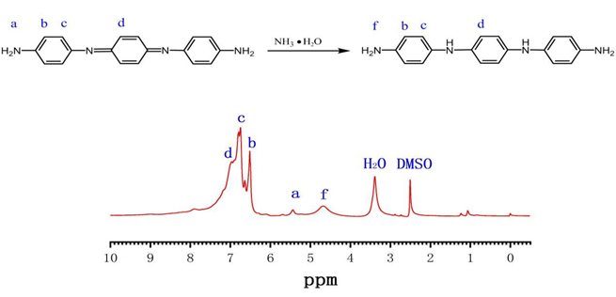
Fig. S1 ¹H NMR spectrum of the synthesized AT and fully reduced state AT.

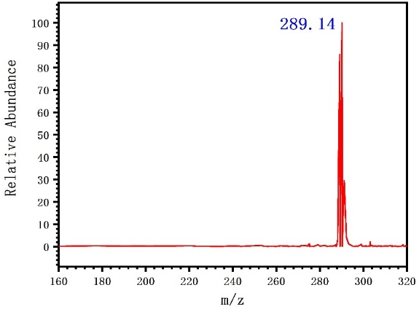
Fig. S2 MS spectra of aniline trimer.

References
1. Wei Y, Yang C, Ding T (1996) A one-step method to synthesize N, N′-bis(4′-aminophenyl)-1,4-quinonenediimine and its derivatives. Tetrahedron Lett. 37 (6): 731–734

