Figure S1:A 45-year-old woman with laparoscopic surgery, the anterior bladder space behind the pubic bone is unremarkable, this area is rich in fat, loose fibrous tissue and venous plexus.
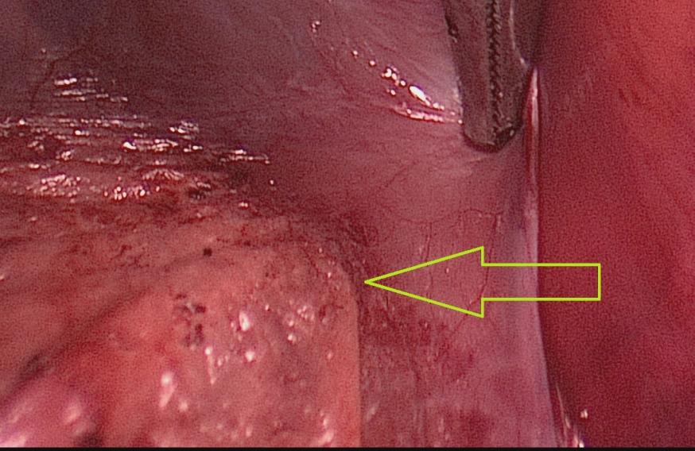

Figure S2:Autopsy of a 72-year-old female showing a marked presence of the anterior bladder space in the pelvis, due to muscle and ligament laxity and steatosis.
