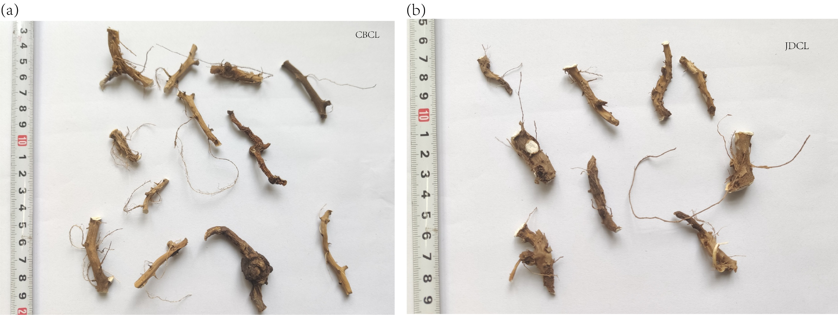
Fig. S1 Specimen of D.nipponica. (a) Wild specimens of D.nipponica from Changbai Mountain. (b) Cultivated specimens of D.nipponica from research facility.
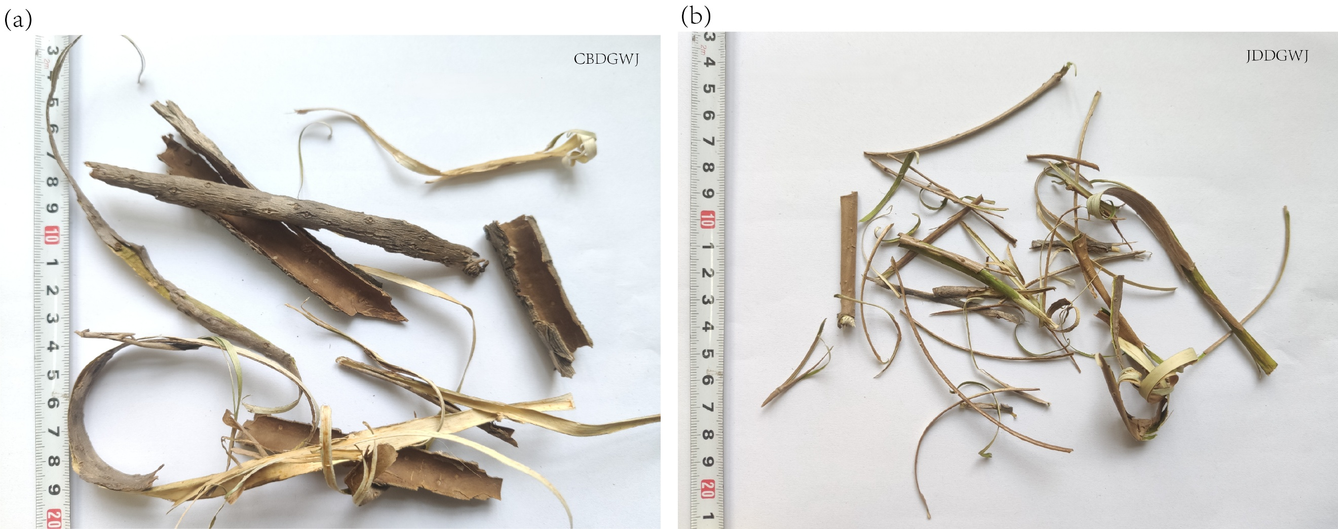
Fig. S2 Specimen of A.sessiliflorus. (a) Wild specimens of A.sessiliflorus from Changbai Mountain. (b) Cultivated specimens of A.sessiliflorus from research facility.
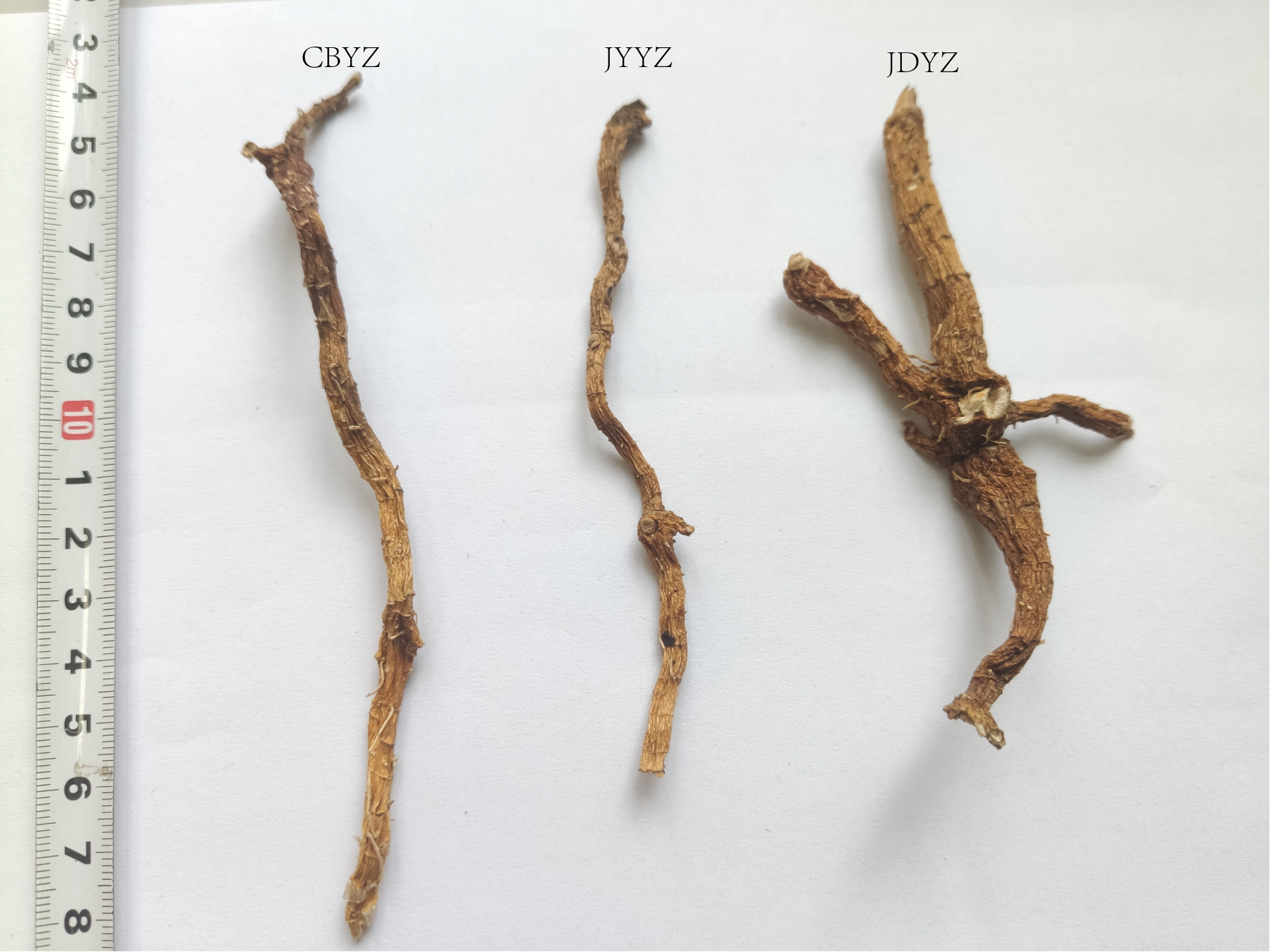
Fig. S3 Specimen of P.odoratum. CBYZ: Wild specimens of P.odoratum from Changbai Mountain. JYYZ: Wild specimens of P.odoratum s from Jingyuetan. JDYZ: Cultivated specimens of P.odoratum from research facility.

Fig. S4 HPLC fingerprints of different population in three medicinal plants. HPLC fingerprints obtained from wild populations and cultivated population and black dots represent peak. (a) HPLC fingerprints of P.odoratum; 1: Rutinum, 2: Dioscin. (b) HPLC fingerprints of A.sessiliflorus; 1: Chlorogenic acid, 2: Syringin(Eleutheroside B), 3: Eleutheroside E, 4: Isofraxidin, 5: Rutinum. (c) HPLC fingerprints of D.nipponica; 1: Dioscin, 2: Disogluside.
Table S1 Details of sampled of cultivated and wild populations for three medicinal plants
Population Sample plot Altitude(m) Quality Longitude and Latitude
CBCL-1 Changbai Mountain 850 Wild N42°21′51″E127°59′23″
CBCL-2 Changbai Mountain 750 Wild N42°22′56″ E128°6′1″

JDCL Cultivation base 219 Cultivation N43°56′48″E125°14′26″

CBYZ Changbai Mountain 720 Wild N42°24′30″ E128°6′11″

JYYZ Jingyuetan 236 Wild N43°46′45″E125°28′35″

JDYZ Cultivation base 219 Cultivation N43°56′48″E125°14′26″

CBDW Changbai Mountain 750 Wild N42°22′55″ E128°1′3″

JDDW Cultivation base 219 Cultivation N43°56′48″E125°14′26″

Table S2 Sequences of SSR primers and annealing temperature
Primer Sequence (5′ to 3′) Tm(℃) | Primer Sequence (5′ to 3′) Tm(℃) | Primer Sequence (5′ to 3′) Tm(℃)
YZ-1F CAGGTGATGCCAGAGGTACT 50.0  YZ-1R ATACCCTTTCCTATCGCTCC  YZ-2F ACAGCAGAAAACACCACCTA 50.0  YZ-2R AAATCCGACTAACATTACACA  YZ-4F TTCCTCCTGGATCGCTGT 50.2  YZ-4R CGGTAGAATAGCGGGTTG  YZ-5F CTAGCCGCCCTTTCCCTT 57.5  YZ-5R CGCCTTGATGTCCTCCAG  YZ-8F TTCAGATCGGACCAGACG 55.0  YZ-8R CAACTACTCCAGCAACGAC  YZ-9F GAAGCAGCAATCAAGCACC 52.0  YZ-9R ACCCAATTCTCATCCTCGC  YZ-10F GCCGTGGGAGATCATAGAG 53.5  YZ-10R CAACATTGTCAGGCAGAGC  YZ-11F TCTTCGTCGTCGTCATCATC 51.0  YZ-11R GAGCTACCAGAGCTGGCAAT  YZ-16F ATCTTCTCCTCCTCGGTG 55.0  YZ-16R CCCTATCCCTGTGTCTGC  YZ-19F TCATTGTCCCCCAAGCTC 52.0  YZ-19R CGGTTCTCGGCTTGTTCT | CLSY-1F GGGGACGCACGAATAATAGC 52.0  CLSY-1R ACTGACTTCCCAATAAATAA  CLSY-2F CCGGCGGTACTTTATTTCTG 53.5  CLSY-2R TGCTACGGTTCTTACATATA  CLSY-3F TATCCGAAGTATTTCCGTGA 55.0  CLSY-3R ACAAGTCCAATCCCAATCTC  CLSY-5F GATTCGCCAAGTCTTAAATG 50.2  CLSY-5R AATTGATCTATTGAAGAAGAGA  CLSY-6F CGGATTTGAACCGATGACTT 52.0  CLSY-6R ATTTATTGTCCTTGAATGAGTT  CLSY-7F ATCCTTGGGCTTCGACTACC 55.0  CLSY-7R GGCATACCTCTTCCGCTTTA  CLSY-8F GGTTTCGGATTGTCCACTA 52.0  CLSY-8R GCATTGATTTCCATACCATA  CLSY-9F ACCAGTAGGTGAGATTTTCC 57.0  CLSY-9R CTTGTTTTCCAGATCGTTAT  CLSY-10F GCGTGTCTACCGATTTCACC 53.5  CLSY-10R ATCCAGTTCTAATAGACAAAAAC  CLSY-12F AAATTAAATGAGCTTTTACCC 53.5  CLSY-12R ATGATAGTATGAGTAGTTTTTTGG | DGWJ-26F GGTGGCGACTAGATCAACG 51.0  DGWJ-26R CCCTGTATAGCTTCTTCAATT  DGWJ-27F AGATTCTCGTGAGTCCGTAT 57.4  DGWJ-27R CCGATTCCCTTCTATTCTAC  DGWJ-28F GTTGGATAGACGGATAGGAA 50.2  DGWJ-28R AAGGGAATGTTACTAATGGAA  DGWJ-30F AGTTTAGTGTATTCCTTATCCC 50.2  DGWJ-30R AAAGGAACCGGCACAATAC  DGWJ-31F AACGTCCACGAATTTGATC 52.0  DGWJ-31R GGGAGAATTTGCACCTACT  DGWJ-32F ATCCTTGGGCTTCGACTACC 52.0  DGWJ-32R GAGATGGTGCGATTTGATT  DGWJ-37F TAATGGCGGACAAACAAAA 50.0  DGWJ-37R CACTGGACTTCCTAGATGACA  DGWJ-38F GGTGGCGACTAGATCAACG 50.9  DGWJ-38R GCCTGACAAAACCCCTGTA  DGWJ-40F GTTGGATAGACGGATAGGAA 50.9  DGWJ-40R CAAGGGAATGTTACTAATGGAA  DGWJ-41F GATTTGAACCGATGACTTAC 53.4  DGWJ-41R TAAGCCACTATCCACTATGA
YZ: P.odoratum; CLSY: D.nipponica; DGWJ: A.sessiliflorus

Species Primer Sequence (5′ to 3′) Tm（℃）

Bacteria
63F CAGGCCTAACACATGCAAGCTC 53℃
1387R GGGCGGWGTGTACAAGGC
Fungus
ITS1 TCCGTAGGTGAACCTGCGC 52℃
ITS4 TCCTCCGCTTATTGATATGC
Actinomycetes
ACF GGCGGCCTATCAGCTTGTTG 52℃
ACR CCGTACTCCCCAGGCGGGG
Table S3 Sequences of RFLP primers and annealing temperature

Table S4 Genetic variation within and among populations of three medicinal plants revealed by AMOVA
Species Source df SS MS Est.Var. % F_{ST} P
D.nipponica
Among Pops 2 59.324 29.662 1.502 31% 0.312 ＜0.001
Within Pops 50 165.694 3.314 3.314 69%
Total 52 225.019 4.815 100%
A.sessiliflorus
Among Pops 1 8.921 8.921 0.253 6% 0.058 ＜0.001
Within Pops 36 148.211 4.117 4.117 94%
Total 37 157.132 4.370 100%
P.odoratum
Among Pops 2 150.933 75.467 3.213 22% 0.223 ＜0.001
Within Pops 57 639.250 11.215 11.215 78%
Total 59 790.183 14.428 100%
df:degree of freedom, SS:sums of the squared deviations, MS:mean squared deviations, %:Total the percentage of the total variance.

Table S5 Similarity of HPLC fingerprints among populations of three medicinal plants
Population CBDW-J JDDW-J CBDW-Y JDDW-Y CBCL-2 CBCL-1 JDCL CBYZ JDYZ JYYZ
CBDW-J 1 0.873 0.485 0.399
JDDW-J 0.873 1 0.438 0.355
CBDW-Y 0.485 0.438 1 0.733
JDDW-Y 0.399 0.355 0.733 1
CBCL-2 1 0.377 0.828
CBCL-1 0.377 1 0.344
JDCL 0.828 0.334 1
CBYZ 1 0.985 0.855
JDYZ 0.985 1 0.869
JYYZ 0.855 0.869 1

Table S6 Correlations between genetic structure and chromatographic fingerprints
Chemical composition
Species Pearson correlation coefficient
A.Sessiliflorus
Chlorogenic acid Syringin Eleutheroside E Isofraxidin Rutinum
Genetic structure -0.176 -0.306 0.171 0.173 0.118
P.odoratum
Total polysaccharide Total flavone
Genetic structure 0.358 0.134
D.nipponica
Dioscin Disogluside
Genetic structure 0.445 0.220
*p<0.05 **p<0.01.

