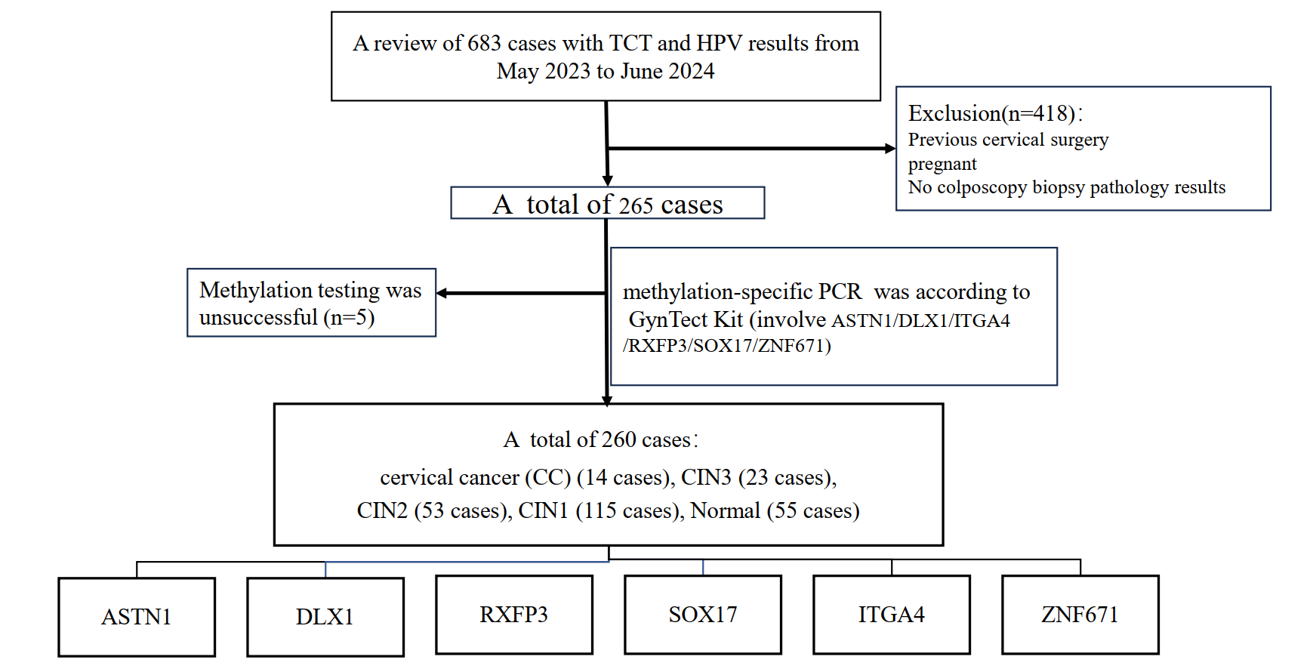
SupplementalS1：the enrollment flowchart of included patients

Supplemental Table S2
AUCs of 6 DNA Methylation screening methods between CIN3- and Cancer (N=90)
Methods | Sensitivity (%) | Specificity (%) | AUC
ASTN1 | 85.71 | 67.11 | 0.833
DLX1 | 100.00 | 63.16 | 0.822
RXFP3 | 100.00 | 55.26 | 0.811
SOX17 | 100.00 | 63.07 | 0.853
ZNF671 | 78.57 | 81.58 | 0.854
ITGA4 | 43.33 | 97.65 | 0.804

