Supplementary Materials

Rhee TG, Shim SR, Nasir M, McIntyre RS, Kaster TS, & Wilkinson ST. Longitudinal Associations of Electroconvulsive Therapy with All-cause Mortality and Suicide Deaths in Depression and Other Psychiatric Disorders: A Systematic Review and Meta-Analysis. Molecular Psychiatry.

Supplementary Figure 1. Cumulative forest plot of all-cause mortality by year

Supplementary Figure 2. Cumulative forest plot of suicide mortality by year

Supplementary Figure 3. Forest plots of all-cause mortality by period (1 month; 3 months; 6 months; and 12 months)

Supplementary Figure 4. Forest plots of suicide mortality by period (1 month; 3 months; 6 months; and 12 months)

Supplementary Figure 5. Funnel plot for publication bias (or small study effects) assessments for all-cause mortality reported in Figure 1

Supplementary Figure 6. Funnel plot for publication bias (or small study effects) assessments for all-cause mortality reported in Figure 2

Supplementary Table 1. Database and search strategy

Supplementary Table 2. Meta-analyses of Observational Studies in Epidemiology (MOOSE) Checklist

Supplementary Table 3. Moderation analyses of all-cause mortality by period

Supplementary Table 4. Moderation analyses of suicide by period

Supplementary Table 5. Newcastle-Ottawa quality assessment of individual studies

Supplementary References.

This supplemental material has been provided by the authors to give readers additional information about their work.
Supplementary Figure 1. Cumulative forest plot of all-cause mortality by year
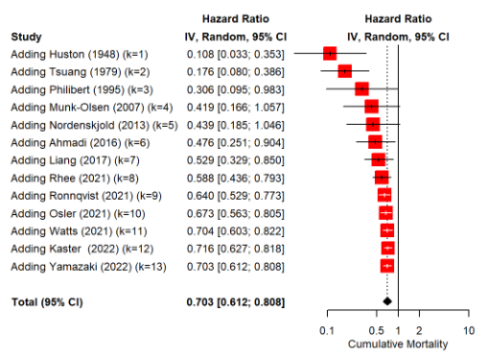
Note: A hazard ratio of <1.0 indicates a reduction of all-cause mortality in the ECT group (i.e., favors ECT).
Supplementary Figure 2. Cumulative forest plot of suicide mortality by year
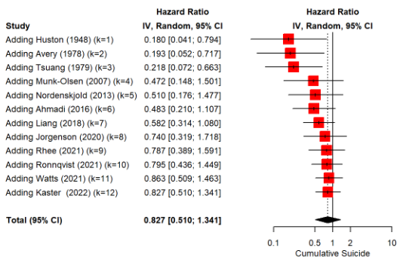
Note: A hazard ratio of <1.0 indicates a reduction of suicide deaths in the ECT group (i.e., favors ECT).
Supplementary Figure 3. Forest plots of all-cause mortality by period (1 month; 3 months; 6 months; and 12 months)

Supplementary Figure 3A. Forest plots of all-cause mortality at 1 month
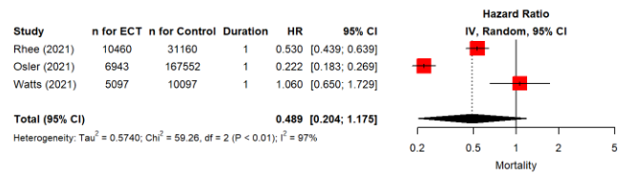

Supplementary Figure 3B. Forest plots of all-cause mortality at 3 months
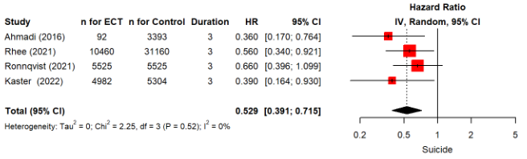

Supplementary Figure 3C. Forest plots of all-cause mortality at 6 months
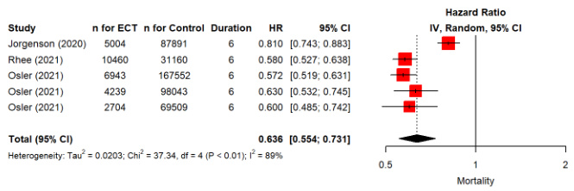

Supplementary Figure 3D. Forest plots of all-cause mortality at 12 months
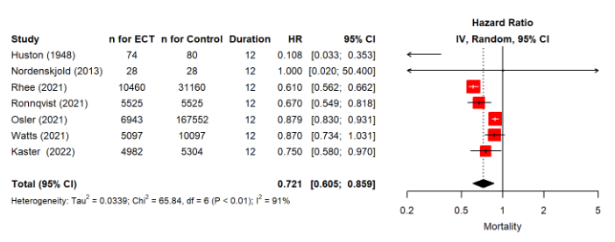
Note: A hazard ratio of <1.0 indicates a reduction of all-cause mortality in the ECT group (i.e., favors ECT).

Supplementary Figure 4. Forest plots of suicide mortality by period (1 month; 3 months; 6 months; and 12 months)

Supplementary Figure 4A. Forest plots of suicide mortality at 1 month
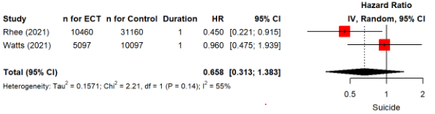

Supplementary Figure 4B. Forest plots of suicide mortality at 3 months
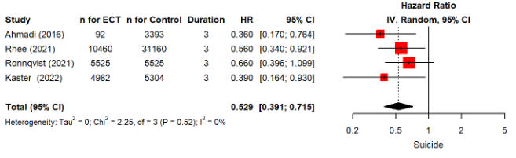

Supplementary Figure 4C. Forest plots of suicide mortality at 6 months
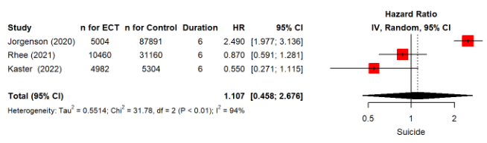

Supplementary Figure 4D. Forest plots of suicide mortality at 12 months
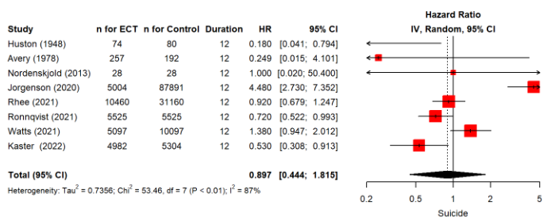
Note: A hazard ratio of <1.0 indicates a reduction of suicide deaths in the ECT group (i.e., favors ECT).
Supplementary Figure 5. Funnel plot for publication bias (or small study effects) assessments for all-cause mortality reported in Figure 1
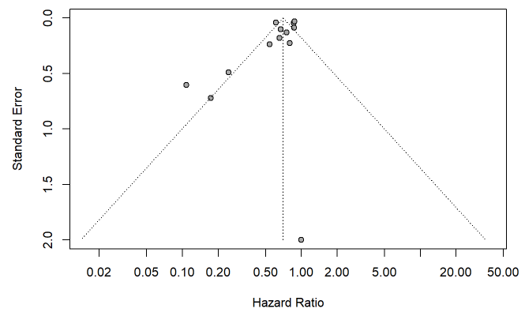
Note: Using an inverse variance weighting method, τ² (tau-squared), multiplicative residual heterogeneity variance, was 5.87. Using Egger’s test (i.e., linear regression test of funnel plot asymmetry), we did not find any evidence for publication bias (p=0.099). Using Begg and Mazumdar’s test (i.e., rank correlation test of funnel plot asymmetry), we did not find any evidence for publication bias (p=0.143).
Supplementary Figure 6. Funnel plot for publication bias (or small study effects) assessments for all-cause mortality reported in Figure 2
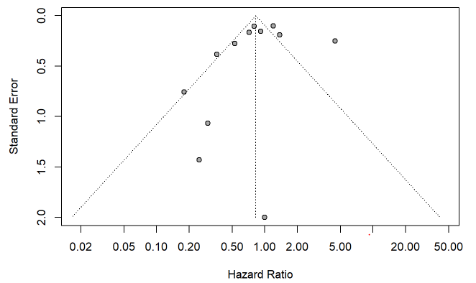
Note: Using an inverse variance weighting method, τ² (tau-squared), multiplicative residual heterogeneity variance, was 6.63. Using Egger’s test (i.e., linear regression test of funnel plot asymmetry), we did not find any evidence for publication bias (p=0.499). Using Begg and Mazumdar’s test (i.e., rank correlation test of funnel plot asymmetry), we did not find any evidence for publication bias (p=0.891).

Supplementary Table 1. Search strategy

# | Strategy | Results
1 | ECT.mp. [mp=ti, bt, ab, ot, nm, hw, fx, kf, ox, px, rx, ui, an, sy, ux, mx, tn, dm, mf, dv, dq, tc, id, tm] | 36,920
2 | electroconvulsive*.mp. [mp=ti, bt, ab, ot, nm, hw, fx, kf, ox, px, rx, ui, an, sy, ux, mx, tn, dm, mf, dv, dq, tc, id, tm] | 55,966
3 | electroshock*.mp. [mp=ti, bt, ab, ot, nm, hw, fx, kf, ox, px, rx, ui, an, sy, ux, mx, tn, dm, mf, dv, dq, tc, id, tm] | 27,190
4 | shock-therapy.mp. [mp=ti, bt, ab, ot, nm, hw, fx, kf, ox, px, rx, ui, an, sy, ux, mx, tn, dm, mf, dv, dq, tc, id, tm] | 14,533
5 | convulsive-therapy.mp. [mp=ti, bt, ab, ot, nm, hw, fx, kf, ox, px, rx, ui, an, sy, ux, mx, tn, dm, mf, dv, dq, tc, id, tm] | 5,997
6 | 1 or 2 or 3 or 4 or 5 | 94,233
7 | mortality.mp. [mp=ti, bt, ab, ot, nm, hw, fx, kf, ox, px, rx, ui, an, sy, ux, mx, tn, dm, mf, dv, dq, tc, id, tm] | 3,656,942
8 | death.mp. [mp=ti, bt, ab, ot, nm, hw, fx, kf, ox, px, rx, ui, an, sy, ux, mx, tn, dm, mf, dv, dq, tc, id, tm] | 2,893,556
9 | suicide.mp. [mp=ti, bt, ab, ot, nm, hw, fx, kf, ox, px, rx, ui, an, sy, ux, mx, tn, dm, mf, dv, dq, tc, id, tm] | 321,492
10 | suicid*.mp. [mp=ti, bt, ab, ot, nm, hw, fx, kf, ox, px, rx, ui, an, sy, ux, mx, tn, dm, mf, dv, dq, tc, id, tm] | 388,860
11 | 7 or 8 or 9 or 10 | 6,089,474
12 | 6 and 11 | 8,737
13 | limit 12 to humans [Limit not valid in APA PsycInfo; records were retained] | 7,530
 | Total: | 7,530
Note: All searches were completed and updated on January 21, 2025 using PubMed/MEDLINE, Embase, PsycINFO, and Cochrane Library.¹

Supplementary Table 2. Meta-analyses of Observational Studies in Epidemiology (MOOSE) Checklist

Item No | Recommendation | Reported  on Page No
Reporting of background should include
1 | Problem definition | 4-5
2 | Hypothesis statement | 4-5
3 | Description of study outcome(s) | 6-7
4 | Type of exposure or intervention used | 6-7
5 | Type of study designs used | 6-7
6 | Study population | 6-7
Reporting of search strategy should include
7 | Qualifications of searchers (eg, librarians and investigators) | n/a
8 | Search strategy, including time period included in the synthesis and key words | 5
9 | Effort to include all available studies, including contact with authors | 6-7
10 | Databases and registries searched | 5
11 | Search software used, name and version, including special features used (eg, explosion) | 9
12 | Use of hand searching (eg, reference lists of obtained articles) | 6-7
13 | List of citations located and those excluded, including justification | 6-7
14 | Method of addressing articles published in languages other than English | 6-7
15 | Method of handling abstracts and unpublished studies | 6-7
16 | Description of any contact with authors | n/a
Reporting of methods should include
17 | Description of relevance or appropriateness of studies assembled for assessing the hypothesis to be tested | 6-7
18 | Rationale for the selection and coding of data (eg, sound clinical principles or convenience) | 6-7
19 | Documentation of how data were classified and coded (eg, multiple raters, blinding and interrater reliability) | 6-8
20 | Assessment of confounding (eg, comparability of cases and controls in studies where appropriate) | 7-8
21 | Assessment of study quality, including blinding of quality assessors, stratification or regression on possible predictors of study results | 7-8
22 | Assessment of heterogeneity | 7-8
23 | Description of statistical methods (eg, complete description of fixed or random effects models, justification of whether the chosen models account for predictors of study results, dose-response models, or cumulative meta-analysis) in sufficient detail to be  replicated | 8-9
24 | Provision of appropriate tables and graphics | 8-9
Reporting of results should include
25 | Graphic summarizing individual study estimates and overall estimate | 9-12
26 | Table giving descriptive information for each study included | 9-12
27 | Results of sensitivity testing (eg, subgroup analysis) | 9-12
28 | Indication of statistical uncertainty of findings | 9-12
Reporting of discussion should include
29 | Quantitative assessment of bias (eg, publication bias) | Appendix
30 | Justification for exclusion (eg, exclusion of non-English language citations) | n/a
31 | Assessment of quality of included studies | Appendix
Reporting of conclusions should include
32 | Consideration of alternative explanations for observed results | 12-14
33 | Generalization of the conclusions (ie, appropriate for the data presented and within the domain of the literature review) | 12-14
34 | Guidelines for future research | 14
35 | Disclosure of funding source | 17
Note: This checklist is from the MOOSE checklist.²

Supplementary Table 3. Moderation analyses of all-cause mortality by period

Supplementary Table 3A. Moderation analyses of all-cause mortality at 3 months
Moderator | k | Coefficient (95% CI) | Hazard ratio (95% CI) | P-value
Number of total patients | 4 | 0.00 (-0.00 to 0.00) | - | 0.260*
Outcome measure
Hazard ratio | 3 | - | 0.49 (0.39-0.62) | 0.712†
Relative risk | 1 | - | 0.54 (0.34-0.86) | 0.712†
Age
Overall | 4 | 0.01 (-0.01 to 0.02) | - | 0.285*
Female sex | 4 | -0.00 (-0.01 to 0.01) | - | 0.877*
Condition
% major depressive disorder | 4 | -0.01 (-0.02 to 0.01) | - | 0.466*
% psychotic depression | 3 | -0.02 (-0.05 to 0.02) | - | 0.308*
% bipolar disorder | 3 | -0.01 (-0.03 to 0.01) | - | 0.313*
Region
United States | 2 | - | 0.54 (0.48-0.61) | 0.154†
Sweden | 1 | - | 0.43 (0.30-0.61) | 0.154†
Japan | 1 | - | 0.17 (0.04-0.72) | 0.154†

Supplementary Table 3B. Moderation analyses of all-cause mortality at 6 months
Moderator | k | Coefficient (95% CI) | Hazard ratio (95% CI) | P-value
Number of total patients | 5 | -0.00 (-0.00 to 0.00) | - | 0.860*
Outcome measure
Hazard ratio | 5 | - | 0.63 (0.55-0.73) | <0.001†
Age
Overall | 5 | -0.01 (-0.02 to -0.00) | - | 0.011*
65 or older only | 3 | -0.01 (-0.00 to 0.00) | - | 0.399*
Female sex | 3 | -0.02 (-0.06 to -0.03) | - | 0.531*
Condition
% major depressive disorder | 3 | 0.00 (-0.01 to 0.01) | - | 0.470*
% psychotic depression | 3 | 0.04 (-0.05 to 0.13) | - | 0.404*
% bipolar disorder | 3 | -0.01 (-0.02 to 0.01) | - | 0.470*
% psychosis or schizophrenic spectrum disorder | 1 | -0.55 (-0.64 to -0.45) | - | <0.001*
Region
United States | 4 | - | 0.65 (0.55-0.77) | 0.234†
Denmark | 1 | - | 0.58 (0.53-0.64) | 0.234†

Supplementary Table 3C. Moderation analyses of all-cause mortality at 12 months
Moderator | k | Coefficient (95% CI) | Hazard ratio (95% CI) | P-value
Number of total patients | 7 | 0.00 (-0.00 to 0.00) | - | 0.262*
Outcome measure
Hazard ratio | 6 | - | 0.68 (0.55-0.85) | 0.083†
Odds ratio | 1 | - | 0.87 (0.73-1.03) | 0.083†
Age
Overall | 7 | -0.01 (-0.02 to 0.02) | - | 0.873*
65 or older only | 3 | 0.01 (-0.02 to 0.04) | - | 0.475*
Female sex | 6 | -0.01 (-0.01 to -0.00) | - | <0.001*
Condition
% major depressive disorder | 6 | -0.02 (-0.07 to 0.03) | - | 0.432*
% psychotic depression | 4 | 0.01 (-0.00 to 0.01) | - | 0.143*
% bipolar disorder | 5 | 0.01 (-0.00 to 0.02) | - | 0.233*
% psychosis or schizophrenic spectrum disorder | 5 | 0.010 (-0.01 to 0.03) | - | 0.203*
Region
United States | 3 | - | 0.44 (0.15-1.34) | 0.030†
Canada | 1 | - | 0.75 (0.58-0.97) | 0.030†
Sweden | 2 | - | 0.67 (0.55-0.82) | 0.030†
Denmark | 1 | - | 0.88 (0.83-0.93) | 0.030†

Note: k, number of effect sizes; Coefficient, regression coefficient; CI, confidence interval. A restricted maximum likelihood (REML) was used. * denotes continuous moderators and † denotes categorical moderators.
Supplementary Table 4. Moderation analyses of suicide by period

Supplementary Table 4A. Moderation analyses of suicide at 3 months
Moderator | k | Coefficient (95% CI) | Hazard ratio (95% CI) | P-value
Number of total patients | 4 | 0.00 (-0.00 to 0.00) | - | 0.634*
Outcome measure
Hazard ratio | 3 | - | 0.57 (0.41-0.79) | 0.274†
Relative risk | 1 | - | 0.36 (0.17-0.76) | 0.274†
Age
Overall | 4 | 0.01 (-0.02 to 0.04) | - | 0.546*
Female sex | 4 | 0.01 (-0.01 to 0.02) | - | 0.373*
Condition
% major depressive disorder | 4 | -0.00 (-0.03 to 0.03) | - | 0.938*
% psychotic depression | 3 | 0.00 (-0.03 to 0.03) | - | 0.876*
% bipolar disorder | 3 | -0.01 (-0.05 to 0.03) | - | 0.523*
% psychosis or schizophrenic spectrum disorder | 3 | -0.00 (-0.11 to 0.10) | - | 0.946*
Region
United States | 2 | - | 0.49 (0.32-0.74) | 0.515†
Canada | 1 | - | 0.39 (0.16-0.93) | 0.515†
Sweden | 1 | - | 0.66 (0.40-1.10) | 0.515†

Supplementary Table 4B. Moderation analyses of suicide at 6 months
Moderator | k | Coefficient (95% CI) | Hazard ratio (95% CI) | P-value
Number of total patients | 3 | 0.00 (-0.00 to 0.00) | - | <0.001*
Outcome measure
Hazard ratio | 3 | - | 1.11 (0.46-2.68) | 0.821†
Age
Overall | 3 | -0.01 (-0.09 to 0.07) | - | 0.762*
Region
United States | 1 | - | 0.87 (0.59-1.28) | <0.001†
Canada | 1 | - | 0.55 (0.27-1.12) | <0.001†
Denmark | 1 | - | 2.49 (1.98-3.14) | <0.001†

Supplementary Table 4C. Moderation analyses of suicide at 12 months
Moderator | k | Coefficient (95% CI) | Hazard ratio (95% CI) | P-value
Number of total patients | 8 | 0.00 (0.00-0.00) | - | <0.001*
Outcome measure
Hazard ratio | 7 | - | 0.80 (0.34-1.88) | 0.254†
Odds ratio | 1 | - | 1.38 (0.95-2.01) | 0.254†
Age
Overall | 7 | -0.01 (-0.09 to 0.07) | - | 0.818*
65 or older only | 3 | 0.01 (-0.01 to 0.03) | - | 0.340*
Female sex | 6 | -0.01 (-0.03 to 0.00) | - | 0.072*
Condition
% major depressive disorder | 6 | -0.02 (-0.07 to 0.03) | - | 0.396*
% psychotic depression | 4 | -0.01 (-0.03 to 0.01) | - | 0.170*
% bipolar disorder | 5 | 0.02 (0.00-0.03) | - | 0.007*
% psychosis or schizophrenic spectrum disorder | 5 | 0.03 (0.01-0.05) | - | 0.003*
Region
United States | 4 | - | 0.71 (0.30-1.72) | <0.001†
Canada | 1 | - | 0.53 (0.31-0.91) | <0.001†
Sweden | 2 | - | 0.72 (0.52-0.99) | <0.001†
Denmark | 1 | - | 4.48 (2.73-7.35) | <0.001†

Note: k, number of effect sizes; Coefficient, regression coefficient; CI, confidence interval. A restricted maximum likelihood (REML) was used. * denotes continuous moderators and † denotes categorical moderators.

Supplementary Table 5. Newcastle-Ottawa quality assessment of individual studies
 |  | Selection |  |  |  | Comparability |  | Outcome / Exposure |  |  |  | Total score | Quality power
 | Representativeness of the exposed cohort | Selection of the non-exposed cohort | Ascertainment of exposure | Demonstration that outcome of interest was not present at start of study |  | Comparability of cohorts on the basis of the design or analysis |  | Assessment of outcome | Was follow-up long enough for outcomes to occur | Adequacy of follow up of cohorts |  | Total score | Quality power
Huston (1948) |  |  | ★ | ★ |  |  |  | ★ | ★ | ★ |  | ★★★★★ (5) | Poor
Avery (1978) |  |  | ★ | ★ |  | ★ |  | ★ | ★ | ★ |  | ★★★★★★ (6) | Fair
Tsuang (1979) |  |  | ★ | ★ |  | ★ |  | ★ | ★ | ★ |  | ★★★★★★ (6) | Fair
Babigian (1984) | ★ | ★ | ★ | ★ |  | ★ |  | ★ | ★ | ★ |  | ★★★★★★★★ (8) | Good
Philibert (1995) |  |  | ★ | ★ |  | ★★ |  | ★ | ★ | ★ |  | ★★★★★★★ (7) | Fair
Munk-Olsen (2007) | ★ | ★ | ★ | ★ |  | ★★ |  | ★ | ★ | ★ |  | ★★★★★★★★★ (9) | Good
Nordenskjold (2013)* | ★ | ★ | ★ | ★ |  | ★★ |  | ★ | ★ | ★ |  | ★★★★★★★★★ (9) | Good
Ahmadi (2016) | ★ | ★ | ★ | ★ |  | ★★ |  | ★ |  | ★ |  | ★★★★★★★★ (8) | Good
Liang (2017) | ★ | ★ | ★ | ★ |  | ★★ |  | ★ | ★ | ★ |  | ★★★★★★★★★ (9) | Good
Liang (2018) | ★ | ★ | ★ | ★ |  | ★★ |  | ★ | ★ | ★ |  | ★★★★★★★★★ (9) | Good
Jorgenson (2020) | ★ | ★ | ★ | ★ |  | ★★ |  | ★ | ★ | ★ |  | ★★★★★★★★★ (9) | Good
Osler (2021) | ★ | ★ | ★ | ★ |  | ★★ |  | ★ | ★ | ★ |  | ★★★★★★★★★ (9) | Good
Rhee (2021) | ★ | ★ | ★ | ★ |  | ★★ |  | ★ | ★ | ★ |  | ★★★★★★★★★ (9) | Good
Ronnqvist (2021) | ★ | ★ | ★ | ★ |  | ★★ |  | ★ | ★ | ★ |  | ★★★★★★★★★ (9) | Good
Watts (2021; 2022) | ★ | ★ | ★ | ★ |  | ★★ |  | ★ | ★ | ★ |  | ★★★★★★★★★ (9) | Good
Kaster (2022) | ★ | ★ | ★ | ★ |  | ★★ |  | ★ | ★ | ★ |  | ★★★★★★★★★ (9) | Good
Yamazaki (2022) | ★ | ★ | ★ | ★ |  | ★★ |  | ★ |  | ★ |  | ★★★★★★★★ (8) | Good
Note: A study can be awarded a maximum of one star for each item, except comparability. A maximum of two stars can be awarded for comparability. Good quality denotes 3 or 4 stars in “selection” domain AND 1 or 2 stars in “comparability” domain AND 2 or 3 stars in “exposure/outcome” domain. Fair quality denotes 2 stars in selection domain AND 1 or 2 stars in comparability domain AND 2 or 3 stars in exposure/outcome domain. Poor quality denotes 0 or 1 star in selection domain OR 0 stars in comparability domain OR 0 or 1 stars in exposure/outcome domain.

* Nordenskjold (2013) was the only randomized controlled trial (RCT), and had a ‘low’ risk of bias as follows:
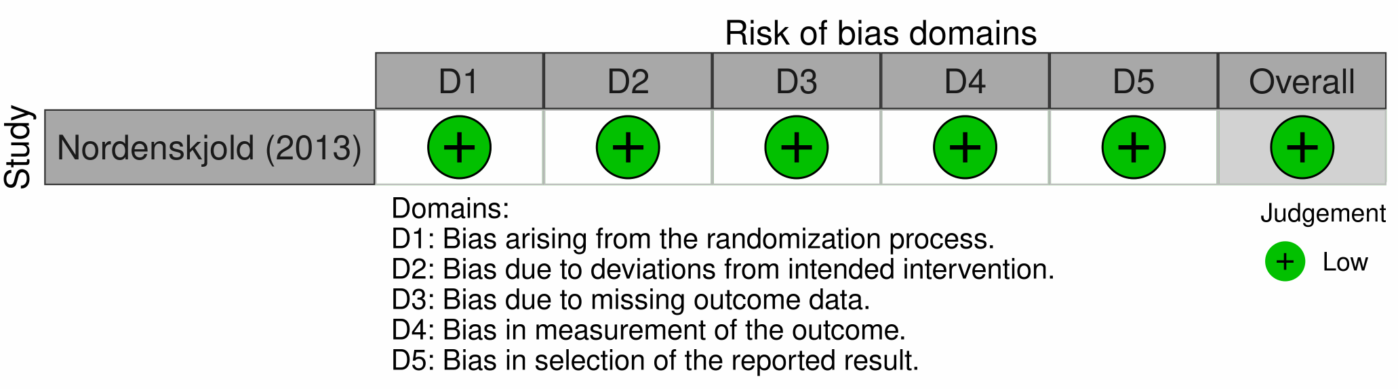

Supplementary References

1. Rhee TG, Shim SR, Popp JH, Trikalinos TA, Rosenheck RA, Kellner CH, Seiner SJ, Espinoza RT, Forester BP, McIntyre RS. Efficacy and safety of ketamine-assisted electroconvulsive therapy in major depressive episode: A Systematic review and network meta-analysis. Molecular Psychiatry. 2024; 29(3): 750-759.

2. Stroup DF, Berlin JA, Morton SC, Olkin I, Williamson GD, Rennie D, Moher D, Becker BJ, Sipe TA, Thacker SB. Meta-analysis of observational studies in epidemiology: a proposal for reporting. Meta-analysis Of Observational Studies in Epidemiology (MOOSE) group. JAMA. 2000; 283(15): 2008-2012.

