Extended Data Figure 1
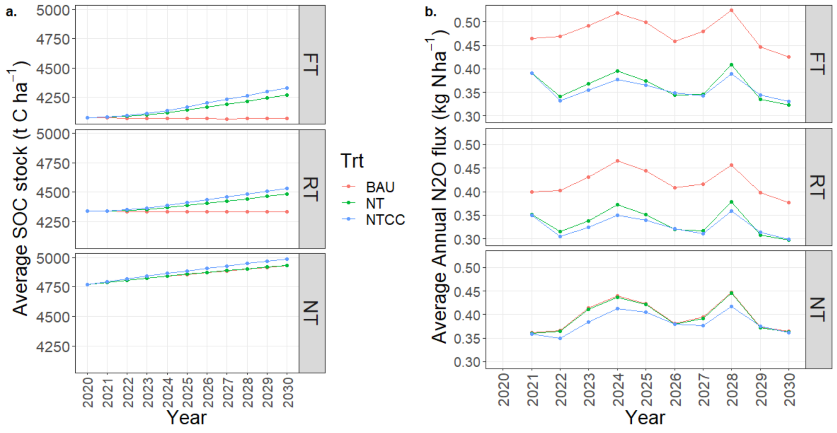

Extended Data Fig. 1. DayCent model soil organic carbon estimates (SOC, a) or annual nitrous oxide fluxes (N₂O, b) for 10-year project periods (2020-2030). Panels represent fields currently managed as either full till (FT), reduced till (RT), or no till (NT). Lines within panels represent SOC stocks or N₂O emissions under "business as usual” (BAU) management, adoption of no till (NT) practices, or adoption of stacked no till and cover crop addition (NTCC). Note that for full-till and reduced-till panels, the “business-as-usual” is full-till or reduced-till, respectively. For the no-till panel, the business-as-usual and no-till estimates are identical.

Extended Data Figure 2

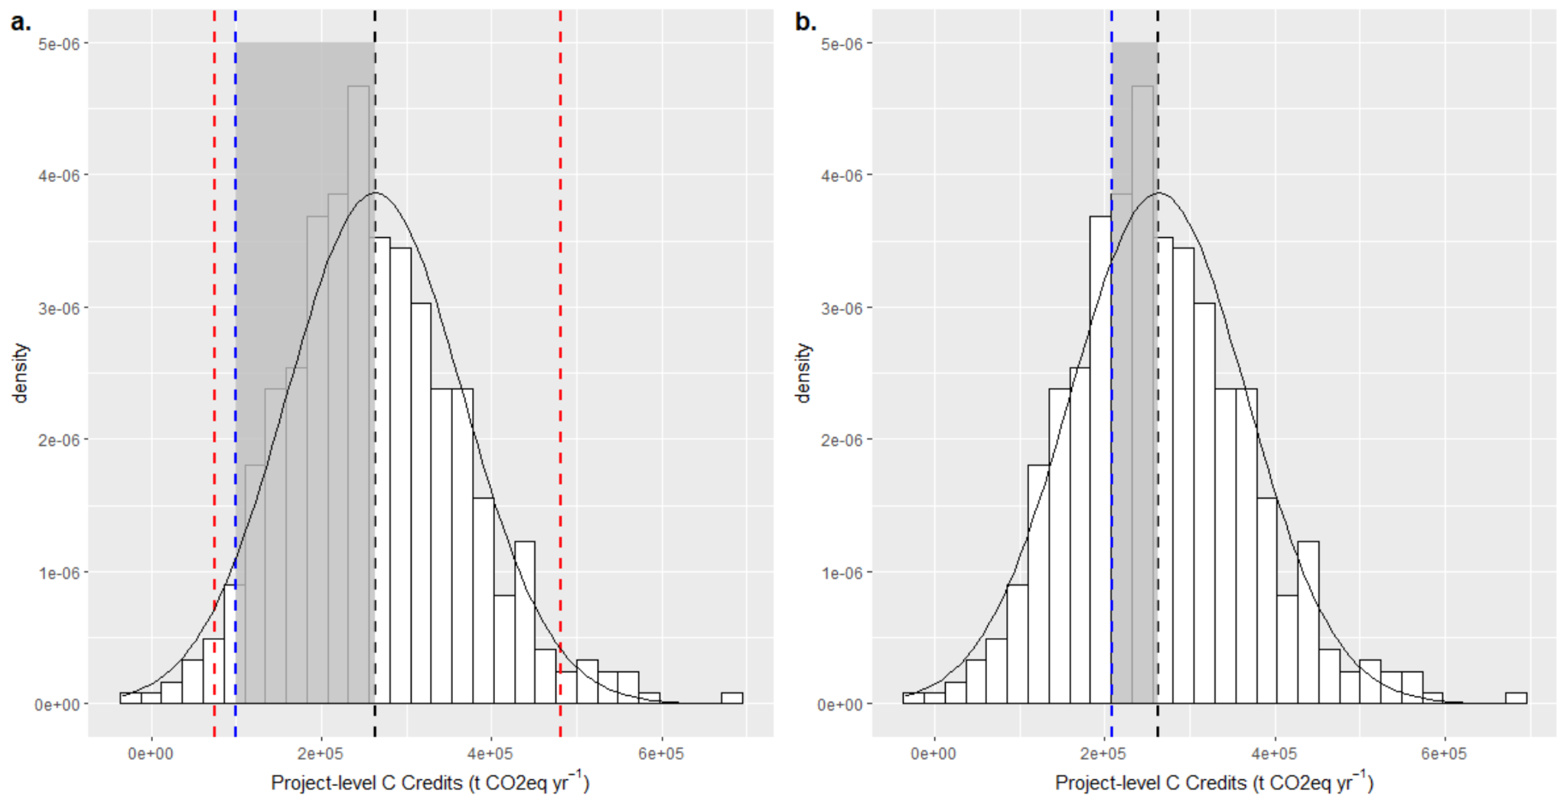
Extended Data Fig. 2. Visualization of two different statistical approaches, the (a) ‘half-width interval’ and the (b) probability of exceedance methods, to estimating uncertainty deductions for modeled carbon credits. Histograms represent modeled carbon credit iterations from 500 iterations of a Markov Chain Monte Carlo analysis for growers practicing no till and cover cropping on 4,784 hypothetical corn/soybean fields in the midwestern United States. Raw credit issuances are demarked as the mean of the modeled outputs (dashed black line) and uncertainty deductions are represented by the blue dashed line and grey rectangle. (a) Historical versions of the Verra (v1.0) and Climate Action Reserve (v1.0) deducted 15% from the half-width of the 95% confidence interval (dashed red lines), which represented an ~60% deduction in our dataset. (b) updated versions of the Verra (2.0) and Reserve (v1.1) protocols now use a probability of exceedance deduction that reduces credits by ~30% in both protocols.

Extended Data Figure 3
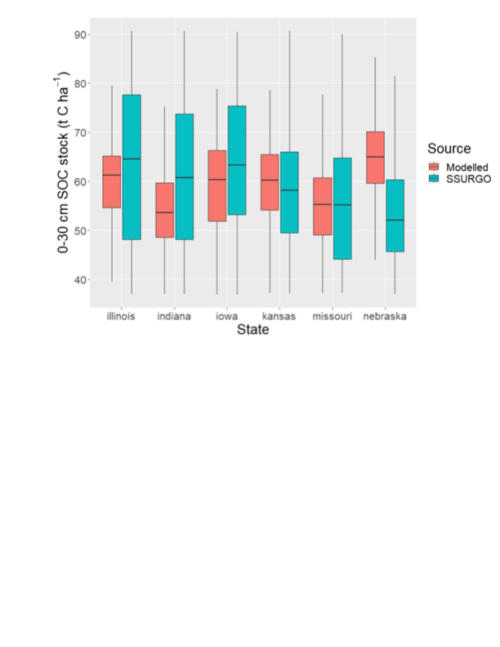
Extended Data Figure 3. Variation in initial soil organic carbon (SOC) stocks for the top 30 cm of soils within fields in 6 midwestern states. Initial SOC values derived from either DayCent model spin-up procedures (“Modelled”) or from the Natural Resources Conservation Services Soil Survey Geographic Database (“SSURGO”, https://www.nrcs.usda.gov/resources/data-and-reports/soil-survey-geographic-database-ssurgo. Box and whisker plots show the inner quartile range (box), median value (horizontal line), and total variation within a state (whiskers).

