Type I collagen enhances biofilm formation of Staphylococcus epidermidis

Chisato Takahashi

Department of Materials and Chemistry, National Institute of Advanced Industrial Science and Technology (AIST), 4-205, Sakurazaka, Moriyama-ku, Nagoya, Aichi, 463-8560, Japan Tel: +81 50 3522 7855; Fax: +81 52 736 7127; email: chisa-takahashi@aist.go.jp

Figure S1. SEM image of S. epidermidis biofilm formation after 17 of cultivation in the presence of collagen.

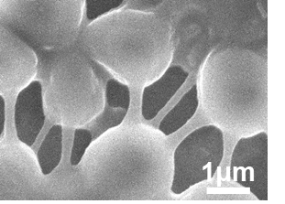

Figure S2: SEM image of S. epidermidis biofilm formation after 30 of cultivation in the presence of collagen.

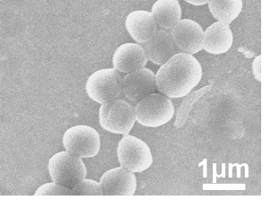

Figure S3: SEM image of S. epidermidis biofilm formation after 36 of cultivation in the absence of collagen.

