Annex
Fig. 4 Distribution of companies in terms of number of properties owned (outliers circled in yellow)
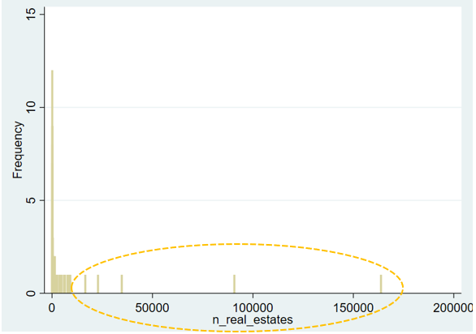
Note: only represented companies with at least 100 real estate to allow visualisations. Made by the authors in Stata v. 16.1.
Fig. 5 Correlations among predictors
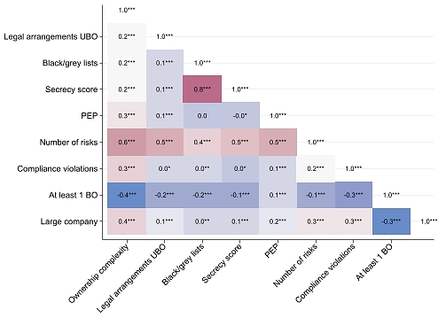
Note: the figure shows pairwise correlations among all the variables used in the regression analysis. Associations between dichotomous variables were computed through the phi coefficient, while those between these latter and ordinal variables with the point bi-serial correlation. The matrix shows the correlation coefficients and the significance levels (* 0.05, ** 0.010, *** 0.001). Colours vary according to the strength of the association. Made by the authors in Stata v. 16.1.
Table 6 Firth logistic regressions on the probability of company’s involvement in financial crimes (sensitivity analysis). Unstandardised odds ratios (standard errors)
 | 0.5% random experiment | 1% random experiment | 2% random experiment
Ownership complexity (ordinal) | 1.2086* | 1.1280 | 1.1708*
 | (0.12) | (0.10) | (0.08)
Legal arrangements UBO | 2.8938** | 3.4426*** | 2.0696*
 | (1.02) | (1.09) | (0.64)
Secrecy score | 3.0819* | 2.6188* | 2.0829+
 | (1.52) | (1.25) | (0.90)
PEP | 3.7252*** | 2.6872** | 2.0308*
 | (1.45) | (1.02) | (0.70)
Compliance violations | 3.1793*** | 2.5891** | 2.4498***
 | (0.99) | (0.78) | (0.64)
At least 1 BO | 0.7509 | 0.8466 | 0.8035
 | (0.22) | (0.22) | (0.18)
Large company | 1.6493+ | 1.5185+ | 1.3603
 | (0.45) | (0.37) | (0.27)
constant | 0.0079*** | 0.0129*** | 0.0207***
 | (0.00) | (0.00) | (0.01)
Observations | 4,292 | 4,292 | 4,292
Tjur's D | 0.0435 | 0.0322 | 0.0248
AIC*N | 665.8256 | 848.2137 | 1155.5671
BIC | 716.7417 | 899.1298 | 1206.4832
Note: Significance levels: + 0.1, * 0.05, ** 0.010, *** 0.001.
Table 7 Distribution of properties with foreign ownership by country
Country | High-risk / other foreign jurisdiction | Number of properties
Canada | Other foreign country | 9,739
Luxembourg | Other foreign country | 7,070
United Kingdom | Other foreign country | 5,855
Germany | Other foreign country | 4,836
Cayman Islands | High-risk jurisdiction | 4,190
Belgium | Other foreign country | 2,069
Netherlands | Other foreign country | 1,787
United States | Other foreign country | 885
Spain | Other foreign country | 829
Switzerland | Other foreign country | 691
Qatar | High-risk jurisdiction | 650
Mexico | Other foreign country | 634
Hong Kong | Other foreign country | 306
Norway | Other foreign country | 302
British Virgin Islands | Other foreign country | 283
Italy | Other foreign country | 240
Singapore | Other foreign country | 136
Bermuda | Other foreign country | 103
Slovakia | Other foreign country | 100
Lebanon | Other foreign country | 100
Cyprus | Other foreign country | 88
Czeck Republic | Other foreign country | 84
Japan | Other foreign country | 78
Azerbaijan | Other foreign country | 52
Denmark | Other foreign country | 40
Sweden | Other foreign country | 28
New Zealand | Other foreign country | 26
United Arab Emirates | High-risk jurisdiction | 21
Portugal | Other foreign country | 20
China | Other foreign country | 18
Kuwait | High-risk jurisdiction | 16
Morocco | High-risk jurisdiction | 14
Israel | Other foreign country | 10
Australia | Other foreign country | 10
Iran | High-risk jurisdiction | 8
Taiwan | Other foreign country | 7
Liechtenstein | Other foreign country | 7
Pakistan | High-risk jurisdiction | 6
Curaçao | High-risk jurisdiction | 5
Algeria | High-risk jurisdiction | 4
Brunei | High-risk jurisdiction | 3
Anguilla | High-risk jurisdiction | 3
Ireland | Other foreign country | 3
Mauritius | High-risk jurisdiction | 2
Chile | Other foreign country | 2
Turkey | High-risk jurisdiction | 1
The Bahamas | High-risk jurisdiction | 1
Panama | High-risk jurisdiction | 1
Oman | High-risk jurisdiction | 1
Angola | High-risk jurisdiction | 1
South Africa | Other foreign country | 1
Republic of Korea | Other foreign country | 1
India | Other foreign country | 1
Gabon | Other foreign country | 1
Finland | Other foreign country | 1
Note: the table displays the number of properties owned by companies owned by at least one foreign intermediate owner (INT).

