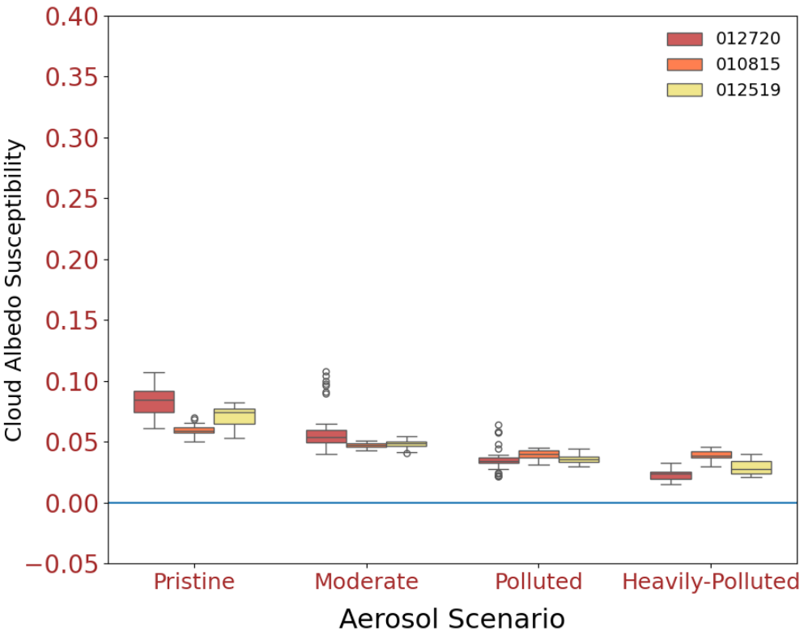
Fig. S1 Box-whisker plot of the cloud albedo susceptibilities in warm cases with the formula $∂A_{c}/∂lnN_{a}$ following Chen et al. (Chen et al. 2014). The color scheme is the same as in Figure 1b.

