Supplementary Information

- Tables and Figures

Appendix Table 1. The normal reference range for serum and plasma biomarkers
Variable | Abbreviation | Unit of measurement | Blood sample type | The normal reference range
Abnormal Prothrombin | PIVKA_Ⅱ | mAU/mL | Serum | 6-32.5
Alpha-fetoprotein | AFP | ng/mL | Serum | 0＜7.0
Carcinoembryonic antigen | CEA | ng/mL | Serum | ＜7.0
Deoxyribonucleic acid of Hepatitis B virus | HBV-DNA | IU/mL | Plasma | ＜1.00E+02
Total bilirubin | TBIL | umol/L | Serum | 5.0-28.0
Aspartate aminotransferase | AST | umol/L | Serum | ＜40.0
Alanine aminotransferase | ALT | umol/L | Serum | ＜50.0
Albumin | ALB | g/L | Serum | 40-55
Erythrocyte | RBC | 10^12/L | Plasma | 4.3-5.8
Leukocyte | WBC | 10^9/L | Plasma | 3.5-9.5
Thrombocyte | PLT | 10^9/L | Plasma | 100-300
Lymphocyte | LYM | 10^9/L | Plasma | 20-50
Monocyte | MONO | 10^9/L | Plasma | 0.1-0.6

Appendix Table2. Comparison of some non-significant baseline characteristics between the group of 5-year survival and the group of death in HCC patents.
Characteristics | Overall (N=76) | Statistics | P-value
Continuous variables | Mean value (SD)
PIVKA_Ⅱ | 5277.90(1.35E +04) | -1.20 | 0.23
CEA | 21.94(116.83) | -0.46 | 0.65
HBV-DNA | 2.04E+03（8.59 E+07) | 0.93 | 0.36
ALT | 52.11(0.0063) | -0.84 | 0.40
PLT | 164.07(0.0025） | 0.74 | 0.46
MONO | 0.78(0.02) | 0.39 | 0.69
NUE | 6.86(8.44) | -0.90 | 0.3706
The number of CTM | 7.87(39.45） | 0.12 | 0.902
The number of CEC | 3.47(11.91) | 0.52 | 0.6037
The number of CEC cluster | 6.75(27.74) | 0.24 | 0.8132
The number of CTC | 9.16(47.39) | -0.01 | 0.9903
Haploid CTC | 4.60(0.51) | 2.34 | 0.0223*
Amphiploid CTC | 0.47(0.81) | -2.58 | 0.0123*
Triploid CTC | 3.13(12.62) | -0.97 | 0.3354
Tetraploid CTC | 2.46(30.84) | 1.55 | 0.1308
The small CTC | 1.59(0.12) | -0.02 | 0.99
Haploid CEC | 0.09(0.70) | -0.74 | 0.46
Amphiploid CEC | 0.55(0.23) | 1.23 | 0.22
Tetraploid CEC | 0.32(0.31) | -1.01 | 0.31
≥Pentaploid CEC | 2.66(0.04) | -0.14 | 0.89
PD-L1(-) CEC | 3.63(0.04) | -0.088 | 0.93
The large CEC | 3.09(0.05) | -0.099 | 0.92
The small CEC | 0.54(0.13) | -0.05 | 0.96
Discrete variables | Number value
Gender
Male | 64 | 0 | 1
Female | 12
Genetic history
Yes | 5 | 0 | 1
No | 71
Smoking history
Yes | 30 | 0 | 1
No | 46
Drinking history
Yes | 31 | 0.41 | 0.52
No | 45
The other underlying diseases
Yes | 24 | 2.58 | 0.11
No | 42
Presence of liver cirrhosis
Yes | 71 | 0.47 | 0.49
No | 5
Presence or absence of vascular invasion
Yes | 33 | 0.35 | 0.56
No | 43

Appendix Table 2a. The distribution of CTC and CEC subtypes in patients with HCC before operation
Subtype | CTC |  |  | CEC
Subtype | Mean±SD | Case Number /% | Detection range | Mean±SD | Case Number /% | Detection range
Haploid | 0.24±0.66 | 5/6.58% | 0-3 | 0 | 0 | 0
Amphiploid | 3.64±2.15 | 14/18.42% | 0-12 | 1.40±0.43 | 6/7.89% | 0-2
Triploid | 3.13±3.55 | 66/86.84% | 0-20 | 1.80±1.13 | 24/31.58% | 0-6
Tetraploid | 1.61±2.37 | 43/56.58% | 0-12 | 1.85±0.93 | 14/18.42% | 0-5
≥Pentaploid | 3.47±3.45 | 57/75.0% | 0-13 | 4.70±5.51 | 44/57.89% | 0-35
Subtype | CTC |  |  | CEC
 | Mean±SD | Case Number /% | Detection range | Mean±SD | Case Number /% | Detection range
The large cell | 6.75±5.27 | 70/92.10% | 0-20 | 3.09±4.88 | 60/78.95% | 0-26
The small cell | 1.59±1.95 | 39/51.32% | 0-7 | 0.54±1.75 | 13/17.11% | 0-12

Appendix Table 2b. The cell size of CTC and CEC in patients with HCC before operation
*The small cell’s diameter was shorter than 7μm.
The large cell’s diameter was longer than 7μm.

Appendix Table 2c. The distribution of CTC-WBC cluster and CEC-WBC cluster in patients with HCC before operation
Subtype | CTC-WBC cluster |  |  | CEC-WBC cluster
 | Mean±SD | Case Number /% | Detection range | Mean±SD | Case Number /% | Detection range
PD-L1(+) | 0.03±0.16 | 2/2.63% | 0-1 | 0.013±0.11 | 1/1.32% | 0-1
PD-L1(-) | 0.47±0.90 | 23/30.26% | 0-4 | 0.29±0.91 | 12/15.79% | 0-5

Appendix Figure 1. SHAP Summary: Feature Importance Ranking
Appendix Figure 2. SHAP Beeswarm Plot: Feature-Wise Impact on Model Output
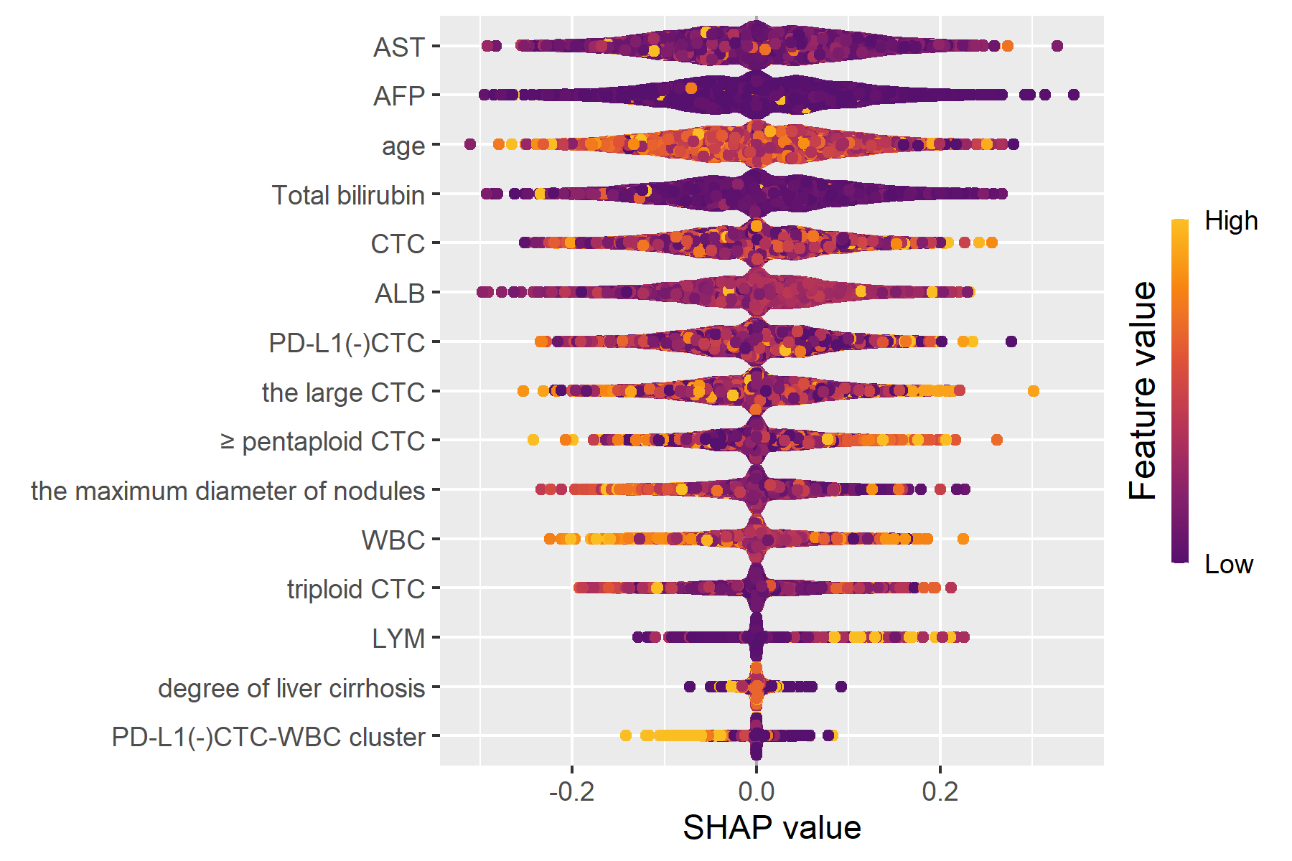

- Internal Validation
We included an additional independent internal dataset as the test set. The inclusion and exclusion criteria were consistent with those used for the training cohort, ultimately 11 HCC patients being enrolled (with a 5-year survival status ratio of 4:7). As this group lacked data on CTCs/CECs, we initially conducted multiple imputation to handle missing variables and ensure data completeness. Subsequently, we trained all models using the full cohort of 76 patients from our study as the training set and evaluated their predictive performance on this independent test set. The results were as follows:
Table 1 Evaluation of the classification performance on five ML models in Internal Validation
Parameter | Logistic | SVM | DTC | RF | XGBoost
Specificity | 0.500 | 1.000 | 0.750 | 0.750 | 0.750
F1 Score | 0.875 | 0.923 | 0.546 | 0.933 | 0.933
Recall Value | 1.000 | 0.857 | 0.429 | 1.000 | 1.000
Accuracy | 0.818 | 0.909 | 0.546 | 0.909 | 0.909
AUC-ROC | 0.786 | 0.929 | 0.536 | 0.893 | 0.786

- External Validation
We conducted external validation using data from the SEER database for HCC patients from 2010 to 2015. Inclusion criteria were: (1) patients diagnosed with HCC between 2010 and 2015; (2) Primary hepatocellular carcinoma. Exclusion criteria included: (1) patients with missing key variables; (2) patients missing survival data. A total of 2,628 patients were selected, with a survival-to-death ratio of 1,892:736 after 5 years. For external validation, we selected 16 clinically relevant variables, including: age at diagnosis, race, sex, sequence number, marital status, T stage, N stage, surgery type, radiation therapy, chemotherapy, tumor size, AFP level, bone metastasis, lung metastasis, fibrosis score, and grade. These variables were all selected using the feature selection methods from our preliminary small-sample study, and they also showed statistical significance in the external data. In the large-sample dataset, we employed five-fold cross-validation to evaluate the performance of the model. The results were as follows:
Table 1 Evaluation of the classification performance on five ML models in External Validation
Parameter | Logistic | SVM | DTR | RF | XGBoost
Specificity | 0.794 | 0.813 | 0.833 | 0.811 | 0.802
F1 Score | 0.799 | 0.806 | 0.769 | 0.758 | 0.736
Recall Value | 0.719 | 0.726 | 0.665 | 0.657 | 0.633
Accuracy | 0.740 | 0.750 | 0.712 | 0.701 | 0.680
AUC-ROC | 0.815 | 0.819 | 0.783 | 0.782 | 0.772

