AUTHORS PROFILE
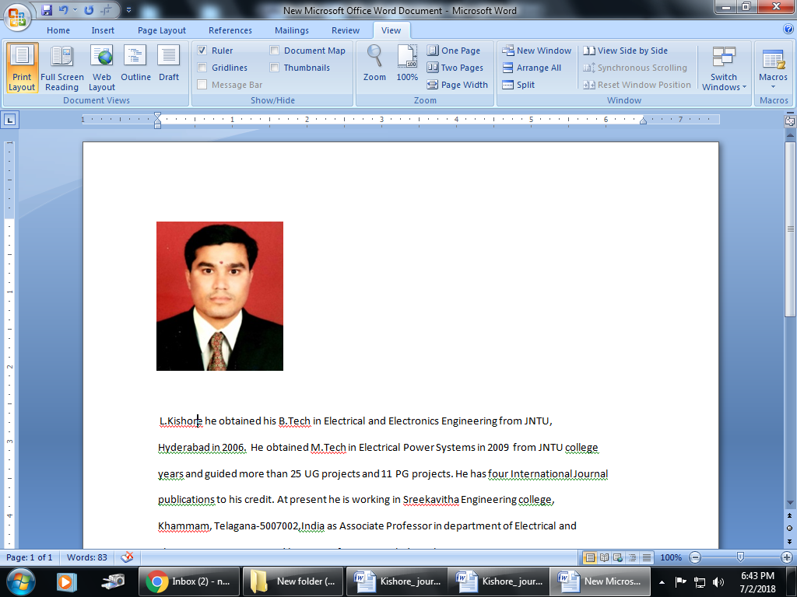
Dr.L. Kishore obtained his B. Tech. in Electrical and Electronics Engineering from JNTU, Hyderabad, in 2006. He obtained a M. Tech. in Electrical Power Systems in 2009 from JNTU Hyderabad and guided more than 147 UG projects and 45 PG projects. He has 21 international journal publications and 4 international conferences to his credit. He is working at Sreekavitha Engineering College, Khammam, Telagana-5007002, India, as an Associate Professor and Principal in the Department of Electrical and Electronics Engineering, and his areas of interest include the 6-Phase System, Power Systems Stability, and Power Systems Protection.


Dr.R.Durga Rao, currently working as an Associate Professor & Head, Department of Electrical & Electronics Engineering, JNTUH University College of Engineering ,Manthani. Obtained his Ph.D in Electrical Engineering (in High Voltage Engineering ) from Jawaharlal Nehru Technological University Hyderabad. He has 20 years of teaching Experience and established various Laboratories in Department of EEE. He has 15 years of administrative experience at various positions. He is technical expert member in various committees.
He is a Fellow Member of the Institution of Engineers, LIFE Member of the Indian society for Technical Education & System Society of India. He has published more than 50 research papers in National & International Journals. He has attended and conducted several conferences, workshops, faculty development programs, orientation courses. He has done extensive research in the areas of Gas insulated Substations, High Voltage Engineering, Electrical Power Systems, Electrical Machines, Electrical Distribution Systems..


Dr.T. Charan Singh he obtained his B.Tech in Electrical and Electronics Engineering from JNTU, Hyderabad in 2001. He obtained M.Tech in Energy Systems in 2006 from JNTU college engineering Hyderabad and pursuing Ph.D at JNTU, Hyderabad. He has teaching experience of 20 years and guided more than 20 UG projects and 7 PG projects. He has five International Journal publications to his credit. He is working at SBIT Engineering College, Khammam, Telagana-5007002, India, as an Associate Professor and Vice Principal in the Department of Electrical and Electronics Engineering and his areas of interest include 6-Phase system, Power Systems stability, FACTS and Smart Grid

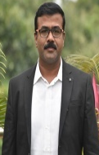
Dr. Vinay Kumar Awaar holds a Ph.D. in Power Electronics from Jawaharlal Nehru Technological University Hyderabad (JNTUH). He completed his M.Tech at JNTU Hyderabad and earned his B.E. from GITAM, Andhra University, Visakhapatnam. With 16 years of teaching experience and two years in the industry, he currently serves as an Associate Professor in the Department of Electrical and Electronics Engineering at Gokaraju Rangaraju Institute of Engineering and Technology (GRIET), Hyderabad. His research interests span Power Electronics, Power Quality, Battery Management Systems, Electric Vehicles, Wireless Power Transmission Systems, and the Internet of Things (IoT).
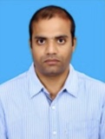
Dr Shashidhar Kasthala has been a faculty member at the Indian Naval Academy, Ezhimala, since 2010. His areas of interest include power line communication.

