Supplementary Materials
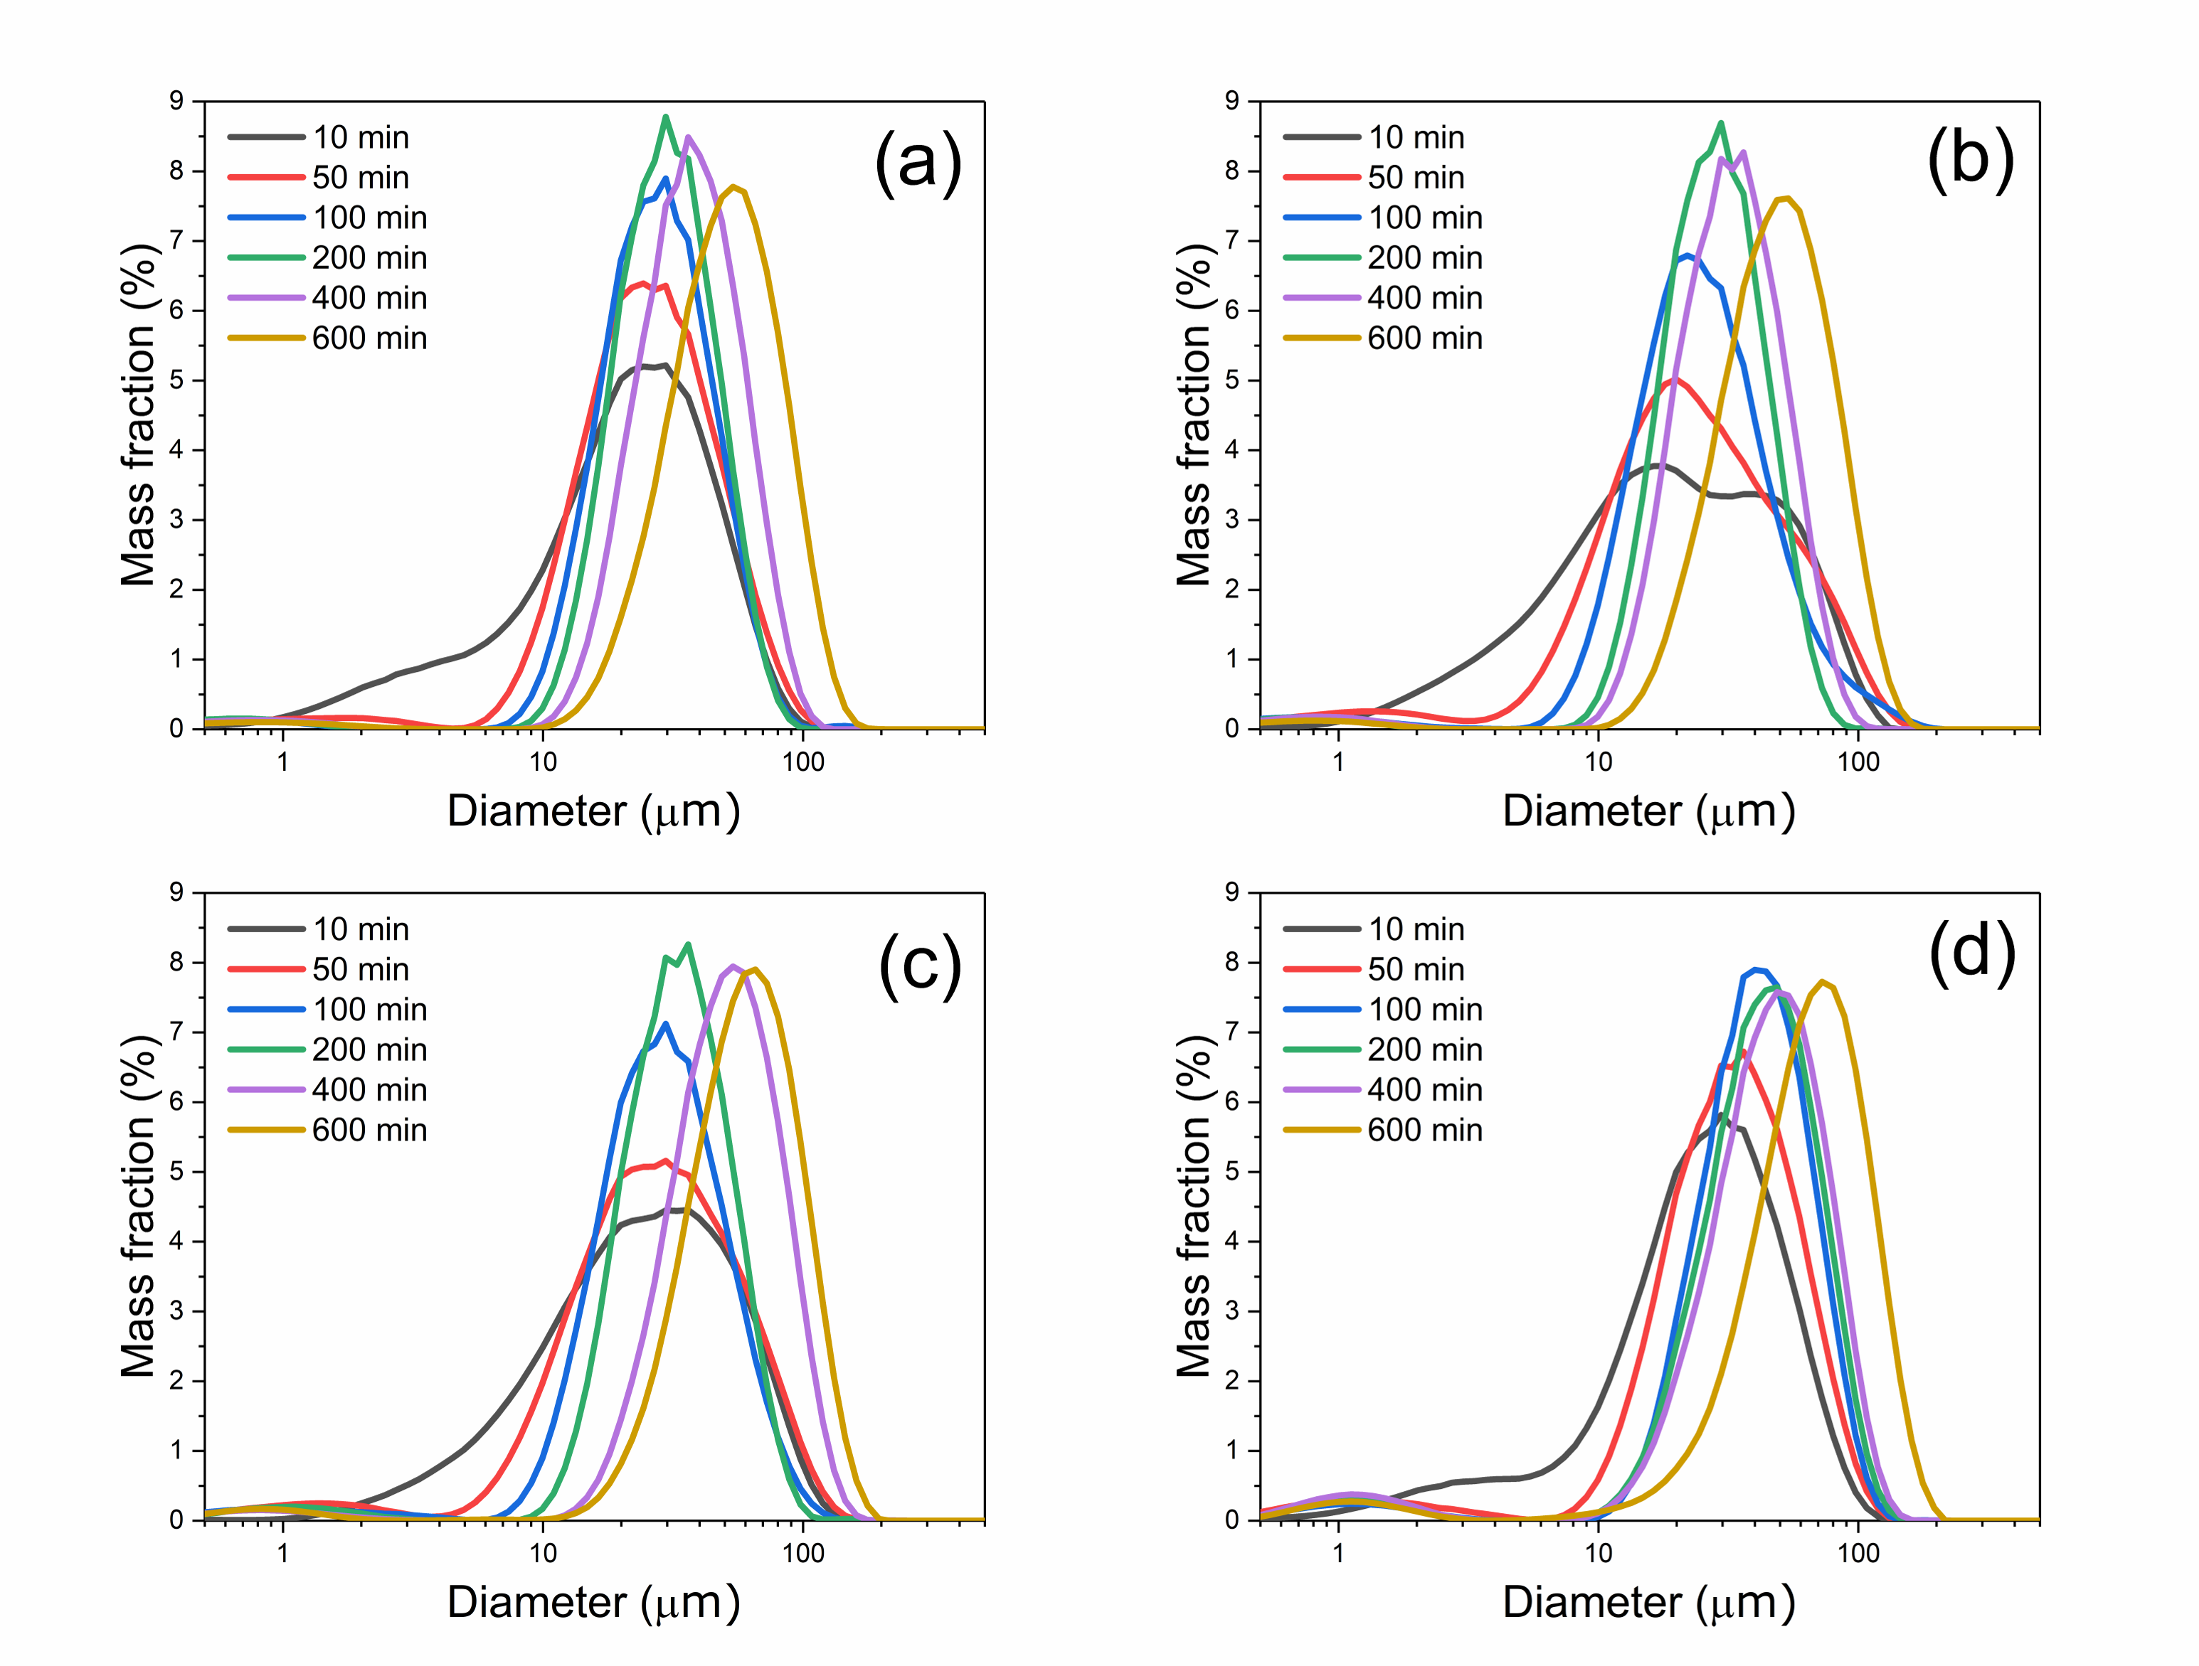
Fig. S1. Particle size distribution at different CDJP stages for samples: a - Zr-2, b - Zr-3, c - Zr-2t and d - Zr-3t.
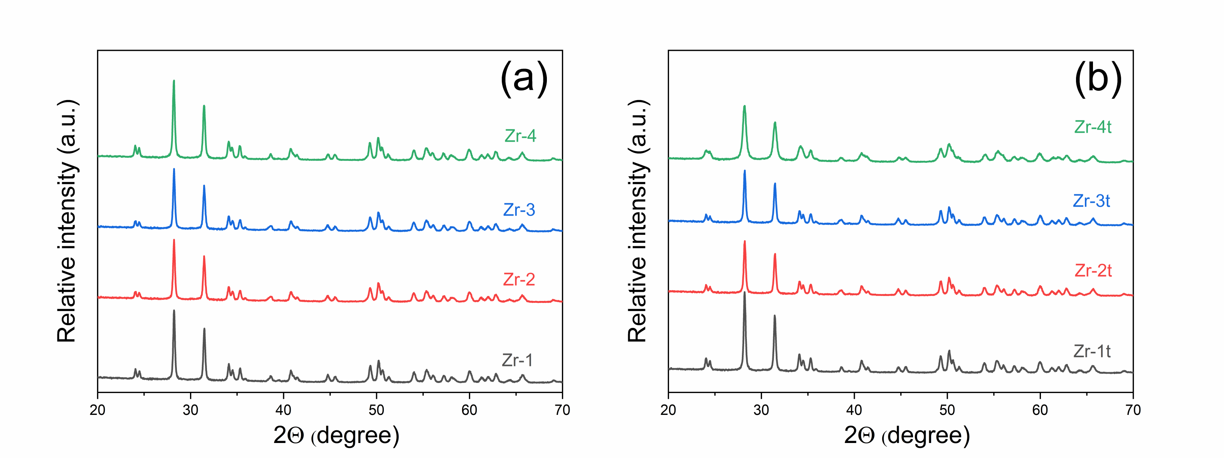
Fig. S2. XRD pattern for first (a) and second (b) series of samples

