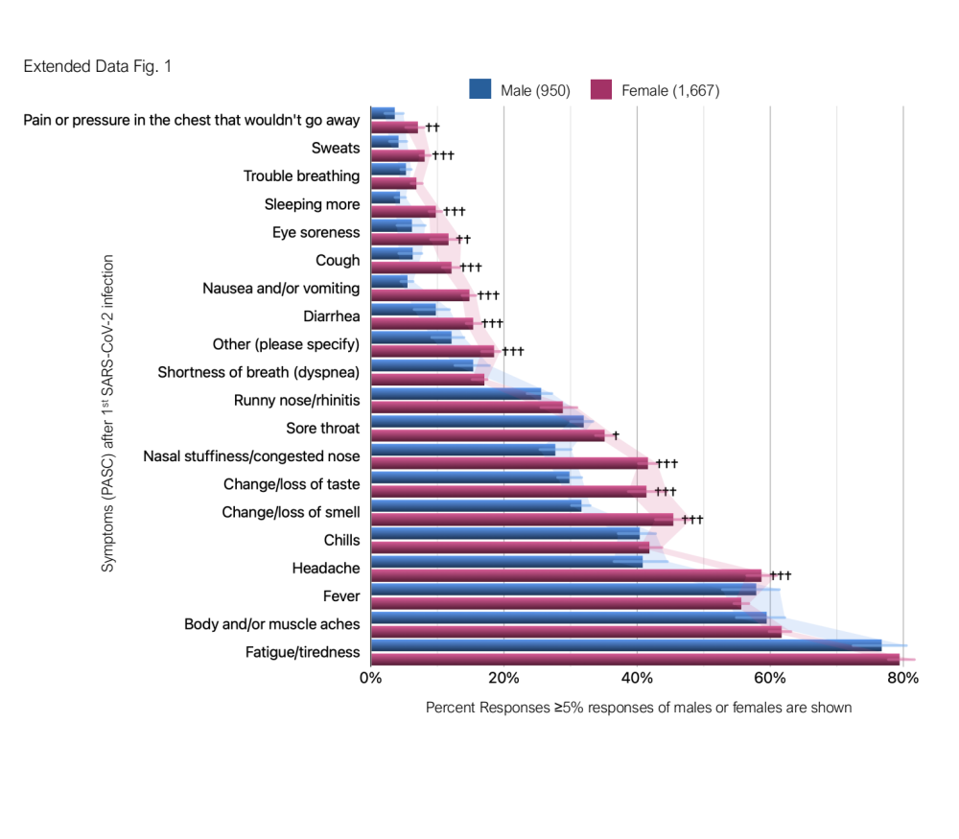

Extended Data Fig. 1. Postacute sequelae (PASC) experienced after 1st SARS-CoV-2 infection in men and women in the PROVES cohort are shown. Bar graphs show median central tendencies with error bars representing interquartile range (IQR) and normalized to percent responses. A two-tailed t-test was used to determine significance. P values based on a two-tailed t-test: †, ††, †††: denoting p<0.01, p < 0.001 and 0.0001 versus previous group, respectively.

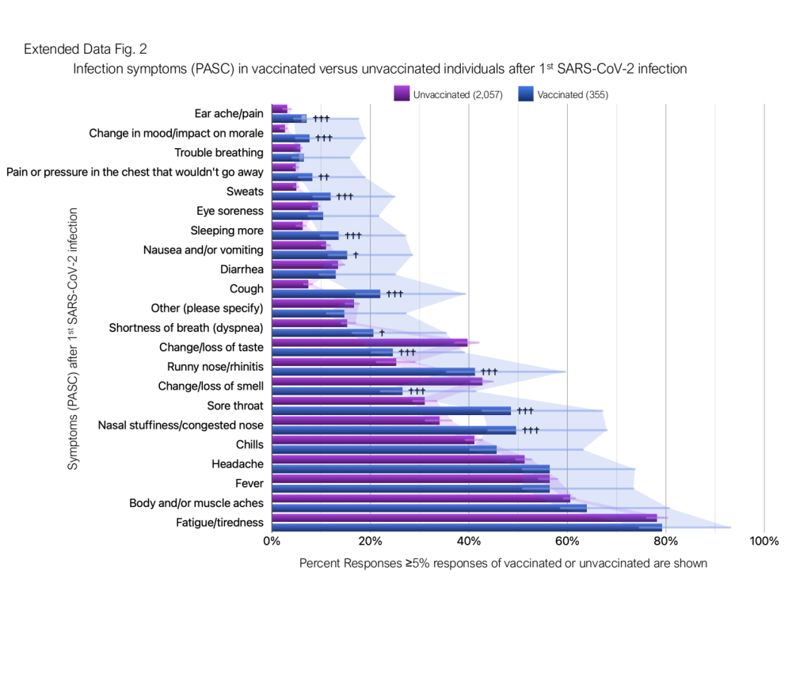
Extended Data Fig. 2. Postacute sequelae (PASC) experienced after 1st SARS-CoV-2 infection in vaccinated versus unvaccinated individuals in the PROVES cohort are shown. Only individuals who confirmed being vaccinated prior to having COVID-19 were included for this analysis. Bar graphs show median central tendencies with error bars representing interquartile range (IQR) and normalized to percent responses. A two-tailed t-test was used to determine significance. P values based on a two-tailed t-test: †, ††, †††: denoting p<0.01, p < 0.001 and 0.0001 versus previous group, respectively. Vaccinated n=355, unvaccinated n=2,057.

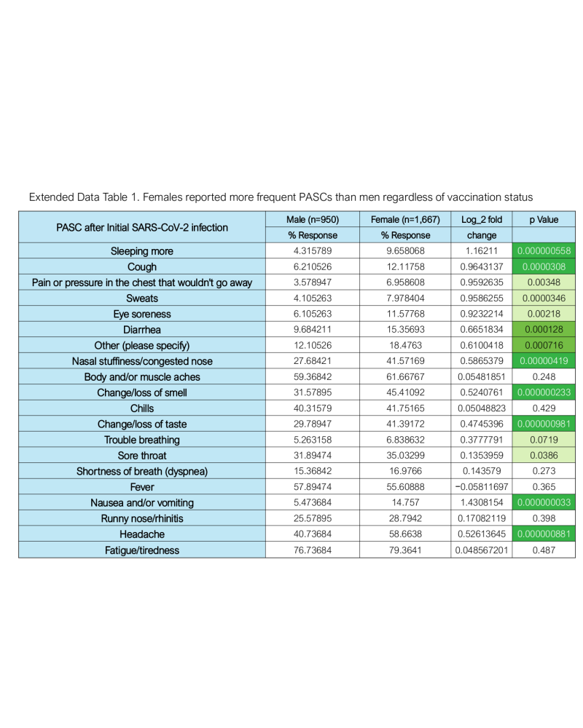

Extended Data Table 1. Females, regardless of the vaccination status reported more frequent PASC than males in the PROVES cohort. Log₂ fold change and their p values for symptoms (≥5% of responses in at least 1 of the groups) is shown. Cells with significant p values based on a two-tailed t-test are filled in green with darkest shade for p<0.001 and lightest for p<0.05. Males (n=950), Females (1,667).

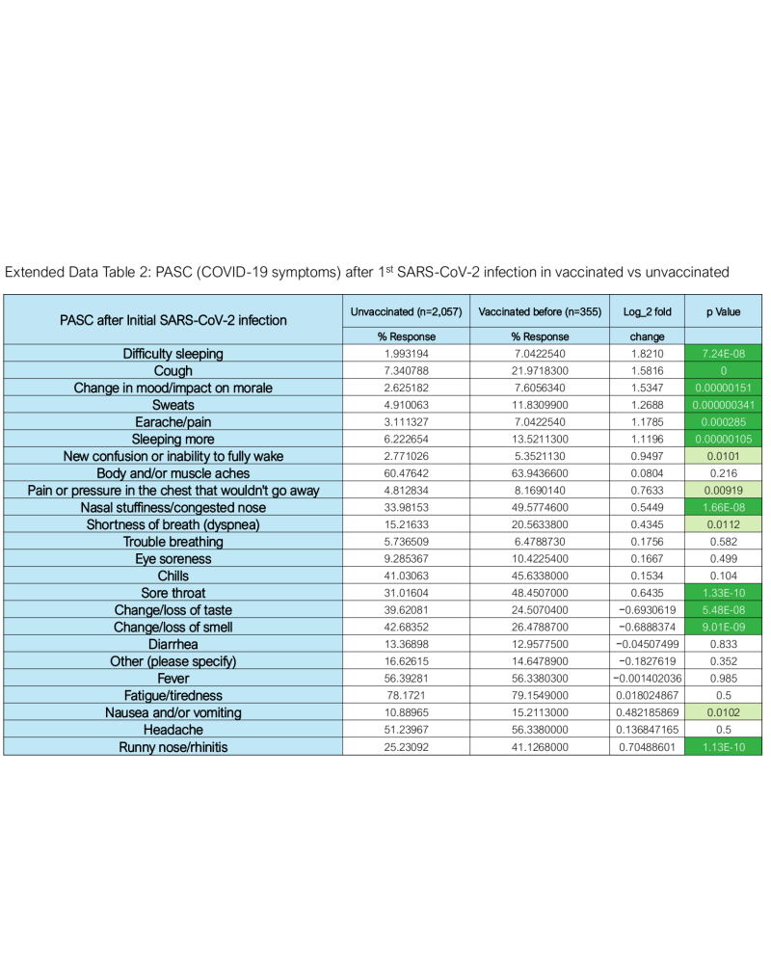

Extended Data Table 2. Comparison of COVID-19 symptoms (PASC) experienced and reported by vaccinated and unvaccinated individuals after 1st SARS-COV-2 infections. Only vaccinated individuals who responded that they were vaccinated before having COVID-19 were included in this comparison. Cells with significant p values based on a two-tailed t-test are filled in green with darkest shade for p<0.001 and lightest for p<0.05. Vaccinated (n=355), Unvaccinated (2,057).

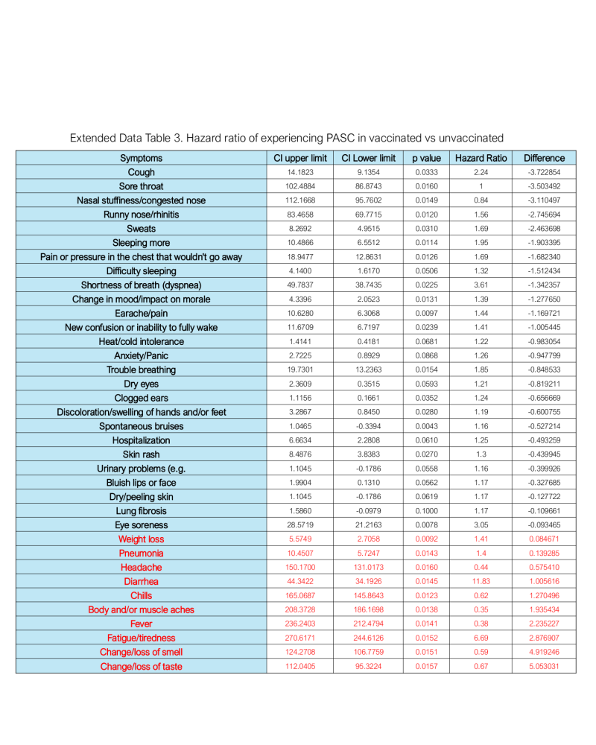
Extended Data Table 3. Hazard ration (HR) of experiencing a given COVID-19-associated symptom after 1st infection in vaccinated versus unvaccinated.

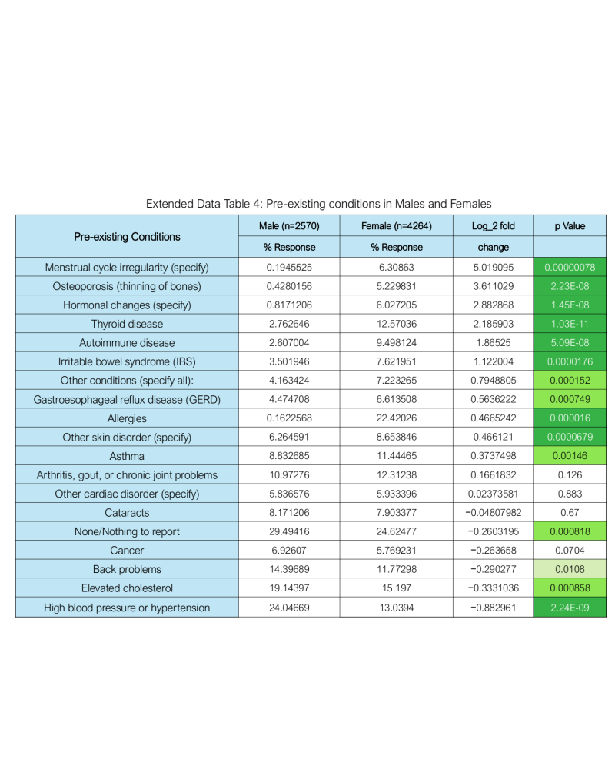

Extended Data Table 4. Pre-existing health conditions in the cohort. Individuals were asked about pre-existing conditions diagnosed by a medical professional. Conditions reported by sex are shown. 5 individuals identified their biological sex as male but gender as either female/woman or none of the above choice for gender, reported menstrual cycle irregularities. See accompanying Fig. 3b for percent change in pre-existing health conditions and their relative risk in experiencing severe vs mild COVID-19 disease. Cells with significant p values are filled in green with darkest shade for p<0.001 and lightest for p<0.05. Vaccinated (n=898), Unvaccinated (2,351).

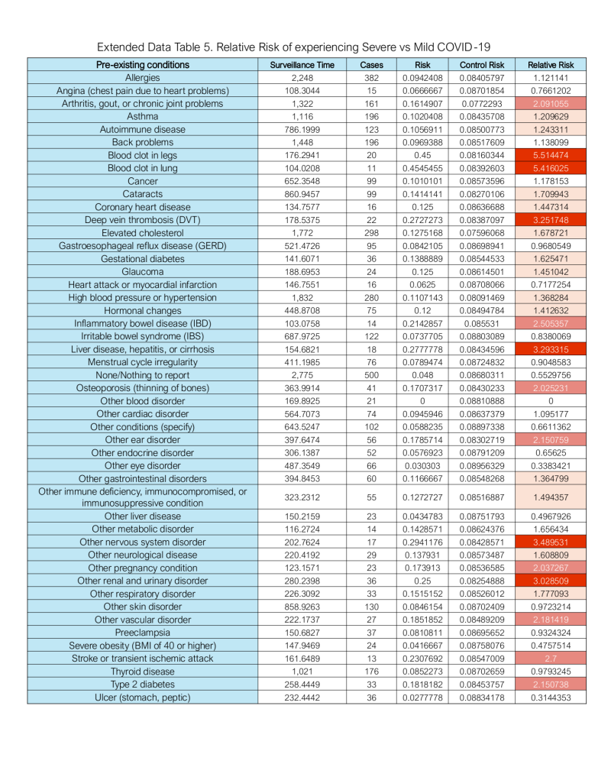

Extended Data Table 5. Relative risk of experiencing severe versus mild COVID-19 diseases for a given pre-existing condition in the PROVES cohort. Control risk (in people without these pre-existing conditions), the risk was low. Cells with RR≥3.0 are filled in darkest red and those with ≥1.2 in lightest.

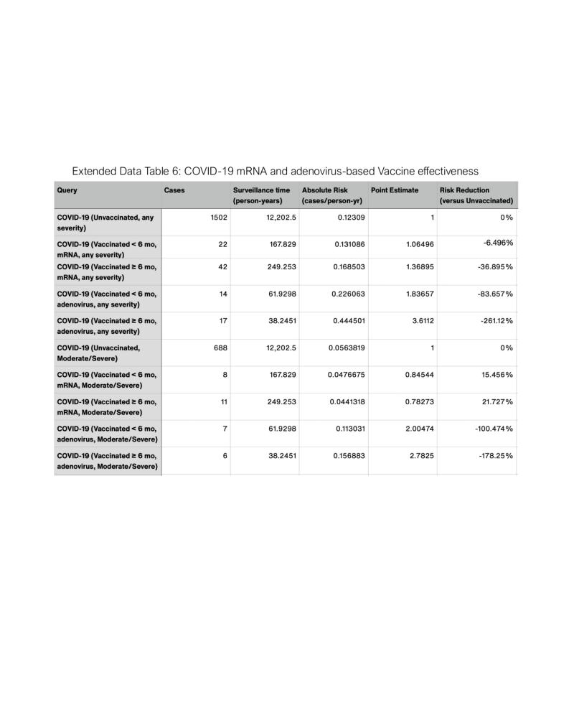
Extended Data Table 6. COVID-19 mRNA and adenovirus-based Vaccine effectiveness in the PROVES cohort.

